Design and Implementation of Digitally Controlled Photovoltaic Maximum Power Tracking System
Mahmoud Shaker Nasr
Department of Electrical Engineering, Faculty of Engineering
University of Babylon, Hilla - Iraq
mahmoud111957@yahoo.com

Abstract

In this paper, the design of controller that realizes the operation of PhotoVoltaic (PV) panel at its maximum power point tracker (MPPT) by means of microcomputer ( microcomputer- based MPPT) and then examine the efficiency of system controller. The maximum power point tracker system used consists mainly of solar panel (the source), DC/DC converter (the load conditioner), the microcomputer ( proceeds the data and execute the MPPT algorithm), the data acquisition ( acquires the real current and voltage from the panel), and the load. The over all system operation is implemented practically using the most popular three control algorithms (P&O, Inc-Cond., and Power derivation), and the obtained results demonstrate the reliability of the control system.

الخلاصـــة
من المعروف أن اللوح الشمسي ينتج قدرة كهربائية ذات قيمة معينة تحددها قابلية اللوح على انتاج هذه القدرة لذا ومن أجل رفع كفاءة نظام الطاقة الشمسية ( كمية الطاقة نسبة الى سعر التكلفة) وجد من الضروري استخلاص كل الطاقة المنتجة من اللوح الشمسي أو مايسمى بـ "البحث عن نقطة القدرة القصوى". في هذا البحث تم تصميم نظام رقمي مسيطر عليه بإستخدام الحاسوب يجبر اللوح الشمسي بالعمل عند نقطة القدرة العظمى. يتكون النظام المقدم في هذا البحث من اللوح الشمسي ( مصدر القدرة)، مغير القدرة نوع DC/DC الذي يقوم بتغيير طبيعة الحمل وهو يمثل قلب نظام السيطرة ( أو مكيف الحمل)(load Conditioner) ، و الحاسوب الذي يقوم بأخذ أو اكتساب المعلومات من النظام (مثل التياروالجهد) ثم يقوم بتشغيل الخوارزمة الخاصة بالسيطرة واخيرا إعطاء الاشارة الضرورية لتشغيل مغير القدرة بحيث أن القدرة الخارجة أو المستحصلة من اللوح الشمسي تكون أكبر قيمة لها. تم تنفيذ نظام السيطرة انف الذكر عملياً وذلك باستخدام ثلاثة طرق لتتبع نقطة القدرة العظمى واثبتت النتائج العملية التي تم الحصول عليها جدارة نظام السيطرة وذلك من خلال مقارنة النتائج بين حالتي عدم استخدام و إستخدام نظام السيطرة في جميع طرق السيطرة الثلاثة.

Keywords: PV panel, MPPT, Digital control MPPT, DC/DC converter.

1. Introduction

The energy extracted from a solar panel is strongly limited by the physical constraints of photovoltaic cells. The approximate power density of the insolation on a sunny day is around 1000W/m². In combination with solar cell efficiencies between 15% and 17% this yields a maximum possible power output between 150W/m² and 170W/m². There are two ways to increase the power coming from a photovoltaic array: One can add more panels to the array, which means an increase in area requirements and a great increase in cost for material. One can also attempt to make the existing array always work at its highest possible efficiency. Since the PV panel generates an electrical power so it is logically to extract all the power generated in order to minimize the cost of PV system.
Maximum power point tracking (MPPT) is an electronic system that operates the photovoltaic (PV) modules or panels in a manner that allows the modules or panels to produce the maximum power they are capable of.
MPPT is not a mechanical tracking system that the modules or panels to make them point more directly at the sun. MPPT is a fully electronic system that varies the electrical operating point of the modules or panels so that the modules or panels are able to deliver maximum available power. MPPT can be used in conjunction with a mechanical tracking system, but the two systems are completely different. The MPPT is required to make sure that the system operates close to the maximum power point (MPP) when it’s subjected to changing environmental conditions, Provide high conversion efficiency, maintain tracking for a wide variation in environmental conditions, and Provide an output interface capable with the battery charging requirements. The main target of this paper which is realization of the controller that force the solar panel to operate at its maximum power point (MPPT), three methods will be presented during the paper namely: Perturbation and Observation, incremental conductance, and power derivation algorithms.[ Thenkani, A., Senthil Kumar, N. , 2011][ Yaden, M.F., El Ouariachi, M., Mrabti, T., Kassmi, K. ,et.al. , 2011][ Yun Tiam Tan, 2004].

2. Methods of MPPT
There are many different approaches to extract the maximum possible power out of the P.V. generator. Some of the concepts are very robust and simple, whereas other approaches require very sophisticated logic devices such as microprocessors combined with high-power high-efficiency switching converters. There are a number of Maximum Power Point Tracking (MPPT) techniques. All of these methods require an algorithm to specify the location of the operating point with respect to the maximum power point. Some of them deliver only a sub-optimum power output. A good MPPT technique should produce a high efficiency at low cost because PV systems will have to be mass-produced. These methods can be classified as indirect methods or direct methods.[ Lopez-Lapena, O. , Penella, M.T. , Gasulla, M.A, 2010] [ Petreus, D. , Dara Daraban, S. , Cirstea, M., Petreus D., Daraban, S., et al, 2011]

2.1. Indirect Methods
Indirect methods are those which use an outside signal to estimate the MPP. Such outside signals are derived by measuring the irradiance, the module temperature, the short circuit current, or the open circuit voltage of a reference cell.
A set of physical parameters has to be given, and the MPP set point is derived from the monitored signal. Derived set point on basis of design parameters, operational parameters, or system characteristics. [Ashraf Abdel Hafeez, Khaled El-Metwally, and Osama Mahgoub, 2006][ Ramaprabha, R., Mathur, B.L., Sharanya, M., 2009]

2.2. Direct Methods
Direct methods, are those which depend on direct measurements of the solar panel. Algorithms in this category are usually based on the measurement of the DC or AC input current and voltage.
Different algorithms were implemented to detect or track the MPP using the measured values by digital signal processor or by analog circuits [De Brito, M.A.G., Sampaio, L.P., Junior, L.G., Canesin, C.A., 2011]. Adjustment of MPP may occur continuously or intermittently. Many direct methods exit in literature such as simple panel-load matching, Voltage control method, Power control method, and Current control method.[ Khan, M.I. et.al., 2009][ Yun Tiam Tan, 2004]

3. Experimental Work
A. System Overview
As known, in most cases when the load is connected directly to the P.V. panel output, the power extracted from the panel is not the maximum value. The extraction of maximum power from P.V. can be obtained by means of a load condition situated between the P.V. and the load, the aim of this conditioner (DC/DC converter) is to force the P.V. panel to operate at its maximum power point (MPP) and then a maximum power can be extracted.
The heart of the above point is to control the operation of the DC/DC converter according to the measured values of P.V. current and voltage, and an algorithm (program) that processes the measured data and determines finally the control signal necessary for the adequate operation of DC/DC converter.
Referring to figure (1), the maximum power point tracking system consists of the following subsystem:-
- A PV panel (Type: LG250-12).
- Sensing circuits (voltage and current).
- Load conditioner (DC/DC booster)
- The controller, that can be divided into:
● Data acquisition.
● MPPT algorithm manipulation.
● D/A converter.
● Driving circuit.

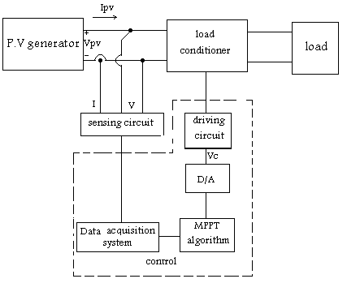

Figure (1) Block diagram of MPPT system.

B. Model of PV and Model Verification.
Modeling of a panel is very important issue, since a model can be used for performance study, analysis, and prediction of the system response prior to its practical implementation. This model is used to investigate the variation of maximum power point with temperature and insolation levels.[ Khan, M.I. et.al., 2009][ Masafumi Miyatake, Tooru Kouno, and Motomu Nakano, 2002][ Ramaprabha, R., Mathur, B.L., Sharanya, M., 2009].
A solar cell is usually presented by an electrical equivalent one- diode model, as shown in figure (2). The model included temperature dependence of photocurrent, I_{ph}, and the saturation current, I_{s}, of the diode. A series resistance R_{s} was included, but not a shunt resistance.[ S. Armstrong, W.G. Hurley, 2004]
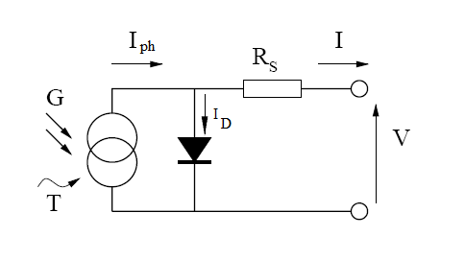

Figure (2) the circuit diagram of the PV model.
The P.V. panel used in this paper is the LG250-12; consist of six modules connected in series. Each of these modules has 36 single crystal silicon solar cells connected in series. It can generate maximum current 2.35 A and a voltage of 16.6 V and each module give rise to a maximum power of 39w. Figure (3) shows a photograph of the panel while table (1) presents its specifications.
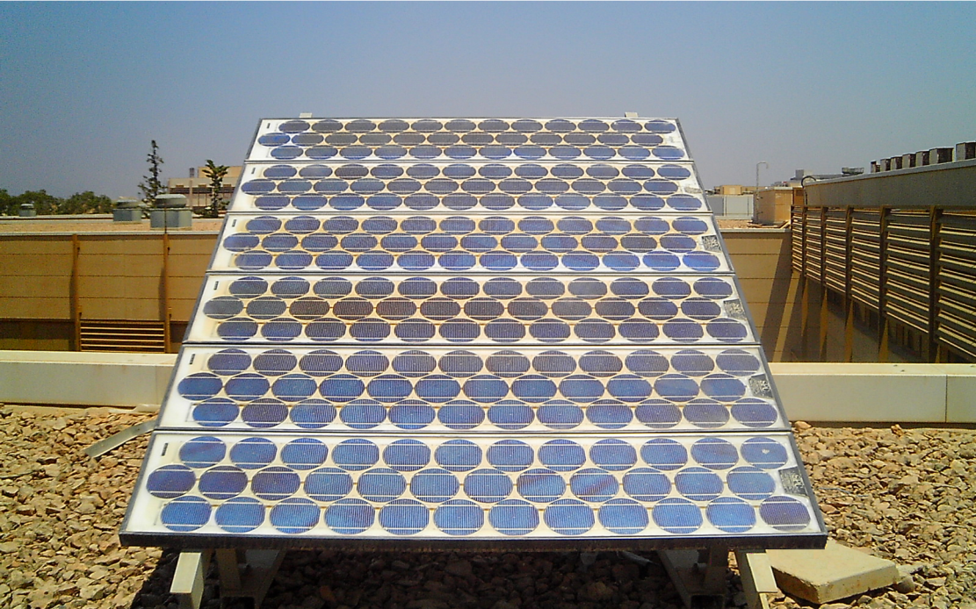

Figure (3). Photograph of LG250-12 panel

The method of parameter extraction and model evaluation in MatLab is demonstrated. The equation which describe the I-V characteristics of the represented panel is,

.....................................................…(1)

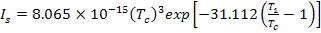
Where :
: Cell output current.
: Cell output voltage.
: Reverse saturation current.
; photo current.
: cell temperature.
: Reference temperature in Kelvin = .
: Short circuit current temperature coefficient.
: Solar intensity at operating condition.

Table (1) LG-250-12 module specifications.
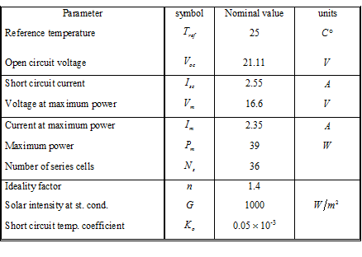
In order to obtain a fair model its necessary the comparison between the experimental and simulation results for the same conditions. Figure (4) represents the experimental and simulation results for the case of G=897.67 w/m² and T_{a}=32c° of PV panel.

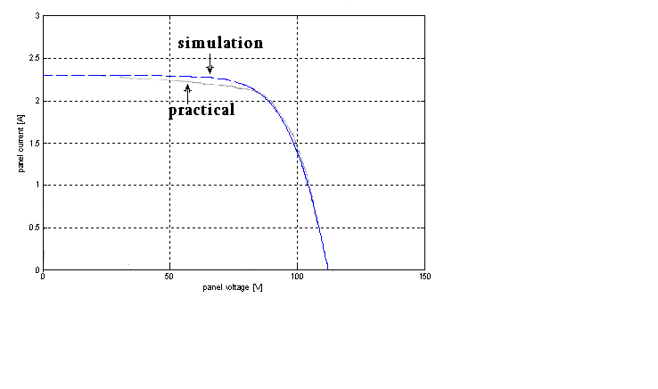
Figure (4) Simulation and practical I-V curves (PV Panel) for G= 897.67 W/m² and T_{a}=$\text{32}°C$

C. Design of Chopper
The most critical section of the power tracker is the switching converter section. The converter force the P.V panel to operate at its maximum efficient point while converting the energy provided up to a voltage that is usable by the rest of the system. It is also in this section that optimal component choice is important. Since all the panel energy flows through the converter, any resistance or loss will contribute to the power loss of the system. The circuit of this converter is shown in figure (5).

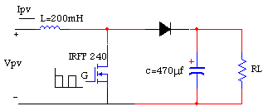

Figure(5) DC/DC boost converter.

The required elements for the boost converter are: MOSFET transistor, inductor, capacitor, and diode. An n-channel enhancement mode power MOSFET IRFP240 is selected as a high speed switching device for the boost converter and the value of inductor and capacitor are 200mh and 470μf respectively.

D. System Software
With the hardware circuit design completed, the next step is the software interpolation of the MPPT algorithm and control of the hardware for the data acquisition and output. During the realization of the presented paper, three algorithms were executed, these are:

1. Perturbation and Observation Method (P&O).
The P & O method is widely used in MPPT, because it has a fewer measured parameters. It can track maximum power point quite accurately through variations in radiation and temperature. It operates by perturbing the system by increasing or decreasing the panel operating voltage and observing the impact of this change on the panel output power. Figure (6) is a flow chart of the P&O algorithm. As shown in Figure (7), if output power has increased, panel voltage is adjusted in the same direction as in the previous cycle. If the output power had decreased, panel voltage is perturbed in the opposite direction as in the previous cycle. When the maximum power point (MPP) is reached, the output voltage will oscillate around the maximum operation voltage.[ S. Armstrong, W.G. Hurley, 2004][ Thenkani, A., Senthil Kumar, N. , 2011]

2. Incremental Conductance Method (Inc.Cond.).
The Incremental Conductance method has been proposed to avoid the drawbacks of the P&O MPPT method. It is based on the fact that the derivative of the output power with respect to the panel voltage is equal to zero at maximum power point. The output voltage and current from the PV panel are monitored upon which the MPPT controller relies to calculate the conductance and incremental conductance, and to make its decision (to increase or decrease duty ratio output). From the PV characteristic of PV panel that shown in Figure (8). The derivative is positive to the left of the maximum point and negative to the right of the MPP. Mathematical of the Inc.Cond. algorithm is discussed below.

Figure (6) Flow chart of P&O algorithm.

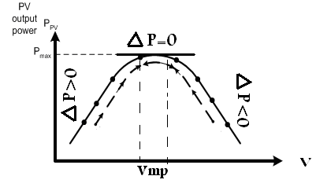

Figure (7) P-V characteristic of PV panel.

The derivative of output power is,

$\frac{\text{dP}}{\text{dV}}=V\frac{\text{dI}}{\text{dV}}+I=0$ …………………………………………………… (2)

$∴\frac{\text{dI}}{\text{dV}}=−\frac{I}{V}$ …….……..……………………………………………… (3)

This leads to the following set of equations:

at the left of MPP …………………………………...…....….. (4)

at MPP …………....……………………………………........ (5)

at the right of MPP ……….…………………………..….….... (6)

Figure (9) illustrate the flowchart of Inc-Cond methods.
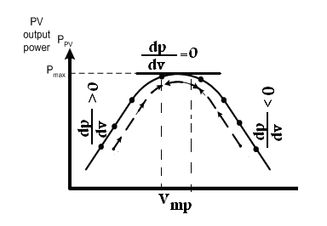
Figure (8) PV characteristic of PV panel.

Figure (9) Flow chart of Inc. Con. algorithm.

3. Power Measurement Method (Power Derivation )
By measuring the panel voltage and current, the PV panel output power is calculated and compared to previous PV output power. Depending on the result of the comparison, the duty cycle is changed accordingly and the process is repeated until the maximum power point has been reached. The MMP tracking process is shown in Figure (10) and the flowchart of this method shows in Figure (11).[ Islam, M.R., Youguang Guo, Jian Guo Zhu , Rabbani, M.G. , 2010] [ M. Jantsch1, M. Real, H. Häberlin, C. Whitaker, K. Kurokawa, G. Blässer, P. Kremer, and C.W.G. Verhoeve, 2008]

Figure (10) MMP tracking process.
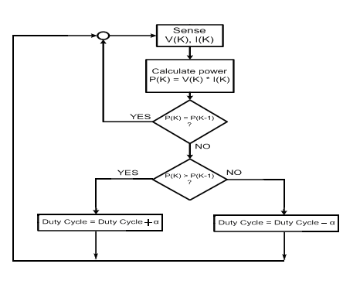
Figure (11) MPPT control flowchart of measure PV (Power Derivation ) method,(α, step of duty cycle).

4. EXPERIMENTAL RESULTS

A. Evaluation of Boost Converter
This converter is capable of delivering most of the input power from P.V. panel to the load. The following results show the behavior to the boost converter under different switching frequency and duty cycle ratios that could affect the power efficiency of the boost converter. Figure (12) shows the obtained relation between the switching frequency (Hz) and the booster output power efficiency. The efficiency for each value of D is calculated and represented against the duty cycle as shown in figure (13).

B. Testing the MPPT Algorithms
In order to demonstrate the effectiveness of the maximum power tracking algorithm and to show how to extract the maximum power from the PV generator, the strategy used in the presented paper consists of the following steps.
1. Study the operation of the PV generator with direct connection of the load (without MPPT controller or without load conditioner) for a certain period of time.
2. After a certain time determined in (1), let the controller operate and the MPPT algorithm control the operation and force the PV generator to operate in its maximum power point.
When the above strategy is applied it is very simple to note the difference between the case of direct connection and the case of conditioned connection where the power difference is very large and clear, so the main goal of MPPT algorithm is satisfied. This strategy is applied for the three methods considered in this paper under different value of radiation and constant load. Figures (14) and (15) show the result obtained applying P&O algorithm. Than the same strategy is applied for the demonstration of Inc. Cond. MPPT algorithm as shown in Figures (16) and (17).
While, the results of third method of MPPT algorithm applied in this paper (Power Derivation Algorithm) are illustrated in figures (18) and (19).

Figure (12) power efficiency of the converter vs. switching frequency.

Figure (13) power efficiency of the converter vs. duty cycle.

C.Long Run System Operation
In order to demonstrate the reliability of the controller, the system is executed for long time and the results are obtained for different algorithms. Figure (20) shows the results for Perturbation and observation algorithm. Figure (21) demonstrates the results for the second algorithm (Inc.Cond. algorithm), while figure (22) shows the results for power derivation algorithm.
Finally figure (23) shows the results of the three different algorithms at the same chart.

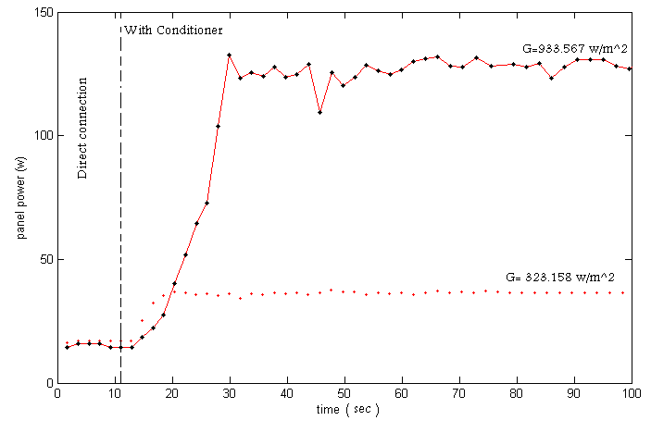
Figure (14) panel power vs. time at G=933.567 W/m² and 323.158W/m² , R_{L}=700Ω applying P&O algorithm.

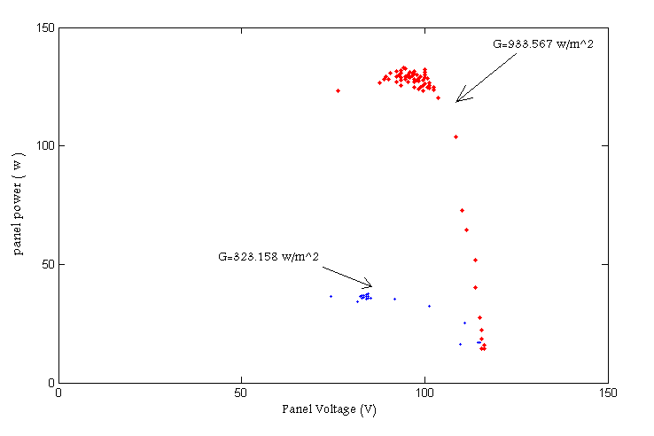

Figure (15) P_{pv} vs. V_{pv} curve applying P&O algorithm.

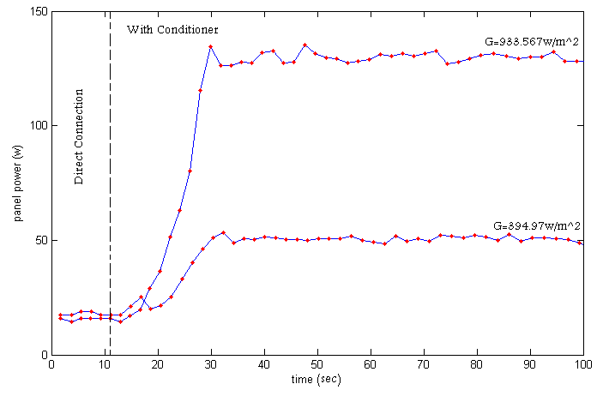
Figure (16) Panel power at G=933.567 w/m² and 394.67 w/m² , R_{L}=700Ω using Inc. Cond. Method.

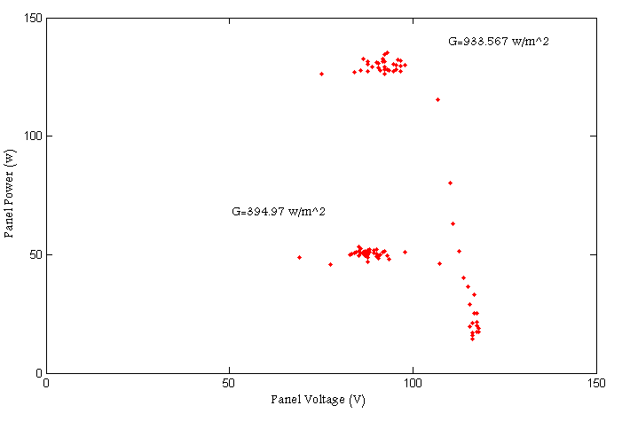
Figure (17) Panel power vs. Voltage at G=933.567 w/m² and 394.67 w/m², R_{L}=700Ω using Inc. Cond. Method.

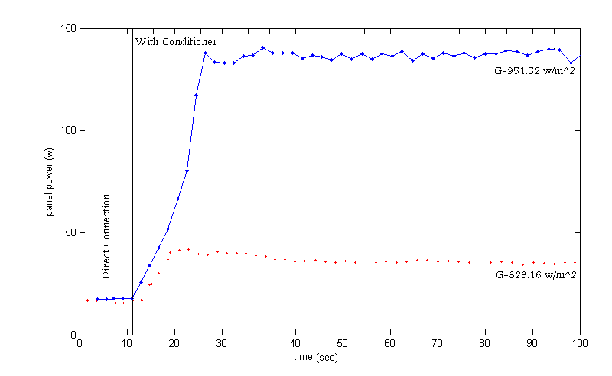
Figure (18) panel power vs. time at R_{L}=700Ω and G=951.52 w/m², 323.16 w/m² using Power Derivation Algorithm.

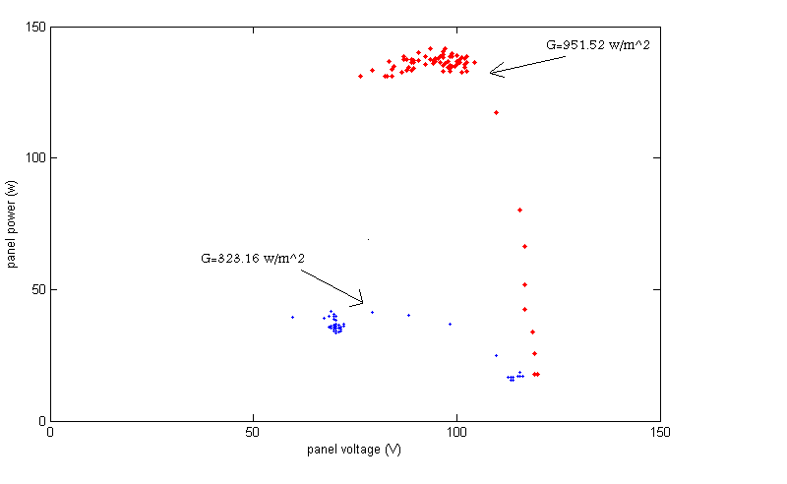

Figure (19) P_{pv} vs. V_{pv} curve at R_{L}=700Ω and G=951.52 w/m², 323.16 w/m² using Power Derivation Algorithm..

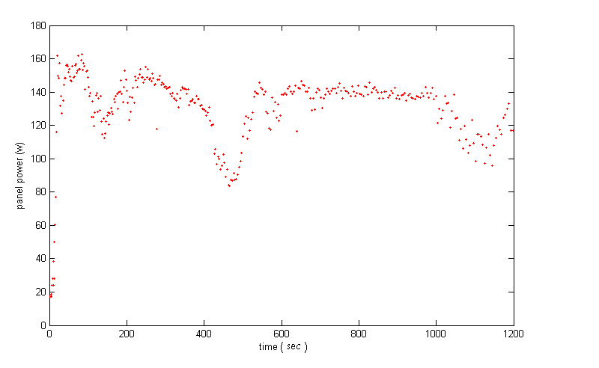
Figure (20) Long time run of Power vs. time. (Perturbation and observation algorithm).

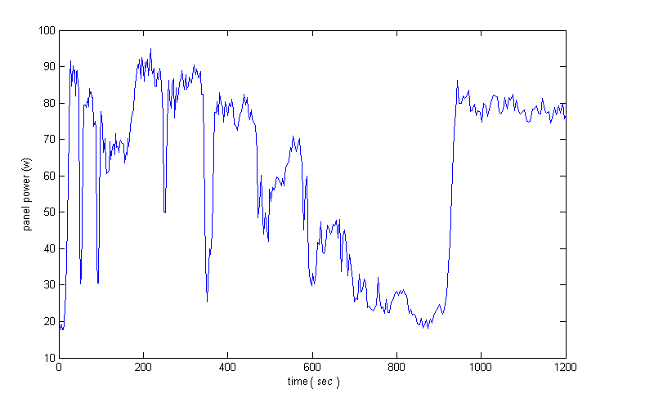
Figure (21) Long time run of Power vs. time. (Inc.Cond algorithm).

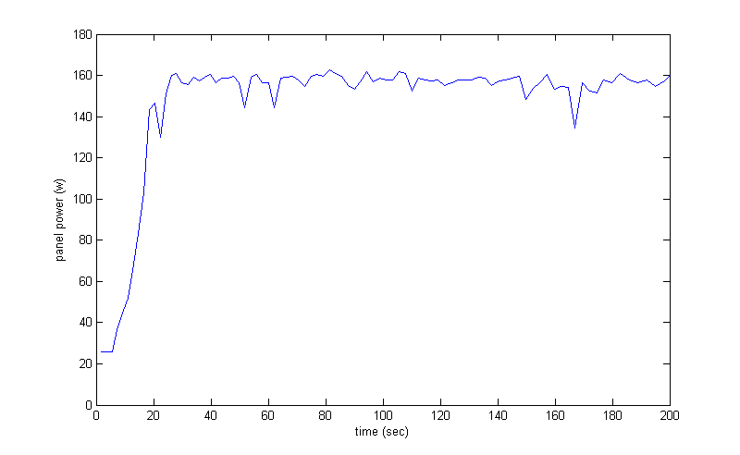
Figure (22) Long time run of Power vs. time. (power derivation algorithm).

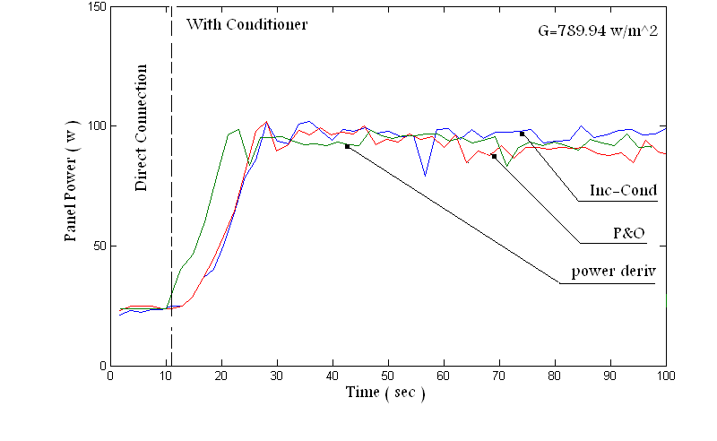
Figure (23) comparison between control algorithms at G=789.94 w/m² and R_{L}=500Ω.

5. Conclusions

The presented paper introduced the design and practical implementation of microcomputer-based maximum power point tracker to allow the transfer of maximum energy generated by photovoltaic panel to the load. The main goal of this work is to increase the efficiency in comparison to systems have no MPPT, and thus to reduce the size and cost of the PV panel. To demonstrate the effectiveness of the MPPT control, the load is first connected directly to the panel without MPPT controller of a certain time and then a controller is applied, in this last case, the power obtained from the panel increased and the panel operated in its maximum power.
The computer is used to fulfill three goals namely, system variables monitoring, measuring device, and the mainly controller.
Three methods of MPPT control algorithms are applied, the obtained results are almost the same but there are some differences in the response time.
From all results, its clear that, the performance of system under conditioner is much better than the direct connection, the change of operating voltage is not large when the radiation is changed, the response system under MPPT control is satisfactory when it operates under random environmental conditions (clear and largely cloudy day), and the operating point of the panel always operates around the MPP as radiation varies. All these results demonstrate that the MPPT controller dominates the dynamic behavior of the PV power generation.

6. References
Ashraf Abdel Hafeez, Khaled El-Metwally, and Osama Mahgoub, 2006, "A Photovoltaic Intelligent Power Conditioning Unit for MPPT Using Neural Networks ", 5th International Engineering Conference, No 2005.
De Brito, M.A.G., Sampaio, L.P., Junior, L.G., Canesin, C.A., 2010, " Evaluation of MPPT techniques for photovoltaic applications ", IEEE International Symposium on Industrial Electronics, PP. 1039-1044, IEEE Publisher.
De Brito, M.A.G., Sampaio, L.P., Luigi, G., e Melo, G.A., et.al, 2011 "Comparative analysis of MPPT techniques for PV applications ", International Conference on Clean Electrical Power (ICCEP) , PP. 99-104, IEEE Publisher.
Eftichios Koutroulis, Kostas Kalaitzakis, and Nicholas C. Voulgaris, 2001 "Development of A Microcontroller- Based, Photovoltaic Maximum Power Point Tracking Control System ", IEEE Transactions on Power Electronics, Vol. 16, No. 1.
Goudar, M.D., Patil, B.P., Kumar, V. , 2011, " Adaptive MPPT Algorithm for a Distributed Wireless Photovoltaic Based Irrigation System ", International Conference on Devices and Communications (ICDeCom), PP. 1-4, IEEE Publisher.
Hannes Knopf, "Analysis, Simulation, and Evaluation of Maximum Power Point Tracking (MPPT) Methods for a Solar Powered Vehicle ", 1999, Msc Thesis, Portland State University.
Islam, M.R., Youguang Guo, Jian Guo Zhu , Rabbani, M.G. , 2010, "Simulation of PV array characteristics and fabrication of microcontroller based MPPT ", International Conference on Electrical & amp; Computer Engineering (ICECE 2010),PP.155-158

Khan, M.I. et.al. "PhotoVoltaic Maximum Power Point Tracking Battery Charge Controller", 2009, 1st International Conference on the developements in Renewable Energy Technology (ICDRET), IEEE Publisher.
Lopez-Lapena, O. , Penella, M.T. , Gasulla, M.A., 2010 "New MPPT Method for Low-Power Solar Energy Harvesting", IEEE Transactions on Industrial Electronics, Volume: 57 Issue: 9 Pages.
M. Jantsch1, M. Real, H. Häberlin, C. Whitaker, K. Kurokawa, G. Blässer, P. Kremer, and C.W.G. Verhoeve, 2008, "Measurement of PV Maximum Power Point Tracking Performance ".
Masafumi Miyatake, Tooru Kouno, and Motomu Nakano, 2002, "A Simple Maximum Power Point Tracking Control Employing Fibonacci Search Algorithm for Power Conditioner of Photovoltaic Generators ", EPE-PEMC 2002.
Matthew Buresch, 1983, "Photovoltaic Energy Systems ", McGraw-Hill, Inc.
Petreus, D. , Daraban, S. , Cirstea, M., Patarau, T., et al. , 2011, "A novel implementation of a Maximum Power Point Tracking system with digital control ", IEEE International Symposium on Industrial Electronics, PP. 977-982, IEEE Publisher.
Ramaprabha, R., Mathur, B.L., Sharanya, M., 2009, "Solar array modeling and simulation of MPPT using neural network ", International Conference on Control, Automation, Communication and Energy Conservation, PP. 1-5, IEEE Published
S. Armstrong, W.G. Hurley, 2004, "Self-Regulating Maximum Power Point Tracking for Solar Energy Systems ", NUI, Galway Faculty of Engineering Research Day.
Thenkani, A., Senthil Kumar, N. , 2011, " Design of optimum Maximum Power Point Tracking algorithm for solar panel ", International Conference on Computer, Communication and Electrical Technology (ICCCET) , PP. 370-375, IEEE Publisher.
Yaden, M.F., El Ouariachi, M., Mrabti, T., Kassmi, K. ,et.al. , 2011, "Design and realization of a photovoltaic system equipped with a digital MPPT control ", International Conference on Multimedia Computing and Systems, PP.1-6, IEEE Publisher.
Yun Tiam Tan, 2004, "Impact on The Power System with A Large Penetration of Photovoltaic Generation", Ph.D. dissertation, Manchester Institute University.
Zhongyi He, Chengyang Liu, Yadong Liu, Yongqin Zeng, , 2010, " Low Cost MPPT Controller for OFF-Grid Solar Applications", International Conference on Electrical Machines and Systems, PP. 447-451, IEEE Publisher.

