Statistical Analysis of Rainfall Ecords of Some Iraqi Eteorological Stations
Z. A. Omran S. T. Al- Bazzaz
University of Babylon, College of Civil Engineering, Babylon, Iraq
F. Ruddock
Liverpool John Moores University, UK
Abstract
Since rainfall is an integral component in the hydrologic cycle, engineers must be able to quantify rainfall in order to design structures dealing with the collection, conveyance, and storage of runoff. In this paper data of annual rainfall depth (mm) from 1969 to 2009 years for four meteorological stations in Iraq, namely, Baghdad, Najaf, Kerbala, and Diwaniya are analyzed to determine the characteristics of the observed frequency distributions. An attempt is made to fit four of the available theoretical distributions, i.e., the Normal, Log Normal, Log Normal type III, and Gamma distributions. The Chi-Square and Kolmogorov-Smirnov indices, and the graphical goodness of fit tests are applied to compare each of the theoretical distributions and those observed. In the remainder of this paper Intensity-Duration-Frequency (IDF) curves for extreme rainfall values for the four meteorological stations in Iraq with durations of 15, 30, and 60 min. are obtained. Gumbel's extreme value distribution, the Normal and the Log Normal distributions are used to fit the annual extremes rainfall data with 5, 10, 15, and 50 years return periods.

الخلاصة
يعد المطر من المكونات المتممة في الدورةِ الهيدرولوجية، لذلك يجب على المهندسين أَنْ يَكُونوا قادرين على تَحديد كمياته لكي يتم تصميم المنشات التي تَتعامل مع تجميع، نقل، وخزن المطر. في هذا البحث تم تحليل بيانات عمق المطر السنوي (مليمتر) من سنة 1969 إلى سنة 2009 لأربع محطات أرصادية في العراق, بغداد، نجف، كربلاء والديوانية, لغرض إيجاد خصائص توزيعات التكرار المُلاحَظِ. أجريت محاولة لمُلائَمَة أربعة مِنْ التوزيعاتِ النظريةِ المتوفرةِ للبيانات وهي التوزيع الطبيعي، التوزيع اللوغارتمي الطبيعي، التوزيع اللوغارتمي الطبيعي من النوع الثالث و توزيع كاما. تم تطبيق فحص مربّع كاي وفحص كولموكروف- سميرنوف وفحص آخر يعتمد على الطريقة البيانية وذلك لغرض مقارنةِ التوزيعاتِ النظريةِ مع التوزيعات المشاهدة. في الجزء المتبقي من هذا البحث تم الحصول على منحنيات شدة المطر ومدته والتكرار لقِيَم المطر العليا للمحطاتِ الإرصادية الأربعة لمدة 15، 30، و60 دقيقة. وتم استعمال توزيع كمبل المتطرّف، التوزيع الطبيعي والتوزيع اللوغارتمي الطبيعي لمعرفة مُلائَمَة البيانات ولفترات عوده 5، 10، 15، و50 سنة.

1.Introduction
Rainfall is one of the most important parts of the water resources. It is vitally important to quantify it accurately. Good estimates of mean rainfall are needed as inputs to hydrologic models (ARM et al., 2009). The amount of rainfall received over an area is an important factor in assessing the amount of water available to meet the various demands of agriculture, industry, and other human activities. Therefore, the study of the distribution of rainfall in time and space is very important for the welfare of the national economy. Many applications of rainfall data are enhanced by a knowledge of the actual distribution of rainfall rather than relying on simple summary statistics. There is a large number of studies investigating the use of particular distributions to represent the actual rainfall patterns (Abdullah and Al-Mazroui, 1998). Information on quantiles of extreme rainfall of various durations is needed in the hydraulic design of structures that control storm runoff, such as flood detention reservoirs, sewer systems etc. Such information is usually expressed as a relationship between Intensity-Duration-Frequency (IDF) of extreme rainfall (Bara et al., 2009). Rainfall (IDF) curves are graphically representations of the amount of water that falls
within a given period of time. These curves are used to help predict when an area will be flooded, or to pinpoint when a certain rainfall rate or a specific volume of flow will recur in the future (Dupont and Allen, 2000).
2. FITTING PROBABILITY DISTRIBUTIONS TO THE DATA
There are two methods of fitting theoretical distributions to the data (two general methods of finding point estimation). They are:
2.1.Graphical Fitting
The visualization of the data is generally performed by using probability papers that allow a graphical analysis of the fit provided by the selected model and an understanding of visual information otherwise easily wasted (Erto and Lepore, 2011). Because population parameters that the sample (data) taking from it anonymous, it is difficult to find probability from the theoretical distribution function so, the following approximate equations are used for this purpose:
2.1.1 Blom formula is used to obtain the plotting positions for the Normal, Log Normal, and Log Normal type III distributions (Chow et al., 1988).
= 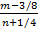 …………………………………………………...…….(1)
Where : is exceedance probability estimate for the mth largest event.
is number of the observed value.
is the rank of a value in a list ordered by descending magnitude.

2.1.2 Weibull formula is used to obtain the plotting positions for Gamma distribution (Matalas, 1963).
= ……………………………………….…………………(2)
2.2.Mathematical Fitting
With regards to this method, parameters of a statistical model are commonly estimated from a sample with either method of moments estimators, or maximum likelihood estimators. Then the values of parameters are substituted into the chosen probability distribution function to solve it and get the probability (U.S. Army Corps of Engineers, 1994). There are many reasonable probability distributions (Frequency analysis models) which are used in statistical analysis. In this paper four probability distributions are used, i.e., Normal, Log Normal, Log Normal type III, and Gamma distributions. All the parameters of the selected distributions are estimated by the method of moments and maximum likelihood. All statistical distributions and their functions that were analyzed in this paper are shown in Table 1.
Table 1. Statistical distributions and their functions.
Statistical Distributions | Functions
Normal Distribution | =
Log Normal Distribution | f (x)=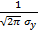 exp [- ()]
Log Normal Type III Distribution | f (x) = 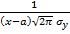 exp [-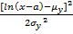 ]
Gamma Distribution | f (x) =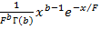
Extreme Value Type I Distribution | f (x;d,c) = exp []exp {- exp []}

Calculations of probabilities by using method of moments (Station: Najaf) for all the selected distributions are shown in Table 2, and Figure 1 shows frequency curve with respect to the Normal distribution (moments and max. likelihood methods) for Najaf station.
Table 2. Calculations of probabilities by using method of moments (Station: Najaf).
LN III | Gamma | Log Normal | Normal | Rank  (m) | Total Rainfall (mm) †
F(x) % | F(x) % | F(x) % | F(x) % | Rank  (m) | Total Rainfall (mm) †
3.817 | 0.878 | 0.102 | 4.792 | 1 | 22.8
5.900 | 2.529 | 0.748 | 6.734 | 2 | 30.3
7.921 | 4.560 | 2.043 | 8.544 | 3 | 35.9
12.733 | 10.142 | 7.043 | 12.737 | 4 | 46.1
14.260 | 12.007 | 8.974 | 14.054 | 5 | 48.8
15.829 | 13.939 | 11.056 | 15.406 | 6 | 51.4
17.296 | 15.752 | 13.065 | 16.672 | 7 | 53.7
17.890 | 16.485 | 13.890 | 17.186 | 8 | 54.6
18.837 | 17.652 | 15.213 | 18.004 | 9 | 56.0
20.806 | 20.073 | 17.992 | 19.712 | 10 | 58.8
24.799 | 24.917 | 23.634 | 23.202 | 11 | 64.1
24.878 | 25.011 | 23.744 | 23.271 | 12 | 64.2
24.956 | 25.105 | 23.854 | 23.340 | 13 | 64.3
25.827 | 26.147 | 25.073 | 24.108 | 14 | 65.4
30.786 | 31.968 | 31.872 | 28.527 | 15 | 71.4
31.643 | 32.954 | 33.017 | 29.299 | 16 | 72.4
33.904 | 35.528 | 35.991 | 31.351 | 17 | 75.0
41.817 | 44.214 | 45.829 | 38.703 | 18 | 83.8
48.597 | 51.279 | 53.543 | 45.229 | 19 | 91.2
48.689 | 51.372 | 53.643 | 45.319 | 20 | 91.3
56.167 | 58.796 | 61.432 | 52.788 | 21 | 99.6
61.270 | 63.669 | 66.360 | 58.053 | 22 | 105.5
64.585 | 66.760 | 69.410 | 61.548 | 23 | 109.5
65.553 | 67.652 | 70.279 | 62.579 | 24 | 110.7
66.508 | 68.528 | 71.128 | 63.602 | 25 | 111.9
66.823 | 68.817 | 71.406 | 63.941 | 26 | 112.3
67.837 | 69.741 | 72.295 | 65.035 | 27 | 113.6
69.965 | 71.667 | 74.130 | 67.347 | 28 | 116.4
70.926 | 72.531 | 74.946 | 68.400 | 29 | 117.7
72.511 | 73.949 | 76.275 | 70.146 | 30 | 119.9
85.837 | 85.636 | 86.797 | 85.275 | 31 | 142.9
86.929 | 86.591 | 87.627 | 86.537 | 32 | 145.4
87.836 | 87.387 | 88.315 | 87.585 | 33 | 147.6
89.854 | 89.171 | 89.852 | 89.911 | 34 | 153.0
91.862 | 90.972 | 91.395 | 92.203 | 35 | 159.3
93.745 | 92.702 | 92.877 | 94.312 | 36 | 166.5
94.456 | 93.372 | 93.451 | 95.092 | 37 | 169.7
94.519 | 93.431 | 93.503 | 95.161 | 38 | 170.0
97.621 | 96.552 | 96.224 | 98.335 | 39 | 190.7
†Source: Iraqi Meteorological Office in Baghdad, Iraq.

Figure 1. Frequency curve with respect to the Normal dis. (moments and max. likelihood methods) for Najaf station.
3.GOODNESS OF FIT TESTS
The goodness of fit tests provide objective procedures to determine whether an assumed theoretical distribution provides an adequate description of the observed data, these tests are valid only for rejecting an inadequate model; they cannot prove that the model is correct. Three types of tests applicable to a wide range of distributions are considered in this paper, these are: Chi-square, Kolmogorov-Smirnov indices, and the graphical goodness of fit tests. These tests are applied to all the distributions that are used in this paper.

3.1.Chi-Square Index
The Chi-Squared statistic depends on specifying the number of histogram classes into which the data will be grouped, and there is no rule that gives the correct number to use (Vose, 2010).The Chi-square test statistic is computed from the relationship:

χ²= 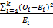 ………………………………………………………(3)
where is the observed and is the expected number of observation in the ith class interval (based on the probability distribution being tested). The expected numbers are calculated by multiplying the expected relative frequency by the total number of observation (Barkotulla et al., 2009). This statistic is distributed as a χ² random variable with k-p-1 degrees of freedom (k is the number of class intervals and p is the number of parameters estimated by sample data). The hypothesis that the data are from a population with the specified distribution is accepted if χ² is lower than the chi-square percent point function with k-p-1 degrees of freedom and a significance level of (expressed as 1– as confidence level, typically, 95% is chosen as the confidence limit). The value of χ² is determined from published χ² tables with degrees of freedom at the 5% level of significance (Ricci, 2005). Results of Chi-Square index are shown in Table 3.
Table 3. Chi-Square index for the stations that are used in the paper.
LN III Dis. |  | Gamma Dis. |  | Log Normal Dis. |  | Normal Dis. |  | Theo. Chi-Sq. | ν | Stations
Obs. Chi-Sq. |  | Obs. Chi-Sq. |  | Obs. Chi-Sq. |  | Obs. Chi-Sq. |  | Theo. Chi-Sq. | ν | Stations
M.L. | M. | M.L. | M. | M.L. | M. | M.L. | M. | Theo. Chi-Sq. | ν | Stations
9.2072 | 9.1656 | 6.7515 | 7.3796 | 7.0481 | 9.4765 | 10.8860 | 10.8860 | 11.0710 | 5 | Najaf
7.9623 | 7.3269 | 5.6213 | 6.8894 | 7.3054 | 9.7515 | 24.6932 | 24.6932 | 11.0710 | 5 | Kerbala
7.7395 | 7.0699 | 6.9159 | 7.0827 | 7.1581 | 8.1002 | 10.5244 | 10.5244 | 14.0670 | 7 | Diwaniya
7.9188 | 7.0315 | 7.2000 | 7.1983 | 6.8071 | 7.4778 | 20.9912 | 20.9912 | 14.0670 | 7 | Baghdad
3.2.Kolmogorov-Smirnov Index
Kolmogorov-Smirnov (K-S) goodness of fit test is based on a statistic that measures the deviation of the observed cumulative histogram from the hypothesized cumulative distribution function (Soong, 2004). Results of K-S index are shown in Table 4.

Table 4. The values of Kolmogorov-Smirnov index for all the stations and with confidence level equal 95%.
Obs. D . |  |  |  |  |  |  |  | Theo. D. | n | Stations
LN III |  | Gamma Dis. |  | Log normal Dis. |  | Normal Dis. |  | Theo. D. | n | Stations
M.L. | M. | M.L. | M. | M.L. | M. | M.L. | M. | Theo. D. | n | Stations
0.12159 | 0.10070 | 0.07492 | 0.09750 | 0.09231 | 0.10824 | 0.12239 | 0.12239 | 0.213 | 39 | Najaf
0.07487 | 0.08130 | 0.10453 | 0.09802 | 0.12759 | 0.12476 | 0.07571 | 0.07571 | 0.213 | 39 | Kerbala
0.11814 | 0.12540 | 0.12785 | 0.12552 | 0.11242 | 0.10253 | 0.16732 | 0.16732 | 0.213 | 39 | Diwaniya
0.06882 | 0.06364 | 0.06493 | 0.06494 | 0.06626 | 0.07506 | 0.11973 | 0.11973 | 0.213 | 39 | Baghdad

3.3.The Index of Goodness of Fit based on the Probability-Rainfall Plot
This index depends on the deviations of points that represent the sample from the theoretical frequency curve on the plot of relationship between probability and rainfall. This index represents the average absolute value of the deviations. The theoretical distribution which has the smallest value for this index represents the more suitable distribution for the data (Alkhafagiy, 1995). Results of this index are shown in Table 5.
Table 5. The values of goodness of fit by using graphical figures for the relationship between rainfall & probability.
Gamma Dis. |  | LN III |  | Log Normal Dis. |  | Normal Dis. |  | Stations
M. L. | M. | M. L. | M. | M. L. | M. | M. L. | M. | Stations
*** | *** | 0.1030 | 0.1070 | 0.1047 | 0.1172 | 0.0891 | 0.0891 | Najaf
*** | *** | 0.0832 | 0.0826 | 0.1433 | 0.1055 | 0.0646 | 0.0646 | Kerbala
*** | *** | 0.0670 | 0.0650 | 0.0559 | 0.0579 | 0.0653 | 0.0653 | Diwaniya
*** | *** | 0.0857 | 0.0865 | 0.0477 | 0.0520 | 0.0702 | 0.0702 | Baghdad
4.ESTABLISHMENT OF RAINFALL (IDF) CURVES
Rainfall intensity at different durations and frequencies are presented as Intensity-Duration-Frequency (IDF) curves which are widely needed for planning, designing, and operating water resource projects, this is to protect the project against flooding and to use the flood water for agriculture use by collecting it in reservoirs (Ghahraman and Hosseini, 2005).

4.1.Methodology
The intensity-duration-frequency analysis starts by gathering records of different durations. After the data is gathered, annual extremes are extracted from the record for each duration. The annual extreme data is then fit to a probability distribution to estimate rainfall quantities. In this study Gumbel extreme value distribution, the Normal and Log Normal distributions are used to fit the annual extreme rainfall data.
Gumbel Distribution
The form of Gumbel probability distribution may be written as follows:
= σ ……………………………………….………………......(4)
where represents the magnitude of the T-year event, μ and σ are the mean and standard deviation of the annual maximum series, and is a frequency factor depending on the return period T or probability of non exceedance which can be calculated from generated uniform random numbers 0<<1, that is T=1/(1-) (Saf, 2005). The frequency factor is applicable to many probability distributions used in hydrologic frequency analysis, for the Gumbel distribution is obtained from Equation 5 (Prodanovic and Simonovic, 2007).
= [0.5772+ln (ln [ [( [ …………………………….......(5)
Tables from 6 to 9 show the values of intensities by using Gumbel distribution for all the selected stations. Figures from 2 to 5 show IDF curves for all the stations that are used in this paper for Gumbel distribution.
Normal Distribution
The value of frequency factor that depends on return period for the Normal distribution is given by Equation 6 (Barkotulla et al., 2009):
= w- ………………...............(6)
Where w= 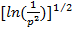 [0p0.5] …………………........(7)
= Exceedance probability
When p0.5; 1-p is substituted for p in Equation 7.
Alternatively the frequency factor is computed by using tables. This gives the value of Kt depends on skew coefficient (Cs=0) with different return periods. When the value of is computed then it is substituted in Equation 4 to obtain the value of extreme rainfall intensity (Barkotulla et al., 2009).
Log Normal Distribution
The value of frequency factor for the Log Normal distribution is computed by the same way as the Normal distribution, but the value of extreme rainfall intensity depends on the logarithm of the data. Then this value is used in Equation 8 to obtain the value of extreme rainfall intensity.
= …………………………………........................(8)
Whereis represents the magnitude of the T-year event, and are the mean and standard deviation of the annual maximum series for the logarithms of the data.

Table 6. Results for Kerbala station (Gumbel distribution).
Intensity (mm/hr) |  |  |  | Duration (min.)
50 year | 15 year | 10 year | 5 year | Duration (min.)
68.7 | 53.9 | 48.8 | 39.8 | 15
42.1 | 32.1 | 28.7 | 22.3 | 30
25.3 | 19.5 | 17.5 | 13.9 | 60
.Table 7. Results for Najaf station (Gumbel distribution)
Intensity (mm/hr) |  |  |  | Duration (min.)
50 year | 15 year | 10 year | 5 year | Duration (min.)
102.2 | 78.6 | 70.4 | 56.0 | 15
62.0 | 47.9 | 43.1 | 34.4 | 30
33.5 | 26.4 | 24.0 | 19.6 | 60
Table 8. Results for Diwaniya station (Gumbel distribution).
Intensity (mm/hr) |  |  |  | Duration (min.)
50 year | 15 year | 10 year | 5 year | Duration (min.)
67.6 | 52.3 | 47.1 | 37.7 | 15
47.7 | 36.5 | 32.7 | 25.9 | 30
28.2 | 21.9 | 19.8 | 15.9 | 60
Table 9. Results for Baghdad station (Gumbel distribution).
Intensity (mm/hr) |  |  |  | Duration (min.)
50 year | 15 year | 10 year | 5 year | Duration (min.)
78.0 | 59.4 | 52.9 | 41.5 | 15
50.2 | 38.3 | 34.1 | 26.8 | 30
30.6 | 23.5 | 21.1 | 16.8 | 60

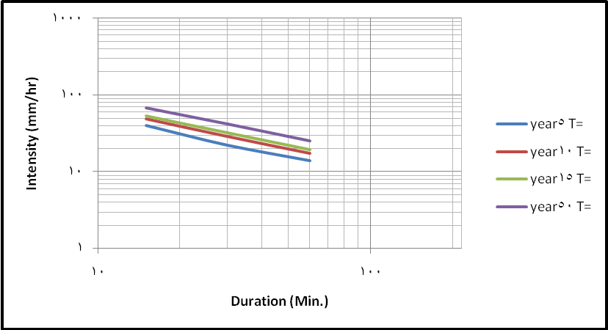
Figure 2. IDF Curve for Kerbala station (Gumbel distribution).

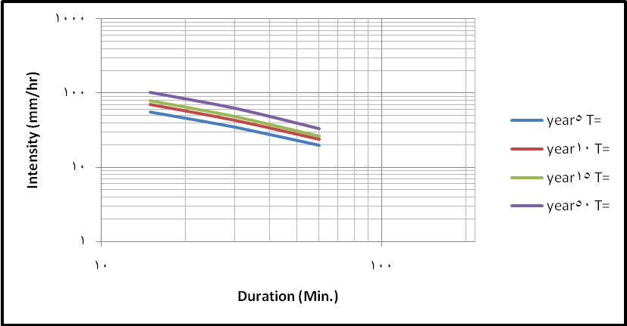
Figure 3. IDF Curve for Najaf station (Gumbel distribution).

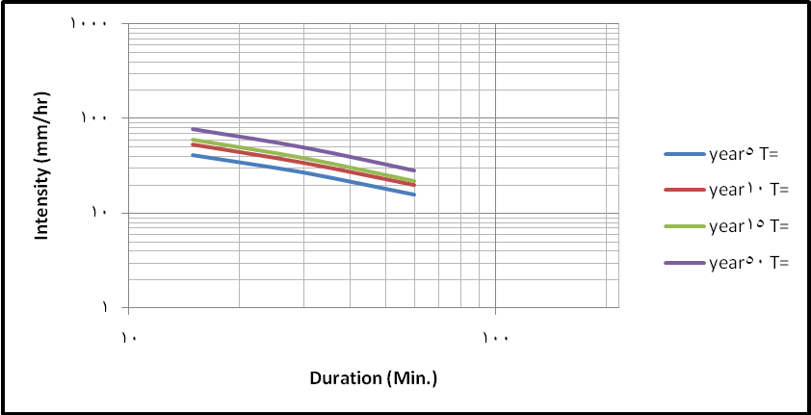
Figure 4. IDF Curve for Diwaniya station (Gumbel distribution).

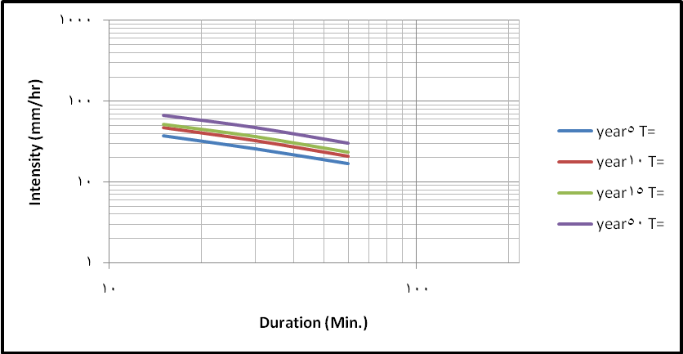
Figure 5. IDF Curve for Baghdad station (Gumbel distribution).

5.CONCLUSION
In this paper four probability distributions are used, i.e., Normal, Log Normal, log Normal type III, and Gamma distributions. These distributions are applied to the data of rainfall depth for four selected stations in Iraq, namely, Baghdad, Najaf, Kerbala, and Diwaniya. Moments and maximum likelihood methods are used to estimate the parameters of the selected distributions. Graphical method depending on two approximate equations (Blom, and Weibull) for the plotting positions on the probability paper is also applied to check the suitability of the distribution visually. For the purpose of testing the suitability of the theoretical distributions to the data, three goodness of fit test are used: The Chi-Square, Kolmogorov-Smirnov, and the graphical goodness of fit tests.
The results of Chi-Square index are as follows:
1.The Normal distribution is acceptable for Najaf and Diwaniya stations by using both the moments and maximum likelihood methods except Baghdad and Kerbala stations.
2.The Log Normal distribution is acceptable for all the stations by using the two methods of estimation (moments and maximum likelihood).
3.The Log Normal type III distribution is acceptable for all the stations by using the moments and maximum likelihood methods.
4.Gamma distribution is acceptable for all the stations by using the two methods (moments and maximum likelihood).
The results of the Kolomogrov-Smirnov index show that all the stations are acceptable for the four distributions by using the two methods (moments and maximum likelihood).
The results of the test based on the plot represent the relationship between probability and rainfall shows that the Normal distribution is suitable for Najaf and Kerbala stations by using moments and maximum likelihood methods, but the Log Normal distribution using maximum likelihood method is suitable for Diwaniya and Baghdad stations. The results for the three statistical tests are shown in Table 10.
Table 10. Summary of results for the three indices.
D Index |  | K-S Index |  | Chi-Square Index |  | Stations
Estimation method | Success Dis. | Estimation method | Success Dis. | Estimation method | Success Dis. | Stations
(M.+M.L.) | Normal | (M.L.) | Gamma | (M.L.) | Gamma | Najaf
(M.+M.L.) | Normal | (M.L.) | LN (III) | (M.L.) | Gamma | Kerbala
M.L.)) | L. N. | (M.) | LN | (M.L.) | Gamma | Diwaniya
M.L.)) | L. N. | (M.) | LN (III) | (M.L.) | L.N. | Baghdad

The (IDF) curves for the four stations in Iraq (Baghdad, Najaf, Kerbala, and Diwaniya) are constructed by using Gumbel extreme value distribution, the Normal, and Log Normal distributions. By plotting the histograms and the probability curves, the results show that for Najaf and Diwaniya stations (15, 30, and 60 min. durations) the Gumbel extreme value distribution is better than the Normal and the Log Normal distributions since the sum of the squared differences between the histogram and the probability curve () for the Gumbel extreme value distribution is minimum, but for 15, 30, and 60 min. durations for Baghdad station and 30, 60 min. durations for Kerbala station the Log Normal distribution is better than the other distributions, for 15 min. duration Kerbala station the Normal distribution is better.

REFERENCES
Abdullah M. A., and Al-Mazroui M. A., (1998). "Climatological study of the southwestern region of Saudi Arabia. I. Rainfall analysis", Faculty of Meteorology, King Abdul Aziz University, PO Box 9034, Jeddah 21413, Saudi Arabia, Vol. 9, PP. (213-223).
Alkhafagiy, Ayad, (1995). "Statistical Analysis of low flow for some of Iraqi rivers", M. Sc. Thesis, College of Engineering, Department of Civil Engineering, Babylon University, Iraq.
ARM, Waleed, Amin, MSM, Abdul, Halim G., Shariff, ARM, and Aimrun W., (2009). "Calibrated Radar-Derived Rainfall Data for Rainfall -Runoff Modeling", European Journal of Scientific Research, ISSN 1450-216X Vol.30 No.4, pp.(608-619).
Bara, M´arta, Kohnov´a, Silvia, Ga´al, Ladislav, Szolgay, J´an, and Hlavˇcov´a, Kamila, (2009). "Estimation of IDF curves of extreme rainfall by simple scaling in Slovakia", Department of Land and Water Resources Management, Faculty of Civil Engineering, Slovak University of Technology, Vol. 39/3, PP. (187–206).
Barkotulla M. A. B., Rahman M. S., and Rahman M. M., (2009). "Characterization and frequency analysis of consecutive days maximum rainfall at Boalia, Rajshahi and Bangladesh", India, Journal of Development and Agricultural Economics Vol. 1(5), pp. 121-126.
Chow, Ven Te, Maidment, David R., and Mays, Larry W., (1988). "Handbook of Applied Hydrology", McGraw-Hill series in water Resources and Environmental Engineering, New York, ISBN 0-07-010810-2.
Dupont, Bernadette S., and Allen, David L., (2000). "Revision of the Rainfall-Intensity-Duration curves for the commonwealth of Kentucky", University of Kentucky, Lexington, Kentucky, UK, Report No. KTC-00-18/ SPR-178-98.
Erto, Pasquale, and Lepore, Antonio, (2011). "A Note on the Plotting Position Controversy and a New Distribution-free Formula", Department of Aerospace Engineering, University of Naples Federico II, P.le Tecchio 80, 80125 Naples, Italy.
Ghahraman B. and Hosseini S. M., (2005). "A New Investigation on The Performance of Rainfall IDF Models", Iranian Journal of Science &Technology, Transaction B, Engineering, Vol. 29, No. B3.
Matalas, N. C., (1963). "Probability Distribution of Low Flows" Geological Survey Professional Paper, 434-A.
Prodanovic, Predrag and Simonovic, Slobodan P., (2007). "Development of rainfall intensity duration frequency curves for the City of London under the changing climate", Department of Civil and Environment Engineering. The University of Western Ontario London, Ontario, Canada.
Ricci, Vito, (2005). "Fitting distributions with R", published by the Free Software Foundation: http://www.fsf.org/licenses/licenses.html#FDL.
Saf Betül, (2005). "Evaluation of the Synthetic Annual Maximum Storms" Pamukkale University, Denizli, Turkey. The Electronic Journal of the International Association for Environmental Hydrology, volume 13.
Soong T.T., (2004). "Fundamentals of Probability and Statistics for Engineers", John Wiley & Sons Ltd, State University of New York at Buffalo, Buffalo, New York, USA.
U.S. Army Corps of Engineers, (1994). "Engineering and design Flood-Runoff analysis", Department of the Army, Engineer Manual 1110-2-1417 ,Washington, DC 20314-1000.
Vose, David, (2010). "Fittin g distributions to data and why you are probably doing it wrong", 15 Feb 2010, www.vosesoftware.com.
LIST OF SYMBOLS
:Mean.μ
:Standard deviation. σ
f(x) :Density function for a distribution.
x :Independent variable.
y :Independent variable for logarithm.
b, F :Gamma distribution parameters.
Г :Gamma function.
c, d :Extreme value type I distribution parameters.
a :Log Normal type III distribution parameter.
χ ² :Chi-square test.
:Frequency factor.
T :Return period.
t :Duration.

