Optimization of Using NaOH in Industrial Cleaning Systems

Wathiq N. Hussein Shaker S. Bahar Nader M. Abdilrida
Babylon University, Electrochem. Eng. Dept.
Summary
For preparing a metal specimen surface the type of the solution needed for such purpose is the most important, so the typical conditions for the behavior of steel in sodium hydroxide solution were selected due to the wide utility of such metal in such environment especially in degreasing or cleaning steps preceded many electrochemical or chemical processes. Behavior of steel in 10, 25 and 50 g/l of NaOH solution for intervals of 30, 60 and 90 minute at 80 ⁰C were analyzed by weight loss and polarization method. It was stated according to statistical study (ANOVA) or (F-Test) that the weight loss change at constant concentration with varying time has little effect. Also with concentration variation at fixed time but their effect together has a sound appearance. By using the said statistica an empirical relation was obtained which interrelates the weight change with concentration and time, from which the optimum concentration of NaOH was appointed.
الخلاصة
لاهمية تحضير سطح عينة ما فأن نوع المحاليل المحضرة لسطح تلك العينة تكون الاهم , لذا فقد تم دراسة انتخاب الظروف المثالية لسلوك محلول هيدروكسيد الصوديوم لعينة الحديد حيث تم اختيار معدن الفولاذ نتيجة استخدامة الواسع مع ذلك المحلول خصوصا في خطوة ازالة الدهون او التنظيف والتي تسبق الكثير من العمليات الكهروكيمياوية او الكيمياوية.
حلل سلوك الفولاذ في محلول 10, 25 و 50 غم / لترمن محلول هيدروكسيد الصوديوم تحت فترات زمنية 30 , 60 و 90 دقيقة وبدرجة حرارة 80 م وباستخدام امكانية طريقة فقدان الوزن وطريقة الاستقطاب. لقد تبين من خلال الدراسة الاحصائية (ANOVA) او (F- Test) ان فقدان الوزن قد يتاثر بصورة طفيفة مع تغير الوقت بثيوت تركيز المحلول او تغير التركيز بثبوت الفترة الزمنية لكن تأثيرهما سويا يظهر بصورة جلية على الفقدان بالوزن. كما تم التوصل الى معادلة تجريبية بطريقة استخدام البرنامج الاحصائي والتي تربط فقدان الوزن مع الفترات الزمنية وتركيز المحلول ومن خلالها تم التوصل الى افضل تركيز.
Introduction
Steel is widely used in contact with sodium hydroxide solutions, one such uses is in degreasing process which is used widely for preparing surfaces of metals for finishing. In these preparation processes hot sodium hydroxide with other ingredients such as trisodium phosphate, sodium carbonate and sodium silicates are used. Every component has its own role in preparing surfaces can be found elsewhere (Lowenheim 1978). Other uses such as metal construction of bath containing sodium hydroxide as a degreaser where in this case some types of steel are recommended (Lowenheim 1978, Mantell 1960, Durney 1986). In some water treatments before boiler ingress is widely takes place in presence of sodium hydroxide (Ahmad 2006). In many references sodium hydroxide in concentration of about 25-50 g/l is used as a degreaser at temperature more than 70 ⁰C is attempted. There was no strict referring to a study of steel in NaOH solution-in the preparation steps- and what concentration is chosen? What is the effect of altering the concentration upon the stated value? Does the corrosion intensity of steel is high? Do we need to a strategy to hamper of NaOH attack –if available-? All these a well as others will be answered throughout this work.
Experimental Work
Weight loss technique is used, i.e., the coupons were of steel with the following composition (the analysis in the technology university) table 1

Table (1) composition of steel used
C | Mn | Si | Ni | S | Cr | Fe
0.1977 | 0.152 | 0.155 | 0.064 | 0.0265 | 0.021 | balance
the exposed area of coupons were 37.6 cm² , the solution was prepared from concentration of 10, 25 and 50g of NaOH diluted with tap water till 1 liter. In order to keep temperature of solution at 80⁰C a Gosonic plate heater (regulated temperature) was used. In order to enlighten the mechanism of NaOH action a computerized Wenking potentiostat with software was used to get polarization curves. Open circuit potential was also detected to get insight on the behavior of steel in NaOH solution. All the potential values were read referring to saturated calomel electrode, sce.

Results and Discussion
According to the information given in table 2 and figure 1, it can be seen that the weight difference value (before and after exposure) is increased with increasing of time especially for all concentrations. In concentration of 10 g/l there was no evidence for any increasing of weight , i.e., at time of about 80 minute a steady state is obtained (no loss no gain), this case can be detected through figure 2 which implies the occurring of passive film that retards further dissolution and the growing film is detected precisely at the end of experiment, i.e., after 90 minutes so it can be concluded that at 10 g/l of NaOH solution the specimen will corrode decreasingly. For the case of 25 and 50 g/l , the corrosion rate is minimal for the former one and the later occupies the second order in corrosion with respect to 10 g/l. The same trend is seen in that at the beginning of exposure the corrosion rate is maximum then it falls gradually with time extending due to film thickenings which is reflected by figures 3-4. These observations are also consolidated by polarization plot through figures 5-7 below where corrosion rate is maximum at concentration of 10 g/l of 1.64 mA/cm² then 50 g/l occupies the second with corrosion current of 9.02 mA/cm² while 25 g/l represents the minimum one with 251.6 μ A/cm². Since these values are considered high limits (Killey et al. 2002) , so it is possible to use inhibitor if desired.

Table 2: Weight difference of coupons exposed to NaOH solutions for different
periods at 80⁰C
NaOH concentration, g/l | Weight difference, g , for a period of
NaOH concentration, g/l | 30 minutes | 60 minutes | 90 minutes
10 | 0.00255** | 0.0008 | -0.0005
25 | 0.0003 | -0.004 | -0.00165
50 | 0.00245 | -0.00025 | -0.0012
*The minus sign refers to increasing of the specimen weight after weighing
** means that the appeared numbers of weight difference in the table are the average of two replicated readings
Figure 1: Weight difference of steel coupons to various concentration
of NaOH solution at 80⁰C

Figure 2: Potential –time curve for steel in 10 g/l NaOH solution at 80⁰C

Figure 3: Potential –time curve for steel in 25 g/l NaOH solution
at 80⁰C

Figure 4: Potential –time curve for steel in 50 g/l NaOH solution at 80⁰C
Figure 5: polarization curves for steel behavior at 10 g/l NaOH
solution at 80 ⁰C
Figure 6: polarization curves for steel behavior at 25 g/l NaOH
solution at 80 ⁰C

Figure 7: polarization curves for steel behavior at 50 g/l NaOH
solution at 80 ⁰C

since the weight loss represents here w1-w2 where w1 is the weight of specimen before and w2 the weight after exposure. When w2 is greater than w1 means either due to deposition process which is excluded here or due to film thickening by corrosion products or some adsorption process of the solution. It is worthy to mention that when the film is appeared -Δw goes to minus sine- does not refer for no corrosion process occur but it could be looked as a two opposite processes taking place, the first is the corrosion of process such as:
Fe=Fe⁺²+2e ……………….1
and the second is a film process. The net action is the difference between those two processes.
To take a deeper look on what is happening on the whole process the average corrosion rate is plotted against time for various NaOH concentrations as in figure 8 below. From figure 8 , it can be seen, that the passive state existence (reduction in corrosion current) is proportional to the time of exposure at specified concentration, i.e. and in general as the concentration of caustic increases the film thickening is greater and the best time for thickenings is about 70 minute.
In our opinion at the beginning of the process, dissolution of steel occurs, such as:
Figure 8: Corrosion rate –time curves for steel for various NaOH concentrations
at 80⁰C

Fe=Fe⁺²+2e ………….1
at the other hand, for cathodic process the following reaction is:
2H₂O+4e+O₂ =4OH⁻ …………..2
According to some theories (Rihan et al. 2006) and by solubility effect of the reaction product a saturation is obtained at the surface of the steel which impedes the dissolution rate and slows it down due to (Rozenfeld 1981):
Fe+2OH⁻→FeO+H₂O …………….3
or in another fashion that is as the concentration of NaOH increases the corrosion rate is reduced, which is attributed mainly to the presence of a specified film, could be as in 3. By returning back to Table 2, one can see that pure corrosion takes place throughout the first 30 minute of exposure, then it is either stopped or reduced further due to thickenings of film which is detected through the minus sign appearance.
In our opinion this behavior can be explained by looking to the reality of solution, in the beginning of experiment, there is no existence for Fe⁺ ions and only OH⁻ ions are available (from NaOH). Due to solution effect of steel after exposure and according to Faradays laws there will be Fe ions gradually increase with progressing time at the same time some of these ions react with that available in the vicinity of the steel of OH ions and due to either precipitation or by other mechanism a film of Fe is formed which impedes further dissolution or at least it lessen it, this is the first attribution. The second attribution is the adsorption process by OH ions directly on the steel surfaces. But why 25 g/l of NaOH shows minimum corrosion current density according to figures above as well as Table 2? To answer this one could interpret this by assuming that the corrosion of steel is OH dependent, i.e., i α OH⁻ but this case is not taken as a notion , there is a limit of OH ions concentration in which minimum corrosion takes place below it a higher corrosion rate is seen and above of it no valuable corrosion is detected and such ticker film is seen. Since all electrochemical reactions are sensitive to temperature, therefore, as the exposure time increases the averaged corrosion rate is increases too and this has no relation to OH ions. So OH ions may play two roles, the first is the responsibility of corrosion occurrence and the second is minimizing it. In industrial applications NaOH solutions are used mainly in degreasing baths and oil removing. To get the best concentration of caustic soda and time that has minimal harmful effects on metal, optimization is needed, indeed no such insisted need to optimize the time of exposure since this factor is specified by worker simple inspection and affected by the shape and complexity of metals, solution is stirred or not, the quality of oils and so on.

Statistical analysis of variance (Anova) or (F-Test):
The Anova test is a powerful technique for analyzing experimental data involving quantitative measurement if there are many variable acting together simultaneously, i.e., finding the interaction between variable.

Table (3 ) weight difference (two readings) of coupons exposed to NaOH solution for different periods at 80 C .
NaOH  concentration | Weight loss (g) |  |  | T_{r}
NaOH  concentration | 30 minutes | 60minutes | 90 minutes | T_{r}
10 | 0.004  0.0011 | 0.0001  0 | 0  -0.001 | 0.0042
25 | 0.0014  -0.0008 | -0.0029  -0.0051 | -0.0004  -0.0029 | -0.0107
50 | 0.0051  -0.0002 | 0  -0.0005 | -0.0047  0.0023 | 0.002
T_{c} | 0.0106 | -0.0084 | -0.0067 | -

r= no. of rows = 3 c= no. of columns = 3
N= total no. of observation=18 x= each of observation
T= total of all Observations = ∑x = - 0.0045
∑x² = 1.091×10⁻⁴ T²/N = 1.68×10⁻⁶
T_{c} = total of each column T_{r} = total of each row
T_{cr} = total of each column–row combination
∑T_{c}² = 2.278×10⁻⁴, ∑T_{r}² = 1.3613×10⁻⁴, ∑T_{cr}² = 9.168×10⁻⁵,
N-1=17
Table (4) Analysis of variance - two variables ( time of exposure and NaOH concentration) in NaOH solution on weight difference.
Source of variation | Sum of squares SS | Degree of freedom DF | Mean Square MS=SS/DF | Mean Square MSR  MS/MS_{residual} | Minimum MSR required for variable to be significant at confidence level  of 95%, F_{0.05 : v1: v2}
Among columns | 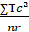- = 3.63×10⁻⁵ | c-1=2 | 1.815×10⁻⁵ | 7.408 | 3.49
Among rows | 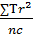- = 2.1×10⁻⁵ | r-1=2 | 1.05×10⁻⁵ | 4.286 | 3.88
Column-row interaction | -×10⁻⁵ | (c-1)(r-1)=4 | -0.291×10⁻⁵ | -1.188 | 3.00
total | ∑x² -=10.742×10⁻⁵ | N-1=17 | - | - | -
Residual (experimental error) | SS_{residual}=SS_{total}-SS_{c}-SS_{r}-SS_{cr}= 2.693×10⁻⁵ | 17-all previous = 11 | =0.245×10⁻⁵ | - | -

From table (4) and figure 9 below , it is seen that both time and NaOH concentration have slight significant effect on weight losses respectively because the mean square ratio is higher than the tabulated F-value at 95% confidence level. The column – row interaction i.e. effect of time with NaOH concentration together is optimization condition that is higher effect on weight difference because the mean square ratio is lower than the tabulated F-value at 95% confidence level where the best equation represents these conditions is:
W=12.308× 10⁻³ – 37.5× 10⁻⁵C – 26.5× 10⁻⁵ t +6× 10⁻⁶ C² +2× 10⁻⁶t²
where w represents weight difference, c is the NaOH concentration and t is the time of exposure.
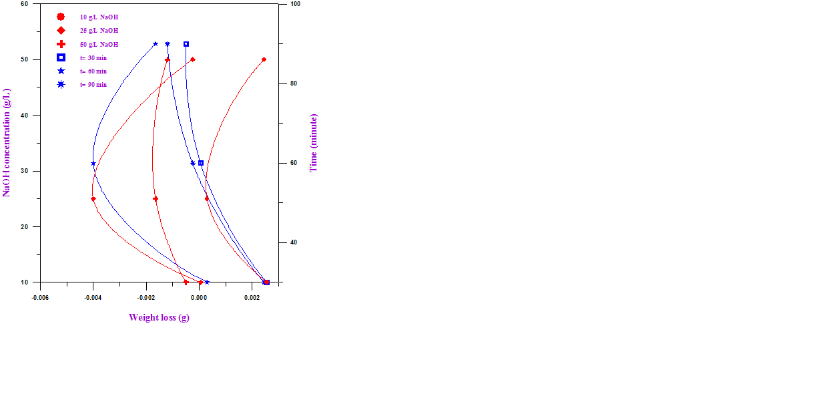
Figure 9: weight difference-time- NaOH relationship

The optimum concentration which gives safer results is given by:
dw/dc = – 37.5× 10⁻⁵ –12× 10⁻⁶ C =0
thus
C _{NaOH} _{optimum} = 31.25 g/l

Conclusions
NaOH can be used for preparing steel metal at concentration of about 31 g/l which represents the safer concentration in the range used 25-50 g/l at 80⁰C, because corrosion rate at these limits is moderately high, so there is a need to use inhibitor-if desired-.

References
Lowinheim, F.A, Electroplating, Mc-Graw Hill, Inc. 1978.
Mantell, C. L., Electrochemical Engineering, Mc-Graw Hill Book Company 1960.
Durney, L.J.'Graham's electroplating handbook' 4th edition.CBS Publishers and Ditributers, India 1986.
Ahmad Zaki, Priciples of Corrosion science and Corrosion control, Published by Elsevier Science & Technology Books, 2006.
Kelly, Robert G, Scully John R, Showsmith, David W, Buchheit, Rudolph G, Electrochemical Engineering Technique in Corrosion Science and Engineering, Marcel Dekker, Inc. 2002.
Omar Rihan, Rihan and Nesic Srdjan, Corrosion Science, 2633-2659, 48, 2006.
Rozenfeld, Corrosion Inhibitors, Mc-Graw Hill Inc.1981.

