Inverse Flood Wave Routing Using Saint Venant Equations
Mustafa Hamid Abdulwahid Kadhim Naief Kadhim
Department of Civil Engineering/University of Babylon, Iraq
e-mail: Mstfee@Gmail.com Altaee_Kadhim@yahoo.com
Salah Tawfeek Albazaz
Department of Civil Engineering/University of Babylon, Iraq
Abstract
The problem of inverse flood routing is considered in the paper. The study deals with Euphrates River in Iraq. To solve the inverse problem the Dynamic wave equations of Saint Venant are applied, First the downstream hydrograph routed inversely to compute the upstream hydrograph, Two models for inverse finite difference scheme of Saint Venant Equations (explicit and implicit schemes) are applied. Then the sensitivity analysis studied for weight factors parameters that effect on the solution and study the stability and accuracy of the result (inflow hydrograph). Finally, the computed inflow hydrograph compared with the observed inflow hydrograph and analyze the results accuracy for both inverse routing methods to evaluate the most accurate one. The results showed that the schemes generally provided reasonable results in comparison with the observed hydrograph and the results for inverse implicit scheme of Saint Venant equations are more accuracy and less oscillation than that obtained by the inverse explicit scheme.
Key words: flood routing, reverse routing, instability, Saint Venant equations.
الخلاصة
تهتم هذه الدراسة باستتباع الموجة الفيضانيه عكس اتجاه الجريان وتم تطبيق هذه الطريقة على نهر الفرات في العراق. تم تطبيق المعادلات الديناميكية لمعادلات سانت فنانت عكسيا لاستتباع النهر. في البداية تم استتباع الهايدروكراف في المؤخر عكسيا لإيجاد الهيدروكراف في المقدم. تم تطبيق نموذجين من مخطط الفروقات المحدودة سانت فنانت هما : (المخطط الصريح و المخطط الضمني). ثم تم دراسة تحليل الحساسية لبارامترات معامل الوزن التي تؤئر على النتائج و دراسة الاستقرارية و الدقة لنتائج الجريان الداخل الى المقدم. و أخيرا تم مقارنة الهيدروكراف الذي تم حسابه في المقدم مع الهيدروكراف الذي تم رصده في المقدم و تحليل دقة النتائج لكلا من طريقتي الاستتباع المعكوس لايجاد الطريقة الاكثر كفاءة.بينت النتائج ان المخططات بصورة عامة تعطي نتائج مقبولة مقارنة مع الهيدروكراف الذي تم رصده و ان النتائج التي تم حسابها بطريقة المخطط الضمني المعكوس لحل معادلات سانت فنانت اعطت نتائج اكثر دقة و اقل تذبذب من النتائج التي تم حسابها بطريقة المخطط الصريح المعكوس.
Introduction
Euphrates is important river in Iraq , flowing from Turkish mountains and pour in Shatt Alarab southern Iraq which withdrawing water from the pool upstream of the AL Hindya Barrage. The river is surrounded by floodplains and considered as an important region of the Iraqi agricultural incoming. The inverse flood routing appears to be a useful for water management in Euphrates plains. The considered reach of length about 59.450 km between Al Hindya Barrage ( 32º 43′ 40" N - 44º 16′ 04" E ) and Al Kifil gauging station ( 32º 12′ 53" N - 44º 21′ 43" E ), where the river branches into Al Kuffa and Al Abbasia branches while there is no branches within the studied river reach.

- Inverse flood routing using Saint Venant equations
The basic formulation of unsteady one dimensional flow in open channels is due to Saint Venant (1871). It can be written in the following form:

- Continuity equation.
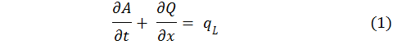
- Momentum equation.

where: t = time, x = longitudinal coordinate, y = channel height, A = cross-sectional flow area, Q = flow discharge, B = channel width at the water surface, g = gravitational acceleration, q_{L} = lateral inflow, S_{f} = friction slope.
The equations (1, 2) are solved over a channel reach of length L for increasing time t, and they are carried out in the following domain: 0 ≤ x ≤ L and t ≥ 0, Figure (1).

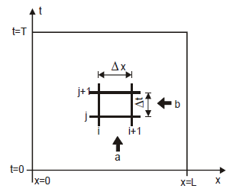

Figure (1). Direction of integration of the Saint Venant equations while (a) is conventional solution and (b) is inverse solution [Szymkiewicz. (2010)].

The following auxiliary conditions should be imposed at the boundaries of the solution domain (Szymkiewicz, 2010):
− Initial conditions: Q (x,t) = Q_{inflow}(t) and h(x,t) = h_{inflow}(t) for x=L and 0 ≤ t ≤ T;
− Boundary conditions: Q(t,x) = Q_{o}(x) or h(t,x) = h_{o}(x) for t=0 and 0 ≤ x ≤ L,
Q(t,x) = Q_{T}(x) or h(t,x) = h_{T}(x) for t=T and 0 ≤ x ≤ L.
where Q(x,t), h(x,t), Q_{o}(t), Q_{L}(t), h_{o}(t) and h_{L}(t) are known functions imposed, respectively, at the channel ends. The Saint Venant partial differential equations could be solved numerically by finite difference formulation. The derivatives and functions in Saint Venant Equation are approximated at point (P) which can moves inside the mesh to transform the system of Saint Venant Equation to a system of non-linear algebraic equations. Two weighting factors must be specified, i.e., (θ) for the time step and (ψ) for the distance step as shown in Figure (2). [Dooge and Bruen,(2005)].
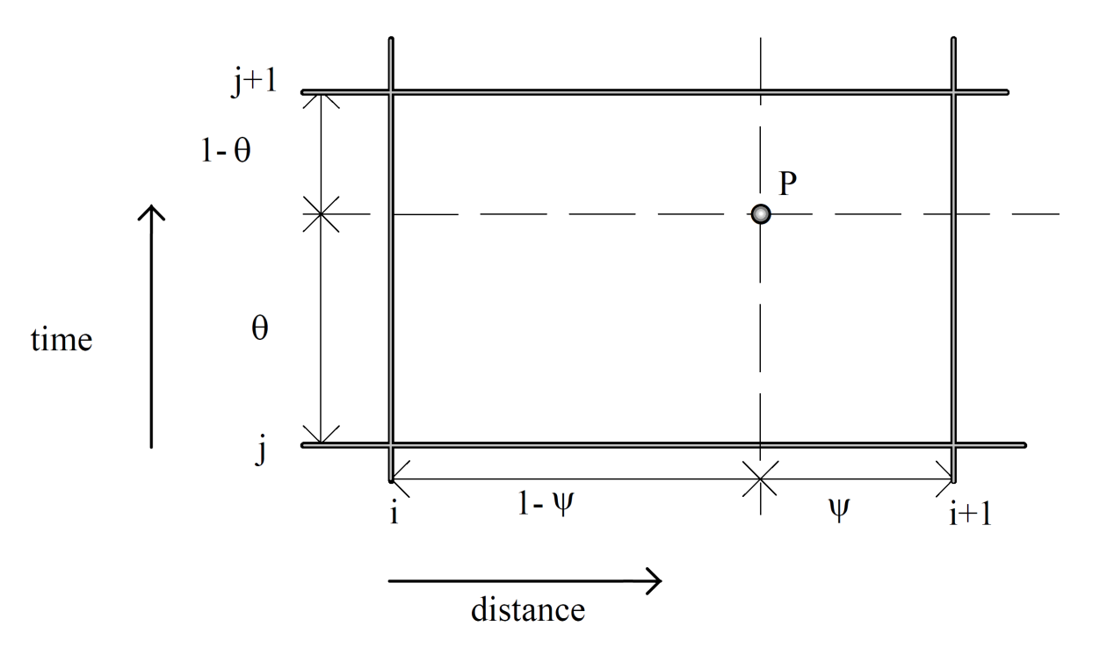
Figure(2). Grid point applied in weighted four point scheme
[Dooge and Bruen,(2005)].
The spatial derivatives of the function ( ) at point ( P ) becomes [Szymkiewicz, (2008)] :

where ψ and θ are the weighting parameters ranging from 0 to 1.
The derivatives and functions approximated at point P transform the system of equations (1 and 2) to the following system of non-linear algebraic equations [Wojciech and Szymkiewicz,(2009)]:
- Continuity equation.
(6)

- Momentum equation.
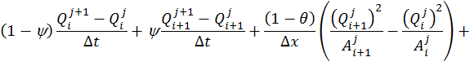
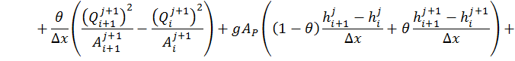
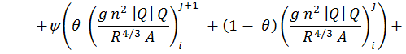
(7)
where i is index of cross section, j is index of time level, and ψ and θ are the weightings parameters ranging from 0 to 1.

- Inverse routing results
Two models for inverse finite difference scheme of Saint Venant Equation (explicit and implicit) used to route the flood wave in Euphrates river (28/11/2011 – 13/12/2011). Figure (3) show the actual and computed hydrographs. the time intervals of 12 hour is used for smoother curvature line of the hydrographs that calculated in different methods and the average bed slope founded to be ( So = 4.3 cm / km ), For inverse explicit finite difference scheme of Saint Venant equations the weight factors were ( θ = 0 and ψ = 0.5 ) this founded to gave the most accurate results and these values of weight factors are compatible with the [Chevereau, (1991)] study and for Inverse implicit scheme the weight factors were ( θ = 0.5 and ψ = 0 ).

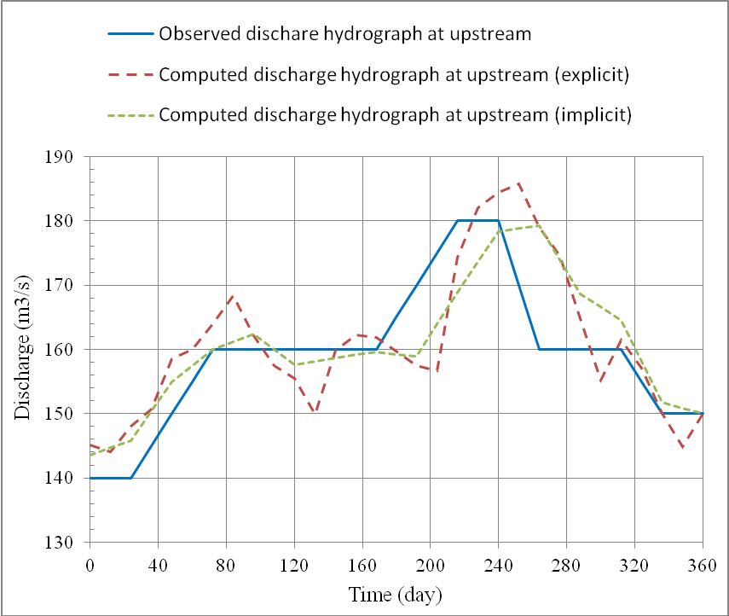
Figure (3) : Observed and computed Hydrographs in explicit and implicit methods,
Station ( 604+350 km ).
Figures (4) and (5) shows model stability analysis with change of the weight factors for explicit finite difference scheme of Saint Venant equations, The results show that the time weight factor is very sensitive for model stability and only model of ( θ = 0 ) is a stable model, but less sensitive for space weight factor.
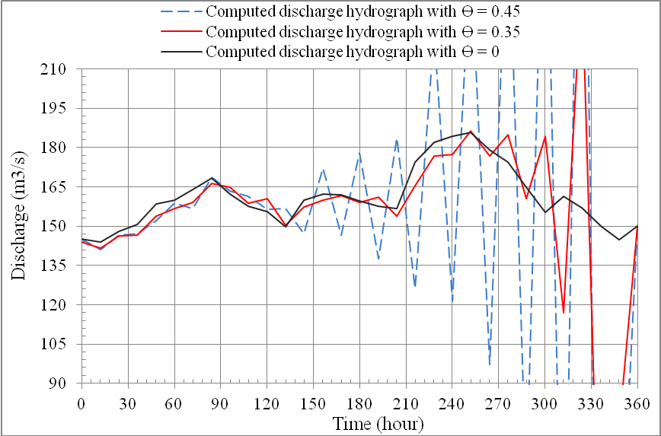
Figure (4). Computed upstream discharge hydrograph in explicit 12 hour interval scheme in different time weight factor ( θ )

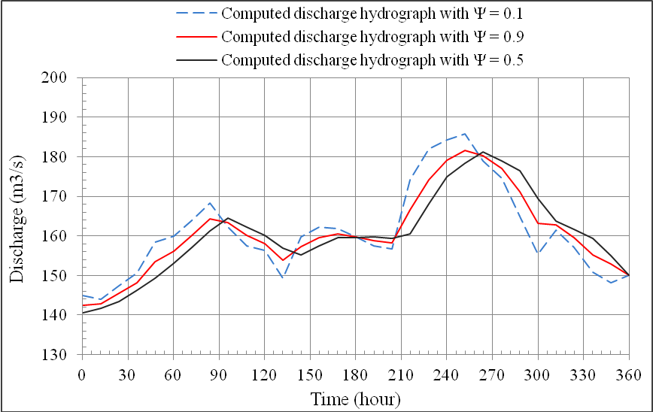
Figure (5). Computed upstream discharge hydrograph in explicit 12 hour interval scheme in different space weight factor ( ψ )

- Accuracy analysis for inverse routing results
According to the inverse routing results the actual observed upstream hydrograph is appointed for the error analysis by evaluate the deviation ratio of the results for each model in different analytic methods with the actual observed inflow. the error percentage is define as equation [Szymkiewicz, (2010)]:
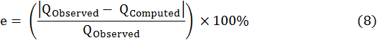

Where is the Observed inflow in upstream station and is the computed inflow by one of the applied inverse routing methods. The values of the mean errors are listed in Table (1) which summarizes the considerations of each method. Knowing that the percentage of the accuracy was determined as :
Accuracy percentage = 100% - percentage of error (9)
The root mean square of error method (RMSE) equation (10) computes the magnitude of error in the computed hydrographs [Schulze et al., (1995)].
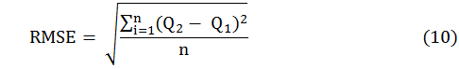
Table (1). Summary of accuracy analysis results.
Method | Mean Error % | Accuracy  % | RMSE  (m³/s) | Time of peak inflow  ( hour ) | Peak inflow  (m³/s)
Implicit | 3.038 | 96.96 | 6.694 | 264 | 179.29
Explicit | 3.779 | 96.22 | 7.907 | 252 | 185.78

- Conclusions
The inverse hydraulic methods represented by (explicit and implicit schemes) considered the hydraulic properties with the actual cross sections along the reach and the implicit scheme of Saint Venant equations gave more adequate results than the explicit scheme, where the implicit scheme accuracy was ( 96.96% ) and for explicit (96.22%). The results show that the time weight factor of finite difference explicit scheme of Saint Venant equations is very sensitive for model stability and only model of ( θ = 0 ) is a stable model , this compatible with [Liu et al, (1992)] as he concluded that the inverse computations produced better results with ( θ = 0 ). While the model is less sensitive for space weight factor ( ψ ) and the model remain stable for wide range of space weight factor values. For implicit scheme the value of time weight factor ( ψ = 0 ) and ( θ = 0.5 ) is founded that it gave the more stable results.

- Notations
A flow cross-sectional area ( L² )
B water surface width ( L )
g gravitational acceleration ( L/T² )
h water level ( L )
i index of cross section
j index of time level
n Manning coefficient ( T/L^{1/3} )
Q flow discharge ( L³/T )
q_{L} lateral flow per unit length of channel ( L²/T )
Q_{L} lateral flow discharge ( L³/T )
R hydraulic radius ( L )
S_{o} channel bed slope ( dimensionless )
S_{f} friction slope ( dimensionless )
t time ( T )
V flow velocity ( L²/T )
x distance along a channel ( L )
y channel height ( L )
θ time step weight factor ( dimensionless )
ψ distance step weight factor ( dimensionless )

References
Chevereau, G. (1991):” Contribution à l'étude de la régulation dans les systèmes hydrauliques à surface libre”. Thèse de Doctorat de l'Institut National Polytechnic de Grenoble, 122 p.
Dooge, C.I. and Breuen, M. (2005): "Problems in reverse routing". Center of Water Resources Research, University College of Dublin, Earlsfort Terrace, Dublin, Ireland.
Miller W.A. and Cunge J.A. (1975):” Simplified Equations of Unsteady Flow in Open Channels”.Water Resources Publications,Fort Collins, Colorado,5:Pages 183-257.
Saint Venant, B. de (1871): “Théorie de liquids non-permanent des eaux avec application aux cave des rivieres et à l’introduction des marées dans leur lit (Theory of the unsteady move-ment of water with application to river floods and the introduction of tidal floods in their river beds)”, Acad. Sci. Paris, Comptes Rendus 73, pp. 148-154 and 33, pp. 237-249.
Schulze, E. D.ct al. (1995): ”Above-ground biom ass and nitrogen nutrition in a chronos equence of pristine Lahurian Larix stands in Eastern Siberia”. Canadian Journal of Forest Research 25: 943—960.
Szymkiewicz, R. (2010) :”Numerical Modeling in Open Channel Hydraulics “, University of Technology, Gdansk, Poland.
U.S. Army Corps of Engineers (1994):” FLOOD-RUNOFF ANALYSIS” DEPARTMENT OF THE ARMY EM U.S. Army Corps of Engineers Washington, DC 20314-1000 USA.

