N. gonorrhoae Lapin Infection Model

Zainab.M.Jassim Shnawa,I.M.S.W. Thewaini,Q.N.O
University of Babylon , Collage of science, Department of Biology

Abstract
N.gonorrhoae (HM15 2x10⁷cell/ml) was elected as infectious dose. Immunologically immature male and female infant rabbits, Cyclosporine A conditioned adult rabbits ,normal non-conditioned rabbits were the test rabbits .The port of entry was intraurethral N.gonorrhoae suspension. Follow up programme of 2,4,6,8 and 10 days post infection. Urethral discharge as well as autopsy tissue samples were subjected reisolation studies and histopathology processing. .
Reisolation studies produced mild ,moderate heavy pure culture of various parts of male and female genital tract. Thus, ascending path of N.gonorrhoae was guessed. They were seen luminal ,parallel to mucosal surfaces ,sub mucosal and lamina propria intracellular and extracellular in various genital organs. Acute and sub acute inflammatory cell infiltrations were noted in urethra, prostate, testicles and vagina from infected infant and Cyclosporine A conditioned rabbits ,but not from non Cyclosporine A treated adults Thus ,N.gonorrhoae lapin infection model is being reported.
الخلاصة:
جرى اختيار الجرعة 2×10⁷ خلية/مل بصفتها جرعة مخمجة .اختيرت الأرانب الرضيعة وأرانب بالغة معاملة بالسايكلوسبورين A وأرانب بالغة غير معاملة بالسايكلوسبورين Aبوصفها حيوانات اختبار .وكان محل دخول الجرعة المخمجة هو الاحليل .وضع منهج متابعة في الأيام 2,4,6,8 و10بعد الخمج .لوحظ الطرح الاحليلي في اليوم العاشر بعد الخمج .أجريت الصفة التشريحية بعد قتل الأرانب وجمعت نماذج من الاحليل ،المهبل والرحم في الأنثى ،البروستات والخصى في الذكور إضافة إلى الطرح الاحليلي قبل التشريح .خضعت النماذج المأخوذة لإعادة زرع البكتريا والأنسجة ثم مداولتها لأجل تحضير مقاطع نسيجية مثبتة ومصبوغة.
بينت دراسة إعادة العزل ظهور نموات خفيفة ،متوسطة وكثيفة نقية من مكورات السيلان من النماذج المزروعة من مختلف أجزاء السبيل التناسلي الذكري والأنثوي .وكان مسار الخمج صاعداً.وشوهدت البكتريا في فجوات الأعضاء التناسلية ،محاذي للطبقة المخاطية وتحت المخاطية وفي الصفيحة الأصيلة داخل وخارج خلايا البلاعم.وبينت مظاهر نسيجية لالتهاب حاد وشبه حاد في هذه الأعضاء وبذلك فانه أمكن تطوير نموذج خمج مكورات السيلان في الأرانب.
Introduction
Unfortunately ,the lake of an adequate N.gonohrroae animal infection model make the hypothesis proposed for explanation of exact pathogenesis &pathogenicity of N.gonohrroae difficult (Fisette etal.,2003 and Mimis etal.2004).Beside there are many unanswered questions exist concerning the attachment and in vivo growth of pathogenic Neisseria species (Rank&Sandras, 1992 and Groisman,2001).Therefore, one can make use of certain animals whose immune systems function in many respect like those of human(Kradin,2010) to study the complex interactions of multiple cellular and humoral factors that are involved in the inflammatory response ,even though these animals may lake the species dependant receptors for tissue of human origin (Johnson etal.,1977).The CD46 receptor utilize the gonococcal pili (Mimis etal.2004 and Groisman,2001).A guinea pig N.gonohrroae infection model showed that outer membrane protein vaccine but not antipili antibody passively administered is immunoprotective (Punslang and Sawyer,1973).Arko (1979) has been reported a chimpanzee N. gonohrroae infection model is the bacteria were inoculated through different routes including urethra ,but there were no urethral discharge from these animals. While mice preconditioned with Ostradiol drug and infected with N.gonohrroae produced urethral discharge (Taylor-Robinson etal.1990).The present work was undertaken to investigate the possible finding of a suitable lapin model for studying pathogenesis and pathogenicity of N.gonorrhoae .The theme including a plane to be attempted ;Apparently normal adult rabbits, Cyclosporine A conditioned adult rabbits and infant normal rabbits from both sexes together with their corresponding controls. . Materials and Methods
1-Infectious dose:-
N.gonorrhoae strain HM15 grown onto chocolate agar plate which was a clinical isolates of human Urethritis ,characterized according to the classic biochemical testes and API system. .
The culture was kept under glycerol layed on the culture medium at 18Ċ(Shnawa,1985).On preparation of the infective dose ,culture revived onto chocolate agar plates .Surface growth scraped with 5 ml sterile normal saline, and collected in sterile plane tubes then centrifuged for 5 min at 5000 RPM. Cell density was adjusted through comparison to McFarland tube No. 0.5 to account of 2x10⁷ (Savanborg-Eden etal.,1985). .
2-Rabbits:-
Eight baby rabbits of obout 250 gm weight &eight male as well as eight female adult rabbits (O.caniculus) of 1-1.5 K.g were elected as a test models. Each of the eight were subdivided into six test and two control rabbits The test rabbits were further subdivided into three conditioned with Cyclosporine drug 10 mg/ml and three non-conditioned .All rabbits were kept through out experimentation period at libidum
3-Infection protocol:-
The infection protocol is depicated in table 1.
* Table (1):-The infection protocol
Intra urethral dose level | Route | Rabbits | No. | Sex | Group
0.2 ml of normal saline  0.2 ml of 10⁷cell/ml  0.2 ml of 10⁷cell/ml | Urethra  Urethra  Urethra | Control  Test  Test | 2  3  3 | Male& female  Male  Female | Baby
0.2 ml of normal saline  0.2 ml of 10⁷cell/ml  0.2 ml of 10⁷cell/ml | Urethra  Urethra  Urethra | Control  Test  Test | 2  3  3 | Male& female  Male  Female | Adult  Without  treatment
0.2 ml of 10⁷cell/ml  0.2 ml of 10⁷cell/ml  0.2 ml of normal saline | Urethra  Urethra  Urethra | Test with  Cyclosporine A  Test with Cyclosporine A  Control | 2  3  3 | Male& female  Male  Female | Adult  Treated
* The authors opinion based on that N.gonorrhoae primary infects the urogenital mucosa (Gray-Owen etal ,2001).
4-Follow up programme:-
At the days 2,4,6,8 and 10 post infection signs and symptoms of infection were observed as redness of genital organ ,fever ,loses of weigh and urethral discharge.Swabs of urethral discharge of the infected animals were sampled for microscopy and culture for reisolation .At the tenth day post infection rabbits were autopsied and organ including penis, urethra ,epidedymis ,prostate in male Vagina and Uterus in female both for reisolation and histopathology. Histopathology samples were kept in 10% formal saline till processed for tissue section preparation (Cook,2000) .
Results:-
1-Pathobiology of the infection:
Cyclosporine A N.gonorrhoae inoculated rabbits revealed marked genital redness ;profuse discharge ,high fever and sever weight loss. Infants infected rabbits showed moderate genital redness ,fever, weight loss and urethral discharge. In comparison non conditioned adult rabbits negative for such changes. Saline control rabbits were also negative for these changes
2-Kock’s postulated
Infected male and female genital organ sample cultures were yielding pure mild ,moderate to heavy growth of N.gonorrhoae in Cyclosporine A treated groups and infants and negative for adult infected non Cyclosporine A treated and saline controls
The colony morphology of reisolation cultures were same as that of the original N.gonorrhoae culture HM15. .
3-Pathogen specificity of N.gonorrhoae HM15:-
No evident pathogenic influences were noticed on adult non-treated with Cyclosporine A .While Cyclosporine A treatment included such pathogenic influences in adults. Infants naturally ,when infected they showed characteristic pathogenic influences (Fig 1) .
4-N.gonorrhoae tissue association :
On examination tissue sections ;N.gonorrhoae were found ;luminal, mucosa associated , wandering in sub mucosa and lamina propria .They were mostly intracellular in phagocytes and extracellular in tissue matrix through the part of male and female rabbit genital tract ,both for Cyclosporine A treated and infants infected with N.gonorrhoae .Beside their shedding in urethral discharges which appeared as a white creamy and mildly thick . .
5-Histopathology :
5-1:Infected infants:-
Phagocytic cells infiltration were seen in uerthral sections with the appearances of intracellular N.gonorrhoae ,Testicle ,however were showed heavy infiltration of mononuclear phagocytic macrophages,lymphocytes and eosinophils.A picture consistent with sub acute inflammation is (Fig 2-5).
5-2:Infected Cyclosporine A treated rabbits(adults):
Examination of urethral sections revealed N.gonorrhoae phagocytosed in the infiltrating phagocytes. Both in male and female rabbits. Mixed inflammatory cell infiltration consistent with sub acute inflammation (vaginitis).while testicles exhibited damaged surface epithelial layer of somniferous tubules with appearances of monocytes ,lymphocytes and plasma cell infiltration (Figure 7-12).No evidence for any tissue changes were apparent in the non Cyclosporine treated adult rabbits. .

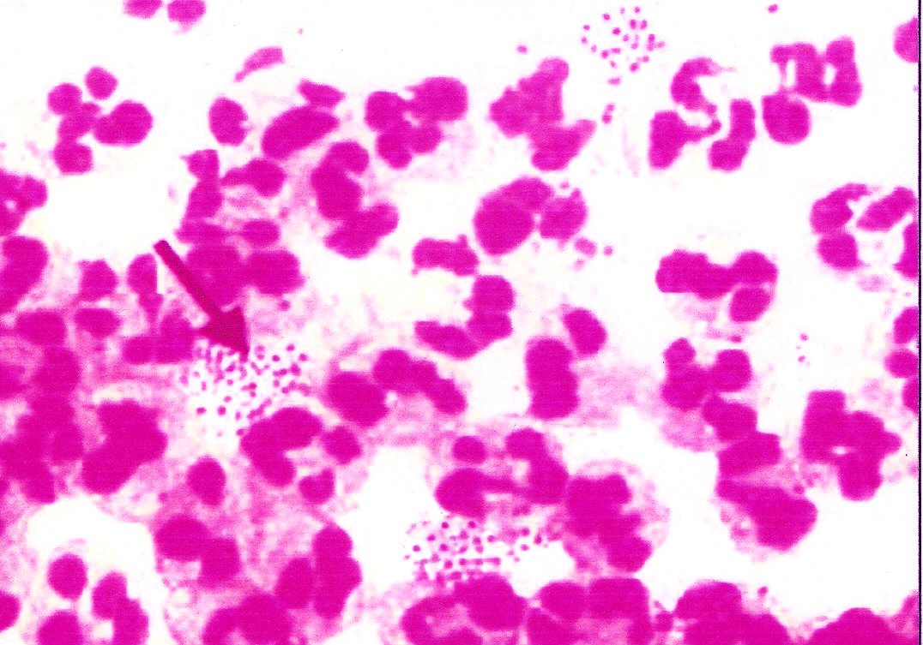
N.g

Figure 1:N.gonorrhoae in urethral discharge Gram’s stained smear 1000X
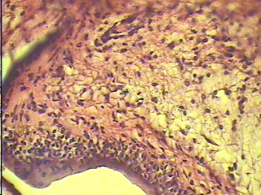
Figure 2:urethra of infant male rabbit explain simple cellular infiltration in the tenth day of infection stained with Haematoxylin &eosin stain(400X)

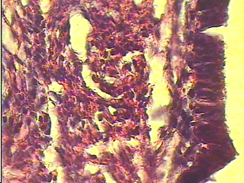
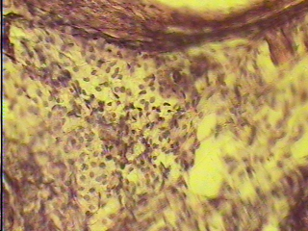
Figure 4:urethra of infant female rabbit explain present of N. gonorroeae inside& outside the phagocytic cell with clear cellular infiltration in the mucosa layer stained with Haematoxylin &eosin stain(1000X)

N.g
N.g

Figure 3:Acrowded infiltration of inflammatory cells (sub acute inflammation) with present of a large amount of phagocytic cells type monocyte,lymphocyte& eosinophils in infant male rabbit stained with Haematoxylin &eosin stain(400X)

N.g

N.g

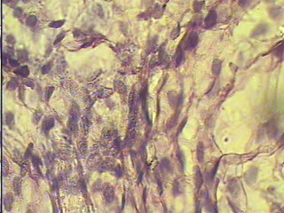
Ll
M

Figure 5 ::A crowded infiltration of inflammatory cells (sub acute gonoccocal inflammation) with present of a large amount of phagocytic cells type monocyte,lymphocyte& eosinophils in the testes of infant male rabbit stained with Haematoxylin &eosin stain(1000X)

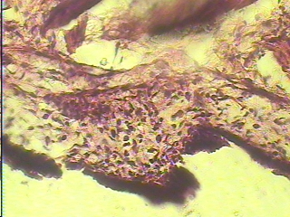
Figure 6:urethra of treated adult male rabbit explain that the surface of mucosal layer is normal and the causative agent present in the sub mucosal layer &in lamina propria .N. gonorroeae present inside& outside the phagocytic cells with simple cellular infiltration stained with Haematoxylin &eosin stain(400X)

N.g

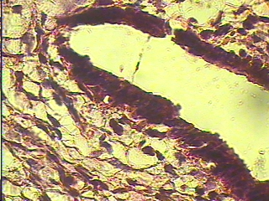
Figure 7:urethra of treated adult male rabbit explain that the surface of mucosal layer is normal and the causative agent present in the sub mucosal layer &in lamina propria .
N. gonorroeae present inside& outside the phagocytic cells with simple cellular infiltration stained with Haematoxylin &eosin stain(1000X)

N.g
Mucosa
Urethra

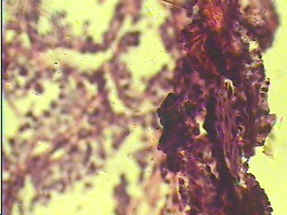
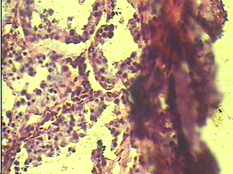
Figure 8 :Cross section of treated rabbit testes explain sub acute inflammation with damage of epithelial layer of seminal fluid tubules with cellular infiltration for monocytes,lympphcytes& plasma cell stained with Haematoxylin &eosin stain(400X)

MM
L
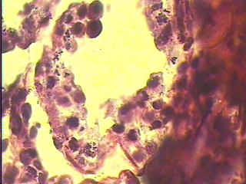
Figure 9::Cross section of treated rabbit testes explain sub acute inflammation with damage of epithelial layer of seminal fluid tubules with cellular infiltration for monocytes,lympphcytes& plasma cell stained with Haematoxylin &eosin stain(1000X)

M
L
Ng

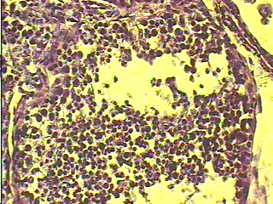
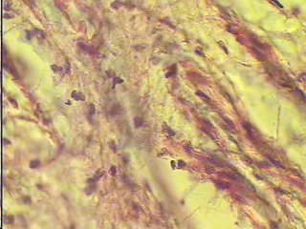
Figure 10::Cross section of trated rabbit testes explain the crowded cellular infiltration for monocytes,lympphcytes& plasma cell with damage of spermatogenesis cells ,phagocytic cells in last stages of mitosis ,no neutrophil cells ,inflammation is chronic stained with Haematoxylin &eosin stain(400X)

:
Figure11:Cross section in female traded vagina show sub acute inflammation with mixed cellular infiltration .N. gonorroeae was engulfed by phagocytic cells in the sub mucosa layer stained with Haematoxylin &eosin stain(1000X)
N..g
g
N.g

g

Discussion
Guinea pig (Puunslang and Sawyer,1973) and white mice (Taylor-Robinsen etal.,1990) has been proved to act as animal model for N.gonorrhoae infection. Johenson et al 1977 and Mimis et al,2004 and Gyles et al,2010 ascribed adhesion of N. gonorrhoeae to human genital mucosa to the reaction that binds thier : pili to CD46 .However ,CD46 has been identified in primates ,pigs, gunia pigs and rabbits. Mice and rat expressed its functional homology (Liszewiski and Atkinson ,1998).Therefore its supposed to be. N.gonorrhoae can infect these species ,but actually it can't and its a human pathogen (Brooks etal.,2007). Going through the structure and functions of CD46 is heterogeneous that consist of rather heterogeneous protein species with 51-58 KD and 59-68 KD. This variability is inherited as three phenotypic patterns consisting upper band predominance 65% of population ,equivalence of upper and lower bands in 29% of the population and predominance of lower band in 6%.This heterogeneity represents a size polymorphism and implicates CD46 as being expressed as family form .Four isoforms that arise by an alternative splicing of a single gene (Liszewiski and Atkinson,1998). .
The CD46 gene consists of 14 exons and 13 introns with a minimum length of 43 Kb and resides in regulatory complement activation clusters on the long arm (193.2) in man.CD46 is expressed as a family of isoforms with variable dominance of isoform in different organ tissue .There is an alterations in function or expression of CD46 in fetal tissue .CD46 act as a adhison receptor for S.pyogenes (Liszewiski and Atkinson,1998),N.gonorrhoae (Johenson et al 1977),herpes virus (Brooks etal,2007), poxvirus (Levison,2008) and HIV1 (Liszewiski and Atkinson,1998). . Thus infant rabbits attempted in this study bears CD46 with variable expression ,function and isoform nature might be different from that of adult rabbits in a sense of isoform amino acid sequence ,quantity and number that makes them suitable for adhesion of N.gonorrhoae in one hand and lymphocyte immaturity lend favor for growth and invasion of infant host on the other hand .Similarity ,Adult non Cyclosporine A conditioned rabbits were resistant to N.gonorrhoae infection although they bears CD46 homologous that as man. The size of gene polymorphism and alternative splicing leading to properly an isoform with amino acid sequence unsuitable for N.gonorrhoae adhesion in quantitative sense. Meanwhile the Cyclosporine A conditioned rabbits found susceptible to N.gonorrhoae infection . Cyclosporine A induce Tlymphocyte activation inhibition through abolishing or reducing H2 producing (Goldsby etal,2000) making tissue microenvironment suitable for initiation of infection in one hand and Cyclosporine A with 11 amino acid sequence might act as transcription regulator so that mRNA alternative splicing CD46 polymorphic gene in a way enhancing amino acid motif in CD46 structural domains suitable for adhesion of N.gonorrhoae on the other hand .By this N.gonorrhoae human specificity is relative ,conditional and of degree but not absolute, since in human beings acts as principle pathogen and in guinea pig, mice and rabbits played a role of conditional pathogen( Liszewiski and Atkinson,1998) .
The photomicrographs (Fig 2-12) of Urethritis ,prostatitis and endometritis in female rabbits include N.gonorrhoae infection through induction Th1,Th2 cytokines which in turn produces reactive oxygen intermediates that cause an immune mediated tissue damage (Fisette etal,2000 and Karden,2010 ). . Finally ,the basic features of this experimental lapin N.gonorrhoae infection are:
1-Genital port of entry .
2- Ascending infection pathway
3 -Induce acute and sub acute inflammation
4-Appearances of tissue damage in genital organs
5-Symptomatic diseases with fever, redness, loss of weight and urethral discharge
6-Cyclosporine A induce more sever course and disease in adults as compared to infant .
7-Choch's postulated positive. .
Thus ,Immune immature N.gonorrhoae lapin infection model and immune conditioned lapin infection model are being reported. .
References
-Arko R.J.(1979).Neisseria gonorrhoae experimental infection of laboratory animals science .177:1200-2101 .
-Brooks,G.F.;Jawetz;Melnick and Adelbergs (2007).Medical microbiology 4th ed. Lang.USA.296-304.
-Cook,D.J.(2000).Cellular pathology ,BMS explanded better work –Heinmann,Oxford .8-38.
-Fisett,P.L.;Ram,S.;Anderson,J.M.;Guo,W. and Ingalls,R.R.(2003).Lip lipoprotein from Neisseria gonorrhoae stimulate cytokines release and NF-KB activation in epithelial cells in Toll-like receptor-2 dependant manner .J.Bio.Chem.278:46252-46260
-Goldsby ,R.A.;Kindth,T.J. and Osborne,B.A.(2000).Kuby ,Immunology .4th ed.W. H. Freeman ans Company N.V.
-Gray-Owen,Dehiv;Rudel,T;Nauman,M.andMeyer,T.F.,2001.Neisseria In, Groisman (ed.). Principles of Bacterial pathogenesis Academic Press,London,559-562.
-Groisman ,E.A.2001.Principles of Bacterial Pathogenesis .AAcademic Press.London.
-Gyles,T.L.;Prescott,J.F.;Songer G.and Thoen C.O.2010. Pathogenesis of Bacterial Infection in Animals .Wily-Black well,Iowa,USA,10.
- Johenson, A.P.; Taylor–Robinson, D. and McGee, Z.A. (1977). A species specificity of attachment and damage to oviduct mucosa by Neisseria gonorrhae, Infec. and Immun. 18:833-839.
-Kradin R.L.2010.Diagnostic Pathology of Infectious Diseases ,Saunder,Philadelphia.
-Levinson, W. (2008). Review of Medical Microbiology and Immunology, Medical Book, MacGraw, Hills. p. 171-179. University of California Lange, San Francisco.
- Liszewski ,M.K. and Atkinson ,J.P.(1998).CD46,membarane cofactor protein MCP.In Delves.P.J. and Roitt,I.eds. Encyclopedia of Immunology .2nd. ed. Acad. Press, London, 495-497.
-Mimis, C.; Dockrell, H.M.; Goering, R.V.; Rpitt.; Wakeline, D. and Zvckerman, M. (2004) .Medical Microbiology 3th ed .p.285-289.
- Rank, R.G. and Standars, M.M. (1992). Pathogenesis of endometritis and salpingitis in a guinea pig model of chlamydial genital infection: Am .J. Pathol. 140:927-936.
-Punslang .A.F,and Sawyer ,W.D.(1973).Role of pili in the virulence of Neisseria gonorrhoae .Infec.Immun.8:255-263.
-Svanborg-Eden,C.;Kulhavy, R. Marlido, S.; Princecos, Jand Mesteky,J. (1985). Urinary Immunoglobulins in healthy individuals and children with acute pyelonephritis. Scand. J. Immunol. 21:305-313.
-Shnawa,I.M.S.(1985).Maintenance of bacterial cultures.Saudi.Med.J.5:236.
-Taylor-Robinson, D.P.; Furr, M. and Hetherington, C.M. (1990). Neisseria gonorrheae colonies the genital tract of ostradiol treated germ-free female mice. Microb. Pathol. 9:369-374.

