Management of Intussusception In children in Bagdad 2006-2008

Amier A. Ejrish
Babylon College of Medicine.
Sadik H. Kadhem F.I.C.M.S (Pediatric Surgeon)
Basrah College of Medicine
Abstract:
Intussusception is the commonest cause of bowel obstruction in infancy and young children. In our study there is 120 cases of intussusception admitted to children welfare teaching hospital over a 2- year ( 2006-2008 ) , signs and symptoms , diagnostic modalities, treatment, and outcome were documented. Abdominal X-ray was done to all patients while U/S done for 20 cases only. Barium enema was not included in our study. In this study the Intussusception is a common surgical emergency that occurs most commonly in children between the fifth and ninth months of life. There was a high rate of delayed diagnosis of intussusception (43%).Patient`s age ranged from 17 days to 7 years. 76.8% occurred in age 5 month-2 years, A triad of abdominal pain, bleeding per rectum, and palpable abdominal mass was present in 76 early cases (67.9%) and 37 late cases (77.1%), Prolonged mean duration of recognizable symptoms of 2 days accounted for a 16.1% bowel resection rate while a delay of 3 days resulted in 18.75% resection rate.Clinical diagnosis had a high sensitivity and specificity in both early and late cases but U/S is superior to clinical diagnosis, particularly for challenging cases.Complications rate was 20.5% (4.8% for early cases and 41.8% for late cases). Ileocolic intussusception was the prime type and presented (87.5%), the primary intussusceptions were predominant (93.7%). the mortality rate was 1.8% . we concluded The early symptoms of intussusception would seem to be missed by primary health care provider with consequently high morbidity and mortality. There is an urgent need to re-emphasize these symptoms to first-line healthcare providers and parents through public enlightenment campaigns. The most common type of intussusception is primary ileocolic intussusception and the most common leading point in secondary intussusception is Meckel`s diverticulum. delayed referral from primary care givers is a major cause of prolonged duration of symptoms and the attendant high morbidity and mortality in childhood intussusception.
الخلاصة
دراسة حالات تداخل الامعاء حول الاعراض والعلامات السريرية للاطفال ودراسة دور التشخيص بواسطة الفحص الشعاعي والامواج فوق الصوتية مع بيان كيفية معالجتها من خلال التداخل الجراحي اللائق وما يترتب عليها من نتائج ومشاكل جانبية مع بيان كيفية معالجتها. كما تناولت الدراسة مقارنة بين التشخيص المبكروالتشخيص المتاخرلتداخل الامعاء من حيث الاسباب والنتائج. تم معالجة كل المرضى قيد الدراسة في مستشفى حماية الاطفال التعليمي-مدينة الطب في بغداد. تمت المقارنة بين الحالات المشخصة بصورة مبكرة (64 حالة) والحالات المشخصة بصورة متاخرة (48 حالة) من حيث اسباب التشخيص المتاخر والنتائج المصاحبة لذلك. تراوحت اعمار لمرضى بين 17 يوم و7 سنوات. كما كانت نسبة المرضى المصابين بتداخل الامعاء بين عمر 5 شهر و2 سنة حوالي 76,8%. ان تاخر التشخيص قد يكون مصاحبا للعمر اقل من 5 شهر او اكثر من سنتين. عانى جميع المرضى من الام البطن, كما عانى المرضى من الاعراض التالية وبنسب متفاوتة: تقئ المادة الصفراء, كتلة البطن, نزف دموي عن طريق المستقيم, وغيرها.ان تزامن الاعراض التالية (الام البطن, نزف عبر المستقيم, وكتلة البطن) له اهمية قصوى في التشخيص حيث حدث في 67,9% من الحالات المبكرة و 77,1% من الحالات المتاخرة.
ان تاخر تشخيص المرض اكثر من يومين ادى الى زيادة نسبة استاصال الامعاء مع الربط الاولي الى 16.1% كما ادى الى تفويه الصائم في 3.5% من المرضى. يعتبر التشخيص السريري العنصر الاساسي في تشخيص تداخل الامعاء. كما بمكن الاستعانة بالامواج فوق الصوتية في تشخيص الحالات الصعبة. ان نسبة المضاعفات اناتجة عن تداخل الامعاء كانت 20.5%, 4,8% للحالات المبكرة و 41,8 للحالات المتاخرة. علما ان تسرب الربط الجراحي, انسداد الامعاء الالتصاقي, وحالتي الوفات قد حدثت في الحالات المتاخرة فقط. يعتبر تداخل الامعاء احد الاسباب المهمة والشائعة لانسداد الامعاء في سن الطفولة وخاصة بين 5 شهر و سنتين. ان تاخر تشخيص المرض من قبل الكادر الطبي والصحي غير المختص وما يتبعه من تاخر احالة المريض ال مراكز جراحة الاطفال التخصصية هو السبب الرئيسي وراء تاخر تقديم العلاج اللازم للمريض وبالتالي تدهور الحالة المرضية وزيادة نسبة الوفاة (% 1,8 ) .
Introduction:
Intussusception is a frequent cause of bowel obstruction in infants and toddlers (mary 2005 ). The term comes from two Latin words, intus, which means "inside" and suscipere, which means "to receive". It has been reported in neonates and adults (Gordon 2003 ). The ancient Greeks, including Hippocrates, treated intestinal obstruction with enema or insufflations of air into the anus( Gohn 1999) . In 1913, Ladd published the first radiograph of a contrast enema in intussusception. Ravitch published his first article on a large series of successful barium enema reductions of intussusception in 1948 with standard guidelines (Lewis 2006) . Intussusception can occur at any age; however, the greatest incidence occurs in infants between 5-9 months. More than half of cases occur within the first year of life, and only 10-25% of cases occur after age 2 years Approximately two-thirds are boys (James 1998) . Primary intussusception is an idiopathic condition that represents 70-95% of cases ( Charles 2005 ), usually occurs at 5-9 months, and frequently seen in the wake of upper RTI or episodes of gastroenteritis (Wikipedia 2007). It is associated with enlargement of Payer's patches. Adenoviruses, and to a much lesser extent rotavirus, have been implicated in up to 50% of cases (RINTOUL 2004). The Secondary intussusception has a definite anatomic lead point and found in 2-12% of cases, e.g. Meckel`s diverticulum "the commonest", appendix, polyps, carcinoid tumors, Henoch-Schonlein purpura "due to submucosal haemorrhage", non-Hodgkin lymphoma, foreign body, ectopic pancreatic or gastric mucosa, intestinal duplication, and cystic fibrosis(lay 1997)Intussusception produces acute cramping abdominal pain. The child may stiffen and pull the legs up to the abdomen. The pain recurs at intervals from 5 minutes to 30 minutes( Philip 1999). The Red-currant jelly stool will be seen in a quarter of cases and more frequently if formal rectal examination is performed. Most patients with intussusception were well nourished healthy babies ( Judith 1999 ) . Suggestive radiographic abnormalities include a soft tissue mass, abnormal distribution of gas & fecal contents, sparse large bowel gas with absence of cecal gas, and air/fluid levels in the presence of bowel obstruction (Roy 1987) These radiological signs are not diagnostic. If the diagnosis of intussusception is suspected, ultrasonography is now the first line investigation with sensitivity of 98-100% and specificity of 88-100% (Gordon 2003 ) .
Non-operative management consists of nothing per oral, nasogastric tube insertion, intravenous fluid , antibiotics administration and reuction is then done either by hydrostatic reduction or by pneunatic reduction ( Lioyd 2005 ; Richard 2002 ) .
Patients And Methods
Between October 2006 and October 2008, we prospectively kept records of all children presenting with intussusception in the surgical department of children welfare teaching hospital in Baghdad Medical City, detailing the children's age, sex, presenting symptoms and signs, diagnostic modality, symptoms duration as well as the collected cases were divided according to the time of presentation as early when diagnosed within 48 hours (64 cases) or delayed if diagnosis was done after 48 hours (48 cases). The clinical state of each child on admission was noted while mode of treatment and outcome of management in children welfare teaching hospital were documented. Operative findings, procedure performed, peri-operative complications, duration of hospitalization, and prognoses were all recorded.
A comparison between early cases (64) and delayed cases (48) done in the form of age, sex, mode of presentation, diagnostic modality, operative procedures, and outcome. These parameters as well as type of intussusception have an effect on the rapidity of diagnosis of intussusception and may lead to delay in the diagnosis. Simple blood tests including hemoglobin, blood urea, and blood group in addition to abdominal X-ray were done to all patients while U/S done for 20 cases only. Barium enema was not included in this study.

Results

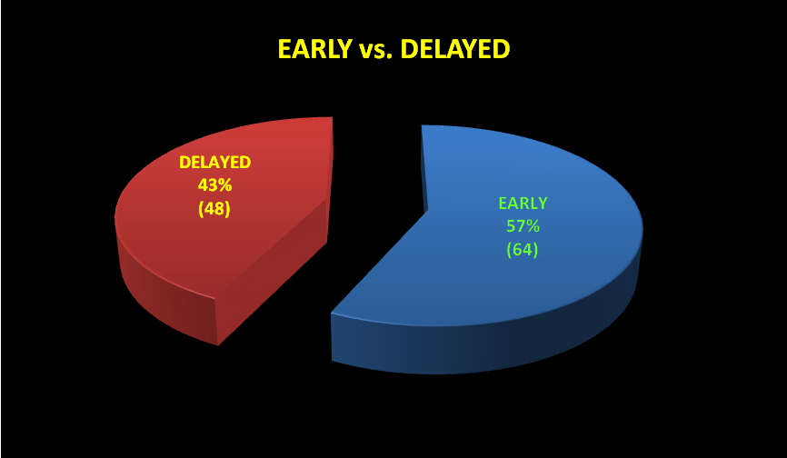

Fig. 1. Distribution of cases according to the time of presentation.
- 43% was diagnosed after 48 hours of presentation, while 57% were diagnosed within 48 hours.

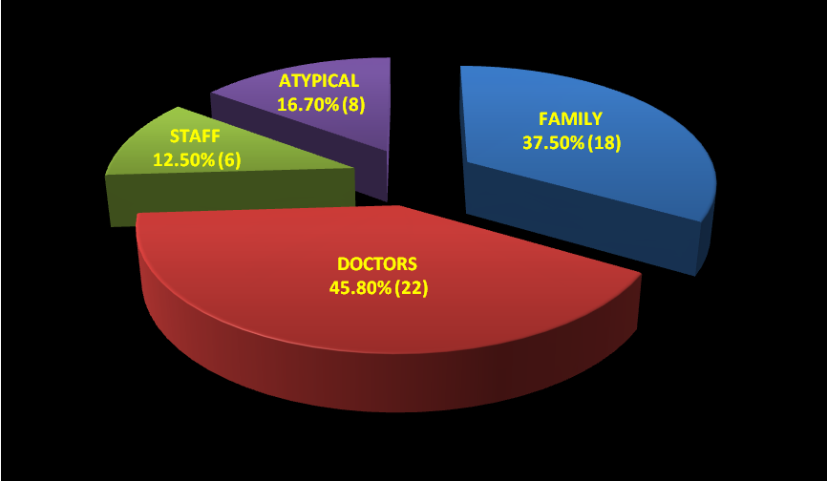

Fig. 2. Number and percentage of causes of delay in the diagnosis.
- Unfortunately, doctors were the most common cause of delayed diagnosis.

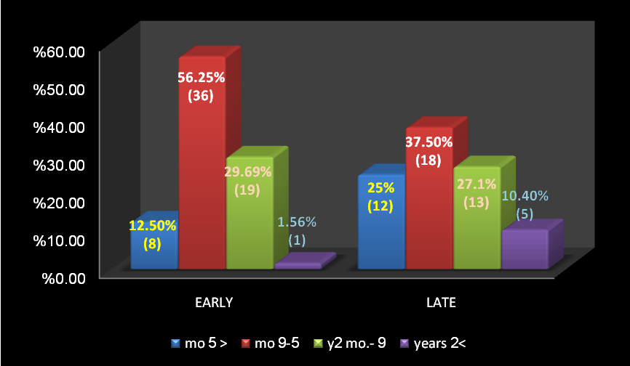

Fig, 3. Age distribution of early and late cases.
- Typical age of presentation is 5-9 months.
- About 56 % of early cases and 37.5% of the late were in this age group.

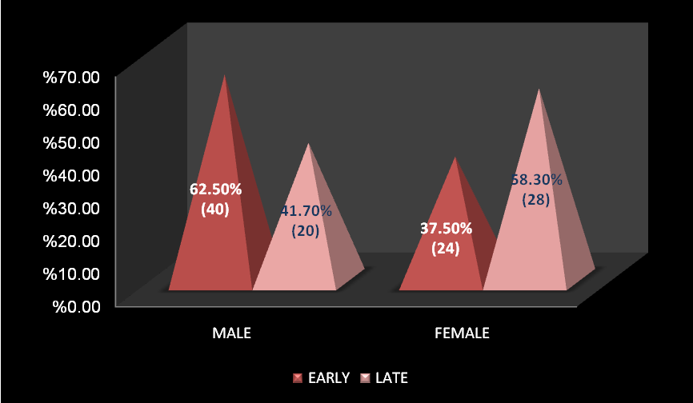

Fig. 4. Sex distribution of cases.
- Male:Female ratio in early cases was 1.7:1 while 0.7:1 in delayed cases.
Fig. 5. Modes of presentations.
- All cases developed abdominal pain.
- Perforation, lethargy, and fit were unique to delayed cases.

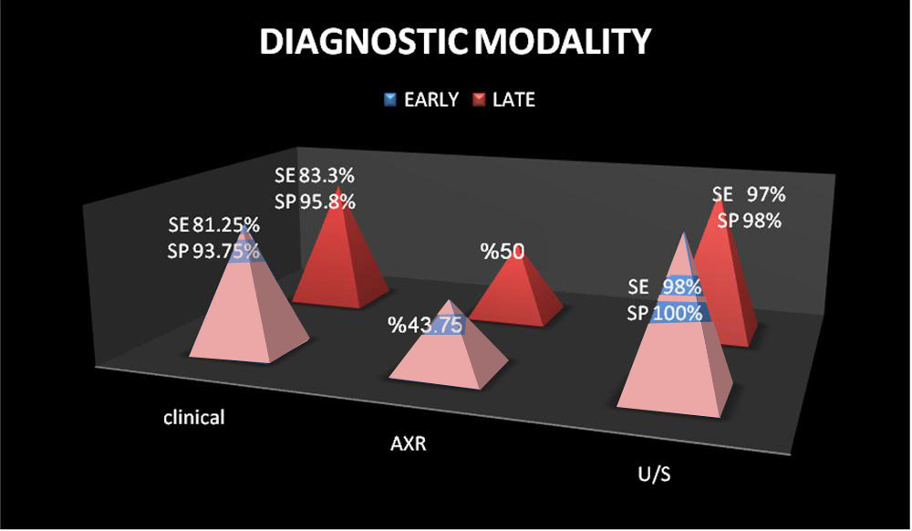

Fig 6. Various diagnostic modalities.
- AXR plain erect considered contributory.
- U/S is excellent in the diagnosis of intussusception

Table. 1 Various types of operative procedures used.
Procedures | Early | Late
Reduction | 100% (64) | 54.20% (26)
Resection and EEA | 0% | 37.50% (18)
Stoma (ileostomy) | 0% | 8.30% (4)
Total | 100% (64) | 100% (48)

- All early cases are treated by simple reduction.
- Resections with primary anastomosis or stomas were associated with delayed cases only.
Table .2 Various types of intussusception encountered.

Type of intussusception | Early | Late
Ileocolic | 100% (64) | 70.80% (34)
Ileoileal | 0% | 16.70% (8)
Ileoileocolic | 0% | 12.50% (6)
Total | 100 (64) | 100% (48)

- All early cases are of ileocolic type.
- About 29% of delayed cases are not ileocolic.

Table. 3 distribution of leading points in early and late cases.

Leading point | Early | Late
No leading point | 98.4% (63) | 85.40% (41)
MD | 0% | 6.20% (3)
Lymphoma | 0% | 4.20% (2)
Polyp | 1.6% | 2.10% (1)
Duplication | 0% | 2.10% (1)
Total | 100% (64) | 100% (48)

- 98.4% of early cases are primary intussusception.
- Leading point is present in 14.6% of delayed cases.
- The most common cause is Meckel`s diverticulum (6.2%).
Table .4 Distribution of early complications.

complications | Early | Late
Wound infection | 1.6% (1) | 16.7% (8)
Wound dehiscence | 1.6 (1) | 6.25% (3)
Anastomotic leak/disruption | 0% | 6.25% (3)
Early adhesions | 0% | 4.20% (2)
Recurrence | 1.6% (1) | 4.20% (2)
Death | 0% | 4.20% (2)
Total | 4.80% (3) | 41.80% (20)

- All complications are higher in delayed cases.
- Death, adhesive IO, and leak/disruption were unique to delayed cases.
Table .5 Duration of hospital stay.

Hospital stay | Early | Late
< 3 days | 46.9% (30) | 22.9% (11)
3-6 days | 53.1% (34) | 58.3% (28)
> 6 days | 0% | 18.8% (9)
Total | 100% (64) | 100% (48)

- Increased duration of admission and then costs with increasing time before admission.
- Average hospital stay was 3.4 days for early and 6.1 days for delayed cases.

Discussion:
Intussusception is a common surgical emergency that occurs most commonly in children between the fifth and ninth months of life. In rare cases, it may also occur in the neonatal period, or after the age of two years.
In our series, there was a high rate of delayed diagnosis of intussusception (43%) which is a high rate that deserves attention owing to the numerous complications and economic burdens associated with delayed diagnosis which may end in loss of the patient due to what should be considered as a relatively non-fatal disease. This fact is different from what was found by William H. Snyder and others (Mhammad 1999 ; Al-hadithi 2005 ) which revealed that the majority of their patients presented within the first 24 hours. Such delay may be due to the variability of signs and symptoms, lack of awareness of the attending practitioners or delay in transporting the patients to our center.
Unfortunately, doctors were the most common cause of delay. Twenty two of delayed cases (45.8%) were miss-diagnosed and faulty treated as simple bloody diarrhea by GP or even by specialist pediatricians. Other causes of delayed diagnosis included patient' family (18 cases, 37.5%), atypical presentation (8 cases, 16.7%), and other paramedical personnels (6 cases, 12.5%).
In our series, patient`s age ranged from 17 days to 7 years (compared with 2 months to 7.5 years in the study performed at Lagos University Teaching hospital, LUTH). The greatest incidence of intussusception was among infants aged 5-9 months old (54 cases, 48.2%) which is similar to the studies done by M.K. Al-sultan, D. A. R. Mohammed, and I.R. Al-hadithi. An atypical age at presentation was associated with increased opportunity of delayed diagnosis of intussusception; about 62.5% of late cases was in the atypical age compared with only 43.75% of early cases was in the atypical age. Generally, 76.8% (86 cases) of intussusception occurred in age between 5 mo-2 years but only 5.3% (6 cases) of intussusception occurred after the age of 2 years. About 85.9% of early cases and 64.6% of late cases were presented in children aged 5 months to 2 years.
Generally, Males were affected more than females with male to female ratio of 1.2:1 (M:F ratio is 1.4:1 in LUTH). Females are an apparent cause of delayed diagnosis with 58.3% (28 cases) female, compared with 37.5% (24 cases) female in early cases. M:F ratio in early cases was 1.7:1 while 0.7:1 in delayed cases.
Symptom duration ranged from 9 hours to 12 days (1-15 days in LUTH). All cases were associated with abdominal pain (100% ⁽²⁾). Vomiting was present in 98.2% (110 cases) of cases (compared with 80% ⁽⁴⁾).
Generally, Bleeding per rectum was present in 70.5% (79 cases) (comparable with 95% ⁽⁴⁾). Abdominal mass presented in 82 cases (73.2%) (in contrast to 85% (Robert 2004). Rectal mass in 12 cases (10.7%) which is lower than what was found in LUTH (43%) or prolapsed mass per rectum (was found in 4 cases, 3.6%, compared with 7.5% in LUTH). Vomiting and abdominal mass occurred more frequently in early cases, while bleeding per rectum and rectal mass more frequently in late cases. Perforation and lethargy/fit we unique to delayed cases (2 cases, 4.2% each) and the latter may divert the physician mind to meningitis. One of them was intussusception and meningitis while the other had convulsions due to electrolyte disturbances.
A triad of abdominal pain, bleeding per rectum, and palpable abdominal mass was present in 76 cases (67.9%), (61% in LUTH), 60.9% (39 cases) of early cases and 77.1% (37 cases) of late cases.
Clinical diagnosis had a high sensitivity and specificity in both early (81.25%, 93.75% respectively) and late (83.3%, 95.8% respectively) cases (with slight higher accuracy in delayed cases) but U/S was superior to clinical diagnosis with 98% sensitivity, 100% specificity in early cases, and 97% sensitivity, 98% specificity in late cases and it is of utmost importance in challenging cases. U/S needed in 12 out of 64 early (18.75%) and 8 out of 48 late cases (16.7%).
Plain x-ray was contributory in diagnosis, about 43.75% (28 cases) in early cases and 50% (24 cases) of delayed cases. Contrast study did not perform in all cases due to high accuracy of clinical and ultrasonographic diagnosis. Even when it was required, facilities were unavailable.
Many cases, 36.6% (41 cases of total cases) and 64.1% of early case were amenable to be treated by non-operative reduction. Owing to the unavailability of contrast material and/or fluoroscope, surgery substituted hydrostatic reduction with higher risk of morbidity, prolonged hospital stay and higher economic costs. Similarly, facilities for pneumatic reduction were unavailable.
Generally, operative reduction was done in 90 cases (80.4%). Primary resection and end-to end anastomosis was done in 18 cases (16.1%), which is higher than what was found by Zollinger (5%) ( Robert 2003 ). If diagnosis delayed for 2 days, the resection rate was 37.5% (of delayed cases) or 43.75% (21 cases) if delayed for 3 days (compared with 70.4% in LUTH if delayed for 3 days) while stomas created (ileostomy) in 4 cases (3.5% generally or 8.3% of delayed cases). All early cases were treated with simple surgical reduction. The rate of complications, particularly anastomotic leaks and those of stoma would increase significantly when the diagnosis delayed.
Ileocolic intussusception was the prime type and found in 98 cases (87.5%, vs. 78.7% in LUTH, or 80% ( Mary 2005 ), followed by ileoileal that found in 8 cases (7.1%, vs. 4.7% in LUTH), and then ileoileocolic in 6 cases (5.4%). Ileocolic intussusception was the most common type and found in all cases of early intussusception and 70.8% of delayed cases. Ileoileal and ileoileocolic intussusceptions were found only in delayed cases. All recurrent cases were ileoileal intussusception (3 cases).
Generally, primary intussusceptions were predominant in 104 cases (92.9%, compared with 94.3% in LUTH), while only 8 cases (7.1%, compared with 6.1%( John 2999), 3-4% (Robert 2003) were with secondary intussusceptions. Meckel`s diverticulum predominates and found (out of 112 cases) in 3 cases (2.7%), followed by lymphomas in 2 cases (1.8%), intestinal polyps in 2 cases (1.8%) and duplications in one case (0.9%). Sixty three (98.4%) of early cases and 41 cases (85.4%) of late cases are primary intussusception. The most common cause of secondary cases was Meckel`s diverticulum and found in 3 of 8 cases (37.5%).
Generally, complications rate was 20.5%, about 4.8% for early cases and 41.8% for late cases. In order of frequency, complications included wound infection in 9 cases (8%, compared with 36.1% in LUTH)), wound dehiscence in 4 cases (3.6% vs. 3% in LUTH)), anastomotic leak/disruption in 3 cases (2.7%), recurrence in 3 cases (2.7%, compared with 4%(John 1999 ), or 1.8% in LUTH), intestinal obstruction in 2 cases (1.8%), anastomotic leak in 2 cases (1.8%). Two patients died making a mortality rate of 1.8% (<1%( Lewis 2006 ), compared with 12.1% in LUTH). One death followed an anastomotic leak and peritonitis while the other was due to recurrent fits caused by electrolyte disturbances. Complication rate was higher in delayed cases with death, anastomotic disruption, and adhesive intestinal obstructions were unique to delayed cases. In early cases, wound infection, dehiscence and recurrence occurred in one case only for each (1.6%). In delayed cases, wound infections found in 8 cases (12.7%), dehiscence in 3 cases (6.25%), anastomotic leak in 3 cases (6.25%), recurrence in 2 cases (4.2%), and adhesive intestinal obstruction in 2 cases (4.2%).
Hospital stay ranged from 2.5 days to 12.9 days. Average hospital stay was 3.4 days for early cases compared with 6.1 days for delayed cases (compared with 3rd or 4th day (Akram 1997). So that delayed diagnosis of intussusception might lead to increased duration of hospitalization, hospital crowdedness, increased risk of hospital-acquired diseases, and finally might burden economy.
Conclusion
- Intussusception is a frequent cause of intestinal obstruction in children younger than 2 years. It may occur in neonate and in older children where it is usually due to leading point.
- Intussusception is a life-threatening condition if not promptly identified and adequately treated. So high index of suspicion is of utmost importance for early diagnosis of intussusception particularly atypical presentation.
- The clinical diagnosis is considered the fundamental tool for the diagnosis of intussusception.
- The most common type of intussusception is primary ileocolic intussusception and the most common leading point in secondary intussusception is Meckel`s diverticulum.
- From this study, it is concluded that delayed referral from primary care givers is a major cause of prolonged duration of symptoms and the attendant high morbidity and mortality in childhood intussusception.
Recommendations
- Delay in the diagnosis of intussusception stems from misdiagnosis of the condition and efforts should be made to improve awareness at both parental and primary care levels to promote early presentation and referral. There is an urgent need to re-emphasize these symptoms to primary healthcare providers and parents through public enlightenment campaigns in order to minimize morbidity and mortality from intussusception.
- Use of U/S for the diagnosis of intussusception and all hospital, particularly pediatric ones, should utilize U/S 24 hours a day.
- Introduction for facilities for non-operative management of intussusception e.g. Fluoroscope or measures for pneumatic reduction.
References
Akram J. Jawad ;Sabah Y. Shibli ;Prem S.Sahni ;and Tajuddin Malabarey , Chronic intussusception. Annalsof Saudi Medicine (Sep.) 1997; 17 (5):545.
Al-hadithi I. R., intussusception, a study of 160 cases, Iraq, 2005:15-19, (thesis).
Charles V. Mann, R.C.G., Russel and Norman S. William: Bailey and Loves short practice of surgery, 24th edition, 2005; 2:1194-1196.
Gordon A. Mackinlay ,Forfar and Arneil`s ,Text Book of Pediatrics ,:surgical pediatrics ,6th edition ,Churchill Livingstone ,2003:1808-1809.
James A.O. Neill J.: intussusception, pediatric surgery, Mosby, 5th edition, 1998; 2:1185-1195.
John G. Raffens Perger , Swenson`s pediatric surgery, 5th edition , 1999:221-229,402
Judith M. Sondheimer, Current Pediatric Diagnosis and Treatment: gastrointestinal tract, 14th edition, Appleton and Lange, 1999:539.
Lay L. Grosfeld, Intussusception ch.38, in David C. Sabiston, Jr., text book of surgery, 15th edition, W.B. sauders company, 1997; 2:1253-1254.
Lewis Spitz and Arnold G. Coran, intussusception in operative pediatric surgery, 6th edition, Hodder Arnold 2006, 445-453.
Lioyd J. Brown , Faap , :intussusception ,Board review series ,pediatrics ,1st edition , 2005:293-294.
Majid K. Al-sultan, the use of air insufflation in the management of intussusception, a study of 78 cases, Iraq, 2004:33-38 (thesis).
Mary E. Fallat , Keith W. Ashcraft , :intussusception ch.38 , pediatric surgery , 4th edition , Elsevier saunders, 2005:533-542.
Mohammad D. A. R., intussusception in childhood, a study of 76 cases, Iraq, 1999:39-49. (Thesis).
Philip C. Guzzetta, and Seymour I. Schwartz, intussusception ch.37 in Schwartz principle of surgery, 7th edition, 1999; 2:1239.
Richard j. Stevenson ,Rudolph`s Pediatrics , :Gastroenterology and Nutrition , edition ,19 :1071, 2002
RINTOUL, Farquharson`s textbook of operative surgery 2004.
Robert M. Zollinger, Jr., F.A.C.S., Zollinger`s Atlas of surgical operation, 8th edition, 2003.
Robert Wyllie. Clinical manifestations of gastrointestinal diseases in ch 309: Behrman R.E., Kliegman R.M., Jenson H.B., Editor: Nelson Text Book of pediatric, 17th edition, saunders, 2004: 1231-1233.
Roy Astley ,Pediatric Gastroenterology ,:Radiology of the Gastrointestinal Tract ,ch.19 ,part one ,2nd edition ,Blackwell Scientific Publications ,1987:799.
Wikipedia contributors Intussusception (medical disorder) Wikipedia, the Free Encyclopedia. 28 January 2007.
William H. Snyder ,Jr. ,Alfred R. Kraus ,and Lawrence Chaffin ,Intussusception in infants and children ,A report of 143 consecutive cases ,Annals of surgery ,1949 August :200-210.

