Hypothyroidism Effects on Testes and Adrenal Glands
Saa’d Merza Al-Araji Naseer Jawad Hamad
University of Babylon, College of Medicine

Abstract
The functional relationship between thyroid, adrenal glands and tests was investigated using adult male rats. Hypothyroidism was produced by the administration of thiouracil in drinking water for 20 days. Hypothyroidism causes decrease in the weight of testes and adrenal gland which used as indicator for their functions as boiassay.
الخلاصة
هذه الدراسة تناولت الربط بين العلاقة الوظيفية لكل من الغدة الدرقية ناقصة النشاط او ماتمى (الدراق) وما لذلك من تأثير على كل من الغدد الخصوية (الخصى) Testes والغدة الادرنيالية Adernal Glands. وذلك من خلال تجريع ذكور الجرذان البالغة الثايوراسيل Thiouracil المضاف الى ماء الشرب لمدة 20 يوماً لغرض احداث هذا العوز والقصور في انتاج الدرقية، ومن ثم دراسة تأثيراته على كل الغدد السابقة حيث ظهر ان لنقص الدريق (الدراق) علاقة وظيفية وبايوحيوية واضحة من خلال قلة الوزن الحاصل في تلك الغدد المدروسة.
Introduction
The biological importance of the thyroid gland has been recognised for years. In response to reduced levels of thyroid hormones, the adrenal cortex has been known to shrink (Kamilaris, et al., 1991) and to enlarge under the influence of excess amounts of thyroid hormones (Boler & Moore, 1982; Sperelakis and Bank, 1998).
In addition to the adrenal gland, it has been reported that hypothyroidism can produce menstrual disorders, amenorrhea or sterility (Hacker & Moor, 1992), and testicular disfunction in adult men (Wortsman el al., 1987). Hypothyroidism decreases the plasma concentrations of luteinizing hormone (LH) and follicle stimulating hormone (FSH) . Hypothyroidism was associated with adrenal glands dysfunction and gonadotrophs. (Jannini et al., 1990):
Materials and Methods
Ten adult male rats (3 00±25 gm weight) were used, divided into two groups, control group and treatment group. Each consists of five animals. The diet and water were available ad. libitum. Hypothyroidism was produced by administration of 0.04% thiouracil in the drinking water of the treatment group for 20 days.
To study the effects of the hypothyroidism by bioassay, the animals were killed after the administration of thiouracil. After killing the animals, testes and adrenal glands were removed and weighted. Statistical analysis according to Steel & Torrie (1980).
Results
Adrenal weights were significantly lower (p<0.05) in the treatment group animals (43 ± 2.2 mg) as compared with control group animals (65.1±4.6 mg ), and there was decrease in the testicular weights of the treatment group animals (2.9 ± 0.3 mg) as compared with the testicular weights of the control group animals (3.2 ± 0.2 rng), but this decrease was non significant (p>0.05) as shown in following table.
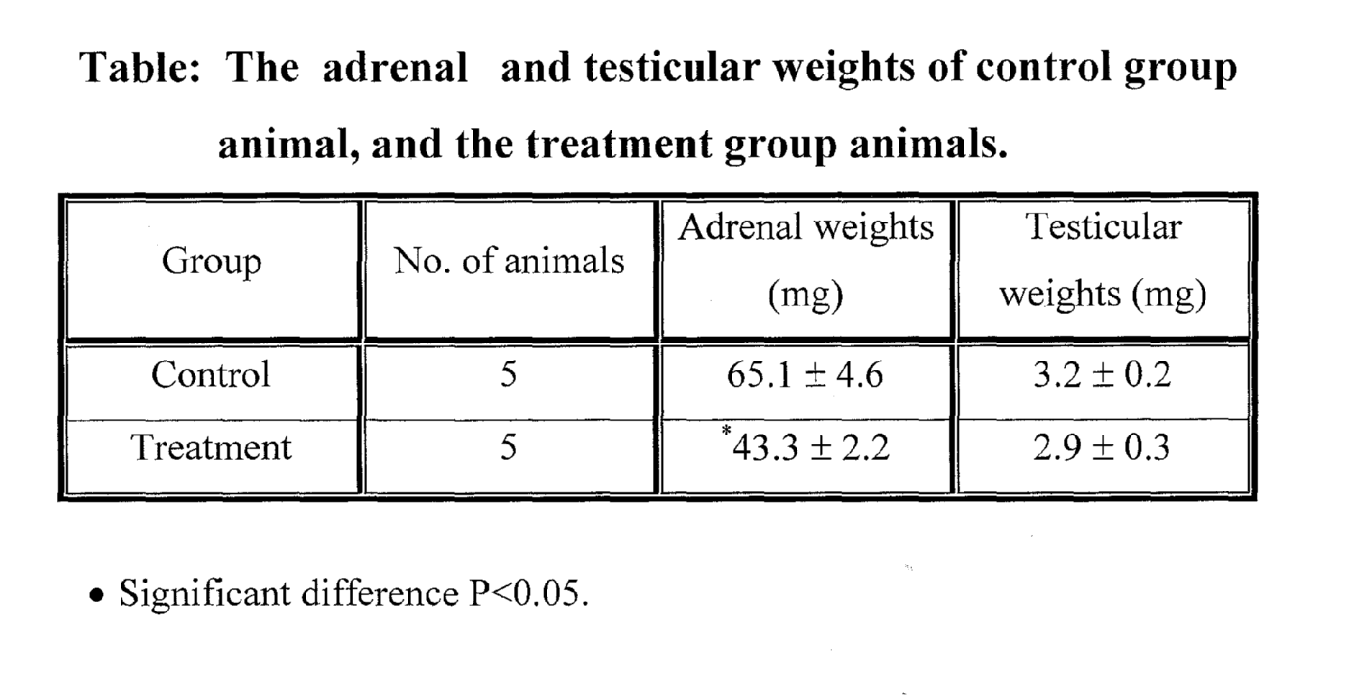Discussion
Hypothyroidism results in a decrease in the adrenal weights. The change in the adrenal weights due to the decrease in the plasma and pituitary levels of adimocorticotrophic hormone (ACTH) according to study of (Murakami et. al., 1984) exploring the effect of hypothyroidism on the circadian adrenocortical rhythm in rats. Thyroidectomy resulted in a decrease in plasma and pituitary level of (ACTH).
Hypothyroidism also affects the gonadotroph functions, pituitary content of luteinizing hormone (LH) and pituitary responsiveness to gonadtropin-releasing hormone (GNRH) for luteinizing hormone release was significantly lowered in hypothyroidism (Jannini et al., 1990 ; Dalon & Carry, 1999).
The inhibition of gonadal function in hypothyroidism animals is primary mediated by the suppression at hypothalamic-pituitary levels (Bruni, et. al., 1975; Wortsman, et al., 1987) It has reported that hypothyroidism is associated with a decrease in the plasma levels of (LH) and (FSH) (Bruni, et al., 1975; Becker, et al., 1990).
References
Becker, K.; Bilezikian, J. & Bremner, W. (1990). Prineiple & Pruetice of endoerinology & Metabolism, philadelphia, J. B. Lippincott.
Boler, R. K. And Moor, N. A. (1982) Depression of adrenocortical by function pharmacologic doses of thyroxin in intact and unilaterally adrenalectomized rats hormone Research, 16.
Bruni, J. F.; Marshall, S; Dibbet, J. A. And Meites, J. (1975). Effects of Hyper and hypothyroidism on serum LH and FSH levels in rats- Endocrinology, 97.
Dofan, L. & Carry, R. (1999). Adrenal disorders . New Youk, Thieme Medical publishers.
Hacher, N. F. and Moor, J. G. (1992). Essentials of obstetrics and Gynecology. Edited by Joan T. Meyer, W. B. Saunders Co., U. S. A.
Jannini, E. A. Ulisse, S. and D’armiento, M. (1990) Thyroid hormone and male gonadal function. Endocrinology, 16.
Kamilaris, T. C. De Bold, C. R. Jolnson, E. 0.; Mamalaki, E.; Listwak, S. J. ; Calogero, A. E. Kalogeras, K. T.; Gold, P. W. And Orth, D. N. (1991) Effects of short and long duration hypothyroidism and hypothyroidism on the plasma adrenocotictropins and corticosterone responses to ovine corticotropin releasing hormone Endocrinology. 128.
Murakami, N.; Hayafuji, C. and Takahashi, K. (1984). Throid hormone Maintains normal circadian rhythm of blood corticosterone levels in the rat by restoring the release and synthesis of ACTH after thyroidectomy . Acta Endocrinologica, 107.
Sperelakis, N. & Bank, R. (1998). Essential of physiology . Evan R. Schnittman.
Steel, R. And Torrie, J. (1980). Principles and procedures of statistics and biometrical Approach. MCGraw.Hill book Co. Newyork.
Wortsman, J.; Rosner, W. and Dufaw, M. (1987). Abnormal testicular function in men with pituitary hypothyroidism. American Journal of Medicine, 28.

