Hydrochemical Characteristics Of The Al-Wardiya Drainage Water North–East Hilla City

Jwad K. Manii
Department of applied Geology , University of Babylon ,Iraq
Abstract
The aim of this study is to assess the quality of water surface of Al- Wardiya drainage. Eight samples were analyzed at may 2009. The analytical results showed that the EC, and the concentration levels of the main ions (Na⁺, K⁺, Ca²⁺, Mg²⁺) and (Cl⁻, NO3⁻, SO4²⁻) reflected high ion concentration . The values of sodium absorption ratio and electrical conductivity of the surface water were plotted in the US salinity laboratory diagram for irrigation water. All the surface water samples fall in the field of C4S1, indicating high salinity and low sodium.

الخلاصة
الهدف من الدراسة هو تقيم نوعية المياه السطحية لمبزل الوردية .تم اخذ ثمان نماذج مياه سطحية لثمان محطات على طول المبزل قيد الدراسة تم تحليل نماذج المياه الماخوذه في شهر مايس من عام 2009 المواصفة المذكورة في البحث .بينت التحاليل للتوصيلية الكهربائية وتراكيز الايونات الرئيسة السالبة والموجبة احتواء تلك المياه على تراكيز عالية منه بالاضافة الى ارتفاع قيمة التوصلية الكهربائية .تم رسم قيم التوصلية الكهربائية ونسبة امتزاز الصوديوم على مخطط الموضوع من قبل مختبر الامريكي لملوحة لمياه السقي ,حيث عند اسقاط نوعية المياه الصوديوم على المخطط كل نماذج المياه كانت ضمن الحقل C4S1 حيث بينت ان تلك المياه عالية الملوحة ونسبة صوديوم واطئة.

1. INTRODUCTION :
The quantity of water utilized for irrigation is quite large, particularly in comparison to the quantity used for other beneficial purposes. Irrigation use accounts for about 90% of the total water use in the basin Agriculture is the most important economic activity within the basin and agricultural land use constitute the most significant aspects in comparison to the other form of land use. The study of surface water chemistry is very importance in the evaluation of surface water resources .The quality of water is not less than the quantity , in another word the chemical and physical characteristic of natural water are very importance on the specification of these water for various utilization. water chemistry can be applied in various ways in planning water use and treatment .The study of natural water chemistry also involves other disciplines, including geology ,hydrology and biological science .The chemical composition of natural water is derived from many different sources of solute , including gases and aerosols from the atmosphere ,weathering and erosion of rocks and soil, solution or precipitation reaction occurring below the land surface ,and cultural effects resulting from human activities(Hem,1989).. Human activities may modify water composition extensively through direct effects of pollution and indirect results of water developments. This work was carried out in the framework of a research project and deals with the water quality of the part of the Al- wardiya drainage basin. Moreover, it aims at proposing a set of actions towards the direction of rational and sustainable management of the surface water resources in the basin.

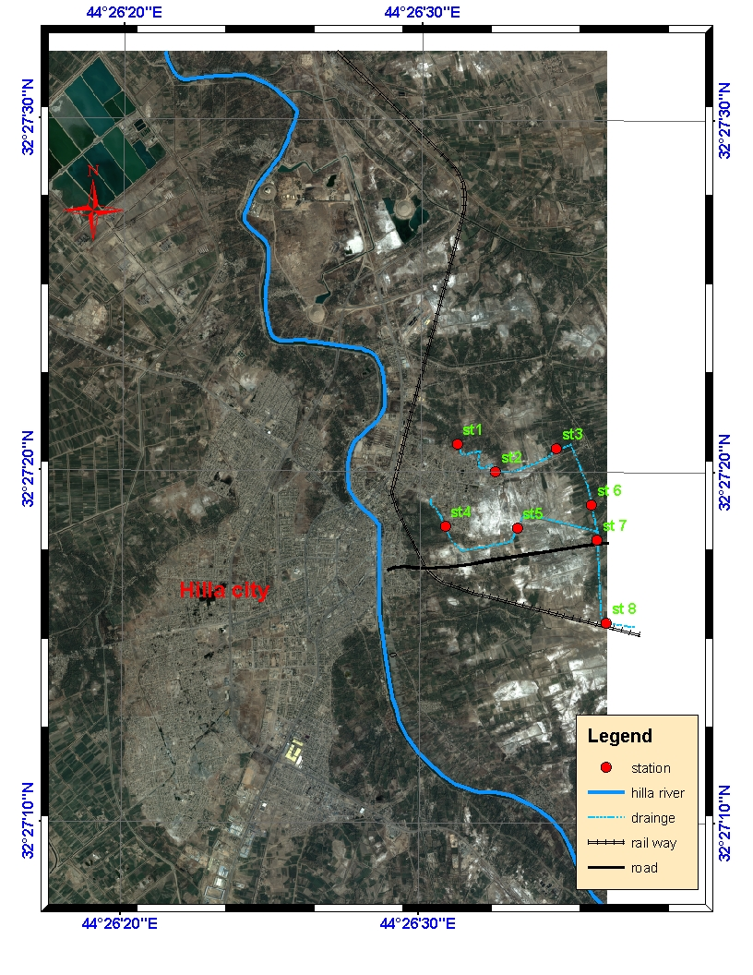
Figure 1 location map, depicting the sampling sites

2.Description of Al wardiya drainage
Al wardiya dranage is located northeast of Hilla city in the midst part of Iraq. It has an area of 225 square kilometers The average interannual precipitations are about 104mm while the average annual temperature is around 23°C(Manii,2003). Geology and hydrogeology of the area, as well as the groundwater quality has been examined by previous study (manii,2003). It is suggested that the main source of groundwater pollution is the soil salinity sporadic incidents of nitrate pollution are also documented and attributed to over fertilization, rendering groundwater unsuitable for human consumption. The Geology is formed of, Quaternary deposits. Al wardiya drainage is located in the northern part of Hilla city flows through the agricultural lands and discharges into the main drain , south east Hilla city. Two main tributaries contribute to the drainage. The flow goes north to southeast and supplied by irrigation water or by disposal of bordering citiy and villages.

3. Materials and Methods
3.1. Water Samples
Samples were collected in good quality polyethylene bottles of 1 liter capacity. Sampling was carried out directly without adding any preservatives in clean bottles to avoid any contamination and brought to the laboratory. Monitoring was done for eight samples at may 2009). Only high pure chemicals (Analr Grade) and double distilled water were used for preparing solutions for analysis. Physical parameters like pH, TDS and EC were determined at the site with the help of digital portable water analyzer (Model No.: CENTURY-CK-710), and measured in situ. The total hardness (TH) was determined by the following equation Todd (1980): TH = 2.497Ca + 4.115Mg.Determination of major cations and anions were realized in the laboratory using the analytical methods shown in Table (1) were analysed followingstandard guidelines and procedures (APHAet al. 1998; Vogel 1961).. All the results are compared with standard limits recommended by World Health Organization WHO (1993).

Table 1: water quality parameters
Parameters | Method used
Chloride (as Cl in mg/l) | Argentometric titration
Carbonate (as CO₃ in mg/l) | Titrimetry
Bicarbonate (as HCO₃ in mg/l) | Titrimetry
agnesium (as Mg in mg/l) | EDTA Titration
Calcium (as Ca in mg/l) | EDTA Titration
Sodium (as Na in mg/l) | Flame photometric method
Potassium (as K in mg/l) | Flame photometric method
Sulphate (as SO₄ in mg/l) | Gravimetric method
Nitrate (as NO₃ in mg/l) | Spectrophotometric method

4. Results and Discussion:
4.1. Chemical Characteristics:
Analyses were carried out on eight (8) drainage water samples collected from Al wardiya drainage excavated in alluvial deposits. The location of the samples is shown in Figure 1. Table 2 shows the values of the chemical parameters of drainage water. The maximal water temperature. (Tmax =25⁰C). The WHO does not recommend any limit values, however a temperature higher than 15⁰C facilitates the development of microorganisms and in the same time intensifies the organoleptical parameters such as odors and taste( WHO,1993). The pH values range from 7.69 to 8.74 . A slight increase is noticed in the pH which can result from the dissolution of lime grounds which indicates that water is slightly alkaline . Conductivity values varied from 4.2 to 7.6 mS/cm. The maximum limit of EC in drinking water is prescribed as 1.500 mS/cm (WHO standards),all samples exceeds the permissible limit. TDS value ranged from 2496 to 6050, with an average value of 4781, the most desirable limit of TDS is 500, and all samples exceed the desirable limit . classification the drainage water of the study area falls in brakish water According Todd,s (1963) ,(Altoviski(1962) classifications see(table 3). Mg concentration varied from 227.04 to 435.96 mg/l Table 2, with an average value of 321.6 mg/l. The desirable value of Mg is 50 mg/l. The all water samples taken at area exceed the values fixed by WHO1993. The calcium value fluctuated between 176 and 324 mg/l with 257.22 mg/l as a mean value. The desirable limit of calcium for drinking water is defined as a proportion of 75 mg/l. Notice that all water drainage samples of the eight points have exceeded the limit allowed by WHO1993. The sodium and potassium values are respectively 643.08 to 1449.92 mg/l and 6.63 to 8.19 mg/l; all the studied samples exhibit sodium values exceed than those prescribed by WHO1993. The content of bicarbonate varies from 162.87 to 211.06 mg/l where the mean value is 179.95 mg/l. It was noticed that the chloride, the sulphate, the nitrate, are respectively 692.96 to 1695.8 mg/l, 643.2 to 2020.8 mg/l, 1.9 to 11.2 mg/l, and are exceeded the standards prescribed by WHO1993, excepting for nitrate that below standards prescribed by WHO1993 of the maximum admissible concentration of 50 mg/ l. We notice that the values of the EC,TDS fore station (8)are below the value of station (7), this means that due to dilution with stream outlet .

Table (3) Estimation of water salinity
Water class | Altoviski,1962 (T.S.S)mg/L | Todd,1963 (T.S.S)mg/L
Fresh | 0-1000 | 0-1000
Slightly brackish | 1000-3000 | -
Brackish | 3000-10000 | 10-10000
Saline | 10000-50000 | 10-100000
Brine | 50000 | 100000

4.2. Classification of Surface Water
Major cations and anions such as Ca, Mg, Na, K, HCO3, SO4 and Cl in meq/l were plotted in Piper’s trilinear diagram Piper (1944) to evaluate the hydrochemistry of surface water of alwardiya drainage Fig. 2. The following facies are indicated:Two discrete water types may be distinguished from the study of the constructed Piper diagram: Na- (Mg)-Cl and Na-Cl, as illustrated in Figure 2.Table four showing water type fore all water sample from the Al wardiya drainage.
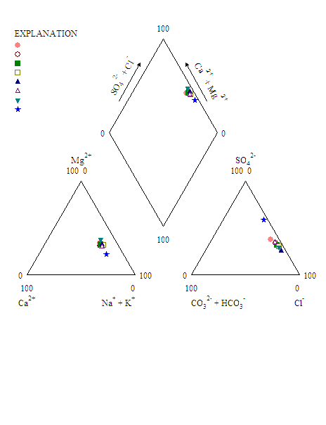
St.1
St.2
St.3
St.4
St.5
St.6
St.7
St.8

Figure 2. PIPER diagram of the 8 water discharges in the alwardiy drainage .. The labels are meant as an indication for the l water chemistry, of the single samples.

4.3. Quality of Irrigation
4.3.1. pH
The normal pH range for irrigation water is from 6.5 to 8.4. An abnormal value is a warning that the water needs further evaluation. Irrigation water with a pH outside the normal range may ause a nutritional imbalance or may contain a toxic ion(Sanjay and Dinabandhu,2009). The pH value of all water samples lies in the range from 7.69 to 8.74which implies that waters are suitable for irrigation purposes with respect to pH, i.e. there is no alkalinity hazard as shown in Table 2.
4.3.2. Salinity Hazard
Electrical conductivity is a good measurement of salinity hazard to crop as it reflects the TDS in surface water. All sampling points are found unsuitable with respect to EC for irrigation purposes. According to Wilcox classification Wilcox (1955), the water surface in the study area is unsuitable for irrigation uses Table 5. The primary effect of high EC reduces the osmotic activity of plants and thus interferes with the absorption of water and nutrients from the soil(Hem,1989).
4.3.3. Total Hardness (TH)
Total hardness varies between 1337 to 2441 mg/l. Maximum allowable limit of TH for drinking water is specified as 500, and the most desirable limit is 100, as recommended by WHO 1993 ndard. The classification of surface water based on total hardness shows that a majority of the surface water samples fall in very hard Table 4.
4.3.4. Sodium Percentage (Na %)
Sodium percentage values reflected that the water was under the category of ‘good’ (20-40 Na %), ‘permissible’ (40-60 Na %) and ‘doubtful’ (60-80 Na %) class Wilcox (1955). The sodium percentage is calculated as follows:

Na %= (Na+k) 100/(Ca+Mg+Na+k)
Here all the concentrations are expressed in meq/l. The values of sodium percent are varying from 49.3 % to 62.1 % Table 1. all of the sampling stations falling under the permissible category to doubtful category Table 5. When the concentration of sodium ion is high in irrigation water, Na tends to be absorbed by clay particles, displacing magnesium and calcium ions. This exchange process of sodium in water for Ca and Mg in soil reduces the permeability and eventually results in soil with poor internal draining Richard (1954).

4.3.5. NO₃
Nitrate values are from 7.8-11.2 mg l-1 and nitrate sources are agricultural activities and
sewage effluent through seepage from septic tanks. It is pointed out that, both manure and fertilisers are applied at the cultivated crops of the study area.

Table (4) surface Water Types
Water sample | Water Type
St1 | Mg-Na-Chloride
St2 | Mg-Na- SO₄-Chloride
St3 | Mg-Na- SO₄-Chloride
St4 | Mg-Na- SO₄-Chloride
St5 | Mg-Na- SO₄-Chloride
St6 | Mg-Na- SO₄-Chloride
St7 | Mg-Na- SO₄-Chloride
St8 | Ca- Mg-Na- SO₄-Chloride

Table 5: Classification of surface water on the basis of Na %, , EC, TH and TDS Wilcox (1955),

Parameter | Range | Water class | Samples
Na% | 20  20-40  40-60  60-80  80 | Excellent  Good  Permissible  Doubtful  Unsuitable | Nil  nil  St1,2,3,4,5,6,7  ,st8  Nil
EC | 250  250-750  750-2000  2000-3000  3000 | Excellent  Good  Permissible  Doubtful  Unsuitable | Nil  Nil  Nil  Nil  St,1,2,3,4,5,6,7,8,
TH | <75  75-150  150-300  >300 | Soft  Moderately hard  Hard  Very hard | Nil  Nil  Nil  St,1,2,3,4,5,6,7,8,
TDS | <1000  1000-3000  3000-10000  10000-30000 | Fresh  Slightly saline  Moderately saline  High saline | Nil  Nil  St,1,2,3,4,5,6,7,8,  Nil

5. Conclusion
Interpretation of hydrochemical analysis reveals that the water of the studied area very hard, to slightly saline to moderately saline in nature. The hydrochemical composition of the water show that they are not suitable for human drinking according the recommended standards given by WHO .The trilinear diagram shows that most of the water samples fall in the field of Two discrete water types may be: Na-(Mg)-Cl and Na-Cl.The US salinity diagram for all the water samples fall in the field of C1S4, indicating high salinity and low sodium water, indicating high salinity and low sodium in the water, which cannot be used for irrigation on almost all types of soil with high danger of exchangeable sodium. The significant variation was indicated for the water type that the concentration levels of the main ions (Na⁺, K⁺, Ca²⁺, Mg²⁺) and (Cl⁻, NO3⁻, SO4²⁻) reflected a very high ion concentration in last part of Al-wardiya drainage due to accumulation ions from filtrate water with agricultural fertilizers, draining and the dissolution of the clay and high surface water evaporation from low inflow water. Excessive concentrations of nitrate in water of the studied area it appears that the surface waters of the drainage are more
infected by the pollution that the urban one. Such values show on some way the presence of
anthropogenic sources in the area. where large number of animals are confined When this solution reaches the water some dilution can generally be expected, but the potential for high nitrate concentrations in the water obviously is present in the area studied. The hydrochemical analysis of surface water in the Al-wardiya drainage basin has provided useful information on water quality. Surface water quality deterioration is apparent and is mainly attributed to anthropogenic pollution.
References
Altoviski, M.E., 1962. Handbook of hydrology ,Gosgoelizdat, oscow, Vssr (in Russian), 641p.
APHA, AWWA, WEF.,1998. Standard methods for the examination of water and wastewater (20th ed.).Washington, DC: merican Public Health Association.
Hem, J. D. ,1989.Study and interpretation of the chemical characteristics of natural water U.S. Geological Survey ,Water supply paper 2254 ,246p.
Leo M.L. Nollet.,2007. Handbook of water analysis, CRC PressTaylor & Francis Group,pp786.
Manii, J.K.,2003.Hydrochemistry of the ground water and its relationship with the mineral of open aquifer sediment in selected location within Babylon governorate , un published M.Sc thesis university of Baghdad ,189p.
Piper, A.M., 1944. “A graphic procedure in the geochemical interpretation of water analyses”.Transactions American Geophysical Union, 25: 914-928.
Richard, L.A., 1954. “Diagnosis and improvement of saline and alkali soils”. Agricultural
handbook 60. Washington, DC: USDA, pp. 160.
Sanjay, K.S.,Binod, B. N.& Dinabandhu,B.,(2009). Environmental studies on river water quality with reference to suitability for agricultural purposes: Mahanadi river estuarine system, India – a case study.
Todd, D.K. (Ed.)., 1963. The Water Encyclopedia. Water Information Center, Inc. 500pp.
Todd, D.K., 1980. « Ground water hydrology » New York: Wiley, pp. 180.
Vogel, A. L. (1961). A text book of quantitative inorganic analysis (3rd ed.). London: Longmanns.
WHO (World Health Organization)., 1993. “Guidelines for drinking water quality”, (2nd
edition), Volume 1, Geneva, WHO, pp. 130.
Wilcox, L.V., 1948. “The quality of water for irrigation use”. U.S. Department of Agriculture, Technical Bulletin 962.Washington, DC: U.S. Department of Agriculture, pp. 40.
Wilcox, L.V., 1955. “Classification and use of irrigation waters”. U.S. Department of
Agriculture Circular 969. Washington, DC: U.S. Department of Agriculture, pp. 19.

