Assessment of Hydrochemical Water Quality on Al Delmaj Marsh Application Of The CCME WQI

Jwad K. Manii
Department of geology, College of Science Babylon University.
Aqeal A. Al- Zubaidi
Natural History Museum ,Baghdad University

Abstract:
An attempt has been made to evaluate water quality for al delmaj marsh using seven water parameter quality. The parameters include pH, total dissolved solids (TDS), electrical conductivity (EC, mS cm ⁻ ¹), nitrate (NO⁻³ ), chloride (Cl⁻),sodium Na⁺ and sulphate (SO2⁻⁴ ) and pH measured at six sample station , using the Canadian Council of Ministers of the Environment Water Quality Index (CCME WQI). The model was applied in two approaches based on the data and the CCME aquatic life guidelines as objectives. Water quality indices (WQIs) were calculated for uses of the marah water, i.e. irrigation, drinking and aquatic life, using the CWQI 1.0 model developed by the task group of the Canadian Council of Ministers of the Environment (CCME). The results revealed that the marsh water is not fit for drinking at any sampling stations another results of the study revealed that the water quality of the marsh is made worse by effluents added through surface drains along marsh. The WQIs are mostly ranked as ‘‘marginal’’ or ‘‘fair’’ for aquatic and irrigation uses.
الخلاصة
البحث هو محاولة لتقيم نوعية مياه هور الدلمج با ستخدام معاير نوعية المياه شملت قياس بعض الخصائص الهيدروكيميائية (قياس التوصليية الكهربائية,تراكيز المواد الدائبة الكلية ,تراكيز كل من الكبريتات والنترات والكلورايد وتراكيز الصوديوم ) وجرى تطبيق طريقة المجلس الكندي لوزراء البيئة في بيان نوعية المياه وقد تم حساب الارقام القياسية حسب النمودج الكندي وكشفت الدراسة ان مياه الهور وحسب تلكم الطريقة غير صالحة للشرب ولجميع المحطات .كدلك بينت الدراسة ان مياه الهور تصنف كونها هامشية من حيث صلاحية استخدامها لاغراض الري وكدلك للاحياء المائية.

1-1-introduction
The marsh region is situated in the southern basin (alluvial plain) of the rivers Tigris and Euphrates at 30⁰35' -32⁰45'N and 46⁰13' -48⁰E, with a maximum length of about 210 km and width of 170 km. Its total area of about 35000 km2 is covered by water at the time of peak flood. The daily mean temperature (30 years) is 12.4 ⁰C in January and 33.9 ⁰C in August. The annual rain fall varies from 84 to 296 mm. The dry period is from June to October (Al-Saadi, H. A& Al-Mousawim,1988) . For the present study, the marsh, Al- Aldelmj (local name Hor Al- Aldelmj) was select ed. Hor Aldelmj located in the alluvial plain, which represents one of the three topographic zones in Iraq, in addition to the mountainous region in the north and north-east, the western plateau on the western side. The alluvial plain low topography, as to not exceed a height of 25 meters and is surrounded by hills from the east, which increases the height of 300 meters, and the Western Sahara from the west, with a rise in Shithathah 88 meters, and the mountains of Makhool from the north, which reaches a height of 400 meters above sea level. And Hor Aldelmj, a large body of water fed by the Tigris and Euphrates, and is located between the provinces of Qadisiyah (west), Wasit (east). Known delegations large numbers of migratory birds each year from Europe and Asia, to him, as well as the presence of large quantities of fish for that is one of Wetlands of International Importance (Evans, 1994). Not far from the city of Nippur archaeological mission. The area of ​​Hor Aldelmj 120 000 acres located around the perimeter of marsh areas of archaeological too many in addition to that this marsh was once considered one of the archaeological sites.

1-2-Aim of study :
This study is an attempt to evaluate water quality of Al Aldelmj marsh to capture the environmental impacts of effluent irrigation in different locations at marsh through primary surveys and secondary information by number of water quality measurements can serve, and have already been used, as indicators of water quality that can describe overall water quality of water boody and aquatic ecosystem.

1-3- Study Site
We selected the Hor Aldelmj area (32◦ 22⁻-32◦ 15⁻ N; 45◦ 13⁻ 45◦ 32⁻ W) Figure (1) as the study site because it is the most extensive marsh 120 000 acres located around the perimeter of marsh areas on the in the alluvial plain. The marsh and surrounding areas are characterized by a arid climate, records the weather forecasters for decant that the highest monthly average temperature up to 36.2 ⁰C in Samawah, and 35.7 ⁰C in the neighborhood, and 34.8 ⁰C in Diwaniya. And the lowest monthly average temperature is: 10.4 ⁰C in the neighborhood, and 10.1 ⁰C in Diwaniya, and 10.5 ⁰C in Samawah. The wind is dry and rain is a clear impact on the size of sand dunes, and shape, and movement. And sand storms is due to increased wind speed caused by the passage of depressions, with a monthly average of wind speed in July, 5.9 m / s in the neighborhood, and 5.3 m / s in Diwaniyah, and 4.3 m / s in Samawah. And increase the process of transferring the crumbs up the sandy wind speed increases during the day during the hot summer months. The average monthly relative humidity in the winter of January, has reached 69% in Samawah, and 77% in the neighborhood, and in Diwaniya, 70%, either in the summer month of July amounted to Samawah in 19%, 24% and in the neighborhood, and in Diwaniya, 24.5%. And the rate of precipitation is rain in January to 23.6 Faisal in Samawah, and 27.1 mm in the neighborhood, and 22.1 mm in Diwaniyah Precipitation and temperature data were obtained from the Monthly Climatic Reports Information (board of Meteorological).
1-3-Vegetation:
The climate of the most influencing factors on the prevalence and distribution of vegetation as well as terrain, soil, and grow near the Hor Aldelmj plants that are tolerant to drought and high temperatures, so adapted to resist drought, which lasts for eight months, through its roots long, and storage of water, and leaves needle pointed Amotat layers of wax a few pores, and the most important plants are: Acacia (Acasia spp.), and the bush (Atriplex spp.), and Akol (Alhaji mauroum), and forks (Prosopis spp.), and reed (Phramitis communis), and (Tamarix articulata) (Shaker,1985).

1-4- Methodology:
sampling program was carried out at 2010 ,water samples were collected from six locations. All water samples were collected in plastic vials, hermetically closed and taken in a portable refrigerator to the laboratory, where they were filtered and frozen at −20◦C until being analyzed no more than one month later according to the standard sampling methods (APHA,1998). . The samples were not acidified prior to analysis(Hem,1989). In each sampling plot, pH level were measured with a portable pH meter at the sampling time . For all water samples, electrical conductivity (EC) at 25◦C, pH, nitrate (NO⁻³), chloride (Cl⁻),sodium Na⁺ and sulphate (SO2⁻⁴ ) concentrations were determined.NO⁻³ were measured at λ = 220 nm and the interference due to organic matter corrected by measuring absorbance at λ = 275 nm (AOAC, 1975) and expressed as NO^{−3 .}. Cl⁻ by titration with AgNO3 (APHA, 1998), and SO2⁻⁴ by turbidimetry with BaCl2 (APHA, 1998), .

1-5 -Water quality monitoring:
Surface water quality of the marsh was monitored sampling performed once a month during the year 2010 for three months (July, March, December ). six stations were selected on the marsh for the collection of samples for water quality determination . A variety of water quality parameters were used to examine the water quality condition of Al-delamj marh with reference to (CCME WQI ).

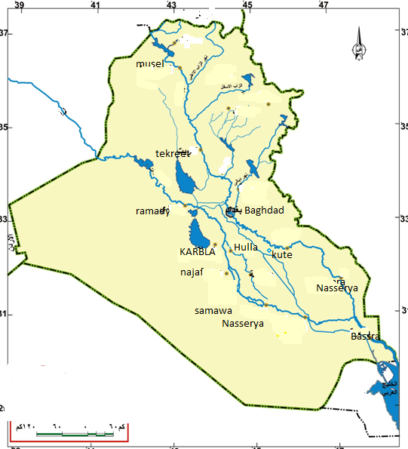

32⁰ 33⁻ 30⁼

1
2
3
4

5
6

32⁰ 0⁻ 30⁼

Figure 1 Map of the study area

2-1 The Canadian Council of Ministers of the Environment
The Canadian Council of Ministers of the Environment (CCME) has developed a Water Quality Index (WQI) to simplify the reporting of complex and technical water quality data (CCME 2001).The CCME WQI is a science-based communication tool that tests multi-variable water quality data against specified water quality benchmarks determined by the user. TheWQI mathematically combines three measures of variance (scope, frequency and magnitude) to produce a single unitless number that represents overall water quality at a site relative to the benchmark chosen (e.g., protection of aquatic life). The end result is a single unit-less number from 0 to 100, where ascore of 100 indicates that all variables were at or below the selected benchmarks during all monitoring times(table 3). To simplify, the CCME developed a calculator that is a pre-programmed spreadsheet with mathematical equations that helps users evaluate the condition (or health) or a water body.. The body of water to which the index will apply can be defined by one station (e.g., a monitoring site on a particular river reach) or by a number of different stations (e.g., sites throughout a lake). The more stations that are combined, the more general the conclusions will be(CCME WQI,2001). It is important to note that the CCME WQI is not a substitute for detailed analysis of water quality data and should not be used as a sole tool for management of water bodies. It was simply developed to provide a broad overview of environmental performance (Khan,A.A.,et all,2004). The CCME Water Quality Index (1.0) is based on a formula developed by the British Columbia Ministry of Environment, Lands and Parks and modified by Alberta Environment. The Index incorporates three elements:scope - the number of variables not meeting water quality objectives; frequency - the number of times these objectives are not met; and amplitude - the amount by which the objectives are not met. The index produces a number between 0 (worst water quality) and 100 (best water quality). These numbers are divided into 5 descriptive categories to simplify presentation table 3(CCME WQI,2001).

2-2 The model
The CWQI 1.0 model consists of three measures of variance from selected water quality objectives: scope (F1),; frequency (F2), and amplitude (F3), the amount by which the objectives are not met. The index produces a number between 0 (worst water quality) and 100 (best water quality). These numbers are divided into five descriptive categories to simplify presentation. The model calculates the WQI as follows:

Scope (F1) represents the extent of water quality guideline non-compliance over the time period ofinterest:

In Equation (1), variables indicate the water quality parameters tested during the time period for index
calculation. _ Frequency (F2) represents the percentage of individual tests that do not meet the objectives, i.e. failed tests.

Amplitude (F3) represents the amount by which failed test values do not meet their objectives. F3 is calculated in three steps as follows. Step 1. The number of times by which an individual concentration is greater than (or less than, when the objective is a minimum) the objective is termed an ‘‘excursion ‘and is expressed as follows. When the test value must not exceed the objective:
For the cases in which the test value must not fall below the objective:

where i and j=1, 2, 3, .. . ., n.

Step 2. The collective amount by which individual tests are out of compliance is calculated by summing the excursions of individual tests from their objectives and is divided by the total number of tests (both those meeting objectives and those not meeting objectives). This variable, referred to as the normalized sum of excursions, or NSE, is calculated as
Step 3. Finally F3 is calculated by an asymptotic function that scales the normalized sum of the excursions from objectives (NSE) to yield a range between zero and 100:

The WQI is then calculated as:
The WQI values are then converted into rankings by using the index categorization schema as presented in Table 3. The rankings range from poor to excellent based on the WQI scores. This ranking schema was more suitable for aquatic and irrigation uses but in the case of drinking use, it was better to convey a clearer message (e.g. fit or unfit) due to the involvement of potential risks of human health hazards. Therefore, a different ranking criterion was set for drinking use as presented in Figure 2. The CWQI model provides a mathematical framework for assessing ambient water quality conditions relative to water quality objectives. It is flexible with respect to the type and number of water quality variables to be tested, the seven variables will be considered in the calculation(Total dissolved solids (TDS), Electric conductivity (EC), pH, Sodium adsorption ratio (SAR), Chloride (Cl), Sodium (Na) , Sulphate (SO₄).

Table 2. Water quality standards for different water uses(OBJECTIVE:).
quality parameters | Unit | Drinking | Aquatic |  | Irrigation
Total dissolved solids (TDS) | mg l⁻¹ | 800 | 1000 |  | 1000
Electric conductivity (EC) | mScm⁻¹ | 1250 | 1500 |  | 1500
pH | Minimum  maximum | 6.5  8.5 | 6.5  8.5 |  | 6.4  8.4
Sodium adsorption ratio (SAR) |  | N/A | N/A |  | 8
Chloride (Cl⁻¹) | mg l⁻¹ | 100 | N/A |  | 250
Sodium (Na⁺)  Sulphate (SO4⁼)  NO3 ⁻¹ | mg l⁻¹  mg l⁻¹  mg l⁻¹ | 200  250  50 | 2 |  | N/A  N/A  N/A
N/A not applicable or not available.
Source: the WWF Water Quality Guidelines 2007, (CCME) (2007able 3.

Table 3. CCME WQI categorization schema for aquatic and irrigation uses .
Rank | WQI value |  |  | Description
Excellent | 95–100 | Water quality is protected with a virtual absence of threat or impairment; conditions very close to natural or pristine levels. These index values can only be obtained if all measurements are within objectives virtually all of the time.
Good | 80–94 |  | Water quality is protected with only a minor degree of threat or  impairment; conditions rarely depart from natural or desirable levels.  .
Fair | 65–79 |  | Water quality is usually protected but occasionally threatened or impaired; conditions sometimes depart from natural or desirable levels.
Marginal | 45–64 | Water quality is frequently threatened or impaired; conditions often depart from natural or desirable levels.
Poor | 0–44 |  |  | Water quality is almost always threatened or impaired; conditions usually depart from natural or desirable levels.
Source: CCME WQI,2001

Table 4. Summary of water quality index calculations for different water uses at selected sites of the marsh.
Station  No. | Water  uses. | Number of variables tested | Number of failed variables | Scope, frequency and amplitude for different water uses  F1 F2 F3 | CCMEWQI
D1 | Drinking  Aquatic  irrigation | 7  7  8 | 5  3  3 | 71 35 55.922  42 15 20.50  38 18 26.04 | 44.0  71.6  71.4
D2 | Drinking  Aquatic  irrigation | 7  7  8 | 5  3  3 | 71 35 71.65  42 15 54.29  38 18 41.01 | 38.3  59.4  66.0
D3 | Drinking  Aquatic  irrigation | 7  7  8 | 5  3  3 | 71 35 72.56  42 15 56.96  38 18 44.71 | 38.6  58.2  64.5
D4 | Drinking  Aquatic  irrigation | 7  7  8 | 5  3  3 | 71 35 72.56  42 15 57.56  38 18 41.19 | 38  47.5  66.
D5 | Drinking  Aquatic  irrigation | 7  7  8 | 5  3  3 | 71 35 81.16  42 15 58.60  38 18 46.32 | 34.3  57.4  63.8
D6 | Drinking  Aquatic  irrigation | 7  7  8 | 5  3  3 | 71 35 61.01  42 15 45.00  38 18 33.72 | 42  63.4  68.8

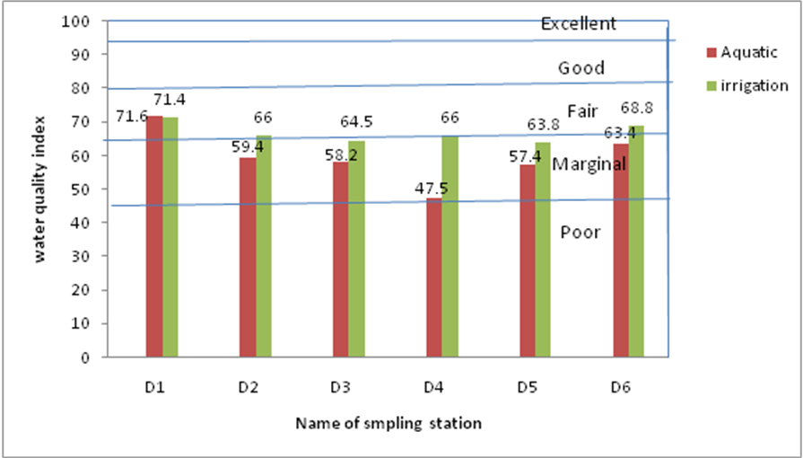
Figure 2. Water quality indices for irrigation and aquatic life at different locations on the marsh

3- Results
3-1 -Water quality indices Based CCME WQI Analysis:
By applying the equations in the materials and methods section above, the values of F1 and F2, respectively presents a summary of three measures of variance according the (CCME WQI), table 4, i.e. F1 (scope), F2 (frequency) and F3 (amplitude)for selected water uses. The table shows that among all water uses, F1 has higher values than F2 at all the selected sample stations. It denotes that there is a higher percentage of failed variables than the percentage of individual failed tests and the amount by which they failed. Table 4 further denotes that F1,F2 values show as the same increasing trend from all sample station . This trend infers that all water quality variables failed (did not meet their objectives) . The highest values of F2 are observed for drinking and lowest for irrigation use. It shows that the percentage of individual failed tests is highest in the case of drinking and lowest for irrigation. Similarly, F3 values are also higher in the case of drinking as compared to the aquatic life and irrigation uses of marsh water. The reason is that for the uses of aquatic life and irrigation, the values of failed variables do not exceed as much from their objectives as for drinking. The water quality parameters with the highest value of normalized sum of excursion (NSE) are given in the table. It is clear from the table that values of use for drinking, aquatic life and irrigation uses respectively. for Irrigation WQIs ranged in ranking from ‘‘marginal’’ to ‘‘fair’’ at sampling sites. For aquatic life, the marsh water WQI ranked ‘‘marginal’’ to (‘‘fair’’) .for drinking. Table 4 indicates that the marsh water was ‘‘not fit’’ for drinking at all the sampling stations.

3-2 Conclusions
In this study, monitored for water quality at six locations at the Al-Delmaje marsh .The WQIs were calculated using the CWQI 1.0 model. To simplify presentation, these indices were divided into five descriptive categories (‘‘poor’’ to ‘‘excellent’’) for aquatic life and irrigation uses. A different categorization method was developed to assess the water quality for drinking,in this case ,instead of ranking into categories, the marsh water was declared ‘‘fit’’ or ‘‘unfit’’ based on WQI scores as well as presence or absence of pollutant the marsh water is not fit for drinking at any sampling stations. The results of the study revealed that the water quality of the marsh is made worse by effluents added through surface drains along the marsh. The WQIs are mostly ranked as ‘‘marginal’’ or ‘‘fair’’ for aquatic and irrigation uses.. Contributed to climate change in the decrease or lack of water resources of the Hor Aldelmj, and increased rates of evaporation and salinity to the border that threaten biodiversity.

References:
Al-Saadi, H. A., & Al-Mousawi ,A.H.,1988. Some notes on the ecology of aquatic plants in the Al-Hammar marsh, Iraq. Vol. 75, No. 3 (Jun. 30, 1988), pp. 131-133Published by: Springer.
Amir Ali Khan, Renée Paterson and Haseen Khanm,2004 . Modification and Application of the Canadian Council of Ministers of the Environment Water Quality Index (CCME WQI) for the Communication of Drinking Water Quality Data in Newfoundland and Labrador
AOAC Methods: 1975, 12th edition. AOAC Internacional, Arlington, Virginia, USA.
APHA, (1998), APHA-AWWA-WPCF,Standard Methods for Examination of Water
and Waste Water. APHA Inc., New York, 20th Edition, 29,248,487,4134,53,947.
Buday, T., 1980, The Regional Geology of Iraq, Stratigraphy and Paleogeography. S.O.M., Baghdad, Iraq, 445 P.
Canadian Council of Ministers of the Environment(CCME) (2007). Canadian environmental quality guidelines: Canadian water quality guidelines for the protection of aquatic life. Winnipeg, MB, Canada
Canadian Council of Ministers of the Environment. 2001. Canadian Water Quality Guidelines for the Protection of Aquatic Life: CCME Water Quality Index 1.0 User’s Manual. Winnipeg, Canada.
Shaker, S.N., 1985, dune geomorphology of the area located between Kut - Diwaniya - Nasiriyah. Unpublished Master Thesis, college of Science, University of Baghdad, 208 p.
Maréchal, J. C.; Ahmed, S.; Engerrand, C.; Galeazzi, L.; Touchard, F. 2006. Threatened Groundwater Resources in Rural India: An Example of Monitoring. Asian Journal of Water, Environment and Pollution 3(2): 15–21.
Newman, S. and Pietro, K.: 2001, ‘Phosphorus storage and release in response to flooding: implications for Everglades storm water treatment areas’, Ecological Engineering 18, 23–38.
Water quality is a key environmental issue facing the agricultural sector today (Maréchal et al. 2006). Meeting the right quantity and desirable quality of water for agriculture is not only essential for food security but also for food safety.
White, J. S., Bayley, S. E. and Curtis, P. J.: 2000, ‘Sediment storage of phosphorus in a northern.
prairie wetland receving municipal and agro-industrial wastewater’, Ecological Engineering 14,127–138.
World Wide Fund. 2007. National Water Classification Criteria and Irrigation Water Quality Guidelines.
The board of Meteorological, 2005-201, climate information, the Ministry of Communications, Baghdad, Iraq.

