Synthesis of Some New Schiff Bases, Tetrazole and 1,3-Oxazepine Derivatives Containing Azo Group and 1,3,4- Thiadiazole Moiety
Zaid Hassan Abood Rahman Tama Haiwal
Chemistry Department ,College of Science ,University of Kerbala
Hasan Thamer ghanim
Chemistry Department ,College of Education for women ,
University of Kufa
Sajid Maqsad Radhi
Chemistry Department ,College of Science ,University of Kerbala
Abstract
In this research new Schiff bases [5-6], tetrazole [9] and [12] and 1,3-oxazepine [7-8] and [10-11] derivatives were prepared starting from azoaldehyde derivative 5,5'-(biphenyl-4,4'-diylbis(diazene-2,1-diyl))bis(2-hydroxybenzaldehyde) [1] and the primary amines 5-(butylthio)-1,3,4-thiadiazol-2-amine[3] and 5-(benzylthio)-1,3,4-thiadiazol-2-amine[4].
Azo aldehyde derivative[1] was prepared via coupling reaction between o-Hydroxy benzaldehyde and diazonium salt which was formed via reaction of benzidine with concentrated hydrochloric acid and sodium nitrite . The primary amines [3] and [4] were prepared by reaction of each n-butyl bromide and benzyl chloride ,respectively ,with 5-Amino-1,3,4-thiadiazole-2-thiol [2] in dry dioxane in presence of potassium hydroxide .5-Amino-1,3,4-thiadiazole-2-thiol [2] was prepared by reaction of thiosemicarbazide with carbon disulfide in presence of anhydrous sodium carbonate in absolute ethanol.The new Schiff bases [5] and [6] were prepared by reaction of azo aldehyde derivative [1] with each prepared primary amines[3] and[4],respectively , in presence of glacial acetic acid as catalyst , The new 1,3-oxazepine derivatives [7] , [8] and [10], [11] were obtained from treatment of each prepared Schiff bases derivatives [5] and [6] with each maleic anhydride and phthalic anhydride , respectively ,in dry benzene .Treatment of each prepared Schiff bases [5] and [6] with sodium azide in dry dioxane resulted the formation of new tetrazole derivatives [9] and [12] ,respectively .These new synthesized derivatives might have some biological activity.
All new derivatives were characterized by melting points and are uncorrected ,(C.H.N.) elementary analysis and FT-IR spectra.
الخلاصة
تم في هذا البحث تحضير مشتقات قواعد شيف [5-6] وتترازول [9] ، [12] و 3،1- اوكسازيبين [7-8] ، [10-11] جديدة من مشتق الازوالديهايد 4,4'-(بايفنل -4,4'-داييل بس(دايازين-2،1-داييل)) بس (2-هيدروكسي بنزالديهايد [1] والامينات الاولية 5-(بيوتيل ثايو)- -4،3،1-ثايادايازول-2- امين [3] و 5-(بنزيل ثايو)- 4،3،1-ثايادايازول-2- امين [4] .
حضر مشتق الازوالديهايد [1] من خلال تفاعل الازدواج بين O - هيدروكسي بنزالديهايد وملح الدايازونيوم المتكون من تفاعل البنزيدين مع حامض الهيدروكلوريك المركز مع نتريت الصوديوم . حضرت الامينات الاولية 5-(بيوتيل ثايو)- -4،3،1-ثايادايازول-2- امين [3] و 5-(بنزيل ثايو)- -4،3،1-ثايادايازول-2- امين [4] عن طر9يق تفاعل كل من بروميد n - بيوتيل وكلوريد البنزيل ، على التوالي ، مع 5-امينو -4،3،1 – ثايادايازول-2- ثايول [2] في الدايوكسان الجاف بوجود هيدروكسيد البوتاسيوم. حضر 5-امينو -4،3،1 – ثايادايازول-2- ثا يول [2] من تفاعل الثايو سيميكاربزايد مع ثنائي كبريتيد الكاربون بوجود كاربونات الصوديوم اللامائية في الايثانول المطلق. حضرت قواعد شيف الجديدة [5] و[6] عن طريق تفاعل مشتق الازو الديهايد [1] مع كل من الامينات الاولية المحضرة[3] و[4] ، على التوالي ، في الايثانول المطلق بوجود حامض الخليك الثلجي كعامل مساعد .
تم الحصول على مشتقات 3،1 – اوكسازيبين الجديدة [7]، [8] و [10] ، [11] من معاملة كل من مشتقات قواعد شيف المحضرة [5] و [6] مع كل من انهدريد المالييك و انهدريد الفثاليك ، علي التوالي في البنزين الجاف . ان معاملة كل من مشتقات قواعد شف المحضرة [5] و [6] مع ازيد الصوديوم في الدايوكسان الجاف اعطت مشتقات تترازول جديدة [6] و [9] على التوالي. ان هذة المشتقات الجديدة قد تمتلك فعالية حيوية . كافة المركبات الجديدة تم تشخيصها بوساطة درجات الانصهار غير المصححة والتحليل الكمي الدقيق للعناصر (C.H.N.) واطياف الاشعة تحت الحمراء.

Introduction
Azo group is considered biological active group (Wilson and Givolds, 1982 and Pod Dick et.al., 1985).The most important method for preparing azo compounds is the coupling reaction between diazonium salts and phenols (Vogel, 1973) .
Schiff bases or imines are prepared via acid-catalysed condensation reaction of aromatic aldehydes or ketones with primary amines (Al-juboori , 2005 and Salih, 2005).Azo Schiff bases are prepared by reaction of azoaldehydes with primary amines(Jarrahpour et.al., 2004). Mechanism of Schiff base formation was well known (Al-juboori , 2005 and Salih, 2005) .Various azo Schiff bases derivatives were prepared and some of them showed biological activity such as anticancer (Desai et.al., 2001), antiviral (Wang et.al., 1990),antifungal (Singh and Dash, 1988) , antibacterial (More et.al.,2001) and anticonvulsant (Verma et.al., 2004) .Thiadiazoles have a variety of potential biological activities (Noto et.al., 1996 and Al-Ani, 2004) , therefore a large number of thiadiazole derivatives have been prepared (Noto et.al., 1996 and Al-Omran et.al.,2002) .Many synthesis of 1,3,4-thiadiazoles proceed from thiosemicarbazide or substituted thiosemicarbazide (Ainsworth,1956 and Mohan et.al., 1988) . For a long time, the synthesis of 1,3- and 1,4-oxazepine rings was based on two limited classical types of reactions, the first reaction is called Valence-bond isomerization which is carried out via irradiation of polyarylpyridine N-oxides. This irradiation results in ring expansion to 1,3-oxazepine in high yield and some deoxygenation to the parent amines (Buchardt et.al., 1972) . The second reaction is called Enamines condensation which is carried out by reaction of Erythro 1,2-diphenyl-2-phenylaminoethanol with dimethylacetylene dicarboxylate in methanol at room temperature to give a mixture of the Michael adduct and tetrahydro-1,4-oxazepin-7-one (Tsuge et.al., 1982). Recently, a pericyclic reactions are used to synthesis of 1,3-oxazepine ring (Ali,2005, Al-Jamali,2008,Haiwal,2008 and Abood,2009). This type of reactions is not limited and gives various 1,3-oxazepine ring derivatives. The type of cycloaddition reaction that used to synthesis of 1,3-oxazepine ring was classified as (2+5) → 7 cycloaddition reaction in which two atoms of imine group as two-membered component was added to five-membered component such as maleic or phthalic anhydrides to give a seven-membered heterocycle (Ali,2005, Al-Jamali,2008,Haiwal,2008 and Abood,2009) .Some oxazepine derivatives showed biological activities against various types of bactria (Serrano et.al., 2002) and some of them act as inhibitors of some enzymes action (Smith et.al., 2006) .
Also , the 1,3-dipolar cycloaddition reaction,which was used to synthesis of tetrazole ring was classified as (2+3) cycloaddition , in which two atoms of the first component ( imine or nitrile groups as a 1,3-dipolarphiles) react with three atoms of the second component ( azide group as a 1,3-dipolar molecule ) (Miller, 1998 and Abood et.al. 2008) .Tetrazole derivatives showed fungicidal and antiviral activities (Modzelewska et.al.,2004) .
The aim of this research is synthesis of some new oxazepine and tetrazole derivatives containing the biologically active azo group and thiadiazole ring all together, as attempt for increasing the biological activity and its variety.

Experimental

General
1) The solvents and liquid reagents were purified when it was necessary; the solid materials were also dried under reduced pressure when it was necessary.
2) TLC were performed on pre-coated sheets with 0.25 mm layer of Silica Gel GF254 of the Merck company, the detection was followed by coloring with iodine or H₂SO₄ in ethanol (60%) followed by heating.
3) Evaporating of solvents by using Buchi vacuum rotary evaporator type 160.
4) Melting points (M.P.) were determined by Stuart melting point apparatus.
5) Elemental analysis measured on E.A.300, Euro- Vector, Italy, 2003.
6) FT-IR spectra were recorded on FT-IR 8400_{S}, Schimadzu-Spectrophotometer and using KBr discs.
Preparation Methods
Synthesis of 5,5'-(Biphenyl-4,4'-diylbis(diazene-2,1-diyl))bis(2-
hydroxybenzaldehyde) [1] (Vogel, 1973)
Benzidine (1.84g, 0.01 mole) was dissolved in (16mL) of concentrated hydrochloric acid and (16 mL) of distilled water contained in a small beaker. The mixture was cold at (0°C) in an ice bath.Then a solution of sodium nitrite (1.656g, 0.024 mole) dissolved in (20 mL) of distilled water was added dropwise to the mixture with stirring, the temperature of the ice bath was controlled between (0-5°C). A solution of 2- Hydroxybenzaldehyde (2.44g, 0.02 mole) dissolved in (20 mL) of (10%) sodium hydroxyide solution in (150 mL) beaker was prepared and cold to (5ºC ) by immersion in an ice bath. 2-Hydroxybezaldehyde solution was then stirred vigorously,then the diazonium salt solution was added very slowly to the 2- Hydroxybezaldehyde solution, a red colour developed and red crystals soon separated. When all the diazonuim salt solution was added, the mixture was allwoed to stand in an ice bath for 30 min. with occasional stirring. The solution was filtered, washed well with distilled water, recrystallized from ethanol and dried upon filter paper, yield 51%, M.P.234-236 ºC .
Synthesis of 5-Amino-1,3,4-thiadiazole-2-thiol [2] (Abood, 2008)
A mixture of (4.55g,0.05mole) of thiosemicarbazide and (2.65g,0.025 mole) of anhydrous sodium carbonate was dissolved in(25mL) absolute ethanol , to this solution (5g,0.0657mole) of carbon disulfide was added . The reaction mixture was refluxed on a water bath at 60 ºC for 24hrs. ,T.L.C. (ethanol:pet.ether(1:3) R_{f} = 0.82.The reaction mixture was then allowed to cool down to room temperature , then (25mL) of distilled water was added with stirring to the mixture , the solution was carefully acidified with conc.hydrochloric acid to give pale yellow precipitate . The product was filtered under reduced pressure , washed well with cold distilled water and recrystallized from distilled water , yield 88% , M.P.230-232ºC , Lit. (Abood, 2008) 232-233 ºC .
Synthesis of 5-(Butylthio)-1,3,4-thiadiazol-2-amine [3]
5-Amino-1,3,4-thiadiazole-2-thiol [2]( 1.33 g 0.01,mole) was dissolved (20mL) of dry dioxane ,then potassium hydroxide ( 0.56g ,0.01mole ) ,dissolved in amount of water at least as possible , was added .The mixture was then refluxed with stirring at (80 ºC) for 20 min., then n-butyl bromide (1.37 g , 0.01mole ) was added dropwise , then the mixture was refluxed with stirring at 80 ºC for 3hrs. , T.L.C. (ethanol:pet.ether)(1:1), R_{f} = 0.66.The mixture was allowed to cool down to room temperature.The solvent was then removed by evaporation and the product was extracted by addition of distilled water (30mL) and ethyl acetate (2×25mL) .The organic layer was dried with anhydrous mangensium sulphate and removed by evaporation ,recrystallized from methanol , yield 73% , M.P.115-117 ºC.
Synthesis of 5-(Benzylthio)-1,3,4-thiadiazol-2-amine [4]
5-Amino-1,3,4-thiadiazole-2-thiol [2] (1.33g,0.01mole) was dissolved (20mL) of dry dioxiane ,then potassium hydroxide ( 0.56g , 0.01mole ) ,dissolved in amount of water at least as possible , was added .The mixture was then refluxed with stirring at (80 ºC) for 20 min., then n-benzyl chloride ( 1.265g ,0.01 mole ) was added dropwise , then the mixture was refluxed with stirring at 80 ºC for 3hrs. , T.L.C. (ethanol:benzene)(1:1) ,R_{f} = 0.8.The mixture was allowed to cool down to room temperature.The solvent was then removed by evaporation and the product was extracted by addition of distilled water (30mL) and ethyl acetate (2×25mL) .The organic layer was dried with anhydrous mangensium sulphate and removed by evaporation ,recrystallized from ethanol , yield 70% , M.P.225-227 ºC.
Synthesis of 4,4'-(Biphenyl-4,4'-diylbis(diazene-2,1-diyl))bis(2-((E)-(5-(butylthio)-1,3,4-thiadiazol-2-ylimino)methyl)phenol) [5]
Azo Benzaldehyde derivative [1]( 0.45g , 0.001 mole) was dissolved in (15 mL) of absolute ethanol containing a drop of glacial acetic acid ,then 5-(butylthio)-1,3,4-thiadiazol-2-amine [3] (0.378 g ,0.002 mole ) was dissolved in (15 mL) of absolute ethanol and added dropwise . The reaction mixture was refluxed with stirring on a water bath at ( 70 ºC ) for 2hrs.T.L.C. (ethanol:pet.ether)(1:1) ,R_{f} = 0.61.Then the mixture was allowed to cool down to room temperature , the coloured precipitate was filtered and recrystallized from ethanol ,yield 86% , M.P.245-247ºC.
Synthesis of 4,4'-(Biphenyl-4,4'-diylbis(diazene-2,1-diyl))bis(2-((E)-(5-(benzylthio)-1,3,4-thiadiazol-2-ylimino)methyl)phenol) [6]
Azo Benzaldehyde derivative [1]( 0.45g , 0.001 mole) was dissolved in (15 mL) of absolute ethanol containing a drop of glacial acetic acid ,then 5-(benzylthio)-1,3,4-thiadiazol-2-amine[4] (0.446g,0.002 mole ) was dissolved in (15 mL) of absolute ethanol and added dropwise . The reaction mixture was refluxed with stirring on a water bath at ( 70 ºC ) for 2hrs.T.L.C. (ethanol:pet.ether) (1:1) R_{f} = 0.69.Then the mixture was allowed to cool down to room temperature , the coloured precipitate was filtered and recrystallized from ethanol ,yield 84% , M.P. 263-265 ºC.

Synthesis of 2,2'-(5,5'-(Biphenyl-4,4'-diylbis(diazene-2,1-diyl))bis(2-hydroxy-5,1-phenylene))bis(3-(5-(butylthio)-1,3,4-thiadiazol-2-yl)-2,3-dihydro-1,3-oxazepine-4,7-dione) [7]
A mixture of imine derivative [5]( 0.1584 g, 0.0002 mole) and maleic anhydride (0.0392 g ,0.0004mole) in ( 20 mL) of dry benzene , was refluxed on a water bath at (75ºC) for 4hrs. T.L.C. (benzene:methanol ) (3:1) R_{f} = 0.79. , then the mixture was allowed to cool down to room temperature . The resulting solid crystals were filtered and recrystallized from dioxane, yield 71% , M.P.140-142 ºC.

Synthesis of 3,3'-(5,5'-(Biphenyl-4,4'-diylbis(diazene-2,1-diyl))bis(2-hydroxy-5,1-phenylene))bis(4-(5-(butylthio)-1,3,4-thiadiazol-2-yl)-3,4-dihydrobenzo[e][1,3]oxazepine-1,5-dione) [8]
A mixture of imine derivative [5]( 0.1584g, 0.0002mole) and phthalic anhydride ( 0.0592g ,0.0004mole) in ( 20 mL) of dry benzene , was refluxed on a water bath at (75ºC) for 4hrs. T.L.C. (benzene:methanol) (3:1) R_{f} = 0.77. , then the mixture was allowed to cool down to room temperature . The resulting solid crystals were filtered and recrystallized from dioxane, yield 69% , M.P.155-157ºC.

Synthesis of 4,4'-(Biphenyl-4,4'-diylbis(diazene-2,1-diyl))bis(2-(1-(5-(butylthio)-1,3,4-thiadiazol-2-yl)-1H-tetrazol-5-yl)phenol) [9]
A mixture of imine derivative [5] ( 0.1584g, 0.0002 mole) and sodium azide (0.026 g , 0.0004mole ) in ( 20 mL) of dry dioxane was refluxed on a water bath at (75ºC) for 5hrs, T.L.C. (benzene:methanol ) (1:1) R_{f} = 0.58.The reaction mixture was allowed to cool to room temperature , filtered and recrystallized from ethanol , yield 60 % , M.P. 222-224 ºC.

Synthesis of 2,2'-(5,5'-(Biphenyl-4,4'-diylbis(diazene-2,1-diyl))bis(2-hydroxy-5,1-phenylene))bis(3-(5-(benzylthio)-1,3,4-thiadiazol-2-yl)-2,3-dihydro-1,3-oxazepine-4,7-dione) [10]
A mixture of imine derivative [6]( 0.172 g, 0.0002 mole) and maleic anhydride ( 0.0392g ,0.0004mole) in ( 20 mL) of dry benzene , was refluxed on a water bath at (75ºC) for 4hrs. T.L.C. (benzene:methanol) (3:1) R_{f} = 0.69. , then the mixture was allowed to cool down to room temperature . The resulting solid crystals were filtered and recrystallized from dioxane, yield 72 % ,M.P. 162-164 ºC.
Synthesis of 3,3'-(5,5'-(Biphenyl-4,4'-diylbis(diazene-2,1-diyl))bis(2-hydroxy-5,1-phenylene))bis(4-(5-(benzylthio)-1,3,4-thiadiazol-2-yl)-3,4-dihydrobenzo[e][1,3]oxazepine-1,5-dione) [11]
A mixture of imine derivative [6]( 0.172 g,0.0002 mole) and phthalic anhydride ( 0.0592g ,0.0004mole) in ( 20 mL) of dry benzene , was refluxed on a water bath at (75ºC) for 4hrs. T.L.C. (benzene:methanol) (3:1) R_{f} = 0.67. , then the mixture was allowed to cool down to room temperature . The resulting solid crystals were filtered and recrystallized from dioxane, yield 74 % , M.P.175-177ºC.

Synthesis of 4,4'-(Biphenyl-4,4'-diylbis(diazene-2,1-diyl))bis(2-(1-(5-(benzylthio)-1,3,4-thiadiazol-2-yl)-1H-tetrazol-5-yl)phenol) [12]
A mixture of imine derivative [6] ( 0.172g, 0.0002 mole) and sodium azide (0.026g ,0.0004 mole ) in ( 20 mL) of dry dioxane , was refluxed on a water bath at (75ºC) for 5hrs, T.L.C. (benzene:methanol )(1:1) R_{f} = 0.55. The reaction mixture was allowed to cool down to room temperature , filtered and recrystallized from ethanol , yield 62 % , M.P. 233-235 ºC.

Table (1): Melting points , percent yields and (C.H.N. )analysis
of the prepared compounds (1-12)
C.H.N analysis |  |  |  |  |  |  | M.Wt | M.F | Yield % | M.P ºC | Comp.  No.
Found% |  |  |  | Calculated%
N | H | C | N |  | H | C
12.75 | 3.83 | 69.64 | 12.44 |  | 4 | 69.33 | 450 | C₂₆H₁₈N₄O₄ | 51 | 234-236 | [1]
- | - | - | - |  | - | - | 133 | C₂H₃N₃S₂ | 88 | 230-232 | [2]
- |  | - | - |  | - | - | 189 | C₆H₁₁N₃S₂ | 73 | 115-117 | [3]
- | - | - | - |  | - | - | 223 | C₉H₉N₃S₂ | 70 | 225-227 | [4]
17.39 | 4.41 | 57.80 | 17.67 |  | 4.54 | 57.57 | 792 | C₃₈H₃₆N₁₀O₂S₄ | 86 | 245-247 | [5]
15.98 | 4.07 | 61.51 | 16.27 |  | 3.72 | 61.39 | 860 | C₄₄H₃₂N₁₀O₂S₄ | 84 | 263-265 | [6]
14.01 | 4.33 | 56.16 | 14.17 |  | 4.04 | 55.87 | 988 | C₄₆H₄₀N₁₀O₈S₄ | 71 | 140-142 | [7]
13.06 | 4.30 | 59.22 | 12.86 |  | 4.04 | 59.55 | 1088 | C₅₄H₄₄N₁₀O₈S₄ | 69 | 155-157 | [8]
25.90 | 4.14 | 51.89 | 25.62 |  | 3.89 | 52.17 | 874 | C₃₈H₃₄N₁₆O₂S₄ | 60 | 222-224 | [9]
13.51 | 3.68 | 58.88 | 13.25 |  | 3.40 | 59.09 | 1056 | C₅₂H₃₆N₁₀O₈S₄ | 72 | 162-164 | [10]
11.89 | 3.60 | 61.97 | 12.11 |  | 3.46 | 62.28 | 1156 | C₆₀H₄₀N₁₀O₈S₄ | 74 | 175-177 | [11]
24.06 | 3.34 | 54.79 | 23.77 |  | 3.18 | 56.05 | 942 | C₄₄H₃₀N₁₆O₂S₄ | 62 | 233-235 | [12]

Results and Discussion

Benzidine was converted to the corresponding diazonium salt , via reaction with concentrated hydrochloric acid and sodium nitrite at (0 ºC) , which was directly introduced in a coupling reaction with 2-hydroxy benzaldehyde dissolved in sodium hydroxide solution at ( 0-5) ºC to give azo aldehyde derivative [1] (Vogel, 1973) ,then the two carbonyl groups in azo aldehyde derivative [1] were introduced in acid -catalysed condensation reaction with amino groups for each 5-(butylthio)-1,3,4-thiadiazol-2-amine [3] and 5-(benzylthio)-1,3,4-thiadiazol-2-amine [4] ,respectively in absolute ethanol to give new azo Schiff bases derivatives [5] and [6] , respectively (Jarrahpour et.al., 2004, Abood,2008 and Abood, 2009) .
.
A pericyclic reactions, between imine groups of Schiff bases derivatives [5] and [6], as two-membered components, and cyclic anhydrides (maleic anhydride and phthalic anhydride) as five-membered components in dry benzene, were carried out to synthesis of 1,3-oxazepine derivatives [7] , [8] and [10], [11] ] (Ali,2005, Al -Jamali,2008,Haiwal,2008 and Abood,2009).A pericyclic reaction is a concerted process based on principle of conservation of molecular orbital symmetry between the reaction components during the reaction proceeding which is leading to a cyclic transition state corresponds with arrangement of participating orbitals (Ali, 2005 and Haiwal, 2008). Concerted reaction means that breaking and formation of bonds occur simultaneously via a single transition state and there is no intermediate in the process. Mechanism of the pericyclic reaction for the synthesis 1,3-oxazepine ring shown in scheme (1) (Ali, 2005 and Haiwal, 2008)

Scheme(1): Approximate transition state geometry for maleic anhydride addition to imine group

Tetrazole derivatives [9] and [12] were prepared by reaction of Schiff bases derivatives [5] and [6] with sodium azide in dioxane,respectively .The mechanism of this reaction was systematically investigated as [2+3] cycloaddition which christened as 1,3-dipolar cycloaddition.It is involved the addition of unsaturated systems ,dipolarphiles ,to 1,3-dipoles,a molecule possessing resonance contributors in which the positive and negative charges are located in 1,3-positions relative to each other.The addition results in a five-membered ring .Azides are a prominent class of 1,3-dipoles and azides 1,3-dipolar cycloadditions are of great synthetic value and have been studied mechanistically in great detail(Padwa, 1984 and Salih, 2005).
The common features of this type of reactions is best accommodated by transition state geometry in which the dipolarphile and its ligands lies in one plane ,and the azide lies in a parallel plane above or below,so that the orbitals perpendicular to the planes interact to form bonds,as it was shown in scheme(2) (Padwa, 1984 and Salih, 2005).

Scheme(2): Approximate transition state geometry for azide addition to imine

The structures of all synthesised compounds[1-12] were shown in scheme (3) and scheme (4) .The new synthesised compounds were characterized by their melting points ,(C.H.N.) elementary analysis which showed nearness between the found and calculated values for all compounds as it was shown in Table (1) and FT-IR spectra as it was shown in Table (2).
FT-IR spectrum of azoaldehyde derivative [1] showed the following characteristic absorption bands: the sharp absorption bands at 3296 cm⁻¹ and 3200 cm⁻¹ attributed to the υ(O-H) which were shifted to lower frequencies due to intramolecular hydrogen bonding with ortho aldehyde carbonyl group (Williams and Fleming, 1973).The three absorption bands at 3110 cm⁻¹ and 3060 cm⁻¹ attributed to υ(C-H) aromatic.The weak absorption bands at 2970 cm⁻¹ ,2920 cm⁻¹ ,2840cm⁻¹ ,2800 cm⁻¹ and 2740 cm⁻¹attributed to the υ (C-H) aliphatic of aldehyde groups (-CHO) .The sharp strong absorption band at 1645 cm⁻¹ due to the υ(C=O) of aldehyde groups which was shifted to lower frequency due to intramolecular hydrogen bonding with ortho hydrxy group(Williams and Fleming, 1973) .The three absorption bands at 1606cm⁻¹ ,1568 cm⁻¹ and 1492 cm⁻¹ attributed to the υ ( ) aromatic of benzene ring. The weak absorption band at 1405 cm⁻¹ attributed to the δ (O-H) in plane (Williams and Fleming, 1973) . The absorption band for azo group did not appear since it is very weak or inactive in infrared, some times seen in Raman.(Williams and Fleming, 1973) The strong absorption band at 1282 cm⁻¹ attributed to the δ(C-H) aromatic in plane. (Williams and Fleming, 1973) . The two strong absorption bands at 1192 cm⁻¹ and 1153 cm⁻¹ attributed to the υ(C-O) of phenol. The two strong absorption bands at 825 cm⁻¹and 756 cm⁻¹ attributed to the δ(C-H) aromatic out of plane.The weak absorption band at 655cm⁻¹ due to δ(O-H) out of plane. FT-IR spectrum of 5-Amino-1,3,4-thiadiazole-2-thiol [2] showed identical melting point with that published (Abood,2008) .FT-IR spectrum of compound [2] showed the following characteristic absorption bands: the two bands at 3392cm⁻¹ and 3279cm⁻¹ due to asymmetric and symmetric stretching vibrations of (-NH₂) group, an absorption band at 3095cm⁻¹ was due to the (-NH) stretching vibration (tautomeric form). The absorption bands at 2912cm⁻¹ and 2766cm⁻¹ attributable to the intramolecularly hydrogen bonded of (-NH) group(Gupta and Mishra, 1981). The (-SH) stretching band found as very weak shoulder at 2560cm⁻¹. The absorbtion bands at 1597cm⁻¹, 1533cm⁻¹, and 1494cm⁻¹ attributed to the streching vibrations of three different types of imine groups inside thiadiazole rings due to the tautomerism. Also, the absorption bands at (1350, 1280)cm⁻¹ due to the presence of (=N-N-C-) cyclic grouping(Salih, 2005). Moreover, the absorption band at 1180cm⁻¹ for the (C=S) group stretching vibration gives evidence that compound [2] can exist in two tautomeric forms, thiol form [2a] and thione form [2b] (Cho and Kim, 1993).
[2a] [2b]

The strong absorption band at 1058 cm⁻¹ due to the υ(N-N) inside thiadiazole ring .The strong absorption band at 738 cm⁻¹ attributed to the υ(C-S).

FT-IR spectrum of 5-(butylthio)-1,3,4-thiadiazol-2-amine [3] showed disappearance of the absorption band at 1180 cm⁻¹ attributed to the υ (C=S) and appearance of two absorption bands at 2945 cm⁻¹ and 2870 cm⁻¹ due to the υ(C-H) aliphatic of butyl group.The single absorption band at 3095 cm⁻¹ due to the υ(N-H) .The two absorption bands at 3420 cm⁻¹ and 3300 cm⁻¹ attributed to the asymmetric and symmetric stretching vibrations of (-NH₂) group ,respectively. The two strong absorption bands at 1627 cm⁻¹ and 1508 cm⁻¹ attributed to the stretching vibrations of two different types of (C=N) groups inside thiadiazole ring.The two absorption bands at 1415 cm⁻¹ and 1320 cm⁻¹ attributed to the asymmetric and symmetric bending vibrations of (C-H) aliphatic for butyl group,respectively .The strong absorption band at 1045 cm⁻¹ attributed to the υ(N-N) inside thiadiazole ring .The weak band at 680 cm⁻¹ due to the υ(C-S). FT-IR spectrum of 5-(benzylthio)-1,3,4-thiadiazol-2-amine [4] showed appearance of two absorption bands at 3115 cm⁻¹ and 3000 cm⁻¹ attributed to the υ(C-H) aromatic of benzene ring .The strong absorption band at 1470cm⁻¹ due to the υ ( ) aromatic of benzene ring . The strong absorption band at 2920 cm⁻¹ due to the υ(C-H) aliphatic of (-CH₂-) group . The two absorption bands at 3336 cm⁻¹ and 3257 cm⁻¹ attributed to the asymmetric and symmetric stretching vibrations of (NH₂) group ,respectively.The absorption band at 3173 cm⁻¹ attributed to the υ(N-H) . The two strong absorption bands at 1610 cm⁻¹ and 1548 cm⁻¹ attributed to the stretching vibrations of two different types of (C=N) groups inside thiadiazole ring.The absorption band at 1365 cm⁻¹ attributed to the δ (C-H) aliphatic of (-CH₂-) group. FT-IR spectrum of compound [4] showed disappearance of the weak absorption band at 1180 cm⁻¹ due to the υ (C=S) and appearance of broad strong absorption band at 1160 cm⁻¹ attributed to the δ (C-H) aromatic in plane . The strong absorption band at 1053 cm⁻¹ attributed υ(N-N) inside thiadiazole ring. The two strong absorption bands at 885 cm⁻¹ and 752 cm⁻¹ due to the δ(C-H) aromatic of benzene ring out of plane .The weak band at 680 cm⁻¹ due to the υ(C-S). FT-IR spectrum of Schiff base derivative [5] showed disappearance of the absorption band at 1645 cm⁻¹ attributed to the υ (C=O) of aldehyde group and appearance of strong absorption band at 1618 cm⁻¹ due to the υ(C=N) exocyclic of thiadiazole ring.Also ,disappearance of the absorption bands at 3420 cm⁻¹ and 3300 cm⁻¹ attributed to υ(-NH₂). FT-IR spectrum of compound [5] also showed appearance of another important characteristic absorption bands as follow : the absorption band at 1560 cm⁻¹ attributed to the υ(C=N) endocyclic of thiadiazole ring . The strong absorption band at 1489cm⁻¹ attributed to the υ () aromatic of benzene ring.The sharp absorption bands 3320 cm⁻¹ and 3286 cm⁻¹ due to the υ(O-H) The absorption bands at 3057 cm⁻¹ and 3000 cm⁻¹ attributed to the υ(C-H) aromatic of benzene ring. The absorption bands at 2920 cm⁻¹ ,2880 cm⁻¹ and 2840 cm⁻¹ attributed to the υ(C-H) aliphatic. The two absorption bands at 1455 cm⁻¹ and 1365 cm⁻¹ attributed to the δ(C-H) aliphatic of butyl group. The weak band at 1410 cm⁻¹ attributed to the δ (O-H) in plane(Williams and Fleming, 1973). The strong absorption band at 1284 cm⁻¹ attributed to the δ (C-H) aromatic in plane.The strong absorption band at 1188 cm⁻¹ attributed to the υ (C-O) of phenol. The absorption band at 1050 cm⁻¹ attributed to the υ(N-N) inside thiadiazole ring. The three strong absorption bands at 910 cm⁻¹, 827 cm⁻¹ and 750 cm⁻¹ attributed to the δ(C-H) aromatic of benzene ring out of plane.The two weak absorption bands 700 cm⁻¹ and 655cm⁻¹ due to the δ(O-H) out of plane. The weak band at 605 cm⁻¹ due to the υ(C-S). FT-IR spectrum of Schiff base derivative [6] showed disappearance of the strong absorption band at 1645 cm⁻¹ attributed to the υ (C=O) of aldehyde group and the two absorption bands at 3336 cm⁻¹ and 3257 cm⁻¹ due to υ(-NH₂) and appearance of strong absorption band at 1653 cm⁻¹ attributed to the υ(C=N) groups exocyclic of thiadiazole ring. FT-IR spectrum of compound [6] also showed appearance of another important characteristic absorption bands as follow : the srong absorption band at 1540 cm⁻¹ due to υ(C=N) inside thiadiazole ring.The strong absorption band at 1480cm⁻¹ due to the υ () aromatic of benzene ring.The absorption band at 3269 cm⁻¹ attributed to υ(O-H) in plane.The absorption band at 3180 cm⁻¹ attributed to the υ(C-H) aromatic of benzene ring. The two weak absorption bands at 2920 cm⁻¹ and 2841cm⁻¹ due to the δ (C-H) aliphatic of (-CH₂-) group. The weak absorption band at 1430 cm⁻¹ attributed to the δ (C-H) aliphatic. The strong absorption band at 1373cm⁻¹ attributed to the δ (O-H) in plane . The strong absorption band at 1270 cm⁻¹ attributed to the δ(C-H) aromatic in plane. The strong absorption band at 1211 cm⁻¹ attributed to the υ (C-O) of phenol. The weak absorption band at 1080 cm⁻¹ attributed to the υ(N-N) inside thiadiazole ring. The broad strong absorption band at 939 cm⁻¹and the weak absorption band at 755 cm⁻¹ attributed to the υ(C-H) aromatic of benzene ring out of plane.The two weak absorption bands at 646cm⁻¹ and 620cm⁻¹ attributed to the δ(O-H) out of plane . The weak absorption band at 646 cm⁻¹ attributed to the υ(C-S). FT-IR spectrum of oxazepine derivative [7] showed appearance of two strong absorption bands at 1786cm⁻¹ and 1695cm⁻¹ attributed to the υ (C=O) for lactone and lactam in oxazepine ring,respectively. The strong absorption band at 1612 cm⁻¹ attributed to the υ(C=N) inside thiadiazole ring .The absorption band at 1500cm⁻¹ attributed to the υ () aromatic of benzene ring. The weak band at 1390cm⁻¹ attributed to the δ (O-H) in plane. The two weak absorption bands at 1455 cm⁻¹ and 1365 cm⁻¹ due to the δ(C-H) aliphatic for butyl group. The strong absorption band at 1290 cm⁻¹ attributed to the δ (C-H) aromatic in plane. The two absorption bands at 1163 cm⁻¹ and 1109 cm⁻¹ attributed to the υ(C-O) for phenol and υ(C-O) for lactone,respectively. The absorption band at 1043 cm⁻¹ attributed to the υ(N-N) inside thiadiazole ring. The four absorption bands at 970 cm⁻¹, 927 cm⁻¹ ,827 cm⁻¹ and 770 cm⁻¹due to the δ(C-H) aromatic of benzene ring out of plane. The absorption band at 725 cm⁻¹ attributed to the δ (O-H) out of plane. The absorption band at 615 cm⁻¹ attributed to the υ(C-S). FT-IR spectrum of compound [7] also showed appearance of the following absorption bands: The absorption bands at 3200cm⁻¹ , 3150cm⁻¹and , 3105cm⁻¹ and 3000cm⁻¹ attributed to the υ (C-H) aromatic of benzene ring. The two absorption bands at 2976 cm⁻¹ and 2877cm⁻¹ due to the υ (C-H) aliphatic of butyl group . The two sharp absorption bands at 3414 cm⁻¹ and 3288cm⁻¹ due to the υ(O-H) groups.
FT-IR spectrum of oxazepine derivative [8] showed appearance of strong broad band at 1712 cm⁻¹ attributed to the υ (C=O) for lactone and lactam groups in oxazepine ring(interacted) .The strong absorption band at 1610 cm⁻¹ attributed to the υ(C=N) inside thiadiazole ring. The strong absorption band at 1491 cm⁻¹ attributed to the υ () aromatic of benzene ring. The two weak absorption bands at 1450 cm⁻¹ and 1365 cm⁻¹ attributed to the δ (C-H) aliphatic of butyl group . The weak absorption band at 1400cm⁻¹ attributed to the δ (O-H) in plane. The medium absorption band at 1270 cm⁻¹ attributed to the δ (C-H) aromatic in plane. The two absorption bands at 1176 cm⁻¹ and 1110 cm⁻¹ attributed to the υ(C-O) of phenol and υ(C-O) for lactone,respectively. The strong absorption band at 1012 cm⁻¹ attributed to the υ(N-N) inside thiadiazole ring. The broad strong absorption band at 829 cm⁻¹ and the weak absorption band at 765 cm⁻¹due to the δ(C-H) aromatic of benzene ring out of plane. The absorption band at 700 cm⁻¹ attributed to the δ (O-H) out of plane. The absorption band at 615 cm⁻¹ attributed to the υ(C-S). FT-IR spectrum of compound [8] also showed appearance of the following absorption bands: The two absorption bands at 2930cm⁻¹ and 2860cm⁻¹due to the υ (C-H) aliphatic of butyl group. The three absorption bands at3190cm⁻¹ ,3160cm⁻¹,3050cm⁻¹ and attributed to the υ (C-H) aromatic of benzene ring. The absorption bands at 3385 cm⁻¹ and 3320cm⁻¹ attributed to the υ(O-H). FT-IR spectrum of tetrazole derivative [9] showed disappearance of the strong absorption band at 1618 cm⁻¹due to the υ(C=N) exocyclic and appearance of medium absorption band at 1700cm⁻¹ due to the υ(C=N) inside tetrazole ring ( Firrozi et.al.,1995 and Salih,2005).Beside this FT-IR spectrum of tetrazole derivative [9] was devoid of a strong band at 2160-2120 cm ⁻¹ attributed to the stretching vibration of azide group (-N₃) .FT-IR spectrum of compound [9] showed appearance of the following absorption bands: The strong absorption band at 1604 cm⁻¹ attributed to the υ(C=N) inside thiadiazole ring. The medium absorption band at 1487 cm⁻¹ attributed to the υ () aromatic of benzene ring. The medium absorption band 1370 cm⁻¹ attributed to the δ (C-H) aliphatic of butyl group . The medium absorption band at 1315cm⁻¹ attributed to the δ (O-H) in plane. The strong absorption bands 1176 cm⁻¹ attributed to the υ(C-O) of phenol. The weak absorption band at 1080 cm⁻¹ due to the υ(N-N) inside tetrazole and thiadiazole rings. The strong absorption band at 829 cm⁻¹ due to due to the δ(C-H) aromatic out of plane. The medium absorption band at 740cm⁻¹ attributed to the δ (O-H) out of plane. The two weak absorption bands at 630 cm⁻¹ and 595 cm⁻¹ attributed to the υ(C-S). The medium absorption band at 2914 cm⁻¹ attributed to the υ (C-H) aliphatic of butyl group.The weak absorption band at 3150cm⁻¹ attributed to the υ (C-H) aromatic of benzene ring. The two sharp strong absorption bands at 3417cm⁻¹ and 3273 cm⁻¹ attributed to the υ(O-H). FT-IR spectrum of oxazepine derivative [10] showed appearance of two interacted absorption bands at 1697 cm⁻¹and 1680 cm⁻¹ attributed to the υ (C=O) of lactone and lactam groups inside oxazepine ring, respectively .The strong absorption band at 1606cm⁻¹ due to the υ(C=N) inside thiadiazole ring. The strong absorption band at 1500 cm⁻¹ due to the υ () aromatic of benzene ring.The medium absorption band at 1392cm⁻¹ attributed to the δ (O-H) in plane. The absorption bands at 1290cm⁻¹ and 1278 cm⁻¹ attributed to the δ (C-H) aromatic in plane. The absorption bands at 1195 cm⁻¹ and 1090 cm⁻¹ attributed to the υ(C-O) of phenol and lactone, respectively. The strong absorption band at 1020 cm⁻¹ due to the υ(N-N) inside thiadiazole ring. The three absorption bands at 891cm⁻¹ , 835 cm⁻¹ and 752cm⁻¹ attributed to the δ (C-H) aromatic out of plane. The absorption band at 677cm⁻¹ due to the δ (O-H) out of plane. The weak band at 597 cm⁻¹ attributed to the υ(C-S).The two absorption bands at 3412cm⁻¹and 3390cm⁻¹ attributed to the
υ (O-H) . The weak absorption bands at 3180cm⁻¹ , 3091cm⁻¹ and 3000cm⁻¹ due to the υ (C-H) aromatic of benzene ring out of plane. The weak absorption bands at 2970cm⁻¹ , 2940cm⁻¹ , 2872cm⁻¹ and 2800cm⁻¹ attributed to the υ (C-H) aliphatic of (-CH₂-) groups. FT-IR spectrum of oxazepine derivative [11] showed appearance of two interacted absorption bands at 1720 cm⁻¹and 1690 cm⁻¹ attributed to the υ (C=O) of lactone and lactam inside oxazepine ring, respectively .The absorption band at 1612cm⁻¹ attributed to the υ(C=N) inside thiadiazole ring. The medium absorption band at 1490 cm⁻¹ due to the υ( ) aromatic of benzene ring. The weak absorption band at 1450cm⁻¹ due to the δ (C-H) aliphatic of (-CH₂-) group. The weak absorption bands at 1400cm⁻¹ due to the δ (O-H) in planeThe strong absorption bands at 1182cm⁻¹ and 1110 cm⁻¹ attributed to the υ(C-O) of phenol and lactone, respectively. The strong absorption band at 1010 cm⁻¹ due to the υ(N-N) inside thiadiazole ring. The two absorption bands at 887cm⁻¹ and 825 cm⁻¹ attributed to the δ (C-H) aromatic out of plane. The absorption band at 700 cm⁻¹ due to the δ (O-H) out of plane. The weak band at 611 cm⁻¹ attributed to the υ(C-S).The absorption band at 3215cm⁻¹ attributed to the υ (O-H).The weak absorption bands at 3120cm⁻¹ and 3020cm⁻¹ attributed to the υ (C-H) aromatic. The weak absorption bands at 2940cm⁻¹ , 2880cm⁻¹,2850cm⁻¹ and 2800cm⁻¹ attributed to the υ (C-H) aliphatic of (-CH₂-) group. FT-IR spectrum of terazole derivative [12] showed disappearance of the strong absorption band at 1653 cm⁻¹ due to the υ (C=N) exocyclic and appearance of strong absorption band at1716 cm⁻¹ due to the υ (C=N) inside tetrazole ring.(Firrozi et.al., 1995 and Salih, 2005).Beside this FT-IR spectrum of tetrazole derivative [12] was devoid of a strong band at 2160-2120 cm ⁻¹ due to the υ(-N₃). The absorption band at 1625cm⁻¹ attributed to the υ(C=N) inside thiadiazole ring. The medium absorption bands at 1590 cm⁻¹ , 1530 cm⁻¹ and 1490 cm⁻¹ attributed to the υ () aromatic of benzene ring . The absorption bands at 1450cm⁻¹ and 1375cm⁻¹ attributed to the υ (C-H) aliphatic. The absorption band at 1335cm⁻¹ due to the δ (O-H) in plane. The strong absorption band at 1226 cm⁻¹ attributed to the δ(C-H) aromatic of benzene ring in plane. The medium absorption band at 1170 cm⁻¹ due to the υ(C-O) of phenol. The strong absorption band at 1030 cm⁻¹ due to the υ(N-N) inside tetrazole and thiadiazole rings. The strong absorption band at 900cm⁻¹ attributed to the δ (C-H) aromatic of benzene ring out of plane. The weak absorption band at 710cm⁻¹ attributed to the δ (O-H) out of plane. The medium absorption band at 615 cm⁻¹ attributed to the υ(C-S). The two sharp absorption bands at 3269cm⁻¹ and 3200cm⁻¹ attributed to the υ (O-H) groups . The three weak absorption bands at 3150cm⁻¹ ,3070cm⁻¹ and 3020cm⁻¹ attributed to the υ (C-H) aromatic of benzene ring. The weak absorption bands at 2980cm⁻¹ , 2940cm⁻¹ , 2870cm⁻¹ and 2800cm⁻¹ attributed to the υ (C-H) aliphatic.

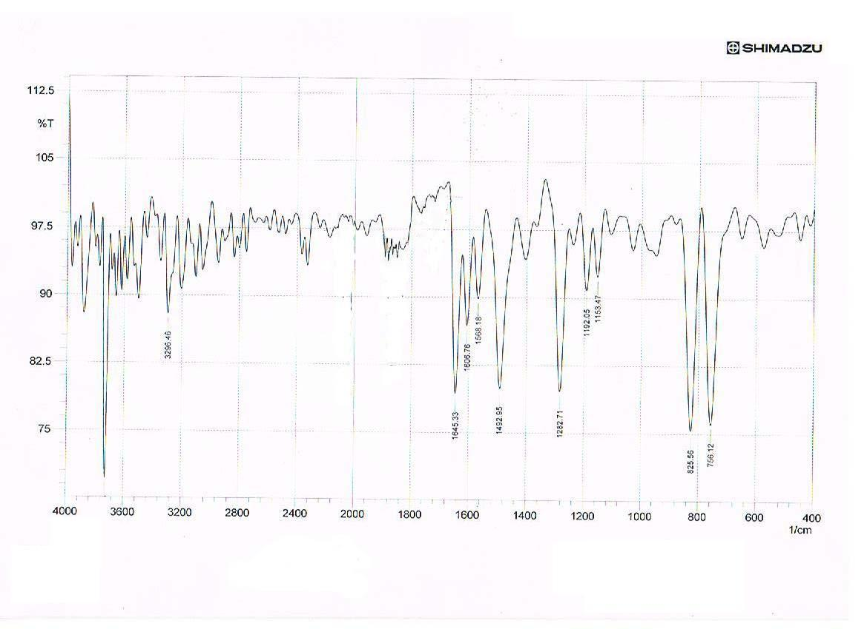
FT-IR spectrum of compound [1]

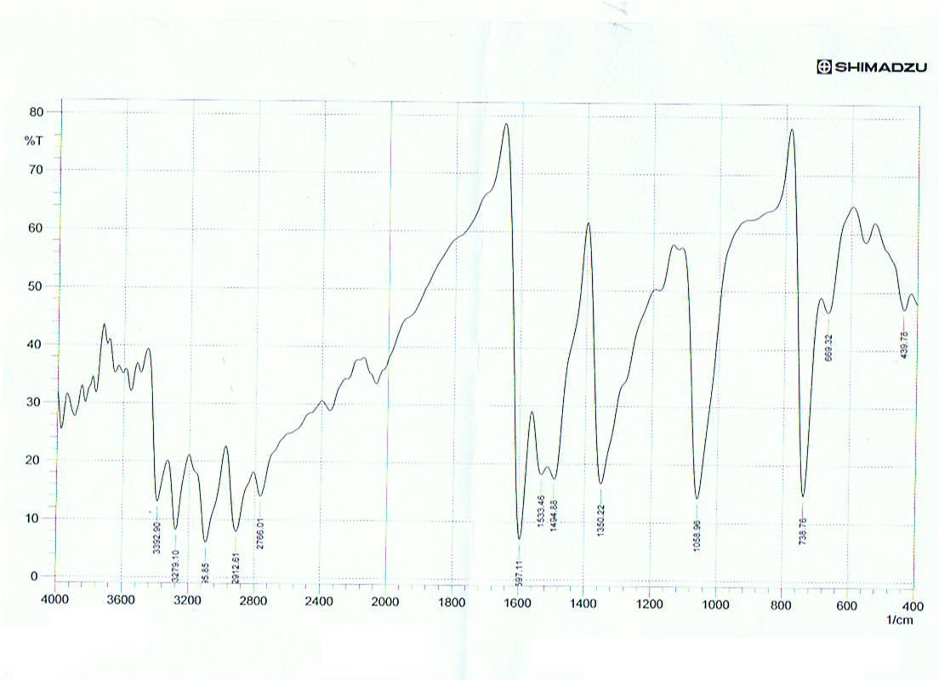
FT-IR spectrum of compound [2]
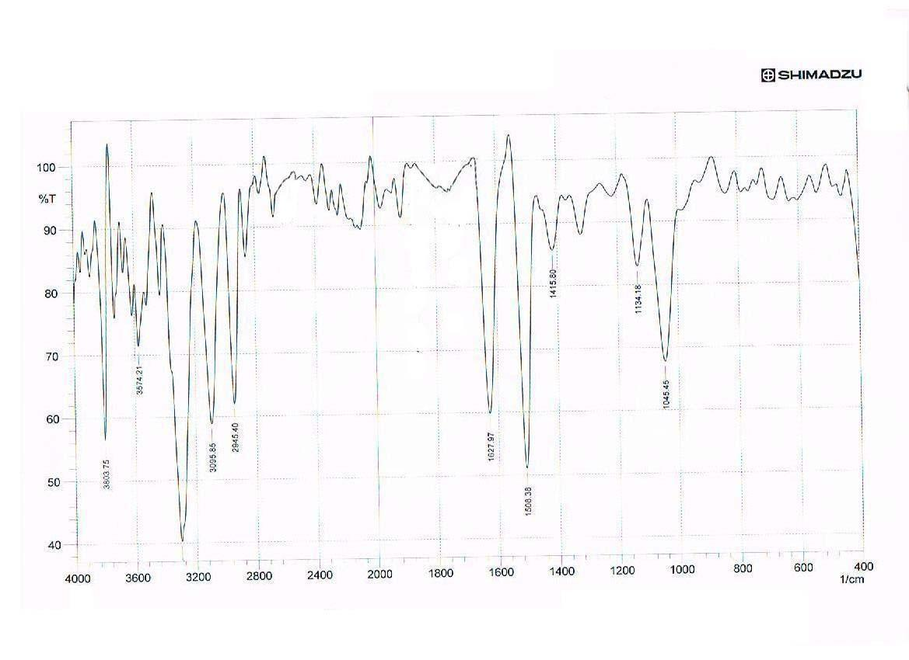
FT-IR spectrum of compound [3]
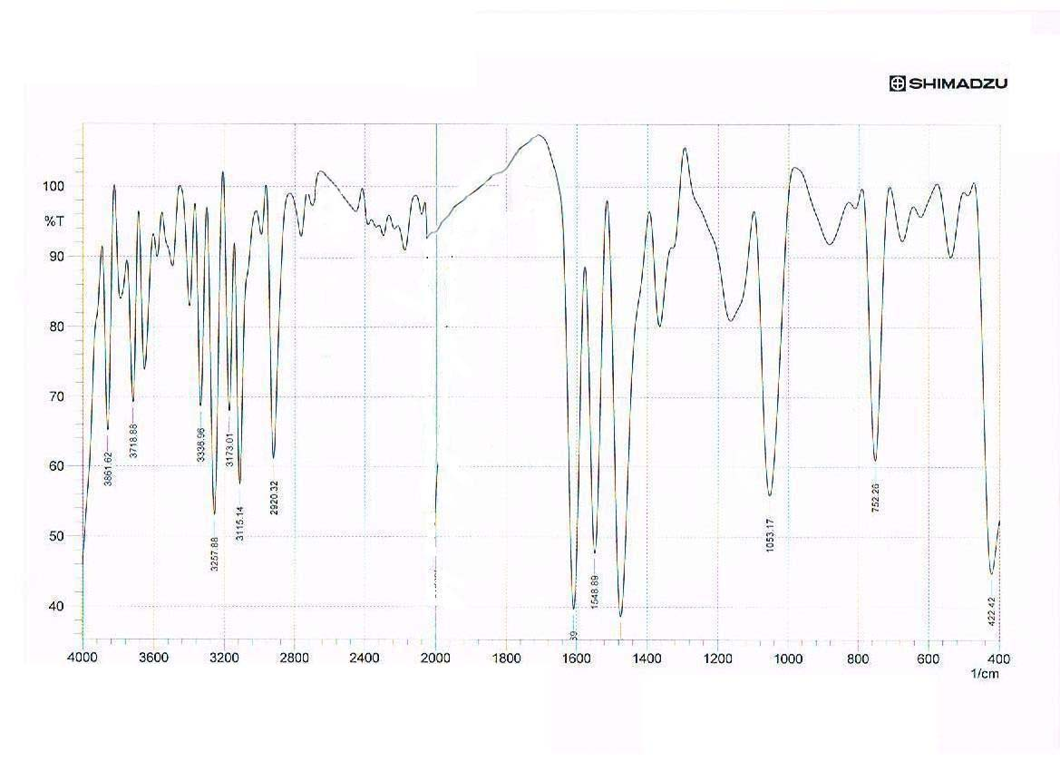

FT-IR spectrum of compound [4]
FT-IR spectrum of compound [4]

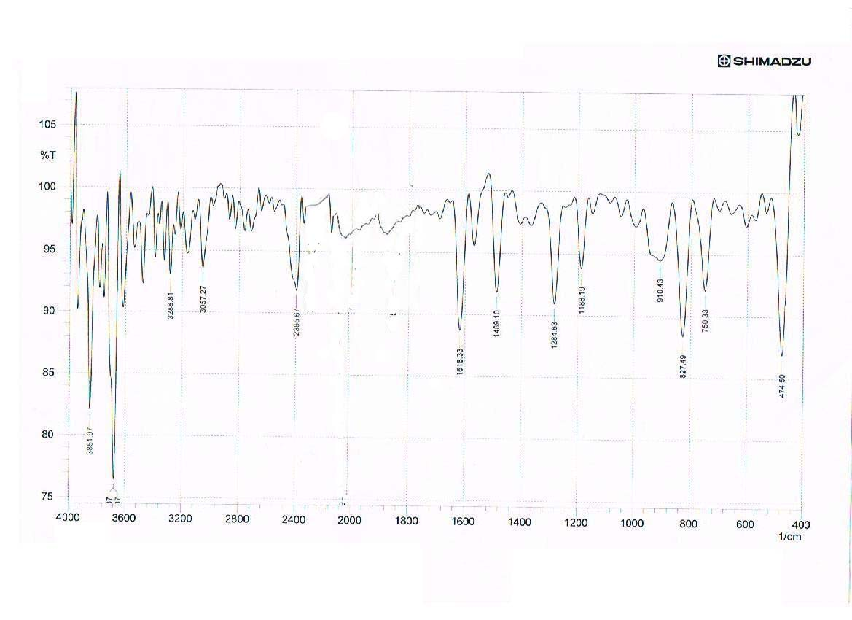
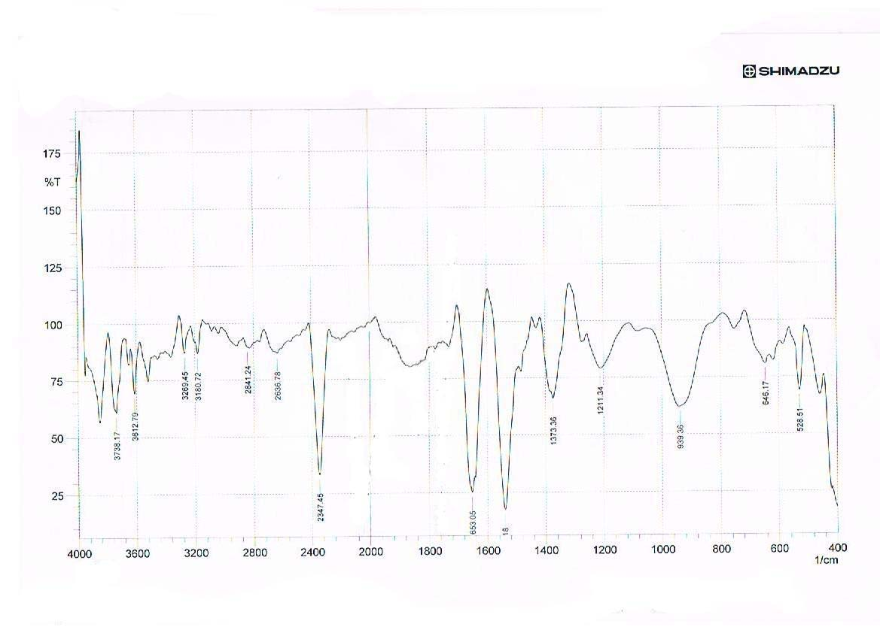
FT-IR spectrum of compound [5]
FT-IR spectrum of compound [6]
FT-IR spectrum of compound [6]
FT-IR spectrum of compound [6]
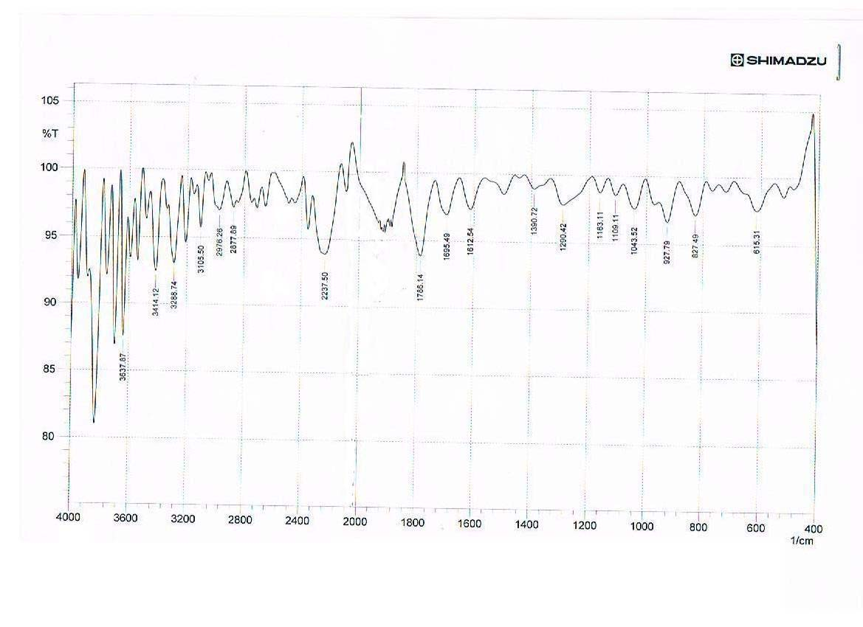
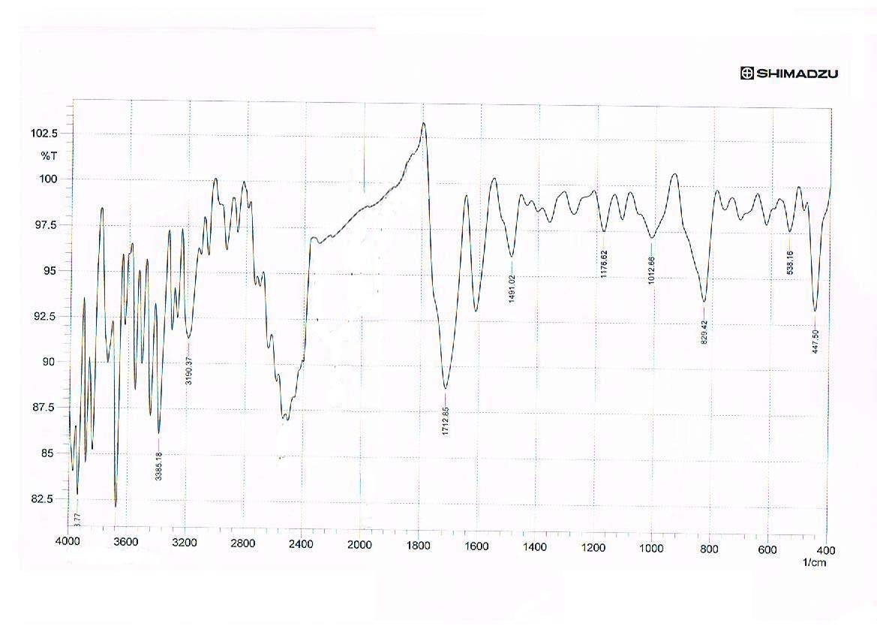
FT-IR spectrum of compound [7]
FT-IR spectrum of compound [7]
FT-IR spectrum of compound [8]

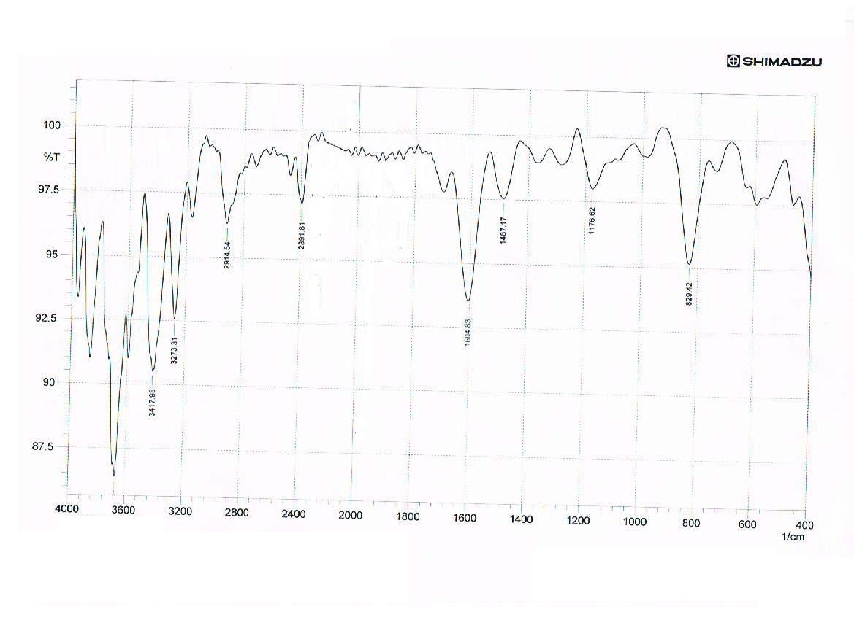
FT-IR spectrum of compound [9]

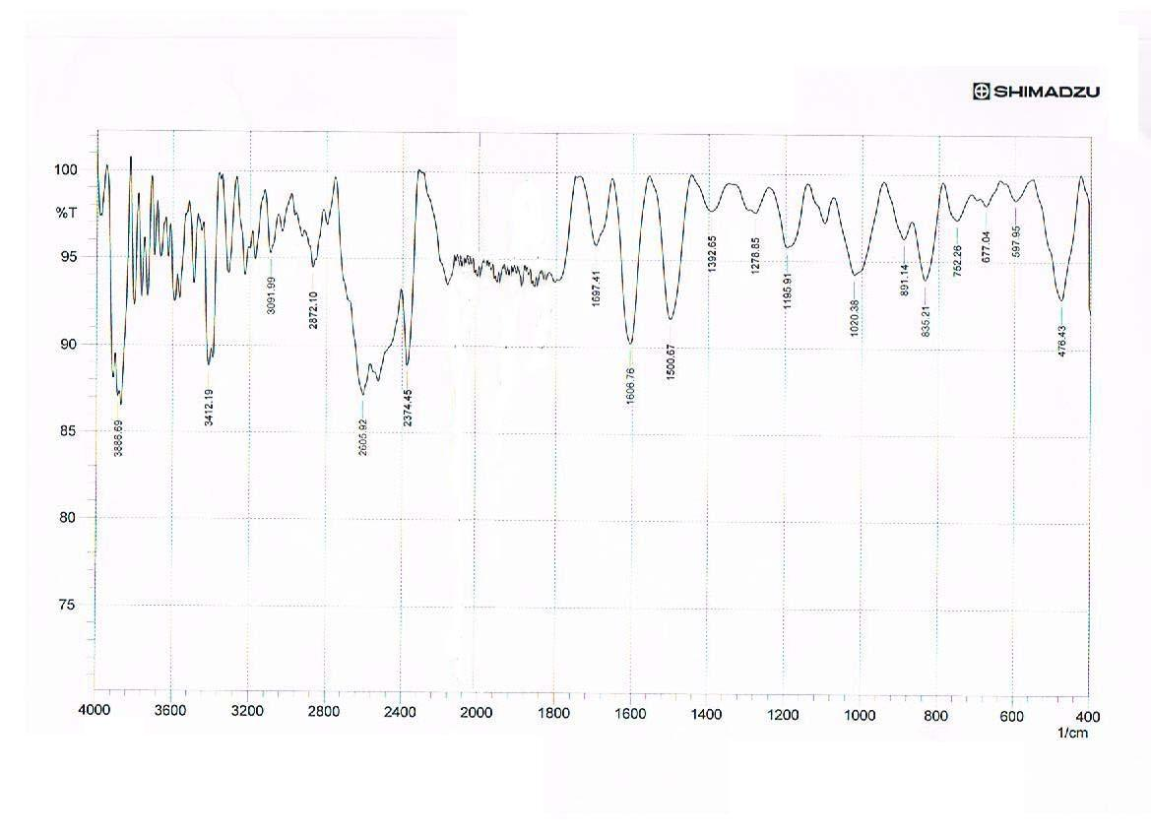
FT-IR spectrum of compound [10]

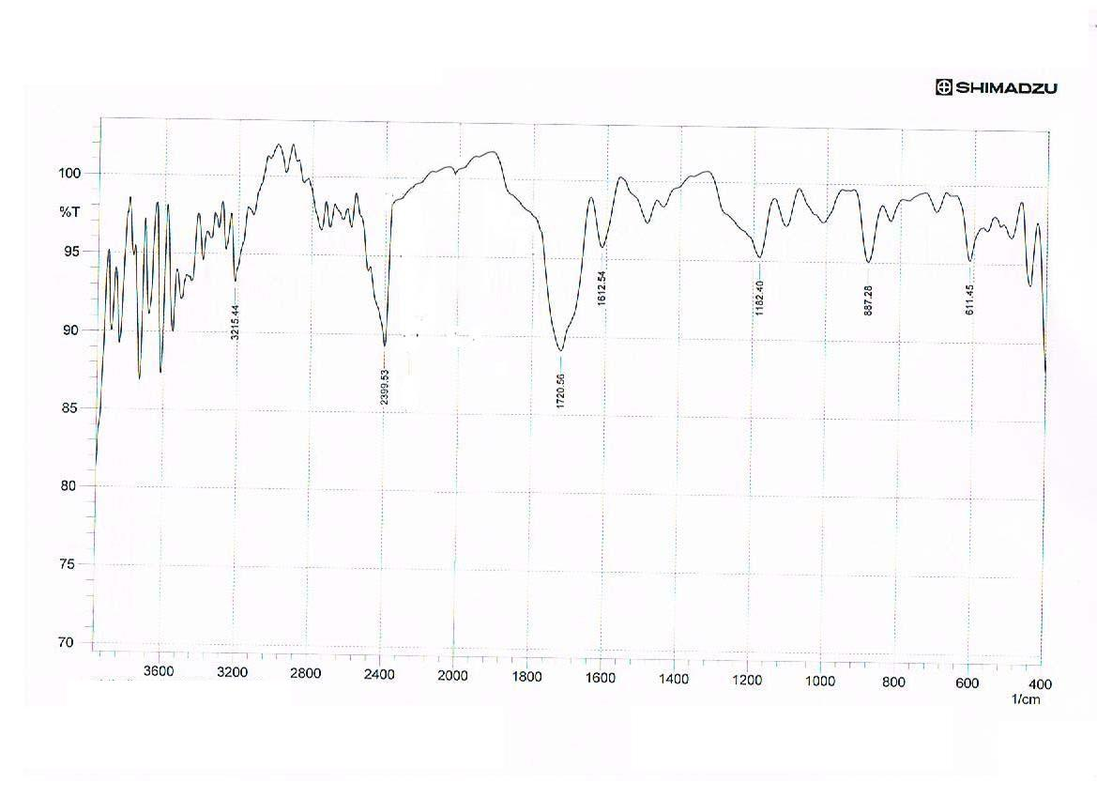
FT-IR spectrum of compound [11]

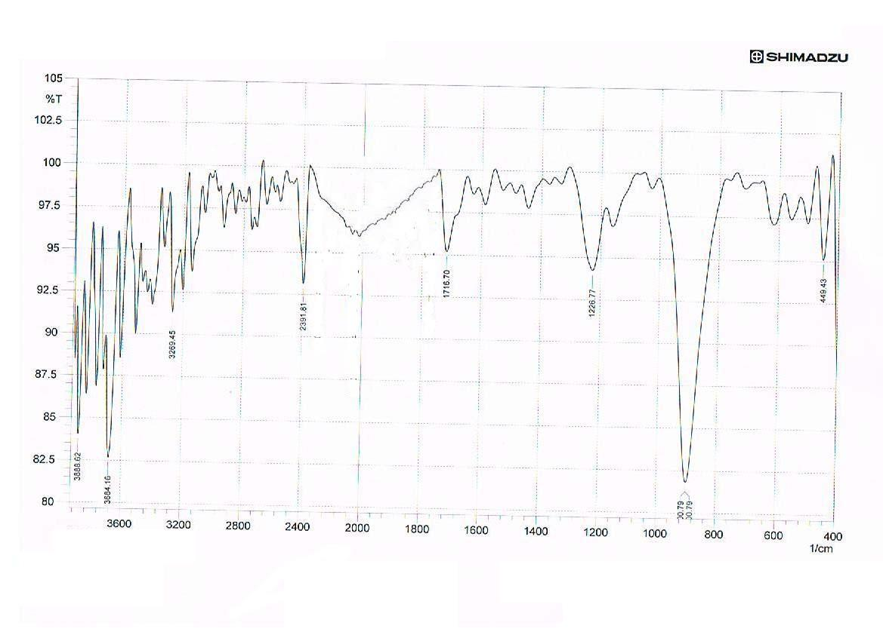
FT-IR spectrum of compound [12]

Reference
Abood Z.H, 2009, J. Kerbala University, 7, 1, 297.
Abood Z.H., Haiwal R.T. and Kadum I.L., 2008, J. Kerbala University, , 6, 4, 140.
Ainsworth C., 1937, J.Am. Chem. Soc., 78,1937.
Al-Ani A.S. , 2004 , M.Sc.Thesis, Al-Mustansiriya University.
Ali K.F, 2005, Ph. D. Thesis, Baghdad University.
Al-Jamali N.M, 2008, Ph. D. Thesis, Baghdad University.
Al-Juboori A.A., 2005 , M.Sc.Thesis, Al-Mustansiriya University.
Al-Omran F. , Mohareb R.M. and Abou El-Khair A. , 2002, J. Heterocyclic Chem., 39, 877.
Buchardt O., Pedersen C.L. and Harrit N, 1972, J.Org. Chem., 37,
23, 3592.
Cho N.S. and Kim G.N. , 1993, J. Heterocycl. Chem., 30, 397.
Desai S.B., Desai B. and Desai K.R. ,2001,Heterocycl. Commun., ,7,83.
Firrozi F.,Javidnia K.,Kamali M.,Foroumadi A. and Shafiee A. ,1995,J .Heterocyclic Chem.,32,1235.
Gupta A.K. and Mishra H.K. , 1981, J. Indian Chem. Soc., 8, 508.
Haiwal R.T, 2008, J. Kerbala University, 6, 4, 216.
Jarrahpour A.A. , Motamedifar M., Pakshir K.,Hadi N. and Zarei M., 2004 , Molecules ,9,815 .
Miller B..,1998,"Advanced Organic Chemistry"1st ed.,Viacom Company.
Modzelewska B. , Banachiewicz J., Chodkowska A. and Mazure L. ,
,2004,Eur .J.Med .Chem.,39,873.
Mohan J.A. , Anjaneyulu G.S. and Kiran R., 1988 , Indian J.Chem.,
27B, 128.
More P.G.,Bhalvankar R.B. and Pattar S.C. ,2001, J.Indian Chem.Soc.,78,474.
Noto R. , Meo P. , Geto M. and Weber G.,1996, J.Heterocyclic Chem. , 93, 3863.
Noto R. , Meo P. , Geto M. and Weber G., 1996 , J.Heterocyclic Chem., 933,863 .
Padwa A., 1984, "1,3-Dipolar cycloaddition chemistry",General
Heterocyclic chemistry series,Vol.1and 2,John wiely and Sons,New
York.
Pod Dick L. ,Roscinand Gh M and,.Olariu C.A., 1985 , Synthesis of nitro azo and azoSulfosalicyclic acids and their bacteriostaticeffectivity, Vol.55,P 13357.
Salih N.A., 2005 , Ph.D. Thesis, Al-Nahrain University .
Serrano-Wu M.H. , Laurent D.R.St.,Chen Y. , Huang S. , Lam K.R , Matson J.A. , Mazzucco C.A. , Stickle T.M. ,Tully T.P., H.S. Vyas D.M. and Balasubramanian B.N , 2002, Bioorganic and Medicinal Chemistry Letters,12 ,19, 2757 .
Singh W.M. and Dash B.C. , 1988,Pesticides,22,33.
Smith L.,Wong W.C.,Kiselyov A.S.,Burdzovic-Wizemann S. ,Mao Y., .Xu Y. , Duncton M.A.J. , Kim K. , Piatnitski E.L. , Doody J.F. , Wang Y. , Rosler R.L. , Milligan D. , Columbus J. , Balagtas C. , .Lee S.P. , Konovalov A. and Hadari Y.R. , Accepted for Publication 11 July 2006 ,Bioorganic and Medicinal Chemistry Letters, Available Online ,2006.
Tsuge O. , Oe K. and Ohnishi T, 1982 , Heterocycles, 19, 9, 1609.
Verma M.,Pandeya S.N.,Singh K.N. and Stables J.P. ,2004 ,Acta Pharm.,54,49.

Vogel A.I. , 1973 , " A text book of Practical organic chemistry " , 3th ed , Longman group limited , London,p.622.
Wang P.H. , Keck J.G. ,Lien E.J. and Lai M.M.C. ,1990 ,J .Med.Chem. ,33,608.
Williams D.H. and Fleming I., 1973, "Spectroscopic method in Organic Chemistry",2nd.,McGraw-Hill Book Co.Limited,London.
Wilson and Givolds, 1982 , " Text Book of Organic Medical and Pharmaceutical Chemistry " , Eight Ed.,.

