Synthesis and spectroscopic studies of some imines derived from Benzidine and their conversion to 1, 3-oxazepine derivatives (I)

Alaa J.Mahrath , Saadon A. Aowda
Chemistry department - College of Science - Babylon University
Sabah N K. Al-Thamir
Department of Pharmacology –College of Pharmacy-Babylon University .

Abstract
In this paper a series of 1,3-oxazepine derivatives have been synthesized through out two pathways .first one synthesis of imines derivatives (w₁-w₄) by the condensation reaction of different substituted aldehyde such as (p-N,N-dimethylamino , p- N ,N –diethyl amino , p-chloro, and p-bromo) benzaldehyde with unsubstantiated Benzidine .while the second pathway involve reactions of the prepared imines (w₁-w₄) via maleic and phthalic anhydride under inert N₂ gas and refluxing conditions to produce 1,3- oxazepine -4,7-dione derivatives (w₁m-w₄m and w₁ph –w₄ph) respectively . All the compounds were monitored and elucidated by TLC and available spectroscopic tools such as IR and Elemental analysis .
Key words: imines, benzylidene and 1, 3-oxazepine-4,7-dione :
الخلاصة
تم تحضير سلسله من مشتقات 1,3- الاوكسازبين من خلال مسارين . الأول: تضمن تحضير مشتقات الايمين w₁- w₄ ) من تفاعلات النكاثف لسلسلة من البنزلديهايدات المعوضة مثل ( بارا- ثنائي مثيل امينو , بارا- ثنائي أثيل أمينو , بارا كلورو و بارا- برومو ) بنزلديهايد مع بنزدين غير معوض . بينما المسار الثاني: تضمن مفاعله الايمينات المحضرة ) w₁- w₄ ) مع كل من انهيدريد ألماليك والفثاليك مع جو من غاز النتروجين الخامل والتصعيد لينتج مشتقات 1,3- أوكسازيبين -4,7 – دايون (w1m-w4m و w1ph – w4ph ) . ثم متابعة وتشخيص جميع المركبات ألمحضره بواسطة تقنيات كروموتغرافيا الطبقة الرقيقة وطيف الأشعة تحت الحمراء بالإضافة إلى التحليل العنصري .
Introduction
The study of the properties and the formation of imines has great interest due to its proceeding in several important chemical [Abdul hakim, et al, 2008] and biological processes[Larken , 1990] , the synthesis of poly azocycles[Nielsen et al., 1979;Balvenga et al., 1988 ; Zombeck et al.,1987] and other nitrogen compounds [Tepaske et al,1989] or in the synthesis of penicillin[Szarvas ,1973], cefaloporfirin [Druey et al.,1995] and many other biologically active compounds[Singh et al,2009;Firestone et al,1974; Tashima et al.,1991] . moreover , imines have attracted much attention because of their wide variety of applications in the electronics and photonics fields [Wang et al., 2001;Kiriy et al., 2004 ; Li et al., 2004]. On the other Aryl amines are a class of chemically and biologically important compounds that have a broad spectrum of applications in different fields such as catalysis, medicine and materials [Lednicer et al., 1998 ;Loutfy et al., 1983 ;Aprano et al., 1995]. In our previous research, we have reported the use of secondary amines as precursor in the synthesis of benzemide derivatives which were used as antimicrobial activity [Mahrath et al., 2008], therefore our attention were synthesize a new series of imines compounds and using them as precursor for synthesis seven member ring compounds through [2+5] cycloadditon reaction via maleic and phthalic anhydride. These compounds posses a wide range of biological activity as antibacterial [Serrano et al., 2002], and inhibitors of some enzymes [Smith et al., 2006]. These indicate that the synthesis of these compounds is interesting.

Experimental
The characterizations of the prepared compounds were accomplished by FT-IR spectra Perkins Elmer with (KBr) disk and an interval ranging from 450- 4400 cm⁻¹. Elemental analysis was carried out using a EuroEA Elemental Analyzer / university of Kufa –Collage of science. Melting points were recorded on a Stuart Scientific- SMP3 apparatus and are uncorrected.
General procedure and spectroscopy:
The mixture of 1mmole of Benzidine and 2 mmole of substituted aldehyde were heated in presence of approximately 10-15 ml of absolute ethanol with 2 drops of glacial acetic acid and molecular sieves in water bath at 70- 80 C for approximately 30-60 min .The process of reaction was followed by TLC , then filtration or evaporation of the solvent then recrystalized from suitable solvent.
(I) Synthesis of imines derivatives:
1) Bis (4-(dimethylamino) benzylidene) biphenyl-4, 4’-diamine (w₁)
Benzidine ( 2 mmole , 0.368 gm) , p-di-methylaminobenzaldehyde (4 mmole , 0.60 gm) were dissolved with stirring in 15 ml absolute ethanol with 2-3 drops of glacial acetic acid .The reaction mixture was refluxed to 70-78 C° for approximately 30 min. the resulting yellow- orange solid product observed ,filtration and drying to get up to 92 % yield , ,m.p= ( 318- 320) C° of the desired product . IR data, shows The stretching frequency at 1608-1583 cm⁻¹ refer to( C=N- ) , 1427-1510 cm⁻¹ ( C=C ) aromatic , 1361 cm⁻¹ (-N-CH₃) , 1166 cm⁻¹ (C-N-) and3098 cm⁻¹ (C-H , benzylic) ,Elemental analysis of the molecular formula C₃₀H₃₀N₄ (calculated / found) : (C, 80.68 / 81.14 ; H, 6.77 / 7.23 ; N, 12.55 / 13.19) .
2) Bis (4-(diethyl amino) benzylidene) biphenyl -4, 4’-diamine (w₂)
Compound (w₂) was synthesized by the method as described before.(2 mmole ,0.368 ) of Benzidine , (4 mmole ,0.70gm) of p-diethyl amino Benzaldehyde in ethanol and drops of glacial acetic acid , after 20 min of refluxing mixture yellow light precipitate with percentage yield = 87 % ,, m.p = (288-289C°) , IR spectrum shows in table (1 ) confirm the suggested product . The stretching frequency of imines group observed at 1606.76 cm⁻¹ , (C=C ,aromatic ) at 1431.23 -1587.47 cm⁻¹ ,( -N-C₂H₅) at 1267.67- 1354.07 cm⁻¹ and ( C-H , aromatic) appear at range 2929.79 - 2970.40 cm⁻¹ and the (C-H , benzylic appear at 3135 cm⁻¹ , .Elemental Analysis of compound (w₂) with molecular formula C₃₄H₃₈N₄ ( calculated /found ) C, 81.24 / 81.90 ; H, 7.62 / 8.12 ; N, 11.15 / 11.77 .
3) Bis (4-chlorobenzylidene) biphenyl-4, 4’-diamine (w₃)
2 mmole (0.368 gm) of Benzidine , 4mmole (0.56 gm) of p-chloro benzaldehyde in 15 ml ethanol absolute and few drops glacial acetic acid were put, then refluxing for about 30 min. Yellow precipitate observed , after workup of the reaction mixture , The yield = 90% , m.p = (269-270) C° ,IR (KBr) shown the sharp absorption band at stretching frequency 1622.19 cm⁻¹ for imine’s group , 1491.02-1555.54 cm⁻¹ (aromatic ,C=C) , 1089.82 cm⁻¹(Ar-N-) ,and (C-Cl) observed at stretching frequency 839.06 cm⁻¹ and at 3143 cm⁻¹ ( C-H, benzylic ) . On the other hand elemental analysis of (w₃) confirm the suggested the molecular formula C₂₆H₁₈N₂Cl₂ (calculated / found) C, 72.73 /73-55; H, 4.23 /5.33; N, 6.52 / 7.24.
4) Bis (4-bromobenzylidene) biphenyl-4, 4’-diamine (w₄)
4 moles (0.73 gm) of p-bromobenzaldehyde and 2 mmole (0.368 gm) Benzidine in 13 ml ethanol were acidified by glacial acetic acid then refluxing for about 40 min . Direct yellow light precipitate observed .Workup of the product with percentage yield = 92 % , m.p = 300-301 C° . IR data, of compound w₄, shows approximately the same infrared of compound w₃, such as 1622.19 cm⁻¹ (C=N-), 1402-1583 cm⁻¹ (aromatic C=C), 1070 cm⁻¹ (C-N-) except stretching absorption at 540.09 cm⁻¹ which belong to (Ar-Br). Elemental analysis of the molecular formula C₂₆H₁₈N₂Br₂ (calculated / found) C, 60.26 /60.97; H, 3.50 /4.63; N, 5.41 / 6.32.

(II) Reaction of the imines derivatives with maleic and phthalic anhydride:
General procedure:
1mmole of desired imine’s (w₁-w₄)was dissolved in suitable solvent under N₂ flow, followed by addition with drop wise the cyclic anhydride under refluxing conditions and monitored with TLC to determine the completion of the reaction. Filtration or evaporation under reduces pressure, drying and recrystilization by a proper solvent.

*With maleic anhydride:
1) synthesis 3,3'-(biphenyl-4,4'-diyl)bis[2-(4-(dimethylamino)phenyl]-2,3-dihydro-1,3-oxazepine-4,7-dione ](w₁m)
1 mmole of compound (w₁)(0.44 gm) was dissolved in dry dichloromethane with stirring under inert nitrogen flow ,2 mmole of maleic anhydride solution 0.2 gm added drop wise with stirring then refluxing at 75C° for 3-4 hr , the reaction mixture is controlled by TLC technique , after workup the orange precipitate of desired product with percentage yield = 68 % , m.p = (220-221) C°, IR spectra shown two absorption bands of carbonyl groups at stretching frequency 1695.49 and 1626.05 cm⁻¹ belong to (–O-C=O ,N-C=O) respectively ,1456 -1593 cm⁻¹ (aromatic C=C) , 1521 cm⁻¹ cat. ( aliphatic C=C) , 1174.59 cm⁻¹ (C-N) , 1234-1193 cm⁻¹ ( C-O-C) and small stretching absorption band belong to C-H benzylic .at 3115cm⁻¹ .Elemental analysis of the molecular formula C₃₈H₃₄N₄O₆ (calculated / found ) C,(71.01 / 72.21 ; H , 5.33 / 6,32 ; N , 8.72 / 9.43 ) .
2) synthesis of 4 , 4'- ( biphenyl-4,4'-diyl) bis (3-(4-(diethyl amino ) phenyl) -3 , 4-dihydro [1,3]oxazepine -1,5- dione ) (w₂m)
In the same way (1mmole , 0.50 gm) of compound w₂ dissolved in 10ml CH₂Cl₂ and (2mmole ,0.20 gm) of maleic anhydride which added drop wise with stirring and refluxing for about 4hr, orange to brown precipitation observed after work up. m.p = 390C°dec., with percentage yield = 75. %. IR spectra confirm the suggested structure mentioned in scheme 2, as follows; two absorptions band at 3010-2974 cm-1 represented (C-H) aromatic and in the 2972-2891 cm⁻¹ (C-H) alphatic 1604 cm⁻¹ (C=N) ,1402-1581 cm-1 (C=C ,aromatic) 1350-1356 cm-1 (N-CH) , .Elemental analysis of the molecular formula C₄₂H₄₂N₄N₆ (calculated / found) C, 72.19 / 72.89; H, 6.06 / 6.69; N, 8.02 / 8.72.
3) synthesis of 3,3'-(biphenyl-4,4'-diyl) bis[2-(4-chlorophenyl)-2,3-dihydro-1,3-oxazepine-4,7-dione ](w₃m)
(1mmole , 0.429 gm) of compound w₃ dissolved in 10 ml CH₂Cl₂ in dry N₂ condition was added to (2.1 mmole , 0.2 gm ) of maleic anhydride drop wise with stirring and refluxing for 7 hr ,evaporation of the solvent to produce compound (w3m) ,with percentage yield = 73.7% ,m.p = ( 240-242 )C° . IR spectra confirmed the suggested structure by two clear absorption bands at 1724 and 1633 cm⁻¹ ( C=O ,ester and amide ) respectively , small bands at 3115- 3045 cm⁻¹ (C-H , aromatic and alkene) , 1560 -1435 cm⁻¹ ( C=C ,aromatic and alkenes respectively . 1219 cm⁻¹ (C-O) and 827 cm⁻¹ due to (C-Cl) .elemental analysis of the chemical formula C₃₄H₂₂Cl₂N₂O₆ (calculated / found) C, 65.29 / 65.87 ; H ,3.55 / 4.26 ; N, 4.48 / 5.04 .

4) synthesis of 3,3'-(biphenyl-4,4'-diyl) bis[2-(4-bromophenyl)-2,3-dihydro-1,3-oxazepine-4,7-dione ] (w₄m ).
Reaction of 1mmole of compound ( w₄) 0.51 gm in 10 ml dioxin under dry conditions with 2 mmole , 0.2 gm of malic anhydride drop wise with stirring then refluxing to 80-90 C , for 6 hr. the reaction was monitored by TLC technique ,evaporation the solvent and treated the mixture with petroleum ether to get solid brown color of compound (w4m) ,with the percentage yield = 55% , and m.p = 200 – 201C° decom. , IR-spectra shown the following absorptions ,two absorption bands in the range of 1714 and 1627 cm⁻¹ belong to ( O-C=O , N-C=O) respectively ,3051-3095cm⁻¹ two ( C-H alkene) 1593 cm⁻¹ (C=C, aromatic ) , 1500-1525 cm⁻¹ (C=C ,alkene’s ), 1255 cm⁻¹ (C-O), 1114 cm⁻¹ (C-N) , 823 cm⁻¹ belong to (C-Br) , on the other hand the Elemental analysis of the desired compound of the molecular formula C₃₄H₂₂Br₂N₂O₆ (Calculated /found ) C, 57.17 / 58.54 ; H , 3.10 /3.73 ; N , 3.92 /4.54 .

** With phthalic anhydride:
5)4,4'-(biphenyl-4,4'-diyl)bis[3-(4-(di-methylamino)phenyl)-3,4-dihydrobenzo[1,3] oxazepine -1, 5-dione] (w₁ph)
In 10ml CH₂Cl₂ dissolved (1mmole , 0.50 gm ) of compound w₁ with stirring and directly added (2,1 mmole ,0.3 gm) of phthalic anhydride drop wise then refluxing the reaction mixture for about 5- 6 hr the reaction, evaporation , filtration and drying to got the percentage yield = 68% , with m.p= ( 335-337)C°, IR spectra showed two stretching absorptions in the range of 1716 &1601(C=O ,ester and amide) , 3059(C-H ,Ar), 2924-2852cm⁻¹ (C-H alphatic), 3104(C-H,benzylic), 1550-1504( C=C,Ar ) 1381(C-CH₃) , 1143 and 1127 ( C-O,and C-N). Elemental Analysis of the molecular formula C₄₆H₃₈N4O₆ shown as follows (calculated /found ) C, 74.38 / 75.09 ; H , 5.16 / 5.63 ; N,7.54 / 8.19 .
6)4,4'-(biphenyl-4,4'-diyl)bis[3-(4-(di-ethylamino)phenyl)-3,4-dihydrobenzo[1,3] oxazepine -1,5-dione] (w₂ph)
2mmole , 0.31 gm of phthalic anhydride solvated in 10 ml dry CH₂Cl₂ was added drop wise to ( 1mmole ,0.50 gm ) of compound w₂ with stirring , then the reaction mixture refluxing for about 4-5 hr ,evaporation of the solvent , filtration and drying .the percentage yield was 75.9% ,m.p = (300-302) C° , The IR spectra shows the following absorption bands ; two medium bands at 1719 and 1653 cm⁻¹ ( C=O ester and amide ) respectively ,3265 cm-1 ( C-H ,benzylic ), 2978 cm⁻¹ (C-H aromatic ) , 1581-1599 cm⁻¹ (C=C , aromatic ) , 1340 cm⁻¹ (N-C₂H₅) , 1188 and 1157 cm⁻¹ ( C-O and C-N) respectively . Elemental Analysis of the molecular formula C₅₀H₄₆N₄O₆ (calculated / found) C, 75.17 / 75.89; H, 5.80 / 6.54; N, 7.01 / 7.65.
7) 4, 4’-(biphenyl-4, 4’-diyl) bis [3-(4-chlorophenyl)-3, 4-dihydrobenzo [1, 3] oxazepine -1, 5-dione] (w₃ph)
1mmole , 0.42 gm ) of compound w₃ dissolved in 15 ml dioxin after completely dissolved ,2mmole ,0.3 gm ) of phthalic anhydride which dissolved in the same solvent under drying and refluxing conditions for about 6hr .after work up the w₃ph was formed with percentage yield =81.4 C , m.p =353-355 C° , IR spectra of w3ph gives two stretching absorption bands at 1697 and 1589 cm-1(C=O for ester and amide ) respectively , 1521 and 1496 (C=C )aromatic, 1312-1280 cm-1 (C-O-C ) , 1072 cm-1 (C-N) , 3064- 2924 cm⁻¹ (C-H ,aromatic .akene ) , and 736 cm-1 (C-Cl ) . Elemental analysis of the molecular formula
C₄₂ H₂₆Cl₂N₂O₆ of the compound w₃ph was (calculated /found) C,60.52 / 61.32 ; H,3.61 / 4.32 ;N , 3.86 / 4.54 .

8) 4, 4’-(biphenyl-4, 4’-diyl) bis [3-(4-bromophenyl)-3, 4-dihydrobenzo [1, 3] oxazepine -1, 5-dione] (w₄ph)
Compound w₄ 1mmole (0.51 gm) was dissolved in 10 ml dioxin with stirring and drying under N₂ ,followed by adding ( 2.1mmole ,0.31 gm) of pththalic anhydride drop wise ,the reaction mixture refluxing for 4.5 hr ,evaporation of the solvent and washing with petroleum ether to get yellow –orange precipitate with percentage yield 60.6 % , m.p = ( 294-296 ) C, IR spectra ,shown two strong adsorption bands in 1712.85 and 1656.91 cm⁻¹ belong to ( C=O) ester and amide respectively . medium band at 3055 cm⁻¹ ( C-H ,alkene’s ) , 1595 cm⁻¹ ( C=C ,aromatic) , 1255 cm⁻¹ (C-O-C ) ,and sharp medium band at 815 cm⁻¹ ( C-Br) and 3290 cm-1 for (C-H ,benzylic ) . Elemental Analysis of w4ph with the molecular formula C₄₂H₂₆Br₂N₂O₆ give us (calculated / found) C, 61.94 / 62.45; H, 3.22 / 4.27; N, 3.44 / 4.21.

Results and Discussion
It is well known that the synthesis of imines compounds ( w₁-w₄) resulted from condensation reactions of biphenyl 4,4’-di-amine with substituted benzaldehyde such as (N,N-dimethyl , N,N-diethyl ,p-chloro and p-bromo ) benzaldehyde scheme (1) . The prepared compounds were identified by m.p , FT-IR and Elemental Analysis table (1) .From IR-spectra can clearly see the disappearance bands of NH₂ at stretching frequency 3430-3205 cm⁻¹ and appearance of sharp medium stretching absorption in the range of 1606-1622 cm⁻¹ due to imines groups (C=N-) , in addition to stretching absorption bands of aromatic groups ( C=C) in the range of 1450-1595 cm⁻¹ beside small absorption bands in the range of 2910- 3100 cm⁻¹ belong to C-H aromatic , therefore as instance the compound w₁ gave beside to the previous bands a stretching absorption at 1361 cm⁻¹ which belong to -N-CH₃ , while compounds w₃ and w4 were gave a common stretching frequency at 736 and 815 cm⁻¹ which belong to C-Cl and C-Br respectively . On the other hand elemental analysis for compounds (w₁-w₄) were confirmed the suggested of molecular formula , see table (1 ) . Mean while these compounds w₁-w₄ reacted with each of maleic and phthalic anhydride under vigorous conditions like long time of stirring, dry and refluxing .Therefore with maleic anhydride the imines compounds (w₁-w₄) reacted under inert N₂ gas and refluxing for about 4- 7 hr in presence of suit solvent to afforded 1,3-oxazepine derivatives (w₁m –w₄m ) scheme (2) . The percentage yield, melting point, infra red spectrum and elemental analysis were recorded in table (2).It is also well known the reaction of imines compounds w₁-w₄ with maleic or phthalic anhydride goes through out cycloaddition reaction between imine ( -N=C-) and five membered ring of the maleic anhydride , i.e (2+5) concerted cyclization reaction[Cary etal ,2007] . infra red spectra of these compounds (w₁m-w₄m) showed clearly disappearance of stretching absorption band of imine groups at 1606-1622 cm⁻¹ and appearance of two sharp (medium –strong) stretching absorption bands at range of 1626 -1724 cm⁻¹ which belong to (C=O) for amide and ester in the seven membered oxazepine ring , table (2 ) . in addition to the (C-H) benzylic obviously observed at stretching frequency higher than expected i.e at 3205-3289 cm⁻¹ due to bonded to three types of electron – withdrawing groups such as substituted phenyl , oxygen and nitrogen )[Obaid ,2001] and these indicated that the formation of the oxazepine ring occurred. On the other hand it was found the elemental analysis of the prepared compounds (w₁m-w₄m) calculated experimentally gives good agreement with the theoretical calculated values table (2 ) , and this give us good evidence for formation of there compounds instead of ¹H-NMR . In the same miner the reaction of imine compounds via phthalic anhydride goes under the same conditions but with more period of time than maleic anhydride scheme (2). Also the prepared compounds (w₁ph-w₄ph) were elucidated by IR spectra and C.H.N. analysis. Table (3). shown two stretching absorption band appear at 1632-1719 cm⁻¹ due to (C=O) of the amide and ester in the oxazepine ring , while disappearance of the stretching absorption bands at 1606-1620 cm⁻¹ which were belong to C=N- group . also C-H benzylic observed in high frequency range than expected due to the electron withdrawing group which bonded to it . On the other hand the elemental analysis of the oxazepine derivatives (w₁ph-w₄ph) were confirmed the suggested structure of the molecular formula which suggested in table (3). The only disadvantage of this type of reaction was long reaction time beside relatively low percentage yield. We try to modify a method to make this type of reaction occur in short time as possible by using selective catalyst. in the second part of this work another types of imines derivatives (w₅-w₈) are preparing and reacting with the same anhydride to producing series of compounds (w₅m-w₈m) and ( w₅ph-w₈ph) respectively .

Scheme 1: Generation of Imine derivatives

Scheme 2: Generation of Oxazepine derivatives

Table 1: physical and chemical analysis of the imines compounds (w₁-w₄)

Prepared comp. | Melting point C°, % Yield | Solvent Recryst. | M.Wt | IR-spectra (KBr)/ cm⁻¹
W₁ | 318-319 / 92% | Methanol absolute | 446.59 | 1608 (C=N) , 1427-1510( C=C ,aromatic ), 1361(-N-CH₃),1166  (C-N-)
W₁ | Molecular formula(calculated/ found) |  | C |  | H | N
W₁ | C₃₀H₃₀N₄ |  | 80.68 /81.14 |  | 6.77 / 7.23 | 12.55 / 13.19
W₂ | 288-289 / 87% | Methanol absolute | 502.69 | 1606 (C=N) , 1431. -1587.( C=C, aromatic) , 1267 – 1354( N-C₂H₅) , 2929. – 2970 ( C-H ,aromatic), 2891-2963 (C-H alkane)
W₂ | Molecular formula(calculated/ found) |  | C |  | H | N
W₂ | C₃₄H₃₈N₄ |  | 81.24 / 81.90 |  | 7.62 / 8.12 | 11.15 / 11.77
W₃ | 269- 270 / 90% | Methanol: CH₂Cl₂ | 429.03 | 1622 ( C=N) , 1491-1555( C=C ,Ar) , 1089 (Ar-N-), 839 (C-Cl)
W₃ | Molecular formula (calculated/found) |  | C |  | H | N
W₃ | C₂₆H₁₈N₂Cl₂ |  | 72.73 /73-55 |  | 4.23 /5.33 | 6.52 / 7.24
W₄ | 300-301 / 92% | Methanol : THF | 518.24 | 1622 (C=N), 1402-1583(C=C ,Ar),  1070(C-N) , 540.09 (Ar-Br).
W₄ | Molecular formula(calculated/ found) |  | C |  | H | N
W₄ | C₂₆H₁₈Br₂N₂ |  | 60.26 /60.97 |  | 3.50 /4.63 | 5.41 / 6.32

Table 2: physical and chemical analysis of compounds (w₁m-w₄m)

Parepared comp. | Melting point C°, % yield | Solvent Recryst. | M.Wt |  | IR-spectra(KBr) /cm⁻¹
w₁m | 220-221 / 68% | n- Hexane | 642.70 | 1695&1626 ( ester and amide), 1456 -1593 (C=C, alkene and aromatic ) , 1234-1193 (C-O-C) ,1174 (C-N) ,3115 (C-H, benzylic ), 1361 (-N-CH₃)
w₁m | Molecular formula (calculated/found) |  | C |  |  | H | N
w₁m | C₃₈H₃₄N₄O₆ |  | 71.01 / 72.21 |  |  | 5.33 / 6,32 | 8.72 / 9.43
w₂m | 388-390/ 75. % | n-hexane- ethanol | 698.81 | 1710 &1631(C=O, ester ,amide ) , 1435-1589 ( C=C ,alkene ,Ar) , 1345 (N-C2H5) , 1254-1189 (C-O-C) , 1154 (C-N) , 3205 (C-H , benzylic) .
w₂m | Molecular formula (calculated/found) |  | C |  |  | H | N
w₂m | C₄₂H₄₂N₄O₆ |  | 72.19 / 72.89 |  |  | 6.06 / 6.69 | 8.02 / 8.72.
w₃m | 240-242 / 73.7% | Dioxane. | 625.45 | 1724 ,1633( C=O ,ester amide) , 3115- 3045 ( C-H ,Ar and alkene) , 1560 -1435 (C=C ,Ar and alkene) , 1219(C-O) , 827 (C-Cl). 3298 (C-H , benzylic )
w₃m | Molecular formula (calculated/found |  | C |  |  | H | N
w₃m | C₃₄H₂₂Cl₂N₂O₆ |  | 65.29 / 65.87 |  |  | 3.55 / 4.26 | 4.48 / 5.04
w₄m | 200-201 / 55% | THF | 714.36 | 1714 and1627( C=O , ester and amide) , 3051-3095 ( C-H ,alkene and Ar ), 1593 (C=C ,Ar ) , 1500-1525  (C=C,alkene ) , 1255 (C-O-C) , 815  ( C-Br) .
w₄m | Molecular formula (calculated/found) |  | C |  |  | H | N
w₄m | C₃₄H₂₂Br₂N₂O₆ |  | 57.17 / 58.54 |  |  | 3.10 /3.73 | 3.92 /4.54

Table (3) physical and chemical analysis of the compounds (w₁ph-w₄ph)

Prepared comp. | Melting point C°, % yield | Solvent Recryst. | M.Wt | IR-spectra(KBr) /cm⁻¹
w₁ph | 379-380/ 68% | THF | 742.82 | 1697 &1643(C=O ,ester and amide) 3014(C-H ,Ar) , 3104(C-H,benzylic), 1594-1532( C=C,Ar) 1332(C-CH₃) , 1143 and 1127 ( C-O,and C-N)
w₁ph | Molecular formula (calculated/found) |  | C |  |  | H | N
w₁ph | C₄₆H₃₈N₄O₆ |  | 74.38 / 75.09 |  |  | 5.16 / 5.63 | 3.92 /4.54
w₂ph | 300-302 /75.9 % | CH₂Cl₂ | 798.92 | 1719 and1653 (C=O ,ester and amide) , 2978 (C-H, Ar) , 1581-1599(C=C,Ar) , 1340 (N-C₂H₅) , 1188 and 1157( C-O , C-N) ,3265 (C-H, benzylic)
w₂ph | Molecular formula (calculated/found) |  | C |  |  | H |  | N
w₂ph | C₅₀H₄₆N₄O₆ |  | 75.17 / 75.89 |  |  | 5.80 / 6.54 |  | 7.01 / 7.65
w₃ph | 325-327 dec. / 81% | Cyclohexane | 725.57 | 1697&1589 ( C=O ,ester ,amide) , 1521 and 1496 ( C=C ,Ar) , 1312-1280 ( C-O-C) , 1072 (C-N) , 3064- 2924 ( C-H ,Ar) , 736 (C-Cl) , 3296 (C-H , Benzyl)
w₃ph | Molecular formula (calculated/found) |  | C |  |  | H |  | N
w₃ph | C₄₂H₂₆Cl₂N₂O₆ |  | 60.52 / 61.32 |  |  | 3.61 / 4.32 |  | 3.86 / 4.54
w₄ph | 294-296 / 60 % | n-Hexane ;pet.ether | 814.47 |  | 1712 and 1656 (C=O , ester &amide ) , 3055 (C-H ,Ar) , 1502- 1519 (C=C , Ar) , 1255 (C-O-C) , 815 (C-Br) ,3290 (C-H ,benzylic)
w₄ph | Molecular formula (calculated/found) |  | C |  |  | H |  | N
w₄ph | C₄₂H₂₆Br₂N₂O₆ |  | 61.94 / 62.45 |  |  | 61.94 / 62.45 |  | 3.44 / 4.21

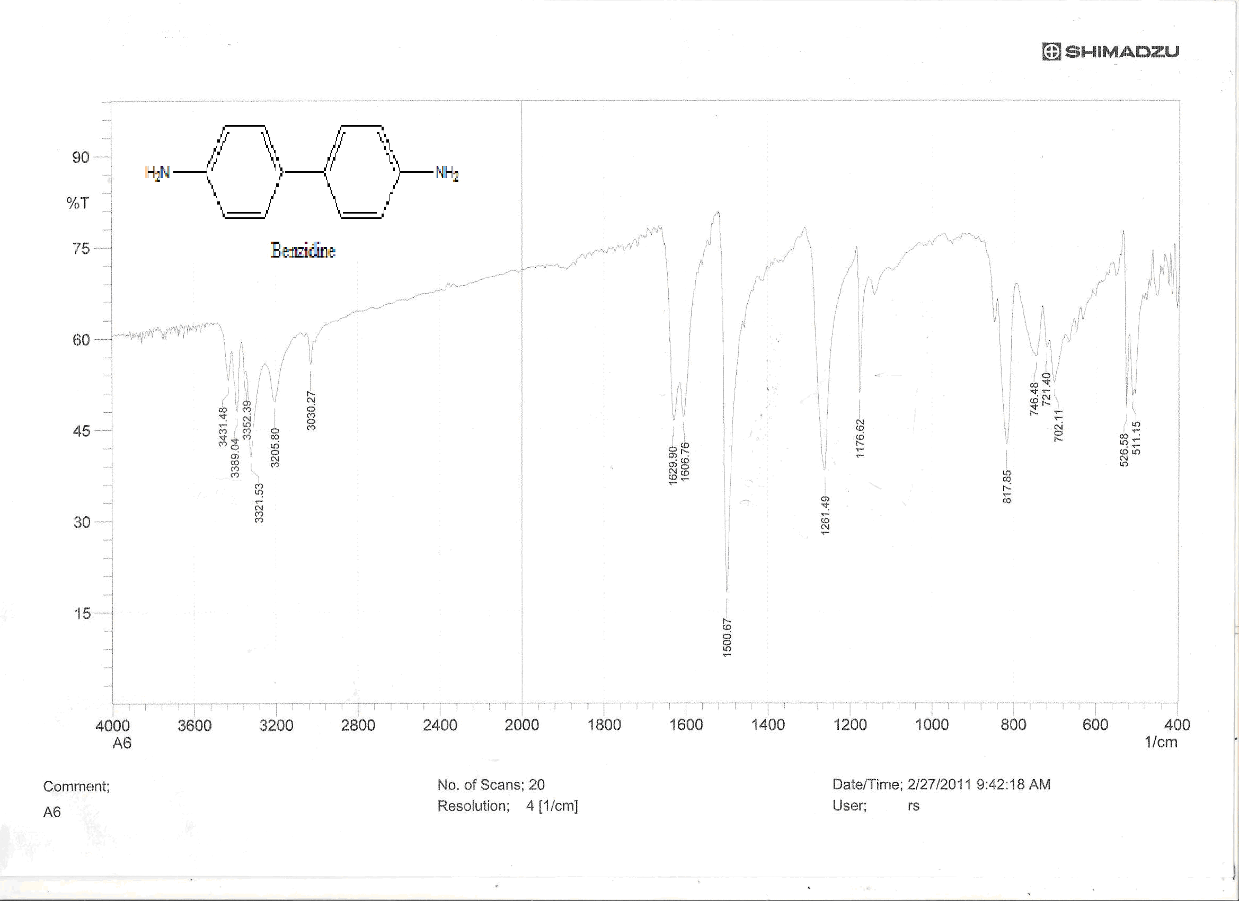

Figure (1) : FT-IR spectra of Benzidine
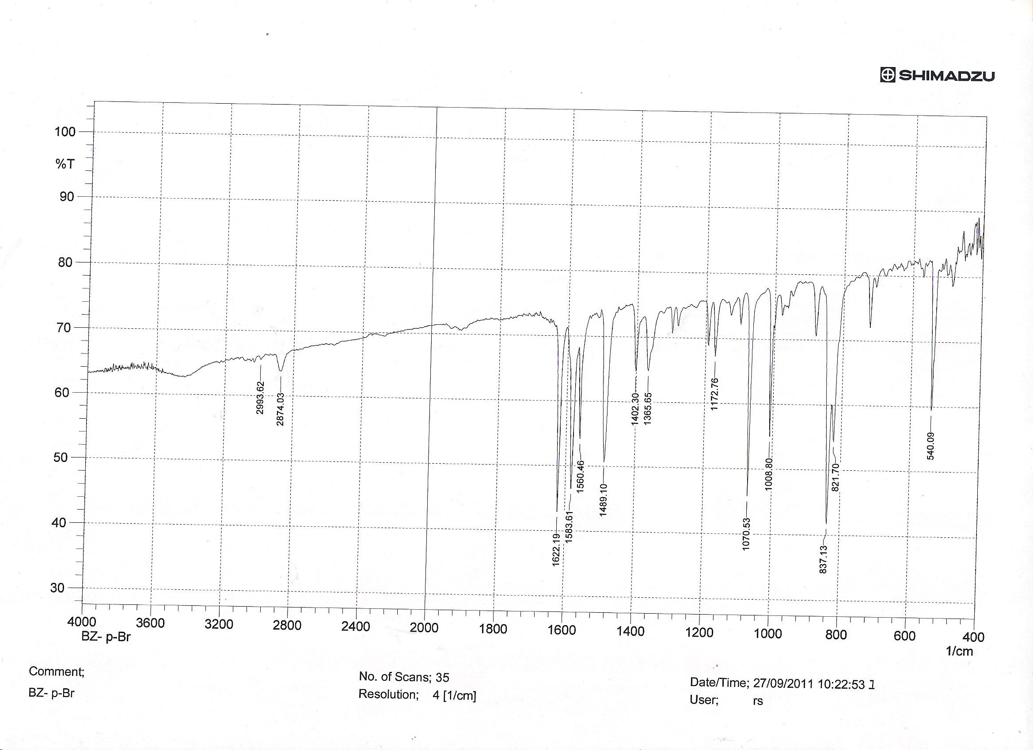

Figure (2) :FT-IR spectra of Bis (4-bromobenzylidene) biphenyl-4, 4’-diamine (w₃)
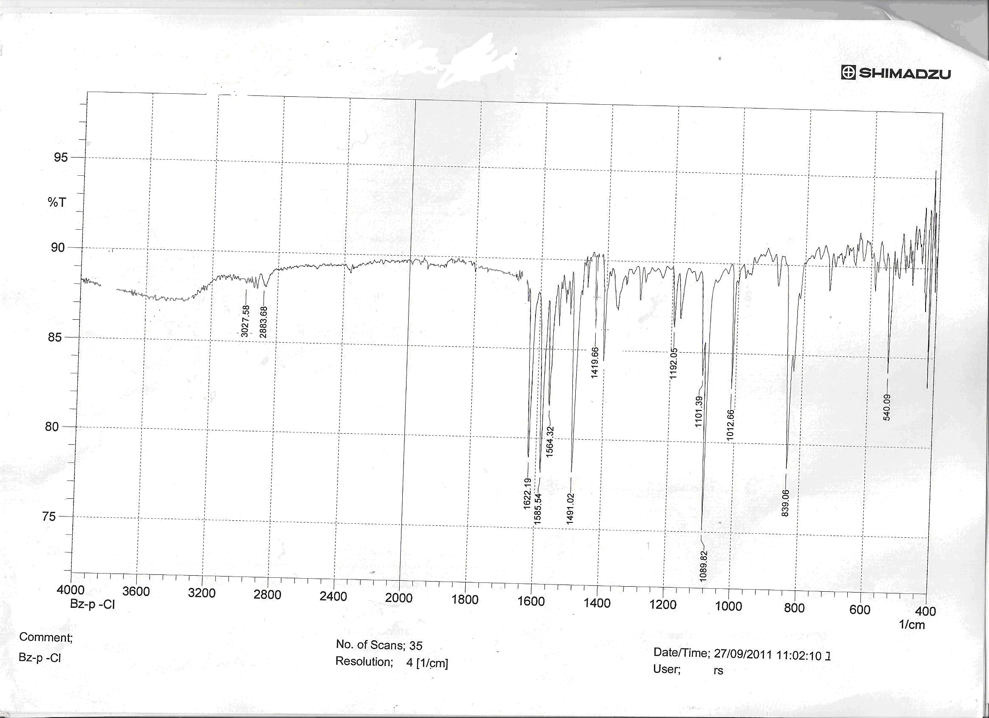

Figure (3) :FT-IR spectra of Bis (4-bromobenzylidene) biphenyl-4, 4’-diamine (w₄)

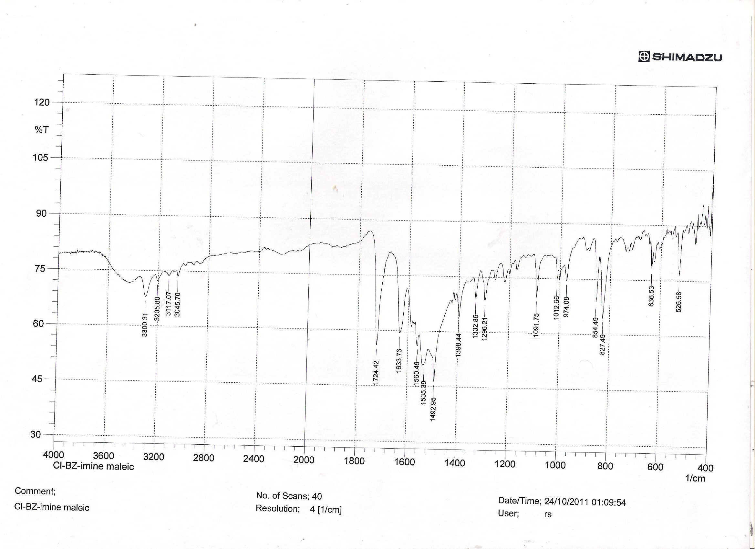

Figure (3) :FT-IR spectra of 3,3'-(biphenyl-4,4'-diyl) bis[2-(4-chlorophenyl)-2,3-dihydro-1,3-oxazepine-4,7-dione ] (w₃m )

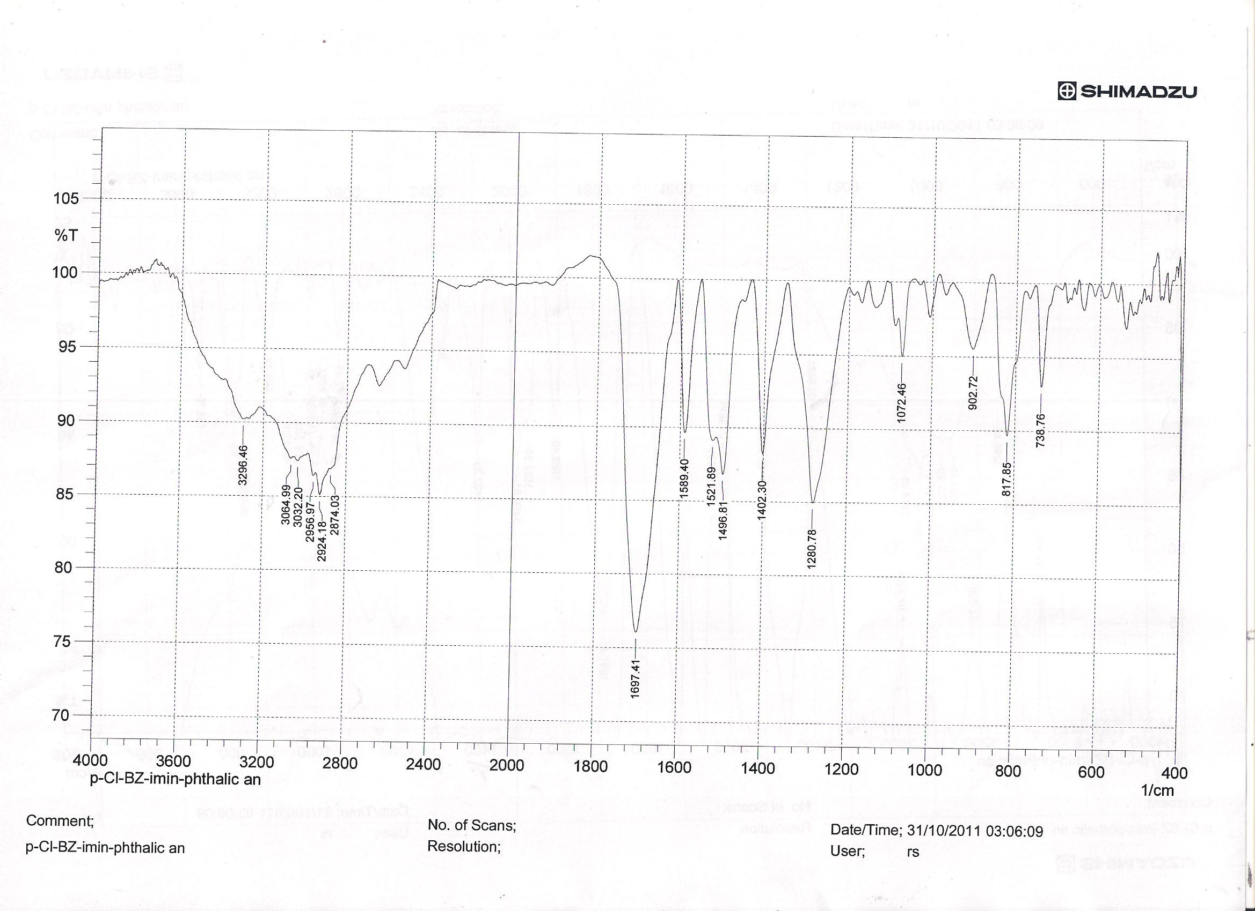

Figure (4) :FT-IR spectra of 4, 4’-(biphenyl-4, 4’-diyl) bis [3-(4-chlorophenyl)-3, 4-dihydrobenzo [1, 3] oxazepine -1, 5-dione] (w₄ph)

References
Ahmed A., Salima. A. BenGuzzi, Journal of Science and Its Applications: 2, (2008), 83.
Balvenga J., Joglar J, Gonzales F.J, . Gotor V, Fustero S., J. Org. Chem. 53 (1988), 5960.
Carey F.A. and.Sundberg R.J; ‘Advanced Organic Chemistry ‘, 5th Ed, Springer (2007).
Druey J., Marxer A., J. Med. Chem. 1 (1995)1.
Firestone R.A., Maliejewicz N.S., . Christensen B.G, J. Org. Chem. 39 (1974) 3384.
Kiriy N, . Bocharova V, Kiriy A., Stamm M., Krebs F.C., Adler H., J. Chem. Mater. 16 (2004) 4765.
Larkin D.R, J. Org. Chem. 55 (1990) 1563.
Li, S. He L., Xiong E., Li Y., Yang G., J. Phys. Chem. B 108 (2004) 10887. (a) Lednicer D., Strategies for
Mahrath A. J., Maslat O. and Mahmoud J.; N. J. C, (2008), 34.
Nielsen A.T., Moore D.W., Ogan M.C, Atkins,R.L. J. Org. Chem. 16 (1979) , 4023.
Obaid H.Abid; N. J. C; 3, (2001) 480.
Organic Drug Synthesis and Design, Wiley, New York, 1998; (b) Loutfy R.O., Hsiao C.K., Kazmaier P.M.,
Photograph. Sci. Eng. 27 (1983) 5; (c) Aprano G. D_, Leclerc M., Zotti G., Schiavon G., Chem. Mater. 7 (1995) 33.
Serrano M.H. Wu , D.R.St . Laurent, Y. Chen, S. Huang, Bioorganic and Medicinal Chemistry Letters, , 12, 19( 2002) , 2757.
Singh H. P., Sharma C.S. and Gautam C. P., Am-Euras. J. Sci. Res., 4 , (2009), 222.
Smith L., Wong W.C., Kiselyov A.S., Lee S.P., Bioorganic and Medicinal Chemistry Letters, 2006.
Szarvas E., J. Med. Chem. 16 (1973) 281.
Tashima T., Imai M., J. Org. Chem. 56 (1991) 694.
Tepaske M.R., Gloer J.B., Wicklow D.T., Dowd P.F., J. Org. Chem. 54 (1989) 4743.
Wang X., Shen Y., Pan Y., Liang Y., Langmuir 17 (2001) 3162.
Zombeck A., Hamilton D.E., Drago R.S., J. Am. Chem. Soc. 109 (1987) 374.

