Synthesis and Identification of Pyromellitamic diacids and Pyromellitdiimides derivatives.

Zainab A. Hadi
Chemistry Department, Ibn –AL-Haitham, College of Education, University of Baghdad

Abstract
New derivatives of pyromellitamic diacids and pyromellitdiimides have been prepared by the reaction of one mole of pyromellitic dianhydride with two moles of aromatic amines, these derivatives were characterized by elemental analysis, FT-IR and melting point.
الخلاصة
تم في هذا البحث تحضير وتشخيص بعض مركبات حامض البايرومليتاميك الثنائية والبايرومليت ايميد الثنائي من تفاعل (1) مول من البايرومليتاميك داي انهدريد مع (2) مول من امينات اورماتية وشخصت هذه المركبات بالطرق الطيفية المتوفرة , طيف الاشعة تحت الحمراء , تحليل العناصر وقياس درجة الانصهار.

Introduction
Phthalamic acids [I] were obtained from the reaction of arylamines with phthalic anhydride [Sherrill , 1928; Allen ,1955; Ponos, 1960; Subbarao ,1962].

Diamic acids synthesized from pyromellitic dianhydride (PMDA) have also prepared from the reaction of amines (2 moles) with (PMDA) (1 mole), Dine etal [dine – hart and Wright,1967] have given the structure [II] for such diamic acids.

Diamic acids on dehydration using acetic anhydride, sodium acetate system yielded, the corresponding diimides [III] [ Awad , and Ali, 1977; Cotter et al., 1961]

The synthesis of pyromellitamic diacids and pyromellitdiimides have been steadily wideniny their application in different fields such as:
Excited doublet states of electrochemically [David Gosztola, et al.,,2000], preparation new alkali-soluble polyimides and alternating multilayer nano-films therefrom [Kyung and follow,2004], neutral [2] Rotaxanes [Takahiro Iijima, Scott A. Vignon, and follow ,2004], formation sole products [Valdimir et al.,,2008], switchable self-Assembly of Donor-Acceptor Metallo-[2] catenanes [Gayane and follow,2008], used in synthesized viaslippage a neutral rotaxane [Richie Kohman, 2005], using for high Mobility n-channel transistor [Qingdong and Follow,2008], as curing behaviour and thermal stability of DGEBA [Darshan and follow,2009], has proven to be a valuable architectural tool in the prepation of large macrocycles [Gondo and follow ,2009], photophysical Behavior of Heteroduplexes [ZHAO Shu-min And follow ,2009], has arisen because of their potential applications for supramolecular and new functional materials [C. Ge and follow ,2009], can be used as liquid-phase, homogeneous catalysts or can be supported on a solid carrier to provide aheterogeneous catalyst [Cheng etal,2009], aqueous suspension prepregging [Liliana Burakowski Nohara and follow,2010].

Experimental Section:
- Materials:
All chemicals used without further purification pyromellitic dianhydride (Fluka), acetone (Fluka), 2,3-dimethyl aniline (BDH), 4-Iodo aniline (BDH), O-Anisidine (BDH), M-Anisidine (BDH), O-Toluidine (BDH), Acetic anhydride (Fluka), sodium acetate anhydrous (Fluka).

- Instrumention:
Melting points were recorded using electro thermal melting point apparatus-Infrared spectra were recorded with (SHIMADZU-FT-IR-8400) in Ibn-Al-Haitham College of Education. Elemental analysis were done on EURO EA instrument in Al-Mustansiriya University.

Synthesis of N,N⁻-Pyromellitamic diacid (II) [Mohammad J. Al-Azzawi and follow,1988]
A solution of pyromellitic dianhydride (PMAD) (1 mole) in (10 ml) acetone was stirred , then a solution of amine (2 moles) in (10 ml) acetone was added drop wise for 2hr. (Table 1). The mixture was left at room temperature for 12hr, with continuous stirring, then the coloured product was filtered, refluxed with (10 ml) ether, (10 ml) acetone, and (10 ml) benzene for 20min, each to remove the remaining starting materials and impurities present after which the product was dried by vacuum oven.
Synthesis of N,N⁻-pyromillitdiimide (III) [Mohammad J. Al-Azzawi and follow,1988]:
(1 mole) of diamic acid (II) obtained, was placed in (100 ml)round bottom flask fitted with mechanical stirrer, and a mixture of freshly fused sodium acetate (1 mole) in (10 ml) acetic anhydride, was added. The mixture was heated up to (90 °C) in a water-Bath with continuous stirring for 2hr. The mixture was stirred for another 2hr at room temperature, then poured on crushed ice (10 fold) before being filtered. The residue was than refluxed with (10 ml) benzene, (10 ml) chloroform, (10 ml) acetone, (10 ml) dichloromethane, (10 ml) ethanol and finally with (10 ml) ether for (10 min) each .
Results and Discussion
The dehydration of diamic acids was carried out using a mixture of acetic anhydride-sodium acetate system according to the following sequence [Robert Thornton Morrison and Robert Neilson Boyd,2007]:

Table 1: The pyromellitamic diacids and pyromellitdiimides synthesized.

Comp.  No. |  | Comp.  No.
1 | R = o-xylene- | 6 | R = o-xylene-
2 | R = p-Iodo phenyl- | 7 | R = p-Iodo phenyl-
3 | R = m-Anisole- | 8 | R = m-Anisole-
4 | R = o-Anisole- | 9 | R = o-Anisole-
5 | R = o-Toluene- | 10 | R = o-Toluene-
The identification of the pyromellitamic diacid and pyromellitdiimides was essentially based on C, H, N analysis, Meting point and their IR spectra (Tables 2 and 3).

Table 2: Structure confirmation of the synthesized compounds by M.P and C, H, N analysis.

Compounds | M.P °C | Yield | C% calculate (found) | H%  calculate (found) | N%  calculate (found)
C₂₆H₂₄N₂O₆ | > 300 | 89 | 67.82  (67.32) | 5.21  (4.98) | 6.08  (5.87)
C₂₂H₁₄N₂O₆I₂ | 210 dec | 77 | 40.36  (40.06) | 2.14  (1.98) | 4.28  (4.08)
C₂₄H₂₀N₂O₈ | > 300 | 78 | 62.06  (61.85) | 4.31  (4.02) | 6.03  (5.81)
C₂₄H₂₀N₂O₈ | > 300 | 88 | 62.06  (61.90) | 4.31  (4.05) | 6.03  (5.86)
C₂₄H₂₀N₂O₆ | 220-222 | 92 | 66.66  (66.12) | 4.62  (4.45) | 6.48  (6.14)
C₂₆H₂₀N₂O₄ | > 250 | 89 | 73.58  (73.22) | 4.71  (4.31) | 6.60  (6.25)
C₂₂H₁₀N₂O₄I₂ | > 250 | 92 | 42.71  (42.23) | 1.61  (1.33) | 4.53  (4.29)
C₂₄H₁₆N₂O₆ | > 250 | 75 | 67.28  (66.90) | 3.73  (3.26) | 3.27  (3.06)
C₂₄H₁₆N₂O₆ | > 250 | 81 | 67.28  (66.94) | 3.73  (3.33) | 3.27  (3.10)
C₂₄H₁₆N₂O₄ | > 250 | 83 | 72.72  (72.22) | 4.04  (3.75) | 7.07  (6.68)

Spectra studies
Infrared spectra
Figures (1, 2, 3, 4 and 5) show the absorption spectra of (P₁, P₂, P₃, P₄ and P₅) exhibited abroad band near the region (2777 – 3444) cm⁻¹ due to stretching vibration of (O-H) carboxylic acid groups often interferes with (C-H) absorptions and (N-H) amide groups for all compounds. Bands near the region (1639-1720)cm⁻¹ were assigned the vibration modes of acid groups [Silverstion, R.M., Bassler and C.G. Morril,1923,1981, Dyer. R. J.,1965, Dudley. H. Williams and Ian Fleming,1995, J. Michael Hollas,2008] for all compounds. Bands near the region (1558-1654)cm⁻¹ were assigned to the vibrational modes of amide groups for all compounds (Table 3).
The bands related to acid and amide groups disappeared after dehydration [Mohammad J. Al-Azzawi and follow,1988], using acetic anhydride-sodium acetate. The characteristic absorption bands of Imides groups near (1612-1720)cm⁻¹ were present in the spectra figures (6, 7, 8, 9 and 10). These absorption bands confirm the presence of imide groups for all compounds (P₆, P₇, P₈, P₉ and P₁₀) (Table 3).
Table 3: Structure confirmation of the synthesized compounds by FTIR.

Compounds | ν(N-H)  amide cm⁻¹ | ν(O-H)  acid cm⁻¹ | ν(C-H)  arom cm⁻¹ | ν(C-H)  aliph cm⁻¹ | ν(C=C)  cm⁻¹ | ν(C=O)  acid  cm⁻¹ | ν(C=O)  amide cm⁻¹ | ν(C=O)  imide  cm⁻¹
C₂₆H₂₄N₂O₆ | 3444 | 2777-  3444 | 3105 | 2981 | 1527 | 1666 | 1577 | -
C₂₂H₁₄N₂O₆I₂ | 3444 | 3444 | 3290 | - | 1489 | 1639 | 1558 | -
C₂₄H₂₀N₂O₈ | 3444 | 3444 | 3305 | 2835 | 1550 | 1666 | 1639 | -
C₂₄H₂₀N₂O₈ | 3444 | 3444 | 3286 | 2843 | 1558 | 1639 | 1639 | -
C₂₄H₂₀N₂O₆ | 3406 | 3406 | 3200 | 2927 | 1566 | 1720 | 1654 | -
C₂₆H₂₀N₂O₄ | - | - | 3089 | 2924 | 1573 | - | - | 1685
C₂₂H₁₀N₂O₄I₂ | - | - | 3070 | - | 1542 | - | - | 1720
C₂₄H₁₆N₂O₆ | - | - | 3078 | 2839 | 1450 | - | - | 1612
C₂₄H₁₆N₂O₆ | - | - | 3078 | 2843 | 1504 | - | - | 1643
C₂₄H₁₆N₂O₄ | - | - | 3116 | 2900 | 1458 | - | - | 1573

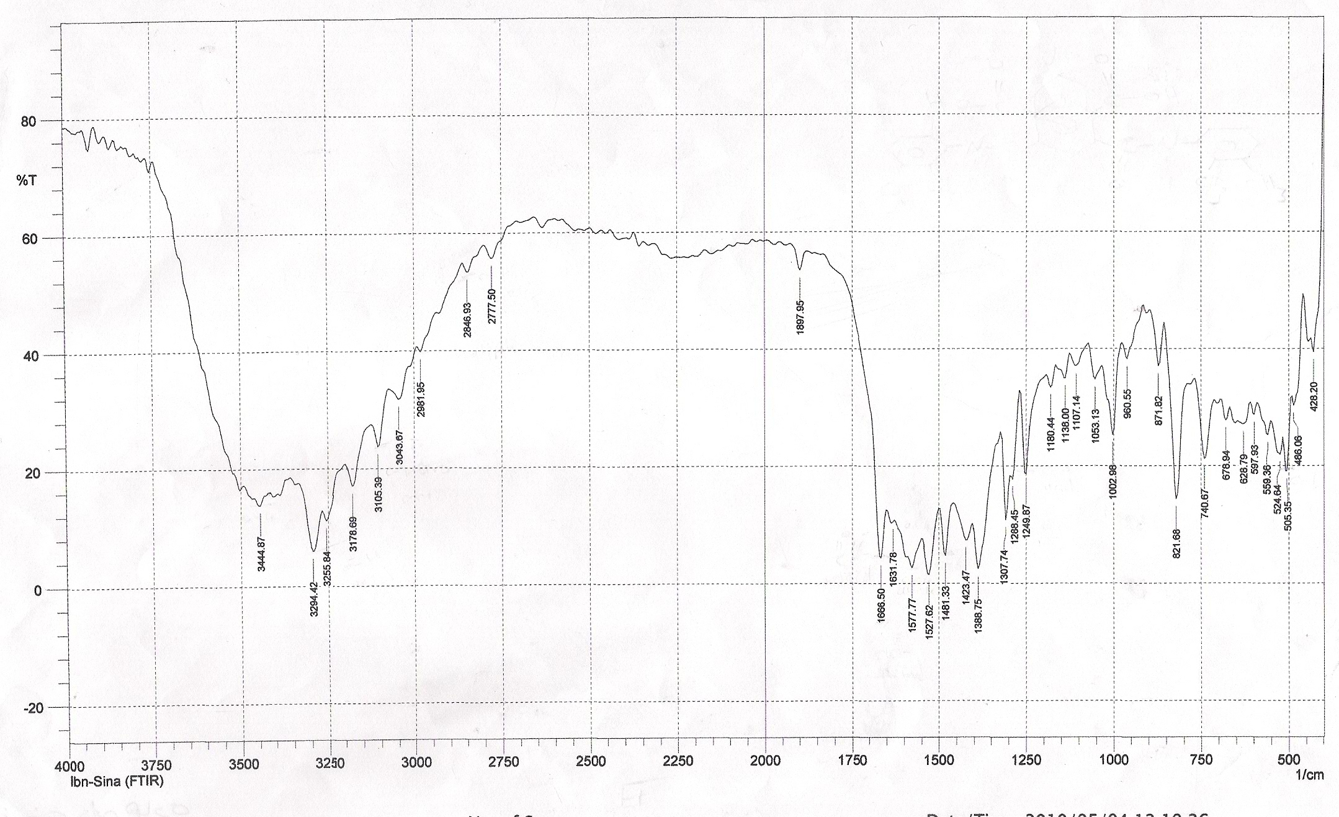

Fig.(1): FT.IR Spectrum of (C₂₆H₂₄N₂O₆).
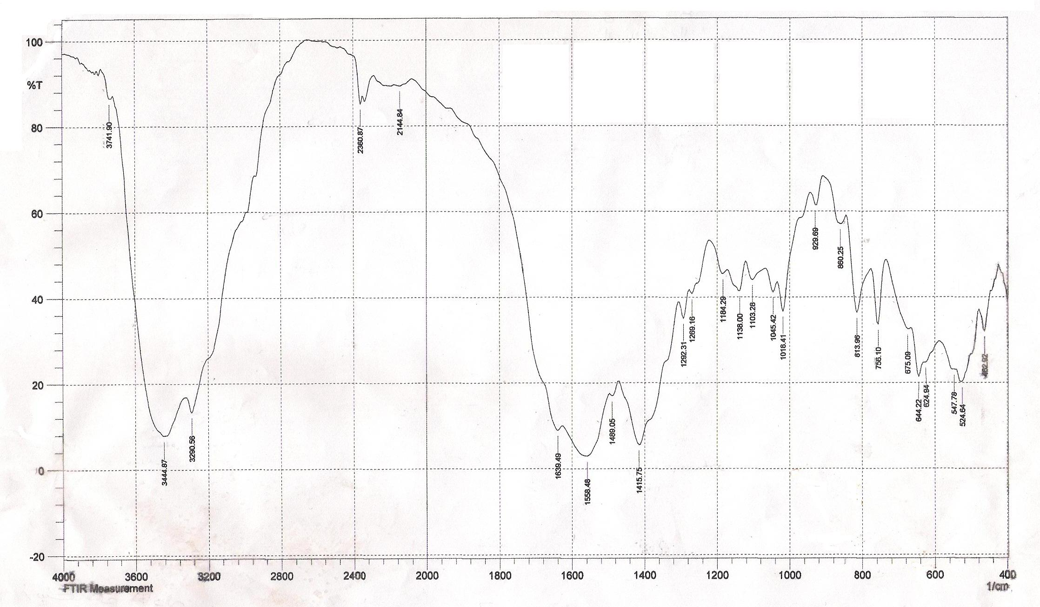

Fig.(2): FT.IR Spectrum of (C₂₂H₁₄N₂O₆I₂).

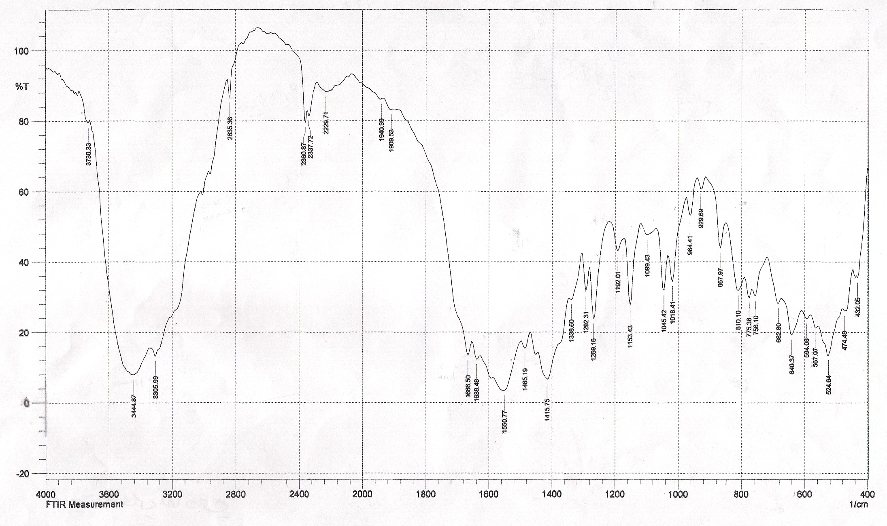

Fig.(3): FT.IR Spectrum of (C₂₄H₂₀N₂O₈).
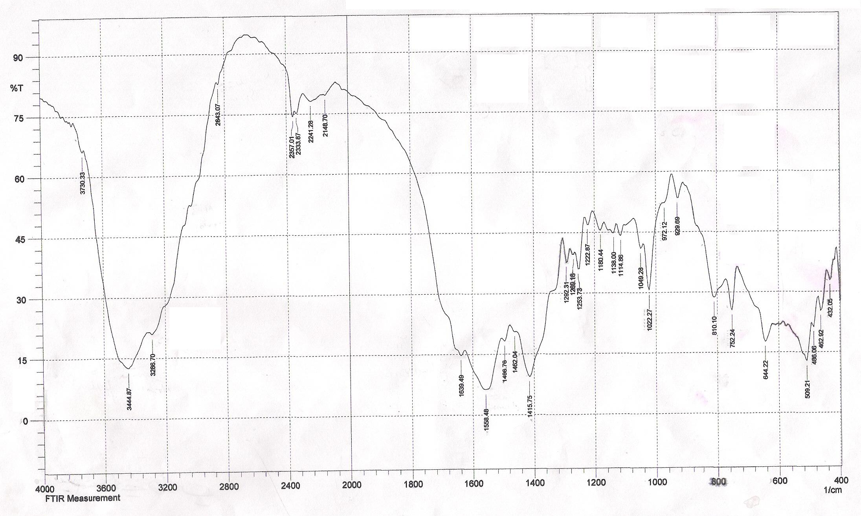

Fig.(4): FT.IR Spectrum of (C₂₄H₂₀N₂O₈).

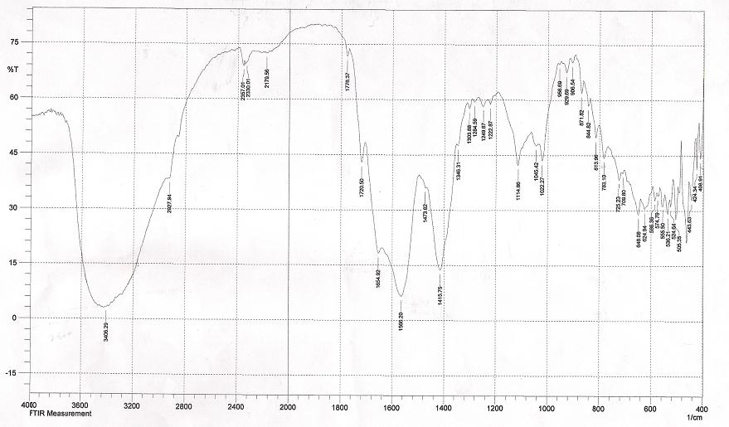
Fig.(5): FT.IR Spectrum of (C₂₄H₂₀N₂O₆).

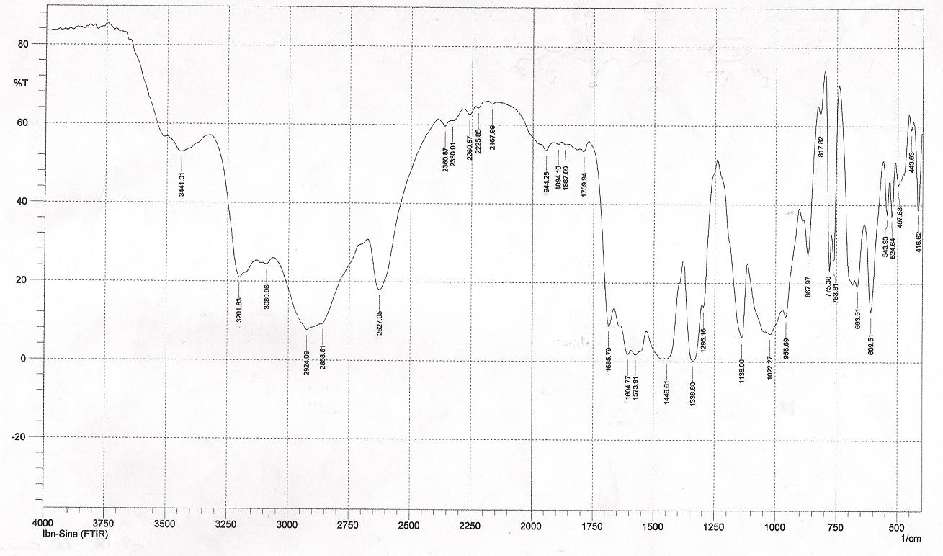

Fig.(6): FT.IR Spectrum of (C₂₆H₂₀N₂O₄).

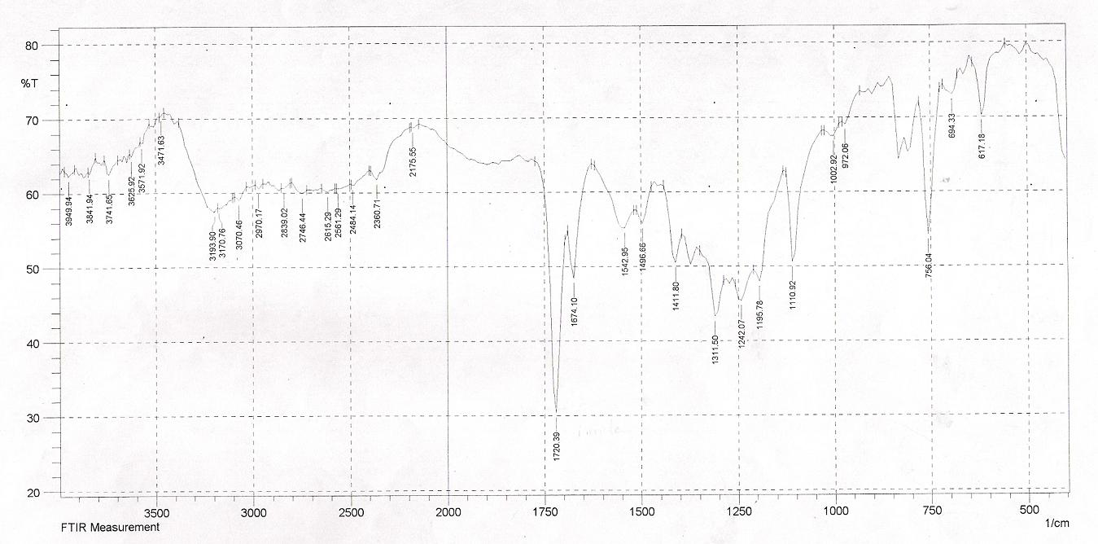
Fig.(7): FT.IR Spectrum of (C₂₂H₁₀N₂O₄I₂).

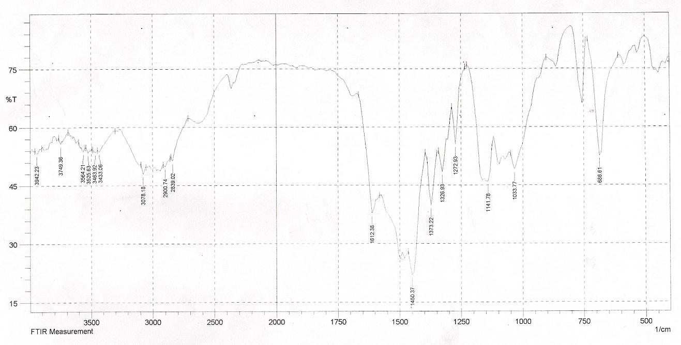

Fig.(8): FT.IR Spectrum of (C₂₄H₁₆N₂O₆).

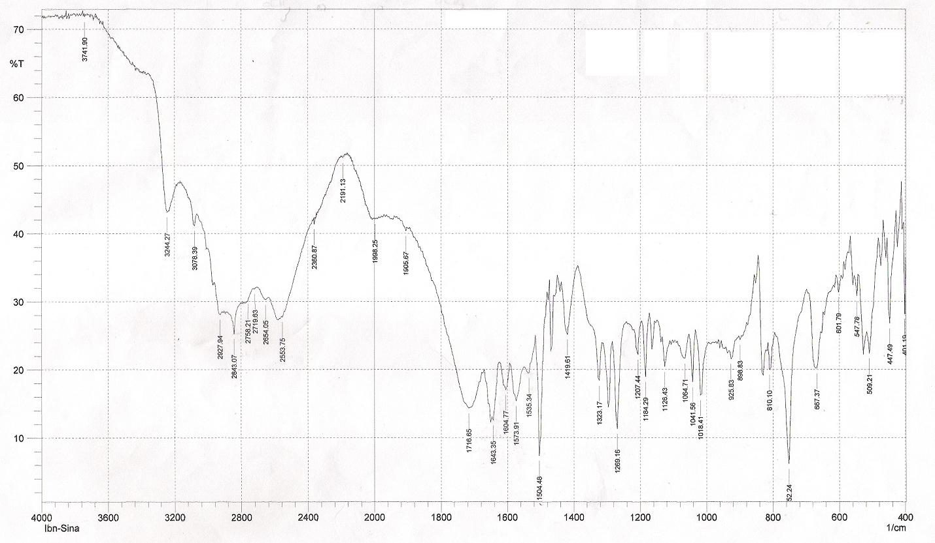

Fig.(9): FT.IR Spectrum of (C₂₄H₁₀N₂O₆).

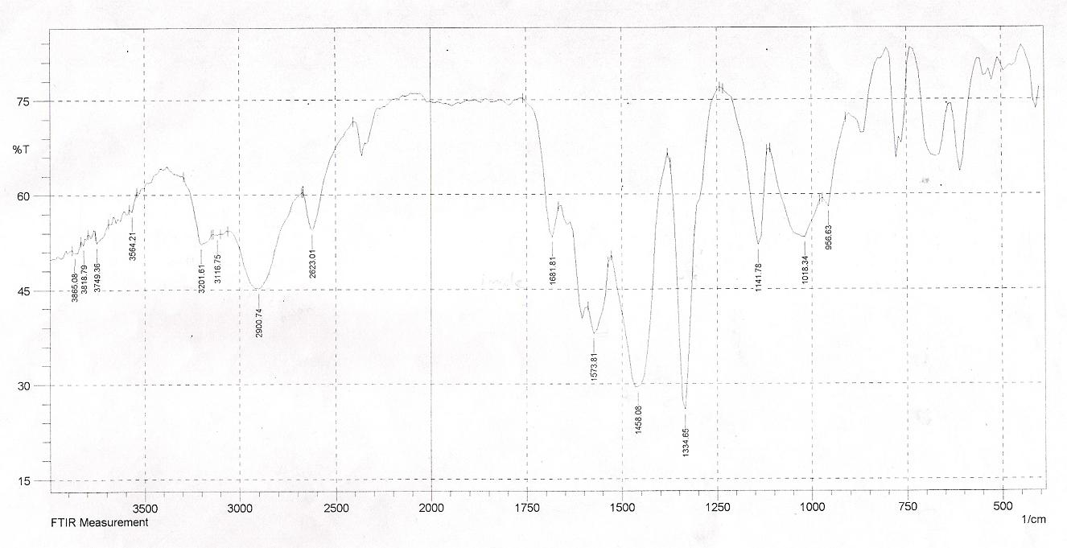

Fig.(10): FT-IR Spectrum of (C₂₄H₁₀N₂O₄).

References
Allen, E.S. and Otto, L.H. Plant –growth regulants and phytocides, can. 519, 684, 1955.
Awad, W. I. and Ali, I. T. Dehydration of pyromellitamic acids, J. Iraqi Chem. Soc. 2(2): 39-51, 1977.
C. Ge, X. Li, X. Zhang, Y. Zhao and R. Zhang, “-(1,3,5,7- Tetraoxo- 1,2,3,5,6,7-hexahydropyrrolo [3,4-f] isoindole-2, 6- diyl) diacetic acid N,N-di- methyl formamide disolvate”, Acta Cryst. (2009). E 65, 02400.
C.A. Gondo, D. E. Lynch and D. G. Hamilton, “-Bis(1-ethynylcyclohexyl) pyromellitic diimide”, Acta cryst. (2009). E65, 02122.
Cheng etal, “Application publication”, U.S. Patent No. 0312580 A1, 17 Dec. 2009.
Cotter, R. J. Sauers, C.K. and whelam, J. M. , New Synthesis of B-cyano esters, J. org. chem. 26: 6-10, 1961.
Darshan, Priti Malhotra & A K Narula , “ Effect of Structure of diamide-diimide-diamines based on L-methionine on curing behaviour and thermal stability of DGEBA”, Indian Journal of Chemistry Vol. 48B, June 2009, pp. 893-903.
David Gosztola, Mark P. Niemezyk, and Walter Svec, “ Excited Doublet states of Electrochemically Generated Aromatic Imides and Diimide Radical Anions” , J. phys-chem. A 2000, 104, 6545-6551.
Dine-Hart, R.A. and Wright, W.W. Preparation and fabrication of aromatic polyimides, J. Appl. Polymer, Sci., 11:5, 609-27, 1967.
Dudley. H. Williams and Ian Fleming, “Spectroscopic Methods In organic chemistry”, 5th ed., Cambridge, 1995.
Dyer. R. J., “Application of Absorption Spectroscopy of organic compounds” , prentice-Hall, Ine-England cliffs, N.J, London, 1965.
Gayane Koshk akaryan, Kumar Parimal, Jiuming He, Xiyun Zhang, Zeper Abliz, Amar H. Flood, and Yi Liu, “π-Stacking Enhanced Dynamic and Redox-Switchable Self-Assembly of Donor- Acceptor Metallo-[2]catenanes from Diimide Derivatives and Crown Ethers” , Chem. Eur. J. 2008, 14, 10211-10218.
J. Michael Hollas, “Modern spectroscopy”, 4th ed., Jhon wiley and sons, Ltd., England, 2008.
Kyung HO choi, Jin Chul Jung, Hyun Su Kim, Byeong Hyeok Sohn, Wang-Cheol Zin, and Moonhor Ree “ Synthesis and characterization of new alkali-soluble polyimides and preparation of alternating multilayer nano-films therefrom”, polymer 45 (2004) 1517-1524.
Liliana Burakowski Nohara, Michelle Leali Costa, Mauro Angelo Alves, Marta Ferreira Koyama Takahashi, Evandro Luis Nohara, and Mirabel Cerqueira Rezende, “Processing of High performance composities Based on Peek by Aqueous suspension prepregging” , Materials Research. 2010: 13(2): 245-252.
Mohammad J. Al-Azzawi, Amir T. Atto, Imad T. Ali, and Balqiz W. Al-Ahdami, “The synthesis of pyromellitamic diacids and pyromellitdiimides and their effect on the Human serum cholinesterase activity in vitro”, J.Biol. Sci. Res, Vol. 19 (1), 1988.
Ponos Grammaticakis, preparation and ultraviolet absorption ability of some N-(-O-carboxy benzoyl) aryl amines and N-arlphthalimides, compt. Rend. 251, 1790-2, 1960.
Qingdong Zheng, Jia Huang, Amy Sarjeant, and Howard E. Katz, “ Pyromellitic Diimides: Minimal Cores for High Mobility n-channel Transistor semiconductors”, J. AM. CHEM. Soc. 2008, 130, 14410-14411.
Richie Kohman, “Applications of Rotaxanes in Dynamic Memory, Bioelectronics, and Membrane transport”, Report. February 24, 2005.
Robert Thornton Morrison and Robert Neilson Boyd, "Organic chemistry" ,6th ed., New Delhi-110001, 2007.
sherrill, M.L. Schaeffer, F.L. and shoyer, E. P. Isomerism of phenylphthalimides and a study of the nitro and chloro derivatives, J. Am. Chem. Soc. 50, 474-85, 1928.
Silverstion, R.M., Bassler and C.G. Morril, “Spectrometric Identification of organic compounds”, 4th ed., John Wiley and Sons, Inc-New York, 1981.
Subba Rao, N. V. and Ratnam, C.V. phthanilic acids as derivatives for characterization of aromatic primary amines, J. Sci. Ind. Res. 21B: No. 1, 47, 1962.
Takahiro Iijima, Scott A. Vignon, Hsian-Rong Tseng, Thibaut Jarrosson, Jeremy K. M. Sanders, Filippo Marchioni, Margherita Venturi, Emanuela Apostoli, Vincenzo Balzani, and J. Fraser Stoddart, “ Controllable Donor-Acceptor Neutral [2] Rotaxanes”, chem. Eur. J. 2004, 10, 6375-6392.
Valdimir N. Bulavka and Vasiliy F. Aristov, “ Hydrazinolysis of 1, 2, 4, 5-benzenetetracarboxylic bis-(Substituted) phenylimides”, 12th International Electronic Conference on synthetic organic chemistry (ECSOC-12) 1-30 November 2008.
ZHAO Shu-min, Gu Hai- ning and ZHOU Qi-Zhong, “ Photophysical Behavior of Heteroduplexes Formed from Naphthalene Incorported Foldamers, and Linear Donors and Pyromellitic Diimide Incorporated Foldamers”, CHEM. RES. Chinese universities 2009, 25 (3), 317-327.

