Study of some Mechanical Properties of PVA/ZnO Composite by Ultrasonic Waves

Abdul-Kareem J. Al-Bermany Burak Yahya Kadem Lames F.N.
Babylon University , College of Science , Physics Department
Abstract
The PVA/ZnO composite polymer membranes were prepared by a sol-Gel casting method, the appropriate weight ratios of PVA are constant (1gm) while the ZnO powder ratios were (0.1, 0.2, 0.3 0.4 0.5) gm. In order to evaluate mechanical properties of PVA/ZnO composite structures ultrasonic measurements were performed these properties are ultrasonic velocity, compressibility, acoustic impedance, relaxation time, the wave length ,bulk modulus, shear viscosity and density were analyzed at (40kHz) frequency, another acoustic mechanical properties were measured and calculated at a same time such as the ultrasonic wave amplitude before and after absorption by composite were measured by oscilloscope ,then we calculated absorption coefficient , transmittance and relaxation amplitude. It was found that there are significant relationship between ultrasonic velocity and material properties also results show that adding ZnO enhanced the physical properties by obtaining high value.

الخلاصة
تم تحضير متراكب بوليمري من مادتي اوكسيد الزنكوبولي فيانيل الكحول باستخدام طريقة صب المحلول الجلاتيني ,وكانت نسبة البوليمر المضاف ثابتة (1 غرام) مع تغير نسب اوكسيد الزنك ( 0.1,0.2,0.3,0.4,0.5) غرام , ولغرض حساب الخصائص الميكانيكية لبنية هذا المتراكب تم استخدام الموجات فوق الصوتية وهذه الخصائص هي سرعة الموجات فوق الصوتية , الانضغاطية , الممانعة الصوتية,زمن الاسترخاء,الطول الموجي داخل النموذج ,معامل المرونة, اللزوجة النسبية والكثافة مع ثبوت التردد (40 كيلوهيرتز) , كما تم حساب خصائص اخرى باستخدام جهاز راسم الاشارة حيث تم حساب قيم معامل الامتصاص والنفوذية وسعة الاسترخاء ,وقد وجدت علاقة وثيقة بين سرعة الموجات فوق الصوتية وخصائص المتراكب , كما اكدت النتائج ان اضافة اوكسيد الزنك تحسن من الخصائص الميكانيكية للمتراكب .
Introduction:
The study of composite materials, i.e., mixtures consisting of at least two phases of different chemical compositions, has been of great interest from both fundamental and practical standpoints, the macroscopic physical properties of such materials can be combined so as to produce materials with a desired average response [Chen et al 2011]. Composites have good potential for various industrial fields because of their excellent properties such as high hardness, high melting point, low density, low coefficient of thermal expansion, high thermal conductivity, good chemical stability and improved mechanical properties such as higher specific strength, better wear resistance and specific modulus [Mahmood Mohsina et al.2011]. PVA is a water-soluble synthetic polymer, due to the characteristics of easy preparation, good biodegradability, excellent chemical resistance, and good mechanical properties, PVA has been used on many biomaterial applications [Vladimir Sedlarik et al 2010].ZnO is a II-VI compound semiconductor with quartzite structure [Lu, et al. 2003], ZnO films have been investigated as electronic and optoelectronic device materials such as, transparent conductors, solar cell windows, gas sensors and surface acoustic wave devices because of their n-type conducting with an optical transparency in the visible range. Various ZnO film preparation methods have been used; magnetron sputtering, spray pyrolysis, chemical vapor deposition (CVD), pulsed laser deposition and sol-gel process [Hassan Karami et al 2010].The absorption of ultrasound in polymer systems is governed by local modes of motion and cooperative because of the existence of strong intermolecular interaction within the polymer. [Abdul-Kareem 2005] Ultrasonic technique is good method for studying the structural changes associated with the information of mixture assist in the study of molecular interaction between two species; some of mechanical properties of different polymers were carried by some workers using ultrasonic technique. [Abdul-Kareem 2005;Boro Djordjevic 2009]
Experimental
Sample Preparation:
PVA (Gerhard Buchman -Germany) with 99 % assay and ZnO with 99 % assay and M.W. (81.38) were used as received without further purification. The PVA/ZnO composite polymer membranes were prepared by a sol-Gel casting method. The appropriate weight ratios of PVA are constant (1gm) with were dissolved in (25ml) distilled water under stirring and heat (90◦C) for (1 hour).ZnO powder was added slowly with stirring to the solution with the ratios (0.1, 0.2, 0.3 0.4 0.5) gm. The resulting solution was stirred continuously until the solution mixture became a homogeneous viscous appearance at room temperature for (30 min.). The PVA/ZnO composite polymer film is obtained by leaving the mixture solution in a petre dish at room temperature for 10 days.
Ultrasonic measurements:
Ultrasonic measurements were made with frequency (f=40 kHz), pulse technique of sender-receiver type (SV-DH-7A/SVX-7 velocity of sound instrument) .The receiver quartz crystal mounted on a digital vernier scale of slow motion, the receiver crystal could be displaced parallel to sender and the samples were put between sender and receiver. The sender and receiver pulses (waves) were displaced as two traces of cathode ray oscilloscope, and the digital delay time of receiver pulses were recorded with respect to the thickness of the samples. The pulses height on oscilloscope (CH1) represents incident ultrasonic wave’s amplitude (A₀) and the pulses height on oscilloscope (CH2) represents the receiver ultrasonic wave’s amplitude (A).

Theoretical calculation:
The absorption coefficient (α) was calculated from Lambert – Beer law [Zong fang Wu1 and Dong C. Liu2011]:
A/A₀ = e ^{(- α x)} …… (1)
Where (A₀)is the initially amplitude of the ultrasonic waves,(A) is the wave amplitude after absorption and (x) is the thickness of the sample, the transmittance (T) is the fraction of incident wave at a specified wavelength that passes through a sample was calculated from the following equation: [Dipak Basu 2001]
T = I / I_{o} ……… (2)
The ultrasonic wave velocity was calculated for the samples from the following equation: [Eric M. Strohm and Michael C. Kolios 2009].
v = x / t …… (3)
Where (t) is time that the waves need to cross the samples. Attenuation is generally proportional to the square of sound frequency so the relaxation amplitude was calculated from the following equation: [Tomasz Hornowski et al 2010]
D = α/ f²……… (4)
The wavelength (λ) is the distance that sound (of a particular frequency) travels during one period (during one oscillation), and it calculated by the equation: [David C. et al. 2002]
λ = v / f ……. (5)
The bulk modulus (B) of a composite is the substance's resistance to uniform compression, it is defined as the pressure increase needed to decrease the volume; it was calculated by Laplace equation where (ρ) is the density [Pradeep et al 2009]:
B = ρ v ²……. (6)
Compressibility (β) is a measure of the relative volume change of a fluid or solid as a response to a pressure (or mean stress) change, it was calculated by the following equation [Hassina Khelladi et al.2010]:
β = (ρ v²)⁻¹ …….. (7)
The acoustic impedance of a medium (Z) is a material property it is defined as the product of its density and velocity and it is important in determination of acoustic transmission and reflection at the boundary of two materials having different acoustic impedance[Auld, B.A. 1990], it was calculated by equation [Jarth Mc-Hugh 2008]
Z = ρ v …….. (8)
On the basis that all solids flow to a small extent in response to small shear stress, some researchers have contended that substances known as amorphous solids, such as glass and many polymers may be considered to have viscosity. This has led some to the view that solids are simply "liquids" with a very high viscosity; the viscosity of the
samples was measured by using the equation: [ A. K. Al-Bermany 2009]
η_{s} = 3 α ρ v³/ 8 π² F²…….. (9)
The relaxation time (τ) was calculated from the equation: [A. K. Al-Bermany 2009]
τ =4 η_{s} /3ρ v²…….. (10)
Results and Discussions
In our study we try to enhance the mechanical properties of PVA/ZnO composite, the ultrasound velocity waves are shown in (Fig.1),this figure shows that the velocities are increasing with the increase of ZnO concentration, this could be attributed to the interaction causing association between the two types of molecules, polymer, solvent molecules (water) and ZnO molecules and there will be entanglement action of high molecular weight of PVA, these entanglements make enhancements to composite samples to become a good transfer medium for ultrasonic waves [Abed Al-Kareem 2005] this behavior similar to that obtained by [B. Boro Djordjevic 2009] for other materials using the same technique, The ultrasonic velocity technique has several advantages over standard techniques where it can be applied, these include ease of use sample size and independence of the size of the tested particles. It does depend on an initial calibration to a direct strength measurement technique[ Eric M. Strohm and Michael C. Kolios 2009] .The viscosity of all samples were calculated and shown in (Fig.3),viscosity is increasing with the increase of ZnO concentrations, this attributed that the mechanism of hydrogen bonding of water attached to oxygen sites, this lead to salvation sheaths and increase the size of molecules, so its viscosity [Tomasz Hornowski et al 2010] at concentration (0.4) the viscosity is increases more than other concentrations this caused by network polymer chain formation [Hassun S.K.(1990)] at high concentrations by adding ZnO and there will be entanglement interaction between the composite molecules. Relaxation time is decreasing with increasing ZnO concentration as shown in (Fig.4), this attributed that when ZnO increasing its molecules attached to the polymer molecules and filled the vacancies, so there will be network formations in the composite which reduces the elasticity then reduce the relaxation time of excited molecules. When ultrasound waves passing the composite the absorption coefficients decreasing with increasing of ZnO concentration as shown in (Fig.5), the caused is that the attenuation of ultrasonic energy depends on viscosity thermal conductivity, scattering and intermolecular processes, thermal conductivity and scattering effects are known to be negligible [Tomasz Hornowski et al 2010 ] so viscosity is the main cause or reducing absorption coefficient as previously (Fig.3) show that viscosity increasing with increasing ZnO concentrations, so the elasticity of samples decreases this means that the composite molecules are restricted and there will be small vibrations for these molecules so there is no more absorption by molecules this make medium to be good for transferring ultrasound waves.The compressibility is decreasing with the increasing of ZnO concentration as shown in (Fig.6) .this attributed when ZnO molecules are increasing it accupied the vacancies and as we explained that absorption coefficient decreasing and velocity increasing so they lead to reduce the compressibility of the molecules which was restricted or the compressibility decreases with increases of ZnO concentration because the molecules will be closer to each other and there will be interactions between them which appear some difficulties for these molecules to compress[Ehssan, 2004]. (Fig.8) shows the acoustic impedance is increasing with ZnO concentration ,the acoustic impedance calculated for any materail so long as its density and velocity are known since velocity increasing then the specific acoustic impedance also increasing as shown in (Fig.7) , the transmitted values of the waves are decreaseing with the increasing the ZnO concentration as shown in (Fig.12) this attributed that the polymer molecules absorbed the sound waves according to Lambert-Beer Law which is baised on concentration [B. Al-Nawas et al. 2000]. (Fig.9) shows bulk modulus is increasing with the increases of ZnO concentration this attributed to the fact that equation (6) inversely related with equation (7) so when compressibility decreases bulk modulus must be increasing this result is similar to that obtained by [Oudry J. et al 2009, S. Cournane et al.2010]. The ultrasonic absorption are decreasing with the increase of wavelenght as shown in (Fig.10) this attributed to the fact that when waveleght increase the energy decreases so there will be small berturbation on modulus according to compression so there are small values of absorption by composite molecules.(Fig.7) shows that ultrasonic waveslenght are increasing with increases of ZnO concentration this attributed that when concentration increase the energy absorbed by molecules decreases according to the resistance of the molecules this means that the wavelenght must increases since has reciprocal relation with energy [Tomasz Hornowski et al 2010].The relaxation amplitude is increasing with ZnO concentration this attributed that the displacement of excited molecules became small because moment of inertia for polymer macro moleclues reduce [Ehssan D.J, 2004] also relaxation amplitude directily proportional to the absorption coefficient and the later decreasing with concentration as shown in (Fig.11)
Conclusions
- Adding ZnO enhanced mechanical properties by giving them high values.
- As the frequency is fixed to 40 kHz, then the variation of the velocity will depend only on the thickness of the material.
- This study shows that there is strong intermolecular interaction which is responsible for reducing elasticity of this composite when adding ZnO this lead to reduce the absorption coefficient.
- Hydrogen bonding attached to oxygen sites which gives composite high value of viscosity.
- There is small strain of the composite as a result of ultrasound stress because the compressibility reduces when ZnO concentration increases.
- The composite tests can be supported by analysis of acoustical signals and the tests can cover large sections of composite material without a need for the extensive point-to-point scanning
- The wave velocity measurements can directly sense mechanical modulus of composite material. And the experimental confirmed the utility of the composite material properties sensing.
- The procedures of measures using ultrasonic transducers for the characterization of the materials become inoperative in the case of structures of narrow and irregular materials.
- The velocity and viscosity results show this composite is good medium to transfer ultrasound waves.

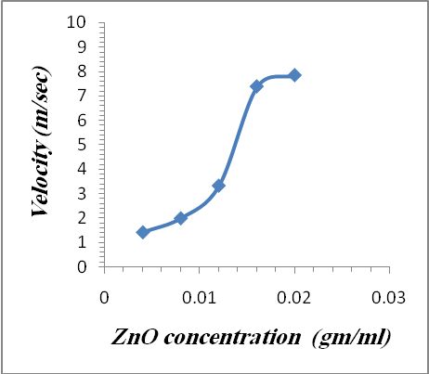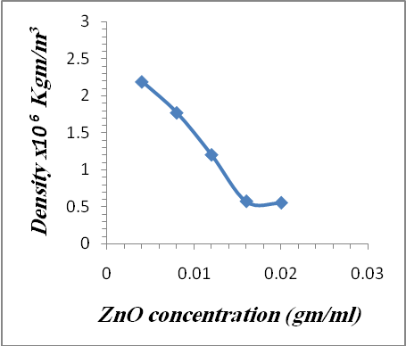
Fig.(1)Ultrasonic wave velosity due to ZnO concentration Fig.(2) Density of samples due to the ZnO concentration
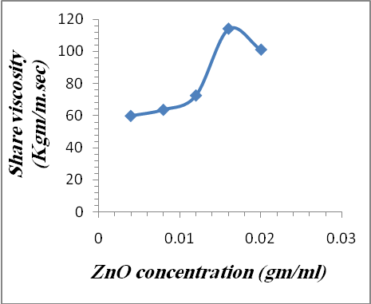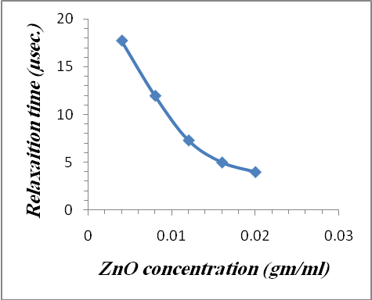
Fig.(3) Share viscosity due to ZnO concentration Fig.(4) Relaxaition time due to ZnO concentration

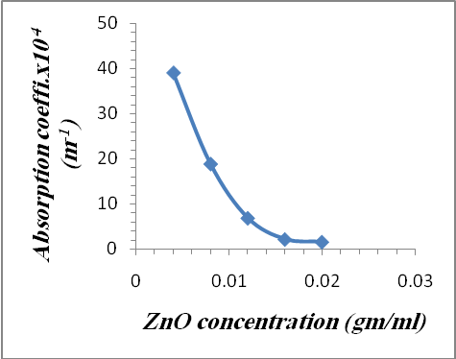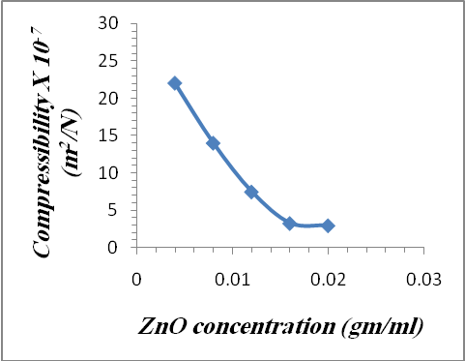
Fig.(5)Absorption coff. due to ZnO concentration Fig.(6) Compressibility due to ZnO concentration
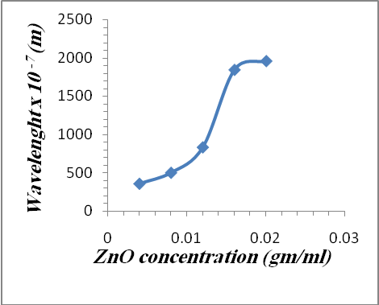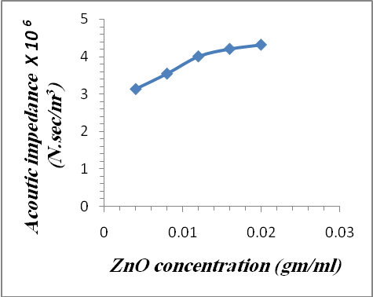
Fig.(7)Wavelenght due to ZnO concentration Fig.(8)Acoustic impedance due to ZnO concentration
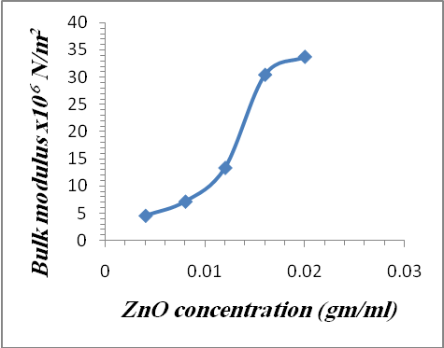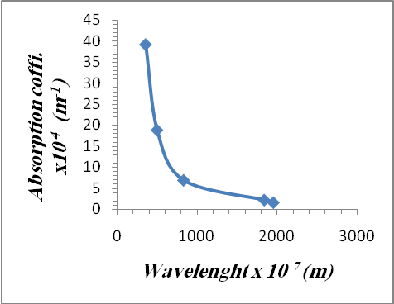
Fig.(9)Bulk modulus due to ZnO concentration Fig.(10)Absorption coff. due to wavelenght
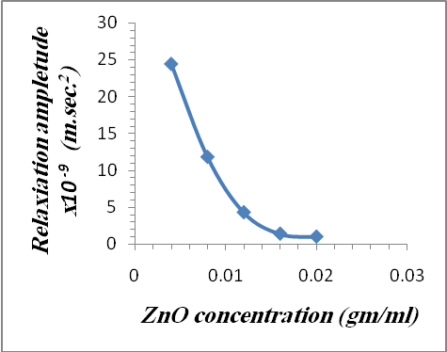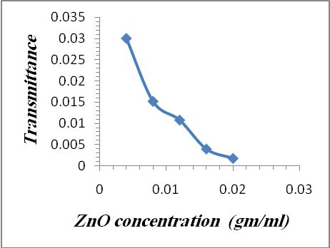
Fig.(11) Relaxiation ampletude due to ZnO concentration Fig.(12)Transmitance due to ZnO concentration

References
Abdul-Kareem, (2005). ”Visco relaxation study of gamma effect on polyethylene oxide by ultrasonic” Journal of Babylon University, 3, 12.
Al-Bermany , A. K.(2009). ”Enhancement of electrical and optical properties for carboxyl methyl cellulose and it’s industrial applications”, journal of college of education Vo.2, no.384.
Al-Nawas B.;. Grötz K. A ; Rose E.; Duschner H.; Kann P. ; Wagner, W.(2000). ” Using ultrasound transmission velocity to analyse the mechanical properties of teeth after in vitro, in situ,and in vivo irradiation”, Clin Oral Invest , 4:168–172 Springer
Auld, B.A.(1990). “Acoustic and waves in solids”vol.1&2,2nd edition Krieger publish.com.
Boro Djordjevic , B. (2009). the 10th International Conference of the Slovenian Societyfor Non- Destructive Testing, Ljubljana, Slovenia, 47-57.
Chen, Z. M. ; Pan, S. J. ; Yin, H. J. ; . Zhang, L. L; Ou, E. C. ; Xiong, Y. Q. ; Xu , W. J. (2011) ”Facile synthesis of superhydrophobic TiO2/polystyrene core-shell microspheres” eXPRESS Polymer Letters Vol.5, No.1 ,38–46
Cournane, S. ; Cannon, L.; Jacinta Browne and A. Fagan , (,(2010). Centre for Advanced Medical Imaging (CAMI), St. James’s Hospital, Dublin 8, Ireland.
David C. Cassidy, Gerald James Holton and Floyd James Rutherford ,(2002). ”Understanding physics” Birkhäuser. pp. 339.
Dipak Basu , (2001). Dictionary of pure and applied physics, CRC Press.
Ehssan D.J, (2004). A thesis M.Sc.”Gamma relaxation effect on some physical properties of polymer xanzan cellulose “, university of Babylon).
Eric M. Strohm and Michael C. Kolios. (2009). ” Measuring the Mechanical Properties of Cells using AcousticMicroscopy”, 31st Annual International Conference of the IEEE EMBS Minneapolis, Minnesota, USA, September .
Hassan Karami , Amir Aminifar, Hossein Tavallali and Zeinol-Abedin Namdar,(2010). ” PVA-Based Sol–Gel Synthesis and Characterization of CdO–ZnO Nanocomposite” J Clust Sci ,21:1–9.
Hassina Khelladi, FrédéricPlantier,Jean Luc Daridon and Hakim Djelouah, (2010). ”Measurements under High Pressure of Ultrasonic Wave Velocity in Glycerol” IEEE International Ultrasonics Symposium Proceedings, 10.1109.
Hassun S.K., (1990). ”visco relaxation studies of polystyrene solutions in different solutions by ultrasonic”,acta polymerica ,vl.41,no.8.
Jarth Mc-Hugh, a thesis PhD, (2008). ” Ultrasound Technique for the Dynamic Mechanical Analysis (DMA) of Polymers” Bundesanstalt für Materialforschung und - prüfung (BAM).
Lu, J., Ye, Z., Wang, L., Huang, J. and Zhao, B., (2003). “Materials Science in Semiconductor Processing” 491-496.
Mahmood Mohsina, Asiful Hossinb and Yousef Haik,(2011). ” Thermo mechanical properties of poly (vinyl alcohol) plasticized with varying ratios of sorbitol”, Materials Science and Engineering A 528:925–930.
Oudry J, Bastard C, Miette V, Willinger R and Sandrin L,(2009). ”Ultrasound Medical Biolology”,1185-97.
Pradeep K. Rohatgi Æ Takuya Matsunaga and Nikhil Gupta, (2009). ” Compressive and ultrasonic properties of polyester/fly ash Composites”, J Mater Sci , 44:1485–1493.
Tomasz Hornowski, Arkadiusz Józefczak ,Andrzej Skumiel and Mikołaj Łabowski ,(2010). ” Effect of Poly(Ethylene Glycol) Coating on the AcousticProperties of Biocompatible Magnetic Fluid”, Int J Thermophys 31:70–76.
Vladimir Sedlarik a,b,*, Tsermaa Galya a, Jana Sedlarikova b, Pavel Valasek c, Petr Saha . (2010).” The effect of preparation temperature on the mechanical and antibacterial properties of poly(vinyl alcohol)/silver nitrate films”, Polymer Degradation and Stability, 95 : 399-404.
Zong fang Wu1 and Dong C. Liu ,(2011). ” Method of improved scatterer size estimation without attenuation known a priori”.IEEE, 978-1-4244-4713-8/10.

