Corrosion Behavior Of Carbon Steel Under Flowing Condition

Shaker Saleh Bahar Wathiq Nasser Hussein Hameed H.Alwan
Babylon University ,College of Engineering,Electrochemical Engineering Department

Abstract
The behavior of carbon steel in 0.1 N NaCl solution under flowing conditions and at 30◦C was analyzed by using two methods, viz, weight method and polarization one and comparing them. It was found that the corrosion rate is affected by alternating the velocity of the solution, generally, higher mass transfer rates were obtained in weight loss than in the polarization method. Empirical equations were obtained for the two methods that relate the corrosion current versus the velocity of solution.
الخلاصة
لقد تم تحليل سلوك الكاربون الفولاذي في محلول 0.1 عياري من محلول كلوريد الصوديوم تحت تاثير سرع مختلفة وبدرجة حرارة 30م باستخدام طريقتين: طريقة فقدان الوزن وطريقة الاستقطاب ومن ثم مقارنة نتائج كلا الطريقتين. لقد تبين ان معدل التاكل قد تاثر بتغير السرع, عموما فان معدلات انتقال المادة كانت اعلى في حالة فقدان الوزن. تم التوصل الى معادلات تجريبية للطريقتين والتي تربط معدل التاكل مع سرعة المحلول.

Introduction
There are several factors that affect corrosion rate like temperature, velocity, pH, concentration, etc. For practical application of electrochemistry and in order to obtain high yield of a process, high mass transfer rates are needed and the stirring of the solution or the instrument in question is the best means to get such rates of transfer. One of the best means used to move a solution in the different field of electrochemistry is the rotating cylinder electrode, it has many advantages and because it is easy to be employed, therefore, it got wide applications. It was found that the velocity has a major effect on the corrosion rate. In the region of limiting current density, the best relation is (Eisenberg et al 1954 ;Henry and Scott 1999; Tretheway 1996)
$i_{l}={\text{kv}}^{n}$ ………………1
where $i_{l}$ is the limiting current density.
k is a constant.
v is the velocity.
n is a constant has a value of 0.2-1.0 and depends on geometry of the employed system.
The aim of the present work is to study the corrosion behavior of carbon steel under flowing conditions in 0.1 N NaCl solutions and compare the results obtained from the weight loss and the polarization studies.

Experimental work
Experimental work was carried out to determine the corrosion rate of carbon steel under static as well as turbulent flow conditions, viz 0, 250, 500, 750 and 1000 rpm at a temperature of 30˚C using weight loss and electrochemical polarization methods. Specimens were cut from carbon steel and then worked to give dimensions of 2.55 cm outer diameter with a length of 2 cm. After cleaning and preparing, the specimens were placed in the test solution (0.1 N NaCl) for 1.5 hour at several velocities. The polarization measurement were carried out using rotating cylinder electrode as a working electrode of the above dimensions, a saturated calomel electrode was used as a reference while the auxiliary electrode was graphite. The whole polarization circuit was monitored manually and figures (1) represents the circuit. The temperature was controlled by a water bath with accuracy of ±$1$˚C and the composition of the carbon steel as follows;

C% | Si% | Mn% | P% | S% | Cr% | Mo% | Ni% | Cu% | V% | Fe%
0.1649 | 0.2559 | 0.5027 | 0.0020 | 0.0068 | 0.0251 | 0.0000 | 0.0088 | 0.1505 | 0.0033 | Rem.

Results and Discussion
Table 1 represents the effect of velocity on corrosion rate by the weight loss method. It is obvious that as the velocity increases, the corrosion rate increases accordingly. This increasing in corrosion rate is attributed to the increasing of oxygen mass transfer. Since in such solutions the basic cathodic reaction is (Steigerwald, 1969 ;Kruger , 2001)
$O_{2}+2H_{2}O+4e=4{\text{OH}}^{−}$ ………….2
These data are supported by the polarization curves ( next paragraph) and suggest that the corrosion current density is a limiting one, therefore, by using equation 1 above, i.e, $i_{l}={\text{kv}}^{n}$ and by using data of table 1 one can obtain a relation of the form of Eisenberg from which can be calculated and compared.

Table 1; Data o weight loss at 30˚C and 1.5 hour
RPM | V  m/s | ∆w  (g) | CR  (gmd) | CR  (mm/y) | CR  (mpy) | i_{d}  (μA/cm²)
0 | 0 | 0.0085 | 85 | 3.942 | 155.197 | 339.644
250 | 0.33 | 0.0150 | 150 | 6.956 | 273.858 | 599.372
500 | 0.66 | 0.0182 | 182 | 8.440 | 332.283 | 727.237
750 | 1.0 | 0.0235 | 235 | 10.898 | 429.055 | 939.015
1000 | 1.33 | 0.0311 | 311 | 14.422 | 567.795 | 1242.397

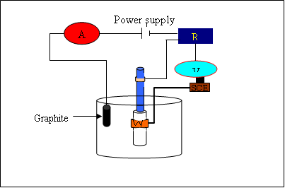

Figure 1: The polarization Circuit, A ammeter, R variable resistance, w working electrode

To check the effect of velocity on corrosion potential, a free corrosion runs were held at several rpm (0, 250, 500, 750 and 1000) and the following graphs show such effect.

Figure 2 : Potential vs. time for a metal specimen in 0.1 N NaCl solution at 0 rpm and at 30 ˚C

Figure 3 : Potential vs. time for a metal specimen in 0.1 N NaCl solution at 250 rpm and at 30 ˚C

Figure 4 : Potential vs. time for a metal specimen in 0.1 N NaCl solution at 500 rpm and at 30 ˚C

Figure 5 : Potential vs. time for a metal specimen in 0.1 N NaCl solution at 750 rpm and at 30 ˚C

Figure 6 : Potential vs. time for a metal specimen in 0.1 N NaCl solution at 1000 rpm and at 30 ˚C

It is obvious that the corrosion potential values are decreased with increasing velocity which could be attributed to the high rates of dissolution and cathodic reaction extent^{[6,7,8,9,10,11,12]}.
In the polarization curves shown below at various velocities, it is shown that the limiting current density in the cathodic branch is dominating.

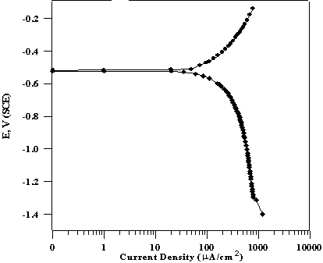

Fig. 7 :Complete Polarization Curves at 0 rpm and T=30ºC

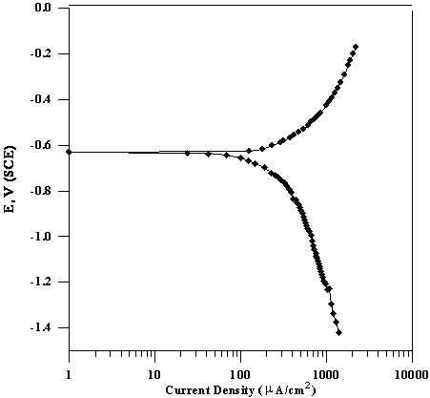

Fig. 8 :Complete Polarization Curves at 250 rpm and T=30ºC.

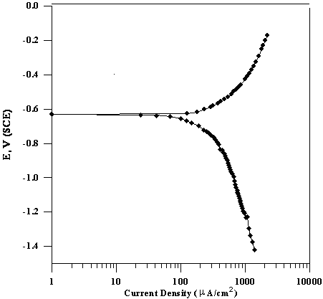

Fig. 9 :Complete Polarization Curves at 500 rpm and T=30ºC.

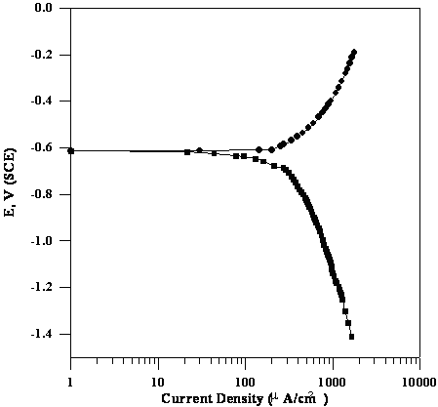
Fig.10 :Complete Polarization Curves at 750 rpm and T=30ºC.

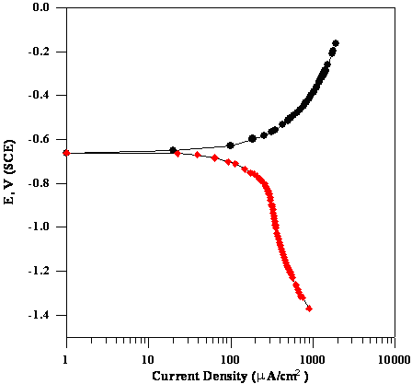
Fig.11 :Complete Polarization Curves at 1000rpm and T=30ºC

The following table is a guide to the values of i_{L} versus rpm.

Table 2 Effect of rotating cylinder speed on i_{L} and K of carbon steel specimen in air-saturated 0.1N NaCl solution, T=30˚C.
RPM | V  m/s | Re | CR  (gmd) | i_{L}  (μA/cm²) | k  (m/s)х10⁵ | Sh
0 | 0 | 0 | 85 | 400 | 4.521 | 572.989
250 | 0.33 | 13169.962 | 150 | 440 | 5.632 | 713.797
500 | 0.66 | 26336.773 | 182 | 480 | 6.557 | 831.031
750 | 1.0 | 39506.74 | 235 | 500 | 7.132 | 903.907
1000 | 1.33 | 52676.707 | 311 | 530 | 7.488 | 949.026

The plot of i_{l} versus velocity gives the value of n (from equation 1) by which one can anticipate the convergence of these plots to that of Eisenberg one ^{[1]}.
The relation between dissolution current density and velocity as follows:

i_{d} =1001.413v^{0.575} C.C=0.88 …………..……3

The relation between the current density and velocity is as follows:

i_{L} =0.5 v^{0.025} C.C =0.891 ………………..3

and the relation between limiting current density and Re and Sc is as follows:

i_{L} =0.127(Re)^{0.011} (Sc)^{0.215} C.C=0.90 ………………..4

This equation were expecting for these conditions where limiting current density was affect by the increasing of rotational velocity i.e. Re at a certain Sc as show in equations 3 and 4.

References
Bahar, S. S. (2002). M. Sc. Thesis, Chem. Eng. Dept., Saddam University, Baghdad, .
Eisenberg M., Tobias C.W., Wilke. C.R. Electrochem. J. (1954). Soc. 101.
Henry S.D. and Scott, W.M. (1999). Corrosion in the Petrochemical Industry, 1st Edition. ASM International, USA..
Kolman, D.G. Ford, D.K. Butt, D.P. and Nelson, T.O. (2002). Materials Corrosion and Environmental Effects Laboratory, Los Alamos, NM 87545.
Kruger, J. (2001). Electrochemistry of Corrosion, The Johns Hopkins University, Baltimore, MD 21218, USA, April .
Poulson, B. (1983). Corrosion Science, Vol, 23, No. 1, P. 391.
Selman, J.R. (1981). AICHE, Vol.77, No.204, P.88.
Shreir, L.L. (2000). Corrosion Handbook, 2nd Edition. Part1, Newness-Butter., London.
Steigerwald, R. F. (1968). Corrosion-NACE, Vol.12, P.1.
Stern, M. (1957). Corrosion-NACE, Vol. 13, P.97.
Tretheway K.R. and Chamberlain, J. (1996). Corrosion Science and Engineering, 2nd Edition., Longman, London.
Ulig, H.H. (1985). Corrosion and Corrosion Control, 3rd Edition., Wiley-Interscience Publication, New York.

