Axisymmetric Vibration of Oblate Spheroidal Shells Of Varying Thickness

Mohamed J. Al – Robaiy and Mohammed A. AL-Shjary
Mustafa T. Hussein
College of Engineering, Babylon University
Abstract
In this paper a detailed study of the theory of free ax symmetrical vibration of thin isotropic oblate Spheroidal shells of varying thickness for head and base and variable thickness of shells. The analysis is performed following the Finite Element method using ANSYS 9.0 program. This method as well as to estimate the natural frequencies and mode shapes for the shells. The obtained results it is found that increase the natural frequencies with increase the thickness of shell and at constant the thickness of base with varying thickness of head the natural frequencies increase.
الخلاصة
يتناول هذا البحث الدراسة النظرية للأهتزازات الحره للقشريات نحيفه الجدران الشبه بيضاوية المتناظرة المحور المتشابهه الخواص في جميع الاتجاهات متغيرة السمك الراس والقاعدة وبسمك متغير للقشرة. وقد أجري التحليل النظري بطريقة العناصر المحددة وباستخدام برنامج 0. ANSYS 9وهذة الطريقة أعطت نتائج جيدة لكل من الترددات الطبيعيه وشكل النسق للقشريات. من خلآل النتائج التي حصل عليها وجد بان الترددات الطبيعية تزداد بزيادة سمك القشرة وكذلك عند تثبيت سمك القاعدة وتغير سمك الراس تزداد التردادت الطبيعية.
1. Introduction
Oblate spheroid shells can be obtained by rotating an ellipse around its minor axis. It is worthy to indicate the industrial applications and importance shell structure. Therefore the study of free vibration becomes very important to prevent the resonance appearance.
The study of free vibration of spheroidal shell takes a considerable at in the published literature. Several investigators, using a variety of mathematical techniques, have obtained approximate solution for the natural frequencies of axisymmetric vibrations of thin oblate spheroidal shells.
De Maggio and Silibiger (1961) obtained a solution for the torsional vibrations of thin prolate spheroidal shell in terms of spheroidal angle functions. Kanins (1963) was concerned with the vibration analysis of spheroidal shells, closed at one pole and open at the other, by means of the linear classical bending theory of shells. Frequency equations are derived in terms of Legender function with complex indices, and axisymmetric vibration of the natural frequencies and mode shapes are deduced for all opining angles ranging from a shallow to closed spherical shell. It was found that for all opening angles the frequency spectrum consist of two coupled infinite sets of modes that can be labeled as bending (or flexural) and membrane modes. It was also found that membrane modes are practically independent of thickness, whereas the bending modes vary with the thickness. The same author concerned with a theoretical investigation of the free vibration of arbitrary shells of revolution by means of the classical bending theory of shells.
A method is developed that is applicable to rotationally symmetric shells with meridional variations (including discontinuities) in Young’s modulus, Poisson’s ratio, radii of curvature, and thickness. The natural frequencies and the corresponding mode shapes of axisymmetric free vibration of rotationally symmetric shell can be obtained without any limitation on the length of the meridian of the shell. The results of free vibration of spherical and conical shells obtained earlier by means of the bending theory. In addition, parapoloidal shells and sphere-one shell combination are considered, which have been previously analyzed by means of the inextentional theory of shells, and natural frequencies and mode shapes predicted by the bending theory are given.
Numergut and Brand (1965) determined the lower axisymmetric modes of prolate shell with five values of eccentricity. DiMaggio and Rand (1966) using membrane shell theory in which the effects of bending resistance are ignored. Their work was distinguished by applying their solution to constant thickness membrane shell by means of integrating numerically the equations of motion. It was found that the frequencies associated with higher modes are strongly dependent on the eccentricity ratio.
Fawaz (1990) Raleigh variation method was used to obtain natural frequencies and mode shape of axisymmetric vibration of thin elastic oblate spheroidal shells and presents the results of both theoretical and experimental investigations of the shell. The experimental investigation involves construction two closed form oblate spheroidal shells with two different eccentricities.
Zhu (1995) based upon general thin shell theory and basic equations of fluid-mechanics; the Rayleigh-Ritz’s method for coupled fluid-structure free vibrations is developed for arbitrary fully or partially filled in viscid, irrigational and compressible or incompressible fluid, by means of the generalized orthogonally relations of wet modes and the associated Rayleigh quotients.
Wasmi (1997) used the finite element and modal analysis techniques to investigate the static and dynamic investigation of oblate spheroidal dishes, prolate and the relevant structures. Different types of elements were considered in one dimension, two dimension and three dimensions. It was found that the natural frequencies of oblate and prolate shells have two types of behavior against increasing the shell thickness and eccentricity, which are the membrane and bending modes. The membrane modes natural frequencies tend to increase with increasing the eccentricity of oblate, while the bending mode natural frequencies decrease with increase the value of eccentricity.
Aleksandr Korjanik et,al (2001) investigated the free damped vibrations of sandwich shells of revolution. As special cases the vibration analysis under consideration of damping of cylindrical, conical and spherical sandwich shells is performed. A specific sandwich shell finite element with 54 degrees of freedom is employed. Starting from the energy method the damping model is developed. Numerical examples for the free vibration analysis with damping based on the proposed finite element approach are discussed. Results for sandwich shells show a satisfactory agreement with various references solutions.
Antoine et,al (2002) investigated the linear and nonlinear vibrations of shallow spherical shells with free edge are experimentally and numerically. Combination resonances due to quadratic nonlinearities are studied, for a harmonic forcing of the shell. Identification of excited modes is achieved through systematic comparisons between spatial results obtained from a finite element modeling, and spectral information derived from experiments.
Nawal (2005) used the Rayleigh –Ritz’s method to investigate the oblate spheroidal shells have variable eccentricity ratio. It was found that the natural frequencies of oblate shells decrease with increase the value of eccentricity.
This investigation deals with the free vibration of thin elastic oblate spheroidal shell. The shell is assumed be of isotropic material. The analysis depends on the Finite Element method.

Major axis
ta
tb
a
b
Minor axis
Model (1) Oblate spheroidal shell with thickness ratio (ta/tb)

ta
a
tb
b
Major axis
Minor axis
Model (2) Oblate spheroidal shell with thickness ratio (tb/ta)

Fig (1): Oblate Spheroidal Shell Models

2.1. Stress-Strain Relation-Ship:
The stress- strain relations in coordinates aligned with principle material directions are given by:
$\left\{\begin{matrix}σ_{x} \\ σ_{y} \\ σ_{z} \\ τ_{\text{xy}} \\ τ_{\text{xz}} \\ τ_{\text{yz}}\end{matrix}\right\}=\left[\begin{matrix}c_{\text{11}} & c_{\text{12}} & 0 & 0 & 0 & 0 \\ c_{\text{21}} & c_{\text{22}} & 0 & 0 & 0 & 0 \\ 0 & 0 & c_{\text{33}} & 0 & 0 & 0 \\ 0 & 0 & 0 & c_{\text{44}} & 0 & 0 \\ 0 & 0 & 0 & 0 & c_{\text{55}} & 0 \\ 0 & 0 & 0 & 0 & 0 & c_{\text{66}}\end{matrix}\right]\left\{\begin{matrix}ε_{x} \\ ε_{y} \\ ε_{z} \\ γ_{\text{xy}} \\ γ_{\text{xz}} \\ γ_{\text{yz}}\end{matrix}\right\}$ ...(1)
From the usual thin shell assumption, the normal stress $σ_{z}$ is assumed small enough to be neglected and the corresponding $ε_{z}$is eliminated (plane stress problem is assumed) [3]. Therefore, the equation (1) becomes:

$\left\{\begin{matrix}σ_{x} \\ σ_{y} \\ τ_{\text{xy}} \\ τ_{\text{xz}} \\ τ_{\text{yz}}\end{matrix}\right\}=\left[\begin{matrix}c_{\text{11}} & c_{\text{12}} & 0 & 0 & 0 \\ c_{\text{21}} & c_{\text{22}} & 0 & 0 & 0 \\ 0 & 0 & c_{\text{44}} & 0 & 0 \\ 0 & 0 & 0 & c_{\text{55}} & 0 \\ 0 & 0 & 0 & 0 & c_{\text{66}}\end{matrix}\right]\left\{\begin{matrix}ε_{x} \\ ε_{y} \\ γ_{\text{xy}} \\ γ_{\text{xz}} \\ γ_{\text{yz}}\end{matrix}\right\}$ ...(2)
or
$\left\{σ\right\}=\left[E\right]\left\{ε\right\}$ where:
c₁₁=c₂₂=(1-$ν$)/A , c₁₂=c₂₁=($ν$)/A , c₄₄=G , c₆₆=c₅₅=fG , A=$\frac{(1−ν)(1−2ν)}{E}$ , G=$\frac{E}{2(1+ν)}$
Where f is the shear factor for homogeneous shell should be given a value of 1.2 in order to account for the fact that the transverse shearing stresses produce too little strain energy [4].

2.2. Element Parameters:
A quadratic element of quadrilateral shape consists of eight nodes, all of which are located on the element boundary have been used to define the shell finite element model. This type of element is used for shell structure applications for both membrane and flexure load conditions. In this section, the parameters that are concerned with the selected element are discussed. These parameters are basically included; the element property parameters include the material properties and the thickness of the element at each node. The formulation of such shell is based on three dimensional elasticity theory. It is assumed that the normal to the center-plane remain straight after deformation, but not necessarily normal to the center-plane. The ration of thickness value to the smallest element dimension must be equal or less than (0.1) in order to maintain the element to be thin [3].
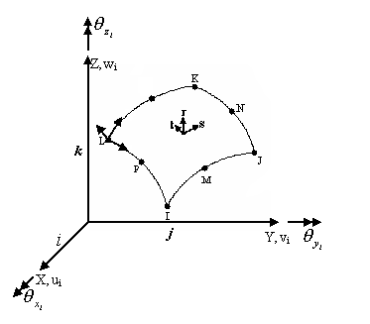
x
y
z

Fig (2): Element Geometry

The displacement at any point within the element is written in terms of nodal translations and rotations as:

$\left\{\begin{matrix}u(ξ,η) \\ v(ξ,η) \\ w(ξ,η)\end{matrix}\right\}=\sum_{i=1}^{8}{N_{i}(ξ,η)\left\{\begin{matrix}u_{i} \\ v_{i} \\ w_{i}\end{matrix}\right\}}+\sum_{i=1}^{8}{N_{i}(ξ,η)\text{rz}\left[\begin{matrix}a_{i}^{u} & b_{i}^{u} & c_{i}^{u} \\ a_{i}^{v} & b_{i}^{v} & c_{i}^{v} \\ a_{i}^{w} & b_{i}^{w} & c_{i}^{w}\end{matrix}\right]}\left\{\begin{matrix}θ_{\text{xi}} \\ θ_{\text{yi}} \\ θ_{\text{zi}}\end{matrix}\right\}$ ...(3)

Where:
z =- $\frac{t}{2}$$→\frac{t}{2}$
N_{i}=Shape functions.
z = nodal thickness
u_{i} , v_{i} , w_{i}= global nodal displacements.
$θ$_{xi} , $θ$_{yi} , $θ$_{zi =} global nodal notations.
r = natural coordinate along thickness direction but normal to the shell surface.
$a_{i}^{u}$, $a_{i}^{v}$, $a_{i}^{w}$= direction cosines of u, v, and with respect to the nodal coordinate system at node i.
It is obvious that each node has six degrees of freedom, and then the element is of (48) degrees of freedom. Not all but some of the element degrees of freedom are considered at each of the finite element models, depending upon the function (boundary conditions) of that model.

2.3. Strain Displacement Relation Ship:
The strain-displacement relationship can be written with its dependence explicitly expressed as:
… (4)
All elements of the strain–displacement matrix, $\left[B\right]$, are derived in terms of the shape function derivatives and the Jacobian matrix.
2.4. Element Stiffness Matrix:
In general, the basic concept of the finite elements method is to discrete the continuum into a definite numbers of small elements connected together at their common nodes. The strain-displacement matrix,$\left[B\right]$, as shown previously is given by:
, and therefore; the element stiffness matrix can be written as:

$[k]^{e}=\int_{V}{[B]^{T}[E][B]\text{dV}=\int_{−1}^{1}{}\int_{−1}^{1}{\int_{−1}^{1}{[B]^{T}[E][B]\text{det}\left[J\right]\text{dr}\text{ds}\text{dt}}}}$ …(5)

in which,
[K]^{e}: is the element stiffness matrix,
$\left|J\right|$: is the determinant of the Jacobian matrix.

2.5 Element Mass Matrix:
To derive the consistent mass matrix, one can consider the kinetic energy of the total solution domain is discretized into number of elements (NE) such that:
$\text{TI}(\overset{˙}{u})=\sum_{e=1}^{\text{NE}}{{\text{TI}}^{e}(\overset{˙}{u})}$ …(6)
where TI and TIe are the kinetic energies of the total solution domain and the sub–domain respectively. The kinetic energy of the element can be expressed as:
${\text{TI}}^{e}=\frac{1}{2}\int_{V}{{\left\{\overset{˙}{u}\right\}}^{T}[m]\left\{\overset{˙}{u}\right\}\begin{matrix}\text{dV}\end{matrix}}$ …(7)
The velocity vector within an element is discretized such that:
$\left\{\overset{˙}{u}\right\}=\sum_{i=1}^{n}{N_{i}\left\{{\overset{˙}{u}}_{i}\right\}}$, n (number of nodes) …(8)
Thus, the mass matrix of the presented curved shell element is written as:
$\left[M_{1}\right]=\text{diag}\begin{matrix}\left[\begin{matrix}\left[M_{0}\right] & \left[M_{0}\right] & \begin{matrix}\end{matrix}\left[M_{0}\right] & \left[0\right]\end{matrix}\right]\end{matrix}$ …(9)
Where
$\left[M_{0}\right]=\int{\sum_{j=1}^{N_{1}}{ρ_{j}\left\{N\right\}\begin{matrix}{\left\{N\right\}}^{T}\text{dV}\end{matrix}}}$ …(10)
Where, $ρ_{j}$ is density of layer j. $\left\{N\right\}$is a vector of the shape functions for in plane motions involving only the nodal translations which are functions of s and t only. $\left[0\right]$ is a null matrix of size 24*24. Equation (10) can be written in an expanded form as:
$\left[M_{0}\right]=\int{\int{\sum_{j=1}^{N_{1}}{ρ\int{\text{det}\left[J\right]\text{dr}\left\{N\right\}{\left\{N\right\}}^{T}\text{ds}\text{dt}}}}}$ …(11)
3 Free Vibration Analysis:
The free vibration analysis is the first step in the dynamic analysis, the natural frequency,$ω$,of the vibration is important to give an idea about the oscillation of the system with time, stiffness to weight ratios for different modes of oscillations, and to determine the natural period (T) of the vibration which represents the time for which the vibration repeats itself, as:
T=$\frac{2π}{ω}$ …(12)
Therefore, the free vibration (modal analysis) is used to determine the basic dynamic characteristic (vibration characteristic) of structures, which are the natural frequencies and mode shapes (normal modes). Natural frequencies and mode shapes are important parameters in the design of a structure under dynamic loading conditions. They are also needed if it is required doing dynamic analysis such as frequency, transient and spectrum analysis. To determine the natural frequencies of a structure, the governing differential equation of motion for the free vibration problem( no external applied loads) and undamped case is assumed in general [3].
$\left[M_{0}\right] \left\{\overset{¨}{X}\right\}+\left[K_{1}\right] \left\{X\right\}=\left\{0\right\}$ …(13)

Assuming harmonic motion that is:
$\left\{X_{i}\right\}=\left\{φ_{i}\right\} \text{sin}ω_{i}t$ ; i= 1,2,….k …(14)
Where:
K= the number of D.O.F. of the system
$\left\{φ_{i}\right\}$=the mode shape vector for the i^{th} mode of vibration, and
$ω_{i}$= the angular frequency of mode i.
Differentiating Equation (14) twice with respect to time yields:
$\left\{X_{i}\right\}=−ω_{i}^{2}\left\{φ_{i}\right\}\text{sin}ω_{i}t$ …(15)
Then, substituting Equations (14) and (15) into Equation (13) yields, after canceling the term (sin$ω_{i}$):
$\left(\left[K_{1}\right]−ω_{i}^{2}\left[M_{0}\right]\right)\left\{φ_{i}\right\}{\left\{φ_{i}\right\}}^{T}=\left\{0\right\}$ …(16)
Equation (16) has the form of the algebraic eigenvalue problem$\left(Kφ=λMφ\right)$. From the theory of homogenous equations, nontrivial solutions exist only if the determinant of the coefficient matrix is equal to zero. Thus:
$\left|\left[K_{1}\right]−ω_{i}^{2}\left[M_{0}\right]\right|=\left\{0\right\}$ …(17)
Expansion of the determinant yields a polynomial of order NR called characteristic equation. The NR roots of this polynomial $\left(ω_{i}^{2}\right)$ are the characteristic values or the eigenvalues. The cyclic natural frequency (f_{i}) is then obtained from:
$f_{i}=ω_{i}$/$2π$ …(18)
Substitution of these roots (one at each time) into the homogeneous equation, (17), produces the characteristic vectors or the eigenvectors $\left\{φ_{i}\right\}$within arbitrary constants. A number of solution algorithms have been developed for the solution of the eigenvalue problem. However, the inverse iteration method will present and used in this work.

4. Results and Discussion
Figure (3) shows the natural frequency (Hz) of the first three modes of vibration as a function of the thickness. It is shown that the increase of the natural frequency with increase the thickness, the reason of that the increase of stiffness for oblate with increase thickness of it.
Figure (4) give the first four the natural frequency as a function of thickness ratio(t_{a}/t_{b}) for model(1) for oblate spheroidal shell have eccentricity ratio (0.684), where shown in this figure increase of the natural frequency with increase or constant the thickness of base and decrease thickness of head, because increase the stiffness of the oblate shell at the clamped region , the reason of that behavior of this case when decrease the thickness of the head this tend to decrease the mass of the oblate shell and the stiffness of shell decrease but clamped region will stronger this week in this case.
Figure (5) it is give the natural frequency as a function of the thickness ratio (t_{b}/t_{a}) for model (2) this figure shown increase or constant the thickness of head and decrease the thickness of base at the support region this case explain the week of oblate shell , because when decrease thickness cause decrease the mass and stiffness of oblate and the support region don’t stronger this week because smallest this region.
Figures (6-9) shows the mode shape of the variable ratio (ta/tb and tb/ta) shown in case thickness ratio (tb/ta) the week of shell closed to the support region but in other case stronger at this region.

Fig (3): Natural Frequencies for First Three modes for Oblate Spheroidal Shell

Fig (4): Natural Frequencies for First Fourth modes for Model (1).

Fig (5): Natural Frequencies for First Fourth modes for Model (2).

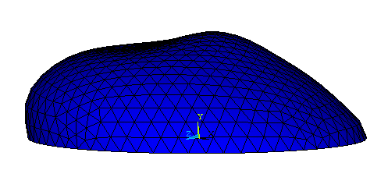
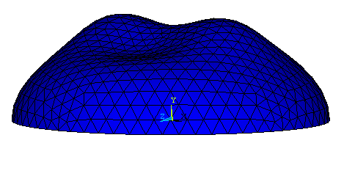
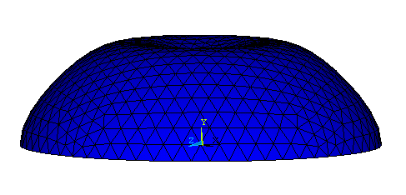
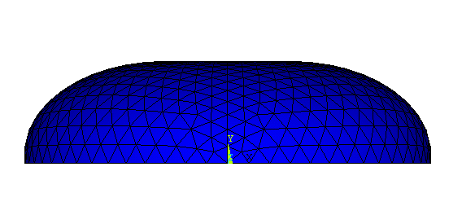
Mode 2
Mode 4
Mode 3
Mode 1

Fig (6): Mode Shapes for Oblate Spheroidal Shell for Model (1) with Thickness Ratio (t_{b}/t_{a}=4/3).

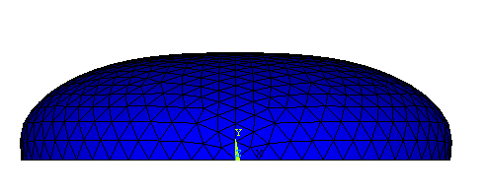
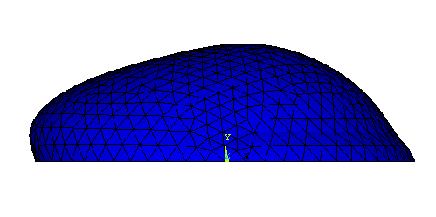
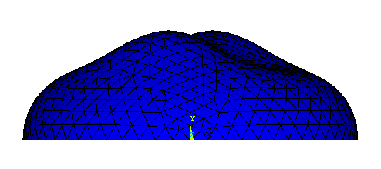
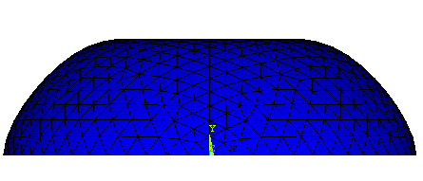
Mode 3
Mode 4
Mode 1
Mode2
Fig (7): Mode Shapes for Oblate Spheroidal Shell for Model (1) with Thickness Ratio (t_{b}/t_{a}=4/1).

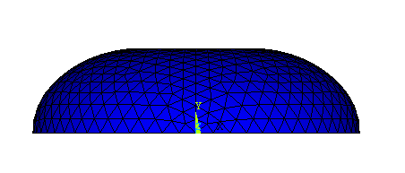
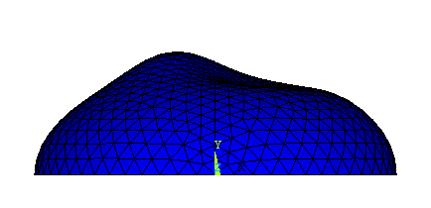
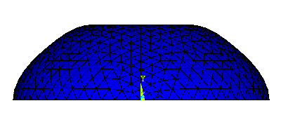
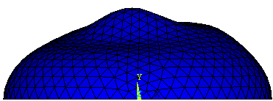
Mode 2
Mode 3
Mode 4
Mode 1

Fig (8): Mode Shapes for Oblate Spheroidal Shell for Model (2) with Thickness Ratio (t_{a}/t_{b}=4/3).

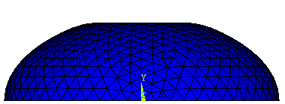
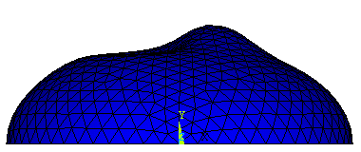
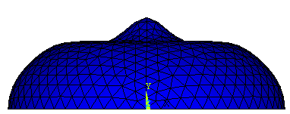
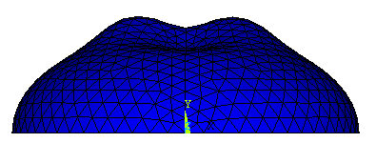
Mode 3
Mode 2
Mode 4
Mode 1

Fig (9): Mode Shapes for Oblate Spheroidal Shell for Model (2) with Thickness Ratio (t_{a}/t_{b}=4/1).

Table (1): Theoretical and Experimental Natural Frequencies for Oblate Spheroidal Shell (e= 0.683 , a=0.185 m , b= 0.135 m , h= 0.0015 m)

Mode | Present work | Experimental work (5) | Nawal H.A. (12)
1 | 2303 | 2412 | 2517
2 | 2815 | 2635 | 2973
3 | 2823 | 2951 | 3086
4 | 3051 | 3126 | 3180

5-Conclusions
The main conclusions of the present work can be summaries as:
- Natural frequencies are seen to have two types of behavior against increasing the thickness ratios (t_{a}/t_{b}) and (t_{b}/t_{a}), where increase with increase the ratio (ta/tb) and decrease with increase the ratio (t_{b}/t_{a})
- The natural frequency increases with increase the thickness of shell.
- In case increase the thickness ratio (t_{a}/t_{b}) give strong structure of shell.
6-References
Burroghs a C.B. nd Magrab E.B. 1978, Journal of Sound and Vibration 57,571-581,"Natural frequencies of prolate spheroidal shells of constant thickness".
Dimaggio F.L. and Rand 1966,J.Acoust.Sco.Amer.,38,262-265,"Axisymmetric vibrations of probate spheroidal; shells"
Dimaggio F.L. and Silbiger A. 1961 ,Journal of the acoustical Society of America ,33,56-58, "Free extensional tensional vibrations of a prolate spheroidal shell"
Fawaz A.N., Thesis," Raleigh- Ritz method in coupled fluid-structure interaction systems and its applications" Journal of the sound and vibration. Vol.186 (4), pp.543-550, 1995.
Kalnins A. and Wilkinson F.P.1965,J.App.Mech.,Vol 9,65-70,"Natural frequencies of closed spherical shells"
Kalnins A.," Free nonsymmetrical vibrations of shallow spheroidal shell" Journal of Applied Mechanical., pp.225-233, 1963.
Krus H. 1967,"Thin elastic shells",Johu Wiley and Sons,NewYork
Marcelin, J.L., and Trompette, P.H., "optimal shape design of thin ax symmetric shells" engineering optimization, Vol.13, p.p.109-117, 1988.
Mustafa, B.A.J., and Ali, R., “Free Vibration Analysis of Multi-Symmetric Stiffened Shells”, Journal of Computers and Structures, Vol. 27, No. 6, 1987, p.p. 803-8107.
Nawal H.A., Thesis," The Dynamic behavior of shell under environmental effect" University of Babelon, 2005.
Nemerugt P.J. and Brand R.S. 1965, J.Acoust.Sco.Amer. 40,179-189,"Axismmetric vibrations of prolate spheroidal shells".
Wilfred E.Baker 1961, J.Acoust. Soc. Amer. Vol.33,1749-1758, "Axisymmetric modes of vibration of thin spherical shell"

Nomenclature:
a | Major semi-axis of a prolate spheroid shell
A | Cross section area
b | Minor semi-axis of a prolate spheroid shell
Ei | Eccentricity ratio(${\sqrt{1−b^{2}}}/{a^{2}}$)
E | Elasticity modulus of isotropic material
{F} | Overall load vector
G | Shear ( rigidity ) modulus of isotropic material
h_{s} | Height of stiffeners
[K] | Element stiffness matrix
N_{i}($ξ,η$) | Shape function at node i
h | Thickness
X,Y,Z | Global coordinate system axis
x ,y ,z | Nodal coordinate system axis
u_{i} | Linear displacement along element x-axis
v_{i} | Linear displacement along element Y-axis
$$σ_{i}$$ | Normal stress in i-direction
$$ε_{i}$$ | Normal strain in i-direction
$$τ_{\text{ij}}$$ | Shear stress component through ij-plane
$$ξ,$$ | Poisson’s ratio of isotropic material
$$ξ,η,ς$$ | Intrinsic coordinate system
$$ρ$$ | Density (Kg/m${}^{3}$)
$$ω$$ | Circular frequency (red/sec)

