Study Of Thermal Solar Energy Storage Using Stationary Batterirs and Melting Salts Technique
Nizar Jawad Hadi
Material Engineering Dept.
Babylon University / Iraq

Ali A. Razzaq Al - Tahir Electrical Engineering Dept.
Babylon University / Iraq

Abstract
One of the most problems encountered in thermal solar energy plant is the efficiency and quantity of energy storage operation, which is performed in the day and then use it at night and cloudy weather periods to increase the plant running time. Two methods are used in this study for storing energy: First, the batteries are used for storing electrical energy which produces from a solar thermal plant. Select stationary battery, which consists from three positive plates and this battery would have a storage capacity of (500) Amp. hour for one hour every day at 25°C (77°F) and (6) Volt per cell with help of Excel and MATLAB Simulation program. This storage is very useful in solar energy system. The second method is collecting and holding the sun heat, which produced by concentrating solar power systems using materials that hold a large a mount of heat and release it slowly. One of these materials is melting salts such as Gloubers Salt (NA2SO4, 10 H2O) which used for this purpose. Salt solidification model is performed by Ansys 5.4 program. The results show that the storage in the first method is very useful in solar thermal energy systems. Also the results show that the storage energy by latent heat of the melting salt is more efficient than that by sensible heat and (90%) of the total storage energy in second method producing by latent heat. Three parameters are affected on the heat gain from salt solidification, which are initial temperature of the salt, geometry and surface area of the salt container and the latent heat value of the salt used.
Keywords Renewable Energy, Solar Energy, Storage, Stationary Batteries, Melting Salts, ANSYS , Excel and MATLAB Programs.

الخلاصة
أن من أهم المشاكل في محطات الطاقة الشمسية الحرارية هي الكفاءة والكمية في عملية خزن الطاقةو والتي تجري اثناء النهار و من ثم تستخدم في اوقات الليل والاجواء الغائمة لغرض زيادة زمن عمل المحطة. طريقتان استخدمت في هذه الدراسة لغرض خزن الطاقة.الطريقة الاولى استخدمت البطاريات لخزن الطاقة الكهربائية الناتجة من المحطة الحرارية الشمسية. لقد تم أختيار بطارية ساكنة والتي تتكون من من ثلاثة الواح موجبة و هذه البطارية تمتاز بسعة خزن حوالي (500) أمبير. ساعة وبمعدل ساعة واحدة يوميا عند 25 درجة مئوية( فهرنهايت77) و (24) فولت لكل بطارية بمساعدة برنامجِ Excel و بأستخدام الحزمة البرمجية مختبر المصفوقات الصدار السايع. الطريقة الثانية هي تجميع حرارة الشمس الناتجة من أنظمة الطاقة الشمسية المتمركزة باستخدام مواد تجمع كميات كبيرة من الحرارة وتطلقها عند الحاجة ببطىء. واحد من هذه المواد هو ملح كلوبر(NA₂SO₄, 10H₂O) والذي يستخدم لهذا الغرض. نموذج انجماد الملح اجري بواسطة برنامج Ansys 5.4 .النتائج اظهرت ان الخزن في الطريقة الاولى مهم جدا في انظمة الطاقة الشمسية الحرارية.كذلك اظهرت النتائج ان خزن الطاقة بواسطة الحراة الكامنة للاملاح المنصهرة هي اكثر كفاءة من الخزن بالحرارة المحسوسة و(90)% من الطاقة الكلية المخزونة في الطريقة الثانية انتجت بواسطة الطاقة الكامنة. ثلاثة عوامل تؤثر على الحرارة المكتسبة من انجماد الملح والتي هي درجة الحراة الابتدائية للملح, الشكل الهندسي لحاوية الملح ومساحتها السطحية, قيمة الحرارة الكامنة للملح المستخدم.
- Introduction
The sun gives off radiating waves of heat and light energy. The sun emits many other kinds of radiation called the electromagnetic spectrum, such as X - rays and ultraviolet waves. All the waves emitted from the sun move rapidly as tiny bundles of energy called photons. These photons travel vast distances from the sun through the vacuum of space. The sun delivers two forms of energy on the Earth: material radiation and electromagnetic radiation. For us only the electromagnetic one is important. There are many reasons why CSP is so interesting and why it should play a major role in the future energy mix. Apart from the fact that solar energy is the most abundant renewable source of energy on earth, the technological advances in the past (3– 4) decades have allowed CSP systems to reach a stage which indicates good potential to attain economic viability, given appropriate condition, in comparison with fossil sources. Today's CSP systems can convert solar energy to electricity more efficiently than ever before, they can be exported to the developing world and an additional advantage is their lack of significant environmental degradation. Since CSP systems produce both heat and electricity, they can be useful in some industrial applications; they have durability and low operation and maintenance costs. Another key competitive advantage of concentrated solar power systems is that they closely resemble the current power plants in some important ways. This means that most of the equipment now used for conventional power plants can also be used for CSP plants [Teacher, 2003]. The solar thermal power system collects the thermal energy in solar radiation and uses at high or low temperature. The low temperature applications include water and space heating for commercial and residential buildings [Sargent, 2004]. Producing electricity using the steam-turbine-driven electrical generator is a high temperature application. Electricity is more versatile in use because it is a highly ordered form of energy that can be converted efficiently into other forms. Electricity can be converted into mechanical form with efficiency near 100 % or into heat with 100 % efficiency. The heat energy can not be converted into electricity with high efficiency, because it is a disordered form of energy in atoms [Marwali, 1998]. For this reason, the overall thermal to electrical conversion efficiency of a typical fossil thermal power plant is under 40 %. A disadvantage of electricity is that it cannot be easily stored on a large scale. Almost all electrical energy used today is consumed as it is generated without storage stage [Dewinkel, 1994].

2. Solar Thermal And Concentrating Solar Power
The main concentrated solar power systems are the parabolic trough system, the parabolic dish system and the central tower system. After giving a first overview of the basic working principle of the different CSP systems, the single technologies will be analyzed in detail: at first the chronology of their development, then their actual and future developments [Chris, 1985]. Concentrating solar power systems use mirrors to concentrate the energy from the sun to heat liquids held in pipes and containers. Using a heat exchanger these hot liquids can then produce steam to drive the turbine that makes electricity. CSP works best with a clear, dry sky and a high concentration of the sun’s rays. In the United States, the sunny southwestern states have been actively exploring this technology. Types of concentrators are shown in Fig. (1). There are numerous methods for the rapid analysis and material design of that transfer leading for optimum operation and the FEM finite element of composite materials and analytical method. In this paper an approach is used to simulate of the previous method. This approach is based on FEM and implemented by using the ANSYS 5.4 program.

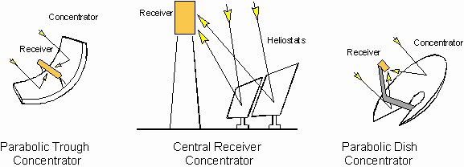
Fig. (1): Types of Concentrators.

2 -1 Solar Dish Engines

Solar dish engines may turn out to be the best option for remote and rural locations .Solar dish engines are composed of two parts: The solar dish is a convenient solution for off-grid electricity supply. Despite its high initial investment costs, it shows very high efficiencies. Two ways of collecting the energy from the sun with a dish have proven successful, giving birth to two different technologies: the dish / sterling systems and the solar farm.
- A curved parabolic mirror that concentrates the sun’s heat. With the absence of nun turn and when the mirror is pure reflector so all the objecting energy collecting in focus
and calculated the concentrated ratio from the following relation[Sol, 1990]:

$C_{r}=\frac{\text{Flux in image}}{\text{Flux intercepated}}=\frac{\text{Intercepated area}}{\text{Image area}}=\frac{A}{A^{−}}$ (1)

A Sterling engine that uses the heat to generate electricity. Dish engines can be used individually, providing between (5 to 25) kW, which is enough power for a farm or village, or can be combined for large-scale, grid - connected operations. Sterling engine also called the hot air machine, which used the air in this machine as material for operating. The cycle of this machine which consists four reversible processes for ideal gas is called Sterling cycle. This cycle consists from two isothermal processes with a two constants volume process. So, the output power can be increased by increasing the rotational speed, but there are practical conditions which limit the speed of machine [Francesco, 2005].
2–2 Parabolic Troughs
Parabolic troughs are long, trough-shaped reflectors that focus the sun’s energy on a pipe running along the mirror’s curve; the concentrated heat warms up oil flowing through the pipe. Heat energy from the oil is transferred through a heat exchanger to boil water to create the steam that drives the turbine. Parabolic troughs rotate from side to side, so they can track the sun as it moves from east to west. They are normally located in many parallel rows [Godfrey, 2001].

2 -3 Central Receiving Towers
Central receiving towers are tall structures with a boiler on top that houses a liquid suitable for heating, such as water. Molten salt. Surrounding the tower are many rows of mirrors, called heliostats, which turn to face the sun and focus its rays onto the boiler throughout the day. The concentrated sunlight from these mirrors heats the liquid to (1000-2700)°C. This produces boiling water, which makes steam for electricity generation. A thermal storage system ensures that even more power can be generated when the sun goes down. In a cavity receiver, which is a chamber-tube receiver, the heat transfer medium flows into the chamber inner walls, inside tubes, which are bent into spirals and connected in parallel? The opening has a little surface, which can be closed in case of temporary absence of light, in order to slow down outward heat transfer and cooling of the heat transfer medium. They are cheap to produce and are suitable for temperatures up to (600) °C. A second type of receiver is the external-receiver, which is made up of heat-transfer panels, i.e. panels composed by many heat-transfer tubes. In case of extended absence of light the tubes therefore must be completely evacuated. At higher temperatures, volumetric receivers are installed. In a volumetric receiver the heat transfer surface is made up of special, high-temperature resistant fibers or wires, either metallic or ceramic, ceramic foam or honeycomb structure. This three dimensions structure absorbs the radiation, and then air is aspirated into it, thus transferring heat to the steam generator. A quartz window is located behind the exit aperture of the concentrator. This window, which is inserted in a pressure vessel, enables the receiver to be operated at pressure of up to (15) bars.
The absorber consists of several layers of porous material, which absorbs the radiation in the depth of the absorber and converts it into heat. For temperatures up to (800) °C, wire meshing of high-temperature resistant metal wire is used, while at higher temperatures the absorber consists of high-porosity ceramic foams. Advantages of the volumetric air-receiver are the uniform distribution of temperature both in axial and radial direction and that the mean temperature of the receiver’s frontal surface, in contrast to the other receiver types, is always lower than the maximum medium’s temperature. Outward heat transfer, who depends on the surface temperature, is therefore decreased. Finally, in direct - absorption receivers the heat transfer is carried out by thin fluid films or by little particles which stream in an air - flow. Receivers of this type nowadays exist only as prototypes; they can achieve peak temperature of (2000) °C and heat densities of (2000) ${\text{kW}}/{m^{2}}$ [http://solar.anu.edu.au, 2005].
3 - Energy Storage Techniques
3-1: Energy Storage by Stationary Batteries:
The battery stores energy in the electrochemical form, and is the most widely used device for energy storage in a variety of applications. The electrochemical energy is a semi-ordered form of energy, which is in between the electrical and thermal forms. It has one-way conversion efficiency of (85 to 90) %. There are two basic types of electrochemical batteries, which are:
- The primary battery, which converts the chemical energy into the electrical energy. The electrochemical reaction in the primary battery is nonreversible, and the battery after discharge is discarded. For this reason, it finds applications where high energy density for one time use is needed.
- The secondary battery, which is also known as the rechargeable battery. The electrochemical reaction in the secondary battery is reversible. After a discharge, it can be recharged by injecting direct current from an external source. This type of battery converts the chemical energy into electrical energy in the discharge mode. In the charge mode, it converts the electrical energy into chemical energy. In both the charge and the discharge modes, a small fraction of energy is converted into heat, which is dissipated to the surrounding medium. The round trip conversion efficiency is between (70 – 80) %.Batteries are at least six major rechargeable electro chemistries available today, which are lead-acid (Pb-acid), nickel-cadmium (NiCd), nickel-metal hydride (NiMH), lithium-ion (Li-ion), lithium-polymer (Li-poly) and zinc-air. Table (1) provides relevant data on some of the many applications in which the stationary battery is used. Photovoltaic systems may be stand-alone power systems in applications such as remote railway crossings, billboards, highway tunnel lighting, etc. These systems have additional considerations, such as the battery remaining in a partial state-of-discharge during periods of insulation [Joseph, J., 1996].
Table (1): Typical Applications for Stationary Batteries.
ApplicationTypical Buck - up TimeRepresentative Capacity RangeNominal Voltage
Volt D.CTypical LoadsElectric Substations5- 8 hrs1800 A.hFrom 48 - 240 voltRelays and SCADA SystemElectric Power Generating Stations2 - 8 hrs2400 A.hFrom 48 - 240 voltInverters and Programble Logic ControlIndustrial Control1 - 5 hrs2000 A.hFrom 48 - 120 voltCircuit Breaker Control and Motor Operators Energy Storage Systems10 - 60 Minutes.20 M.W2000 voltElectric Power Systems

3-1-1: Sizing Battery for Multiple – Load Profile:
To select the ampere – hour sizing industrial battery of lead – acid cell, the load profile has four sections, each of which must be analyzed to determine which section controls the battery size, because the current in each period decreases with time. If the current in any period increased over that in the previous period, the section ending with the period just before the period of increased current would not have to be analyzed. Using formula from IEEE standard (485 - 1997) and the results for required size of battery in ampere – hour of lead – acid (Pb-acid)are shown in Table (2) for (250) maximum D.C Voltage system, (210) minimum D.C voltage and (24) volt per battery end of discharge ^{[Marco, 2000]}. Table (3) shows results of multiple load profile for four sections coming from thermal solar energy; all symbols are defined in nomenclature list.
Uncorrected Cell Size (Amp-hr.) $=\text{max}{}_{S=1}^{S=N}{}\sum_{P=1}^{P=S}{[A_{P}−A_{(P−1)}]\text{.}K_{T}}$ (2)

And,
Required Size (Amp-hr.) = (Uncorrected Cell Size) * (Temperature Correction Factor)*(Design Margin) * (Age Factor) (3)

Capacity
Rating Factor
K_{T}Temperature Correction FactorDesign
MarginAge
FactorRequired Size in
Ah.Max No
of Batteries
for 250 Volt D.CMin No
of Batteries
for 210 Volt D.CSize of Stationary Battery in Amp. hrRepresentative Capacity Range
In kW1.011.0520 %25 %500119500125
Table (2): Results for Required Size of Using Lead – Acid Battery in Ah.

Section
No. A₀
_{Amp.} A₁
_{Amp.} A₂
_{Amp.} A₃
_{Amp.} A₄
_{Amp.} R₁
_{Amp / positive plate} R₂
_{Amp / positive plate} R₃
_{Amp / positive plate} R₄
_{Amp / positive plate}No. of Positive PlatesSection1 0176 - - -125 - - - 1.41Section2 0176141 - -110112 - - 1.29Section3 0176141102 - 9394100 - 1.13Section4 0176141102 87 75 76 80 93 1.24
Table (3): Results of Multiple Load Profile for Four Sections in One Battery.

Reviewing the positive plates required for each section, one finds that section one requires the most positive plates of (1.41) and is thus the controlling section. When the correction factors and margin applied, required size = (Maximum Uncorrected Size). (Temperature Correction). (Design Margin). (Age Factor) = (1.41). (1.05). (1.2). (1.25) = (2.2) positive plates. Select a battery, which consists from three positive plates and this battery would have a storage capacity of (500) Ah for one hour operates every day at 25°C (77°F) and (6) Volt per cell. Fig. (2) shows sizing of battery for a multiple four – load profile from one hour in post meridian P.M to eleven hour in anti - meridian A.M ,using Excel program.

Fig. (2): Sizing of Stationary Battery for a Multiple Four - Load Profile.
Amp

It is evident from electrical results, the number and size of stationary batteries increases as ampere hour rating increased ,so it is needed to connect in series (35) stationary batteries as minimum value to supply (210) VD.C and (42) stationary batteries as maximum value to supply (250) VD.C for a multiple load profile. Off course the electrical results will be changed for a single load profile to select size of stationary battery.
Electrical power plants are most frequently compared on the basis of their levelised electricity costs, which relate the capital cost of the plant, its annual operating and maintenance costs to the annual production of electricity. When the sun light less then the acceptable value, the automatic transfer switch must be change concentrated solar power option to other energy resources such as wind-mill and stationary batteries, which are types of energy resources in Arab homeland [Benz, 2005].
A typical block diagram for electrical power supply is shown in Fig. (3-a), the three phase A.C load can be permanently fed from the direct path, the inverter D.C source being obtained from indirect path by rectifying the A.C voltage generated from three phase synchronous generator. In the event of direct path failure, the inverter will take its power supply from stationary batteries, thus avoiding any interruption to the load.
Loads which typically demand an uninterruptible power supply, are computers, communications links and essential instrumentation in certain processes. An alternative direct link to the load from the salient pole (1500) r.p.m same of thermal plant turbine, four pole synchronous generator and (3 A) D.C field current. A change over from three phase synchronous generator to a three phase square wave inverter supply via 20 dB gain of (L – C) low pass passive (L.P.F) filter will demand that the inverter be synchronized with the synchronous generator to avoid waveforms distortion. In these situations where a short interruption in supply can be tolerated, the inverter would only be brought into operation and connected to the load after synchronous generator failure through an automatic change over for ON and OFF switching.
Fig. (3-b) illustrates MATLAB simulation for three phases inverter voltage source with discrete PWM generator and universal bridge three arms have six insulated gate bipolar transistors and shunt diodes, which has 1V voltage drop for forward conduction, snubber resistance of (1) k Ω and switching ON state resistance of 10 ⁻⁴ Ω.
The system consists of independent circuit illustrating three-phase two-level pulse width modulation PWM. Inverter feeds an A.C load of active power is 120 kW, 50 Hz and inverter voltage of 208 V with a three - phases transformer (Δ / Υ) connection rating of (125) K.V.A . The inverter circuit is controlled by open loop with the discrete PWM generator block with carrier frequency of (1.8) kHz. Harmonic filtering is performed by the transformer leakage reactance of (6) k Ω and load capacitance of (15) KV.A.R. Fig. (3-c) shows time response for output voltage inverter and load voltage between two phases (a and b), which varies between ${}_{−}^{+}{}$ 24 VAC from discharge one battery in inverter circuit thought a power transformer. The inverter voltage varies between (208 - 174) V, which can be calculated from the following formula:
$V_{{\text{ab}}_{(\text{inverter})}}=\frac{m}{2}\text{.}\sqrt{3}\text{.}V_{\text{dc}}$ (4)

Where, m is the modulation index, which has a value of (0.96) in this study.

Fig. (3-a): Typical Block Diagram for Continuous Electrical Power Supply.

3 – Φ A.C
Load
120kW
50 HZ

Selector Switch
Solar
Thermal
Energy
CSP
(210 – 250) V
Thermal
Turbine
3 – Φ Armature
Windings
3 – Φ Bridge Rectifier
α = (15 – 45) º
V_{T} = 1.5 V
Field Windings
L>> R_{internal}
I_{feild} = 3 A
Field

3 – Φ Synchronous
Generator

125 kW
ω _{r}=1500 r.p.m
b

c

a
Stationary Batteries
L - C
Filter
20 dB
3 – Φ Square Wave Inverter
with PWM Generator
Automatic Change Over
ON - OFF
Automatic Change Over
ON - OFF
Direct Path
Indirect Path
Charging
Batteries
Discharging
Batteries
L.P.F
Passive
Filter
Firing Circuit
α = (15 – 45) º

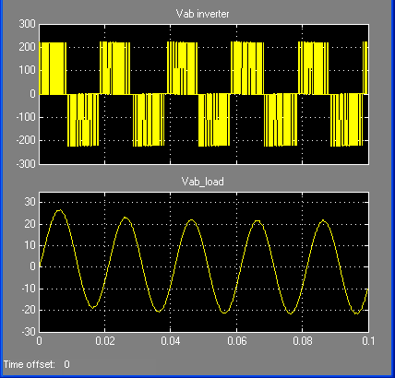
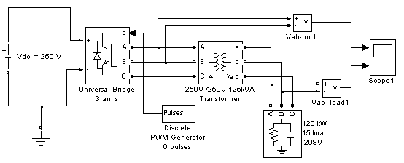
Fig. (3-c): Time Response for One of Three Phases Inverter and Load Line Voltage.
Fig. (3-b): MATLAB Simulation for Three Phases Inverter Voltage Source
with Discrete PWM Generator.

IGBT

3-2: Energy Storage by Melting Salts Technique:
The energy conservation tank is usually used in heating equipments by solar energy. The energy gain from the sun radiation during the sunny day periods can be saved and then used in the night and cloudy periods. When the energy stores in a medium the energy of that medium is increasing and then the kinetic energy of the medium molecules will be increased therefore the temperature increases. The medium energy is stored in the form of potential energy which is the molecules structure of medium material is change as in chemical change or in phase change (melting, evaporating) ^{[Sol, 1989]}.When the sun heat is effect on the medium material temperature that means thermal energy was saved with a sensible magnitude. If there is no change in the material state the increasing in the material temperature approximately proportional with the storage heat and inversely with material mass, the change in the material temperature, as follows:

$ΔT=\frac{Q_{s}}{m_{s}C_{s}}$ (Sensible thermal reservoir) (5)
The most important variable in thermal storing device is the magnitude of storing heat for volume unit therefore, for the sensible thermal storage it can be write equation (5) in the following form, all symbols are defined in nomenclature list:

$\frac{Q_{S}}{V_{S}}=\frac{m_{s}}{V_{S}}C_{S}\text{ΔT}=ρ_{s}C_{S}\text{ΔT}$ (6)
In equation (6) its better to make $ΔT$as small as possible by increasing the reservoir material mass. More efficient approach for temperature fixing is by alternating the sensible heat reservoir by melting potential heat reservoir. During the solid material heating the temperature keep increasing until reach the melting temperature $T_{m}\text{.}$ When another heat adding the temperature don’t change until the material transforms from solid to the liquid state completely. The absorbing heat for mass unit and storage in the medium during the state transformation process is called the latent heat, therefore the storage potential heat for volume unit is [Giere and Black, 2007]: all symbols are defined in nomenclature list.
$\frac{Q_{S}}{V_{S}}=ρ_{S}l$ (7)
The salt ${\text{Na}}_{2}{\text{SO}}_{4}{\text{,10H}}_{2}O$ is used for energy storage by this approach. There are many other salts which can used for the same purpose such as ${\text{Na}}_{2}{\text{CO}}_{3}\text{.}\text{10}H_{2}O,{\text{andNa}}_{2}{\text{HPO}}_{4}\text{.}\text{12}H_{2}O$.

4-2-1: Mathematical Model:
Ansys 5.4 program is used to simulate the solidification process for the salt. A 2d of one unit thick model will be performed as shown in Figs. (4.a) and (4.b).Since the problem is ax symmetric only a small sector is needed. An angle Ө = 10 is used for modeling the circular sector. The water has constant material property. The salt ${\text{NA}}_{2}{\text{SO}}_{\text{4,}}{\text{10H}}_{2}O$ has temperature dependent thermal conductivity k and enthalpy H; both are input in table of values versus temperatures. The enthalpy property table captures the latent heat capacity of the salt as it melts and solidifies.

Fig. (4.a): Full Model Sketch (All Dimensions
in Feet).

X Line of symmetry
r = 0.4 ft
θ = 10⁰
Fig. (4.b): Model Sketch in Polar Coordinates.

r = 0.2 ft
Y Line of symmetry
0.4 ft
0.2 ft
3.2 m
Water
Salt

The material property for the water is:
$ρ=\text{62}\text{.}4\left(\frac{\text{Ibm}}{{\text{ft}}^{3}}\right),C=1\text{.}\text{01}\left(\frac{\text{Btu}}{\text{Ibm}\text{.}F}\right)\text{and},k=0\text{.}\text{32}\left(\frac{\text{Btu}}{\text{hr}\text{.}\text{ft}\text{.}F}\right)$ (8)

The material property of the ${\text{Na}}_{2}{\text{SO}}_{4}{\text{,10H}}_{2}O$ salt is shown in Table (4):
k
H
00.480860.322325950.3151444451040.31315354
Table (4): The Material Property for the Water.

The following differential equations are used in numerical solution applied by Ansys version 5.4 program:

Continuity Equations: $∇\text{.}u=0$ (9)

Momentum Equations: $ρ\left[\frac{∂u}{∂t}+u\text{.}∇\text{.}u\right]=−∇p+∇\text{.}τ$ (10)

Energy Equations: ${ρC}_{P}\left[\frac{∂T}{∂t}+u\text{.}∇T\right]=∇\text{.}\left(K∇T\right)+2{\text{ηγ}}^{2}$ (11)
4-2-2: Results and Discussion
Solution control is used to establish several nonlinear options, including automatic time stepping, which determine the proper time step increment needed to converge the phase change nonlinearity. This means that smaller time step size will be used during transformation from molten salt to solid salt state.
It is evident from Fig. (5) shows the temperatures distribution contours after (12) second. The temperatures reduced gradually from $(\text{94}\text{.}\text{989})^{∘}F$ to $(\text{93}\text{.}\text{229})^{∘}F$ along the sector. The salt zone temperature reduced from $(\text{104})^{∘}F$ to the $(\text{94}\text{.}\text{989})^{∘}F$ in 12sec. and the water zone temperature is increased from $(\text{86})^{∘}F$ to $(\text{93}\text{.}\text{22})^{∘}F$ in the same time period. Fig. (6) show the salt and water behavior in (20) second.
The nods (98 and 107) represent the salt temperature decreasing from $(\text{104})^{∘}F$ to the $(\text{94}\text{.}9)^{∘}F$, while the nodes (35) and 1 represent the water temperature increasing from ${\text{86}}^{∘}F$ to the $(\text{93}\text{.}2)^{∘}F$, Also temperature at node (22) decreasing from $(\text{99})^{∘}F$ to $(\text{94})^{∘}F$. The results show a small temperature difference between the salt and the water, about (1.6) F after (20) second, and the temperatures keep constant after (10.5) second. Fig. (7) show that the temperatures distribution along x axis at Ө = 0. The maximum value is about (94.9) F at the center of the salt tank and reduces gradually until reaches $(\text{93}\text{.}2)^{∘}F$ at the outer surface of the water tank at the end of (10.5) second. Fig. (8), which represents the temperatures distribution on Ө direction at x = 0.4 ft. The temperatures keep constant at $(\text{32}\text{.}2)^{∘}F$ and slightly fluctuated. Figs (7 and 8) show the difference between the temperatures distribution on the x and Ө direction. Fig. (9) illustrates the heat flux distribution contours in the sector after (20) second.
The total storage heat $\frac{Q}{V}$ is about (11098) $\frac{\text{Btu}}{{\text{ft}}^{3}}$ and (90) % of this heat has stored by latent heat. The required volume for storing (11098) Btu. is:
$V=\frac{\text{11098Btu}\text{.}}{\text{11098}\frac{\text{Btu}}{{\text{ft}}^{3}}}={\text{1ft}}^{3}$
The salt container volume used is about (0.125)${\text{ft}}^{3}$ , therefore the heat storage is about (1387) Btu or (0.4) kWh. The initial temperature of the salt and water, the latent heat of the salt, and the geometry of the salt and water containers are the most three affected parameters on the time required and the energy release during the salt solidification and then on the entire storage process. The results show that the thermal energy storing by latent heat is more efficient than that by sensible heat and the heat storing occurs in narrow range of temperatures, also there is a lot of energy for volume unit. The technique problem in this work is that the tank material exposed to damage due to the chemical reactions and the heat transfer process is inefficient if the salt used has low thermal conductivity value. Also, the salt must be melting in temperatures suitable with that which can be actually reached in solar energy system. In any equipment for heat storing the entering temperature of fluid to the tank is bigger than the tank temperature itself otherwise the fluid is absorbed heat instead of given to the tank. Control system may be used to watch the fluid flowing, when the liquid temperature is decreased to the level below the tank temperature, the liquid flowing is stopped to avoid decreasing in the practical efficiency.
5-Conclusions
- Small concentrated solar power units do not take up much space and therefore can be placed in population areas, especially industrial or commercial locations, therefore the storage equipment adding not affect on the entire volume of the plant.
- If the current in any period increased over that in the previous period, the section ending with the period just before the period of increased current would not have to be analyzed. One finds that section one requires the most positive plates (i.e., 1.41) and is thus the controlling section. Select industrial batteries having three positive plates and this battery would have a capacity of (500) Ah for one hour operates every day at (25) °C i.e., (77°F) using Excel program.
3- The number of battery from the voltage considerations is between (9) and (11). It is generally more economical to use fewer battery of higher capacity than more lower- capacity battery. Therefore; select (10) stationary batteries in the battery numbers for the industrial applications.
4- It is evident from electrical results, number and size of batteries increases as ampere hour rating increased so it is needed to connect in series (9) stationary batteries as minimum value to supply (210) Volt D.C and (11) stationary batteries as maximum value to supply (250) Volt D.C for a multiple load profile. Off course the electrical results will be changed if this study uses a single load profile to select size of stationary batteries.
- The results show that the thermal energy storing by latent heat is more efficient than that by sensible heat and the heat storing occurs in narrow range of temperatures, also there is a lot of energy for volume unit.
6- After specific time the temperature reach a certain value depending on the initial temperature, geometry and surface area of the container, and the latent heat of the salt used.
7- Electricity can be converted into mechanical form with efficiency near 100 % or to heat with 100 % efficiency, while the heat energy cannot be converted into electricity with high efficiency, because it is a disordered form of energy in atoms. For this reason, the overall thermal to electrical efficiency of a typical fossil thermal power plant is less 40 %.
6-References
Chris, C., 1985,” Getting a High - Quality Continuous Electricity Supply from a Mixed Solar and Wind Power System”, Mathematics & Statistics, University of Auckland, Private Bag, Auckland,(book).
Dewinkel, C. and Lamopree, J.,1994. “Storing Power for Critical Loads” IEEE Spectrum, pp. 38 - 42.
Francesco, L., 2005” Technical and Economical Analysis of Future Perspectives of Solar Thermal Power Plants”, IER, (book).
Godfrey, B., 2001, ‘Renewable Energy Power for a Sustainable Future’’ Oxford University Press, (book).
Giere, R. and Black, M., 2007 “Metal Sulfates in PM Emissions From A Coal - Fired Power Plant” Gold Schmidt Conference.
http://solar.anu.edu.au, 2005,” Australian National University”, Date of request: 20.06.05.
Joseph, J., 1996,” A Technicians Guide in D.C Power Supplies”, Tab Books, A division of the McGraw - Hill Companies, Inc.
Marco, W., 2000,” Stationary Batteries”, Copyright by the McGraw-Hill Companies, Inc, (book).
Marwali, M., Halil, M.and Shahidehpour, S., 1998. “Short -Term Generation Scheduling in Photovoltaic - Utility Grid with Battery Storage,” IEEE Journal No. PE -184 , PWRS 16 - 09.
Benz, J., 2005,” Key Technology for Solar Power Plant Engineering”: DLR Nachrichten annual, p.p 39 – 41.
Sol, W., 1990,” An Introduction to Solar Energy for Scientists and Engineers”, Publishing by book house management, AL - Mosul University, (book).
Sargent, L., 2004,”Assessament of Parabolic Trough and Power Tower Solar Technology Cost and Performance Forecasts”, National Renewable Energy Laboratory, NREL / SR - 550 - 35060.
Teacher, E., 2003,”Electricity From Renewable Energy”, A Comprehensive Inquiry - Based Unit Correlated to all Applicable Content Standards for California Public Schools.

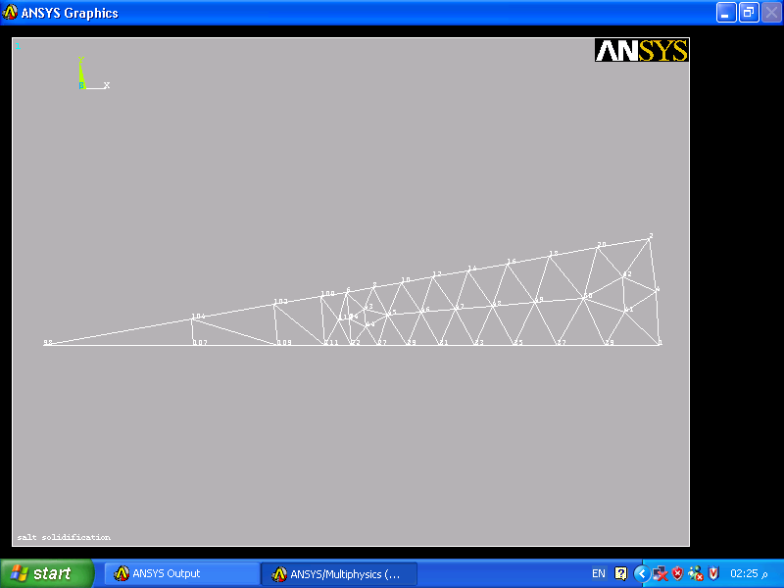
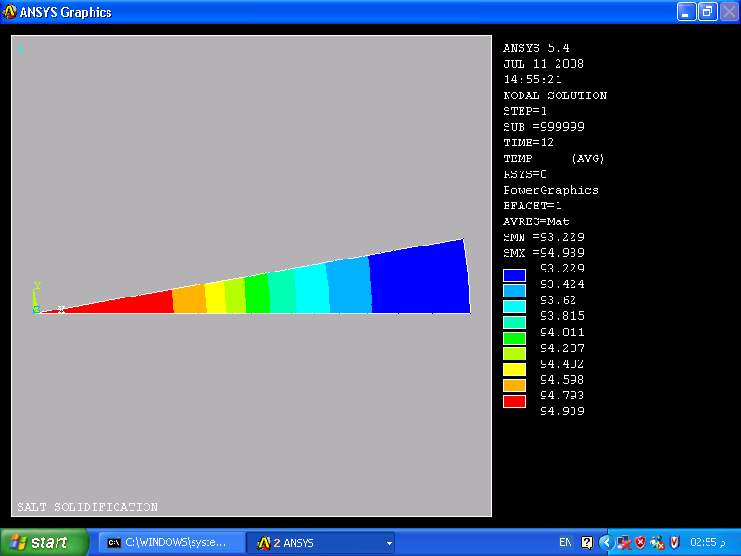
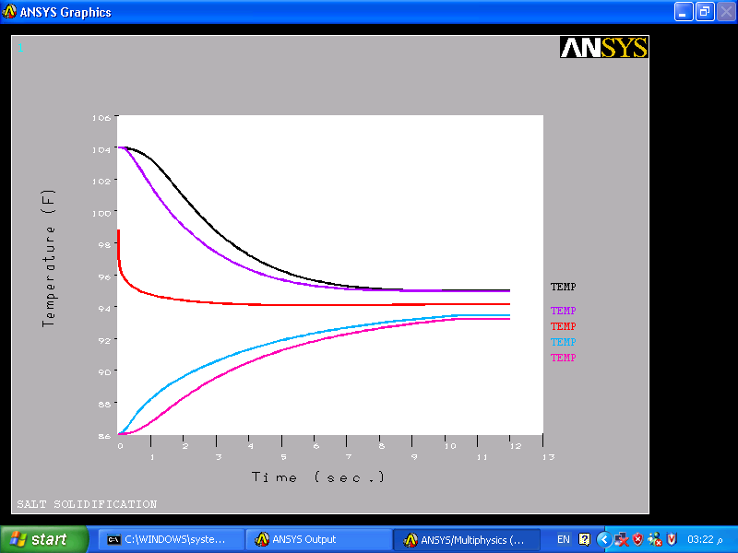
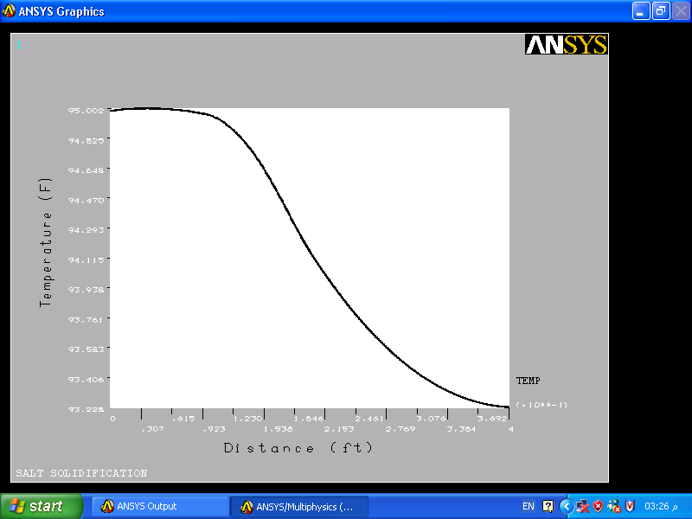
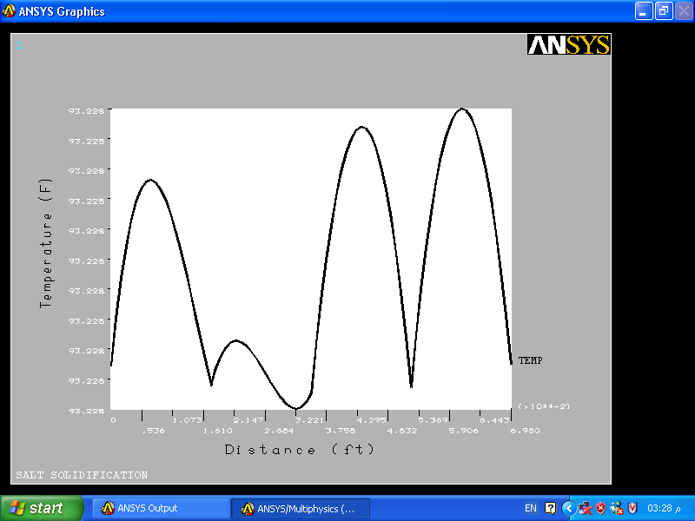
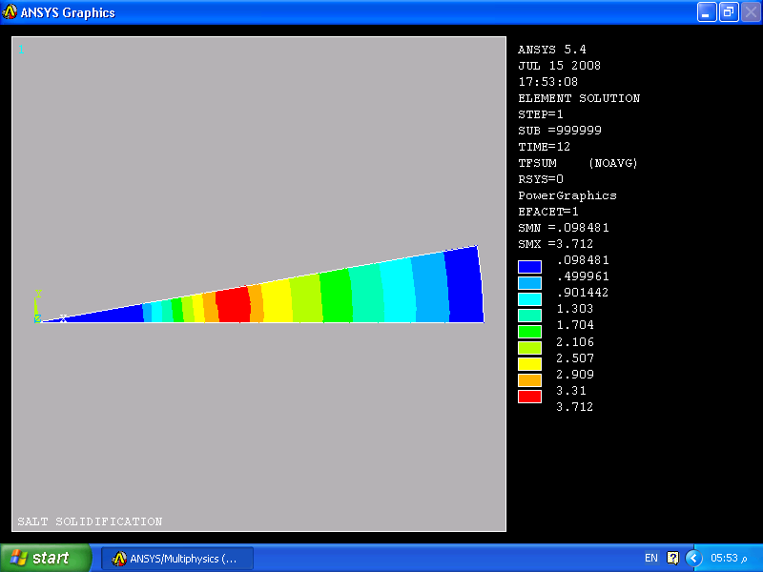
Fig. (6): Temperature Distribution Contours
After (12) Second.

Fig. (5): Finite Element Representation
of the Problems.

Fig. (7): Temperatures Distribution with Time at Nodes 98, 107, 22, 35, and 1.
Fig. (8): Temperatures Distribution Along X Axis and Ө = 0, Starting from the Center to the Outer Surface.

Fig. (8): Temperature Distribution along Ө Direction
at x = 0.4 ft.

Fig. (9): Heat Flux Contours Value in the x Direction after 12second.
107
35
98
22
1

Nomenclature
Symbols Definitions Units

CSP Concentrated Solar Power -
$C_{r}$ Concentrated Ratio -
A Intercepted Area $m^{2}$
$\overset{⃛}{A}$ Image Area $m^{2}$
Ah Ampere hour Amp. hr
$K_{T}$ A capacity Rating Factor -
S Section of load profile Being Analyzed -
N Number of Periods in the Load Profile -
P Period Being Analyzed -
$A_{P}$ Ampere Required for Period P -
m Modulation Index -
ω _{r} Angular Rotated Speed rpm
α Firing Angle Degree
dB Decibel Unit -
IGBT Insulated Gate Bipolar Transistor -
PMM Pulse Width Modulation -
$ΔT$ Temperature Difference in Fahrenheit ${}^{0}F$
$Q_{s}$ Storage Heat Btu / hr.
$m_{s}$ Reservoir Material Mass Ibm
$C_{S}$ Specific Heat Capacity Btu / Ibm. ⁰F
$V_{S}$ Volume ${\text{ft}}^{3}$
$ρ_{s}$ Density ${\text{Ibm}}/{{\text{ft}}^{3}}$
$l$ Latent Heat Btu / Ibm
K Thermal Conductivity Btu / hr .ft. ⁰F
H Enthalpy ${\text{Btu}}/{{\text{ft}}^{3}}$
u Velocity Vector $m\text{/sec}\text{ond}$
t Time Second
P Pressure Vector $N/{m^{2}}$
$C_{P}$ Specific Heat at Constant Pressure J / kg.K
T Temperature Kelvin
$η$ Dynamic Viscosity Pascal. second.
$γ^{∘}$ Shear Rate 1 / second.
$τ$ Shear Stress $N/{m^{2}}$
$θ$ Direction Angle Degree

