Laminating Hardened Glass for Safety Usage

Fadhil M. Hassoun, Firas J. Hmood
Babylon university, College of Eng

Abstract
In this work ion-exchange and laminating process were used for strengthening soda-lime glass which done in fused KNO₃ bath. Glass specimens were totally submerged in the bath. The temperature and time of process were varied in order to make stress profile and to determine the optimum conditions. It is found that ion-exchange process raising fracture strength of glass to 285.4% at 430^{ο}C and 273.7% at 450^{ο}C. It is also found that the hardness values increased to 16% at 430^{ο}C and 16.77% at 450^{ο}C. These values were extracted after 4hours and 2hours of dipping in molten salt respectively. As a result of laminating process, laminated glass has better properties than single glass. The applied load was 0.063KN for single layer while with increasing glass layers to six it became1.25KN. Using strengthened glass in lamination process contributes to improve applied load where it was 0.24KN for single layer and it became 1.91KN for six glass layers.
Keywords: ion-exchange, Fracture strength, Hardness, diffusion, lamination process.
الخلاصة
في هذا البحث تم استخدام طريقتي التبادل ألايوني و التراكب لتقوية الزجاج. في طريقة التبادل ألايوني تم غمر عينات الزجاج بالكامل في منصهر ملحي من KNO₃. إن العوامل التي تم التحكم بها هي الزمن و درجة الحرارة للحصول على أفضل مقاومة كسر للزجاج. الاختبارات التي أجريت هي الانحناء و الصلادة. بعد إجراء اختبار الانحناء وجد إن مقاومة الكسر زادت بنسبة 285.4% عند 430ºC و273.7% عند 450ºC. أما في اختبار الصلادة ظهر إن رقم الصلادة زاد بنسبة 16% عند 430ºC و 16.77% عند 450ºC. بينت نتائج اختبار الانحناء للنماذج المطبقة أن النموذج المكون من عدة طبقات أفضل من النموذج ذو الطبقة الواحدة حيث زاد الحمل المستخدم من0.063KN للطبقة الواحدة إلى 1.25KN لنموذج مكون من (ست) طبقات. كما ظهر من خلال اختبار الانحناء أيضا" إن الزجاج المعالج المستخدم لعملية التطبيق قد زاد قوة التحميل و الإزاحة العمودية قبل الكسر حيث كان الحمل 0.24KN لطبقة زجاج واحدة بينما أصبح الحمل المسلط 1.91KN لنموذج مكون من (ست) طبقات.
الكلمات الرئيسية: تبادل ايوني, مقاومة كسر,صلادة, انتشار, عملية تراكب.
1. Introduction
Glass has a unique combination of desirable properties for various engineering applications such as transparency, hardness, and low cost. The problem of glass is it can easily damaged. Ion-exchange is one of the methods to solve this problem (Haper,2001). The kinetic of ion-exchange in glass is usually described in terms of an interdiffusion coefficient, D, giving by the Nernest-Planks equations (Day,1976):

D = D_{a}D_{b} / (C_{a}D_{a} + C_{b}D_{b}) where:

C_{a}D_{b} = concentration and diffusion coefficient of (a) ions.
C_{b}D_{b} = concentration and diffusion coefficient of (b) ions.
The exchange of large alkali ions from an external source such as molten salt bath with comparatively small host alkali ions, in a glass surface leaves the glass in a state of surface compression (Haper, 2001).
Ion-exchange has many advantages such as: it can be applied to a variety of configurations without loss of optical quality of active element (Callister,2000). The level of stress does not depend as much on thickness (Mc. Lellan and Shand,1984), and it allows to use thin cross-section (Gardon,1985). Otherwise it is much cost in comparison with heat treating of glass (Mc. Lellan and Shand,1984).
lamination process is two or more sheets of glass are bonded together with one or more layers of Polyvinyl Butyral (PVB) (a plastic interlayer in sheet form). The principal benefit of laminated glass is their performance under impact. The laminated glass may break but any broken fragments will firmly bond to the interlayer which also absorbs impact energy, and reducing the risk of penetrating the panel. The interlayer laminated glass provides two additional benefits: reduction of sound transmittance (particularly at the higher frequencies) and ultra-violet radiation (between 320 and 380 nanometers) about 97% (Flinn and Trojan,1986).
Many authors have developed the techniques for strengthening soda-lime glass. H. K. Lee et al. (2003), used single ion-exchange in a molten of KNO₃ to increase fracture strength of soda-lime glass. Peitl O. and Zanotto E. D.,1999, have investigated the effect of ion-exchange on the thermal properties of borosilicate glass. Hobbelman et al. ,2001 studied the behavior of laminated glass under impact and they show that laminating glass has high impact resistance comparable to aluminum alloys. The authors of the present paper have investigated the effect of single ion-exchange upon the strength and of soda-lime glass to be used as safety.
2. Experimental Work
A. Chemical Treatment
Chemical composition of Soda-lime glass is given in Table (1). The glass was cut into beams with rectangular cross section. The dimensions of each sample are 120 x 25 x 1.9mm. Ion-exchange was achieved using a semiautomatic furnace. The molten salt (KNO₃) was put in a stainless steel container equipped with the furnace. The fused salt was recycled during treatment. The temperature of ion-exchange was varied from (430^{ο}C to 520^{ο}C) and the time is ranging from (0.25hr. to 7hr.).
The fracture strength was measured by three point bending (cross head speed: 5mm/min). Hardness was measured by Vicker's apparatus with a load of 0.5N.
Table (1): Chemical composition of Soda-lime glass
Rest% | K₂O% | Al₂O₃% | CaO% | Na₂O% | SiO₂%
10.2 | 0.26 | 1.53 | 9.96 | 9.45 | 68.2

B. Laminated Glass
Composite glass has prepared and the thickness of samples is ranged from 3.8 to 11.5mm. Epoxy resin is used as a glue material to tie glass sheets together. During the tying, glass sheets are put between two wood plies. Pressure is applied on the plies to let air to escape and distribute the glue on a whole area of the samples as shown in Figure (1). Adhered epoxy material is kept on for 7 days at room temperature to cure the whole laminated sample. Test done on this glass was bending to knowing maximum applied load and maximum vertical displacement.
3. Results and Discussion
3.1 Bending Test
Figure (2) shows the effect of dipping time in molten salt on the fracture strength of treated glass (according to JISR 1601, 1981). PHYWE machine model 17571-93, Germany, was used for determination fracture strength. It is clear that the ion exchange increases the strength of treated glass which reaches a maximum value at (450^{ο}C for 2hr. or 430^{ο}C for 4hr.); after that it decreases with increasing dipping time. The degradation of strength is due to structural relaxation at higher temperature with short time as in 520^{ο}C where did not record any increment.
3.2 Hardness
Figure (3) shows the results of hardness number of ion exchanged glass with dipping time in molten salt. It appears that the chemical treatment increased hardness number with increasing dipping time till maximum value at (450^{ο}C for 2hr. or 430^{ο}C for 4hr.); then decreased. The hardness shows the same behavior of fracture strength.
A comparison of Figures (1 and 2) shows that the initial increases of fracture strength is compatible with the growth of exchanged layer. After the maximum regime fracture strength and hardness tend to decrease despite of increasing in exchanged layer thickness, since the structural relaxation becomes preponderant to mechanism of strengthening [Abrams B. M. 2004].
The well performance was dipping glass in fused KNO₃ at 430^{ο}C and 450^{ο}C) for (2hr. and 4hr.) respectively and they are suitable to be used for strengthening glass. Table (2) shows the results of fracture strength and hardness of ion-exchanged soda-lime glass at all treating temperatures (best results for each temperature).

3.3 Bending Test for Laminated Glass
Bending test is done also on composite glass samples (multi-layered glass). In this test the glass sheet was in two states which are Untreated and Treated. Figure (4) shows a relationship between applied load (KN) versus vertical displacement (mm) for single glass layer. In this Figure there are two curves one for untreated glass and the other for treated glass. It is clear that the ion-exchange contributes to raise applied load in comparison with untreated glass.
Figures (5,6,7,8,9) show the same relationship for untreated layered glass. One can see that with increasing the number of glass layers in a sample causing increment in applied load for the sample. Despite this increment in applied load vertical displacement decreases because of brittleness of glass and epoxy. Figures (10,11,12,13,14) illustrate the same relationship for treated layered glass samples of and they shown that the applied load increase due to ion-exchange process. It is appeared in all shapes of laminated glass there is no residual strength because the epoxy resin has low ductility. Table (3) shows results of vertical displacement and load capacity for all laminated samples (untreated and treated).
4. Conclusions
Based on the experimental results which are discussed above, some points can be mentioned as a conclusions:
1. Chemical treatment can increase fracture strength and hardness number of soda-lime glass. The well conditions for processing are heating to 430^{ο}C and soaking for 4 hours or heating to 450^{ο}C and the other is soaking for 2 hours then cooling to room temperature. The fracture strength increased 3.87 times and hardness increased 1.16 times at 430^{ο}C while were 3.74 times and 1.167 at 450^{ο}C.
2. There is a balance between heating temperature and soaking time. Based on this balance, one can sense structural relaxation.
3. Treated glass better than untreated glass specially in composite glass.
4. With increasing glass layers vertical displacement decreases.
5. References
Abrams B. M., thesis,2004,'' Crack propagation and Fracture in Engineered Stress Profile Glass", The Pennsylvania State University, USA.
Callister W. J.,2000," Materials Science and Engineering", USA.
Day D. E.,1979,"Mixed Alkali Glasses-Their Properties and Uses", J. Non-crys. Solids, vol. 21, pp. 343-372, 1976.
Flinn R. A. and Trojan P. K. 1986," Engineering Materials and Their Applications", Loughton Mifflin Company,3rd edition,USA.
Gardon R.,1985,"Strong Glass", Journal of Non-crystalline Solids, vol. 73, pp. 233-246.
Haper C. A.,2001,"HANDBOOK OF CERAMICS, GLASSES AND DIAMOND", McGraw-Hill Companies, Inc., USA.
Hobbelman, C. J., van Zijl, G. P. A. G., Veer, F. A. and Ting, C. N., 2001,"A New Structural Material by Architectural Demand", http://www.bk.tudelft.nl/live/binaries/6757bb4e-14b9-4b65-8121-d7e6f8673362/doc/HOBBELMAN_2001ZuidAfrica_structural.pdf#search=%22A%20new%20%2Bstructural%2Bmaterial%2Barchitectural%2Bdemand%2Bpdf%22 ,.
Lee H. K., Kang W. H. and Green D. J,2003., "Improvement of Mechanical Property by Single Ion-Exchange Process in Substrate Glass", Journal of Information Display, vol. 4[3], pp. 12- 16.
Mc Lellan G. W. and Shand E. B.,1984," GLASS ENGINEERING HANDBOOK ", Mc Graw-Hill Company, Inc., 3rd edition,USA.
Peitt O. and Zanotto E. D.,1999," Thermal Shock Properties of Chemically Toughened Borosilicate Glass", J. non-crys. Solids, vol. 247, pp. 39-49.

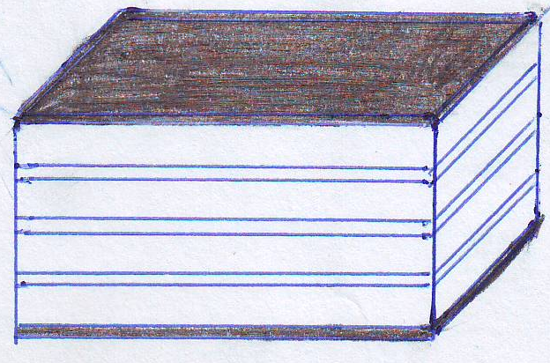
Glass
Glass
Epoxy
Wood
Pressure
Pressure

Fig.(1) Schematic of the forming of laminated glass
Time of dipping, hr.
Hardness, Kgf/mm²
Time of dipping, hr.
Fracture strength, MPa.

Fig. (2) effect of time of dipping on fracture Fig. (3) effect of time of dipping on
strength of ion-exchanged glass. hardness of ion- exchanged glass.

Table (2):Shows the results of fracture strength fracture strength and hardness of ion-exchanged soda-lime glass

Fracture strength of single glass layer, MPa
Treated | Untreated | Temp.,ºC | Time of dipping, hrs.
404.7 | 105 | 430 | 4
392.4 | 105 | 450 | 2
261.8 | 105 | 470 | 1
240.4 | 105 | 500 | 0.5
236.2 | 105 | 520 | 0.25
Hardness of single glass layer, Kgf/mm²
Treated | Untreated | Temp.,ºC | Time of dipping, hrs.
626.7 | 540 | 430 | 4
630.0 | 540 | 450 | 2
606.34 | 540 | 470 | 1
596.34 | 540 | 500 | 0.5
563.34 | 540 | 520 | 0.25

Vertical Displacement, mm

Fig.(4 ) show the relationship between
load-vertical displacement for layered
untreated glass (one layer).

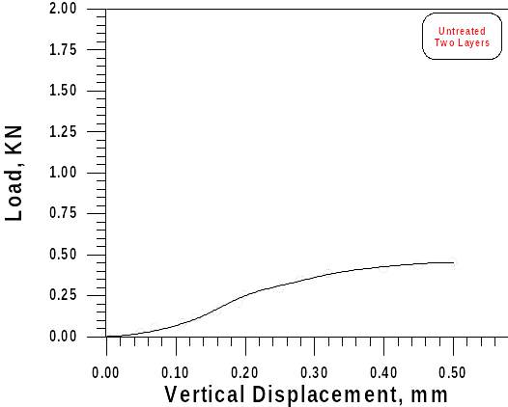
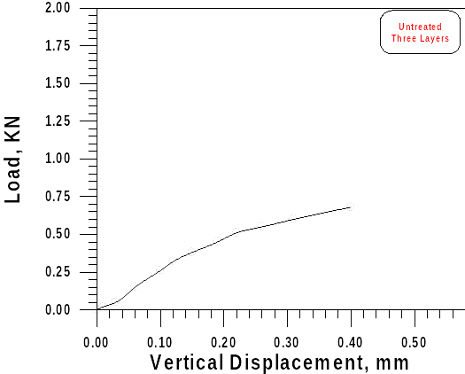

Fig.(5) show the relationship between Fig.(6) show the relationship between
load-vertical displacement for layered load-vertical displacement for layered
untreated glass (Two layers). untreated glass (Three layers).
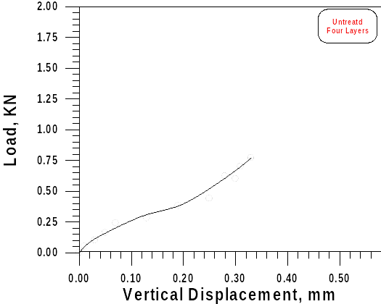
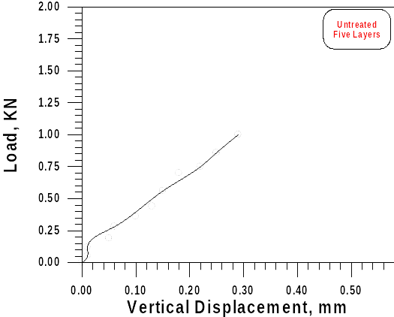

Fig.(7) show the relationship between Fig.(8) show the relationship between
load-vertical displacement for layered load-vertical displacement for layered
untreated glass (Four layers). untreated glass (five layers).

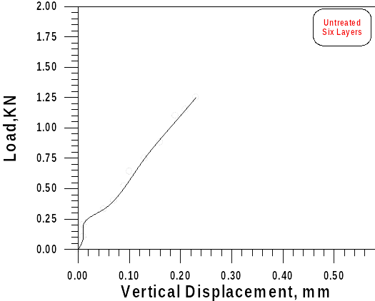

Fig.(9) show the relationship between
load-vertical displacement for layered
untreated glass (six layers).

Fig.(10) show the relationship between Fig.(11) show the relationship between
load-vertical displacement for layered load-vertical displacement for layered
treated glass (two layer). treated glass (three layers).

Fig.(12) show the relationship between Fig.(13) show the relationship between
load-vertical displacement for layered load-vertical displacement for layered
treated glass (four layers). treated glass (five layers).

Fig.(14) show the relationship between
load-vertical displacement for layered
treated glass (six layers).

Table (3):Shows the results of vertical displacement and load capacity for ion-exchanged laminated soda-lime glass

Summary of layered glass
Treated |  | Untreated
Load, KN | Vertical displacement, mm | Load, KN | Vertical displacement, mm | Number of layers
0.24 | 0.012 | 0.063 | 0.002 | 1
0.81 | 0.57 | 0.45 | 0.5 | 2
1.1 | 0.51 | 0.68 | 0.4 | 3
1.22 | 0.45 | 0.77 | 0.33 | 4
1.32 | 0.33 | 1 | 0.29 | 5
1.91 | 0.28 | 1.25 | 0.23 | 6

