Integral Fuel Tanks Corrosion by Fungal Species Proliferation

Wesam abdal-Zhrah Hindi
Technical institute of Babylon

Abstract
Twenty four samples of kerosene fuel from storage tanks were analyzed for fungal contamination , (11) different species were isolated and it was possible to verify the presence of Cladosporium resinae as the principle contaminant in these samples followed by Alternaria alternata , non of the isolated fungi alone except C. resinae were able to utilize kerosene as a sole source of carbon and energy, electrochemical technique reveals the type and magnitude of the attack expected and results showed that pitting potential (Ep) values falls with increasing incubation period and the aggressiveness of the medium toward the aluminum alloy as measured by (Ep) , corrosion potential (Ec) , corrosion current (Ic) , pH and type of attack appears to be related to those parameters and to the accumulation of the metabolites in the aqueous phase due to kerosene utilization. .
الخلاصة
تم فحص 24 نموذج من الكيروسين أخذت من خزانات الحفظ للتحري عن التلوث بالفطريات, عزل 11 نوع فطري مختلف وكان واضحا إن الملوث الأكثر شيوعا في العينات هو Cladosporium resinae متبوعا بالفطر Alternaria alternata وان جميع الانواع المعزوله غيرقادره على استهلاك الكيروسين بمفردها كمصدروحيد للكاربون والطاقه عدا C. resinae , وأظهرت الفحوصات الالكتروكيمياوية نوع ودرجة المهاجمة الحاصلة وان قيم جهد التنقر انخفضت بزيادة فترة الحضانة وان شدة المزرعة اتجاه سبيكة الألمنيوم كما قيست من خلال جهد التنقر , جهد التآكل , تيار التآكل , درجة الحموضة ونوع المهاجمة مرتبطة مع تراكم النواتج الايضيه في الطور المائي لتمثيل الكيروسين .
Introduction
The contamination of fuel systems by microorganisms has been studied by several workers[Dowling & Lundin, 2001]. while local researches in this field are rare . The aim of the study is the incidence of fungal contamination in fuel tanks estimating by an indirect technique. The existence of a 'normal contamination' caused by the inevitable introduction of conidia with fuel or a degree of ' fungal proliferation ' in the interior of fuel tanks such as to justify their being opened up, cleaned, and overhauled. Since the extensive production , transportation, storage and use of fuels, the problems associated with microbiological contamination began to be expanded [Pope&Johannes,2006]. The failures including filters blockage, malfunction of fuel gauges, corrosion of integral fuel tanks alloys associated with coating attack by microorganisms , sludge formation and biodegradation of hydrocarbons were reported [Borenstein ,2003. Lindsay , 2004]. The classic concepts for maintaining an industrial system free of the deleterious effects of microbiologically influenced corrosion(MIC) is to keep the system clean , although in practice this is a very difficult task . Several physical or chemical methods can be used but the most effective way to control proliferation and related problems is considered to be the improvement of the maintenance practices of storage of fuel tanks [Licina & Maner, 2006]. An emphasis on corrosion so far is that four processes are needed for corrosion to occur. One method of these involves biological processes where organisms can produce electron flow or modify the local environment to change from a none corroding to a corrosive one. Monitoring programs for microbiologically influenced corrosion (MIC) have focused mainly on microbial populations in samples and generalized corrosion or polarization resistance probes, however some objections to this kind of monitoring have been made because monitoring methods must provide information for corrosion assessment. The electrical resistance method which is widely used in the industry is only appropriate for indicating a change in the general corrosion rate but the results are difficult to interpret in the presence of localized corrosion such as pitting which is the most frequent form of attack found in MIC [Salvarezza & Videla, 1984] .The polarization resistance reveals that something is happening but may not give an accurate measure of the corrosion rate. The use of any of the techniques jointly with other electrochemical methods or variables assessing localized corrosion hazard can provide valuable data. Many workers introduced pitting potential (Ep) and polarization curves determination as a criterion for evaluating aggressiveness by metabolites in a medium [Videla & Guiamet, 1990 . Johnsen, 2004 ]. The comparison between these electrochemical results with polarization curves performed in water drained from integral fuel tanks may be considered a suitable tool to measure the magnitude of microbial proliferation [Ferrante, et al., 1998]. It is well known that microbial proliferation is strongly influenced by the quality of maintenance , thus the proposed electrochemical measurements may be used to improve in-service maintenance practices [ Franklin et al., 1997 ] .

Materials & Methods
1 – Samples collection
Samples( 1 L ) of kerosene were taken at three different points in the fuel system, (a) storage tanks (b) hose – tips (c) integral fuel tanks , in case of hose tips, sterilized bottles sized one liter were employed , while in the other two cases samples were taken through drainage valves.
2 – Analysis of samples
A millipore membrane sized 0.45^{µ} was used to retain fungal particles, 100 ml. of each sample were filtered in duplicate, samples were vigorously shaken before each filtration, the membrane was then placed on a medium of malt extract agar & incubated at 30 C for 48 – 72 hrs. Isolates were tested for their capacity to metabolize kerosene in flasks containing 100 ml. of Bushnell-Haas mineral salt medium (M.S.M.) with 20 ml. of kerosene as a sole source of carbon and energy and incubated at 30 C for one week [Bushnell & Haas, 1941]. Cultures of mixed isolates were done in the same way for those of a single species with the same amount of spore concentration (36x10³spores/ml) of each fungus was introduced .
3 – Preparation of the alloy specimens & electrochemical studies
Specimens of T351 aluminum alloy of 0.5 cm.² exposed area, polished with 600 grade emery paper were used to obtain polarization curves. The electrolyte was Bushnell & Haas mineral salt medium diluted with distilled water in the ratio of 1: 10 inoculated with C.resinae . Incubation were made into 4 liter flasks in the presence of sterile kerosene as a sole carbon source in a volume ratio of aqueous phase to fuel of 10 :1 .The aqueous phase was separated to perform electrochemical determination in mineral solution. Both in the presence or absence of oxygen. Solutions were de- aerated by bubbling 99.9% N2 through them, magnetic stirring was used to control the hydrodynamics of the system. Drainage water from aqueous phase aliquots were taken after filtration through cotton for separating dirt and mycelium and used for electrochemical determination [Atlas, 1995]. Potentiostats Tassel PRT 20 was used to determine polarization curves and Tacussel servovite 9A for scanning potential. Potential scan was 10 mV/min. In potentiostatic determinations steps of 50 mV were applied each 5 minutes. A pyrex glass cell with a platinum counter electrode was used. The potentials were measured through a luggin capillary with a saturated calomel electrode as reference. Corrosion currents in oxygenated and de-oxygenated media were determined [Magot & Ollivier , 2005] . .
Results & discussion
Table 1 shows a list of the isolated fungi , their percentage frequency of appearance and their maximum and minimum levels of contamination expressed as the number of viable particles (colony count) per liter of fuel , the predominance and high frequency of C. resinae in the samples agree with results obtained in different parts of the world [Zambon,1997; Singh, 2005] and confirms the importance of this species as a principle contaminant of fuel systems. The frequency of appearance and levels of contamination given by various authors show high discrepancies [Dubey & Upadhyay ,2001 . Crolet et al., 2003]. Results of this study are at variance with those of others although there is agreement for a few species [Magot et al., 2000] The absence of Aspergillus spp. and the low frequency of Paecilomyces variotii may be explained by the predominance of different kerosene tolerant strains in different parts of the word [Videla ,2002 ].The capacity of the isolates to metabolize kerosene was tested. Table 2 shows that non of the isolated fungi, except C. resinae, exhibited growth on cultures that having kerosene as the sole source of carbon and energy in the mono-batch cultures, while growth as verified visually, was only observed in those mixed cultures of which one of the component was C. resinae and all the strains of C. resinae exhibited fast and profuse growth with a high degree of sporulation which shows the great adaptation for kerosene assimilation and this results agree with results of other workers [ Horn et al., 2003 . Zhu et al., 2003], and according to the results obtained by others [Videla, 1996 ;Zhu et al., 2004] and to those obtained in the present work, only the extreme variations in the number of viable particles per liter of C. resinae were taken as indices of contamination. Pitting potential (Ep) values of the alloy in the culture of C. resinae incubated for 9 days at 30 C are shown in table 3 for different periods and indicated that Ep falls with increasing incubation period. Polarization curves corresponding to the indicated test conditions for fungus culture shown in figure 1, the main parameters determined were (pitting potential (Ep), corrosion current (Ic), corrosion potential (Ec), pH and type of attack) are shown in table 4. The aggressiveness of the medium measured as Ep, Ec, and Ic of the alloy in the inoculated medium appears to be related to the concentration of one or more of the metabolites accumulated in the aqueous phase, when Ec is less than Ep, generalized corrosion is observed, but when Ec is greater than Ep pitting is produced, decreasing pH values with incubation time refer to growth of the fungus in the culture, although, on the fifth day, a pH decrease of 0.8 units was determined with regard to the sterile medium , the corrosion rate remained in the same order of magnitude in fig, 1 A and B, but for the next 19 days a pH decrease of 1.2 unites was observed and two orders of magnitude increase of corrosion rate can be seen in fig.1C. A pH decrease of 0.5 units in the medium between the 24th and 60th days of incubation corresponds to an acceleration of one order of magnitude in the corrosion rate fig. 1 C and D . Even for periods longer than the life cycle of the fungus , higher corrosion current values were observed (fig.1, D) with increased time. This appears to indicate that not only the metabolites of living cells could be responsible for the increase of corrosion products concentration in the batch system, but also some products of natural decomposition of the fungus itself could cause the metal to corrode. Many mechanisms are proposed to explain the role of microorganisms in the corrosion of aluminum alloys and one of them is that the metabolic products of the biodegradation of hydrocarbons influence the corrosion process. In this work by an electrochemical technique demonstration we conclude with a good agreement with others [Jones et al., 2004; Franklin, et al., 2000] the correctness of this hypothesis.

Table (1) : Fungal isolates of the fuel systems with their percentage & levels of contamination .
Levels of contamination ( particles / L fuel ) | Percentage of contaminated samples (%) | Genera & or species
20 – 260 | 13 | Acremonium sp.
5 – 50 | 30 | Alternaria alternata
10 – 5000 | 65 | Cladospoium resinae
20 – 40 | 17 | C. cladosporioides
40 – 45 | 4.2 | C. sphaerospermum
10 – 20 | 4.2 | Cladosporium sp.
90 – 100 | 4.2 | Epicoccum purpurascens
10 – 20 | 4.2 | Fusarium sp.
200 – 220 | 4.2 | Paecilomyces variotii
10 – 15 | 4.2 | Ulocladium chartarum
50 – 2500 | 4.3 | Penicillium sp.
Table (2) : Synergic effect of the isolated fungi in metabolizing kerosene as a sole source of carbon & energy .
Growth in M.S.M. + KEROSINE | Growth in M.S.M. | Type of culture
 |  | 1 – Mono – culture
_ | _ | Acremonium sp
– | _ | Alternaria alternata
₊ | _ | C. resinae
_ | _ | C. cladosporiodes
_ | _ | C. sphaerospermum
_ | _ | Cladosporium sp.
_ | _ | E. purpurascens
_ | _ | Fusarium sp.
_ | _ | Paecilomyces variotii
_ | _ | U. chartarum
_ | _ | Penicillium sp.
 |  | 2- Mixed cultures
+ | _ | C.resinae + Acremonium sp.
+ | _ | C. resinae + A. alternata
+ | _ | C. resinae + Penicillium sp.
_ | _ | A. alternata + Acremonium sp.
_ | _ | A. alternata + Penicilium sp.
_ | _ | Acremonium sp. + Penicillium sp..
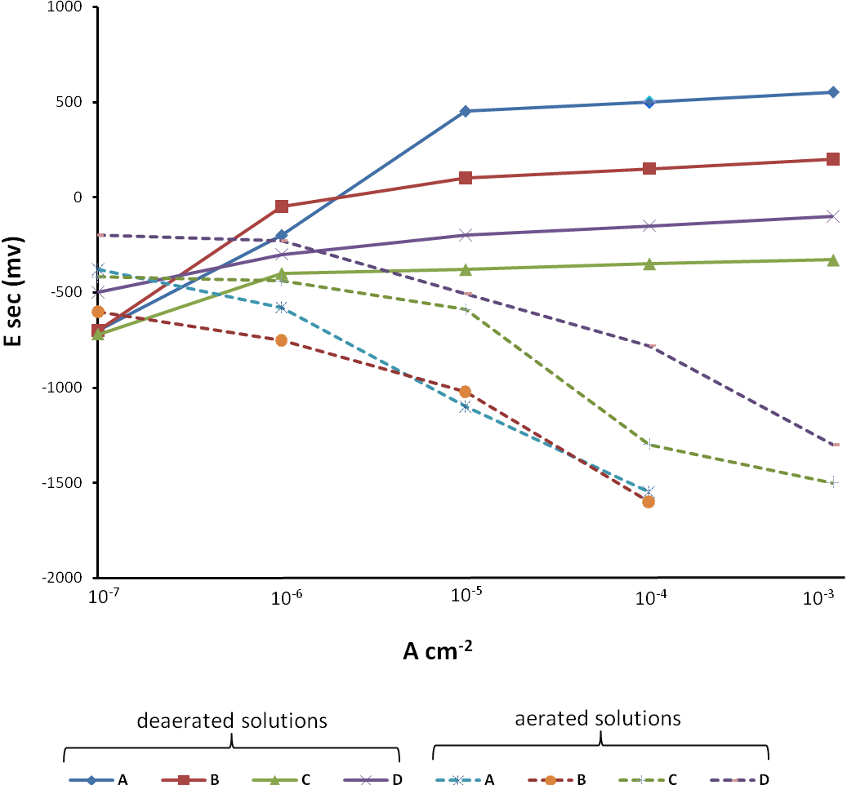
E sec (mV)
A
B
D
B
d
c
a
b

A,a): Sterile M.S.M.)
B,b): M.S.M inoculated with C. resinae for 5 days at 30C° .)
C,c): M.S.M inoculated with C. resinae for 24 days at 30C° .)
D,d): M.S.M inoculated with C. resinae for 60 days at 30C° . )

d
c
b
a

Figure(1): Potentiokinetic polarization of T351 aluminum alloy in Bushnell-Haas M.S.M.

(A,a): Sterile mineral salt medium (M.S.M.))
(B,b): M.S.M inoculated with C. resinae for 5 days at 30C° .
(C,c): M.S.M inoculated with C. resinae for 24 days at 30C° .
(D,d): M.S.M inoculated with C. resinae for 60 days at 30C° .

Table (3) : Pitting potential of T 351 aluminum alloy in Bushnell –Haas medium inoculated with C. resine .

Ep. Values | Duration of incubation ( days )
+550 mV sec.* | Sterile medium ( control )
+ 550 mV sec | 0
+550 mV sec | 2
100 mV sec ─ | 6
350 mV sec ─ | 9
* mV sec = Millivolts per seconds with reference to saturated calomel electrode .

Table (4) : Results of the indicated parameters obtained from Bushnell - Haas medium inoculated with C. resine.
Type of attack | pH | Ec  mV sec. | Ic  A. cm⁻⁻² | Ep. mV sec. | Condition
Uniform corrosion | 6.5 | 420─ | 4.2 x 10 ⁻⁷ | + 550 | Sterile medium
Uniform corrosion | 5.7 | 400─ | 2.2 x 10 ⁻⁷ | + 50 | 5 days incubation
Pitting & uniform corrosion | 4.5 | 310─ | 1 x10 ⁻ ⁵ | 300─ | 24 days incubation
Pitting corrosion | 4 | 40─ | 1.2 x10 ⁻ ⁴ | 150 ─ | 60 days incubation

References
Atlas, R.M., 1995. Petroleum biodegradation & oil spill bioremediation .Mar. Pollut. Bull. 31; 178 –182 .
Borenstein,S.W. 2003. Microbiologically influenced corrosion failure analysis. Mater. Perform. , 27: 51-59 .
Bushnell, L.D. & Haas. H.F. 1941. The utilization of certain hydrocarbons by microorganisms . J. Bacteriol. 41; 653 – 673 .
Crolt , J.L., Leyer & G.G. Tricot. R. 2004. Biocorrosion in oil & gas industry . In S. Audision (ed.) , The multimedia corrosion guide .
Dowling ,N.J. & Lundin, L.C. 2001. Evidence of biogenic corrosion of fuel tanks after exposure to a continuous cultures of microorganisms Corros. Sci, 52; 831-42.
Dubey ,R.S. & S.N. Upadhyay. 2001. Microbial corrosion monitoring by microbial biosensor . Biosensors & Bioelectronics. 16; 995 – 1000
Ferrante, V., Feron D. & Wagner. P.R.1998. microbially influenced corrosion of steels ; a biological & electrochemical study . Biofouling. 15 ; 13– 23 .
Franklin, M.J., White D.C. & Isaacs. H.S. 2000. The use of current density mapping in the study of microbial influenced corrosion. J. Bioeng . Biotech . 40 ; 601 – 608
Franklin, M.J., Nivens D.E. & White. D.C. 1997. Effect of electrochemical impedance spectroscopy on microbial cell number, viability, & activity. Corrosion. 47; 519 – 528 .
Horn, J., Carrillo C. & Dias. V.2003. Comparison of the microbial community composition in sludge from fuel tanks & field environments Appl. Environ. Microbiol. 54; 799 – 808 .
Johnsen, R., 2004. Field guide for investigating integral biocorrosion of fuel pipelines. Corrosion . 36 ; 253 – 273.
Jones, J., Walch M .& Mansfeld. F . 2004 . Microbial electrochemical studies of coated steel exposed to mixed microbial communities. Electrochem. Acta. 43; 77-85 .
Licina, G.J. & Maner. M.K. 2006. In-plant electrochemical studies of service fuel system materials .Int. Mater. Rev . 22 ; 77-83 .
Lindsay, P.B. , 2004 . MIC failure analysis . Mate. Perform., 33;43-56 .
Magot, M. & Ollivier. B. 2005. Petroleum microbiology .ASM Press, Washington, D.C.
Magot, M., Ollivier B. & Patel. B.K.C. 2000. Microbiology of petroleum reservoirs. Antonie leeuwenhock . 77; 103– 106 .
Pope,D.H. & Johannes. D.J. 2006. Microbiologically influenced corrosion of industrial alloys . Mater . Perform. , 23; 14-18 .
Salvarezza, R.C. & Videla. H.A. 1984. Microbiological corrosion in fuel storage tanks, Part 1–anodic behavior. Acta Cient . Venez., 35; 244-247.
Singh, O.P. 2005. Indicators of microbiologically influenced corrosion in fuel systems. Microbiol. Molec. Biol. Rev. 67 ; 503 – 549 .
Videla, H.A. & Guiamet. P.S. 1990 . Bioelectrochemical assessment of biofilm effects on MIC . Corrosion. 1; 56 – 66 .
Videla, H.A.,1996. Manual of bioconversion. CRC Press, Boca Ratan FL., pp. 273.
Videla, H.A., 2002 . Prevention and control of biocorrosion. Int. Biodeter. Biodegr. 49 ; 259 – 270 .
Zambon, J.J., 1997. In-situ identification of microbial species in fuel tanks by using an immunofluorescence technique. Appl. Environ. Microbiol., 48; 1214–1220 .
Zhu, X., Lubeck J. & Kilbeane J. 2003. Characterization of microbial communities in fuel industry pipeline . Appl. Environ. Microbiol. 69; 5354 – 5364.
Zhu, X., Lowe K. & Daram. A. 2004 . Improved method for monitoring microbial communities in fuel pipelines . Bid . Bull., 71 ; 324 – 331 .

