Exterior Personalization Of Multi-Unit Housing
(Residential Campus Of Babylon University,
60thst. In The City Of Hillah…)

Hassan Abd Ali Al-Guesbi
Dept. of Architecture, Faculty of Engineering, University of Babylon.
Abstract
Personalization refers to the marking of places, or the accretion of objects within them, and thereby the staking of claim to them. (If it is an area, that has been marked as a territory). Place attachment represents the bonds that people have to a specific environment, and the subsequent knowledge and values people hold for that environment.
The main goal of this research is to check if there is a statistical significant relationship between personalization and the formation of place attachment, and to increase knowledge about the complex nature of place attachment considering the dynamics of the relationship over time, space, people and context. Also. It is an attempt to explore how the context of a setting might relate to the attachments people form with it.
The observation and listing of architectural physical elements through doing a cross sectional study would be helpful in determining the type of relation between personalization as an independent variable and place attachment as a dependent variable. The hypothesis suppose that much more exterior personalization of multi-unit housing would reflect the feeling of control and place attachment and vice versa. The level and type of personalization the users would like to adapt under the influence of the suggested confounding (sub-variables) of ownership, identity, privacy and security could be detected leading to possible general design responses according to the necessary components of aesthetics physical attractiveness that satisfy people needs.
الخلاصة
يبدو أن هناك علاقة وثيقة، متداخلة ومتبادلة، بين ميل شاغلي الوحدات السكنية للتميّز والتفرّد في إظهار بعض تفاصيل المشهد الخارجي لبيوتهم، وبين إحساسهم بالانتماء والارتباط (البيت ووحدة الجيرة). ويميل البحث للتأكيد على أن زيادة الاعتناء بتفاصيل المشهد الخارجي للوحدات السكنية من قبل شاغليها يعكس مقدار تفاعلهم مع المكان، وإحساسهم بالسيطرة والتملك والهوية والأمان والخصوصية، وبشكل يزيد من انتمائهم وارتباطهم بذلك المكان، والعكس صحيح. وقد تم التحقق من هذا الافتراض بمقابلة ومراقبة بعض الوحدات السكنية الخاصة بأساتذة جامعة بابل في المجمع السكني التابع للجامعة، والواقع قرب كلية الفنون الجميلة، على شارع (60) في مدينة الحلة.
والشيء الملفت للنظر حقاً هو أن مشهد بيوت معظم الشاغلين (المستأجرين) في المجمع يكاد يكون نفسه دون تغيير يذكر أو تميّز أو تفرّد وذلك نتيجة إحساسهم بعدم ملكية المكان بالدرجة الأساس. وبالتالي كانت الملكية (Ownership) ومظاهرها الطبيعية في السيطرة والسيادة والتميّز هي العامل المؤثر الرئيسي على الإحساس بالانتماء والارتباط بالمكان. يليها الإحساس بالأمان (Security)، حيث يفضل الكثير من الشاغلين البقاء في هذا المجمع رغم ارتفاع معدلات الإيجار لأسباب أمنية، وهم يميلون للاعتناء ببعض التفاصيل الضرورية المتعلقة بهذا الجانب. وتأتي الخصوصية (Privacy)، والهوية (Identity)لاحقاً ضمن أولويات الشاغلين.
Territorial Personalization:
Walking into almost any residential campus today, and one would immediately exposed to a wide variety of indications of habitants' personal territoriality: artifacts, such as name plates on doors, coloring and painting of outer doors and windows… These are examples of habitants' attempt to establish, communicate, and control their relationships with the others and the setting (situational) life.
Territorial personalization could be defined as an individual's behavioral expression of his or her feelings of ownership toward a physical or social object. This definition includes behaviors for constructing, communicating, maintaining, and restoring territories around those objects in the setting toward which one feels proprietary attachment.
Territoriality of physical space has been shown to engender a sense of belonging to social groups. (Lewis, 1979). Territorial personalization could be beneficial in clarifying and simplifying social interactions. Despite its prevalence and potential influence, there has been very little theoretical or empirical examination of territorial personalization in organization life. The few studies largely have been carried out within the tradition of environmental psychology. (Pierce, Kostova & Dirks, 2003).
Psychological ownership has its "roots" in three fundamental human drives that provides the reasons for why individuals experience psychological ownership. First, psychological ownership fulfills the need for efficacy: Individuals are motivated to be efficacious and competent and consequently desire to control their environments in ways that might facilitate this. Second, psychological ownership is rooted in the need for self-identity: through connections to organizational objects, one can communicate one's identity, as well as explore and reflect on one's own understanding of that identity. (Pierce, Kostova & Dirks, 2001). Finally, psychological ownership is rooted in the inherent need of people to have a place of their own. (Duncan, 1981). A home, whether physical or metaphorical, can provide physical and psychological security that can serve as a foundation for a variety of positive experience and behaviors. (Brown, Brown &Perkins, 2004).
Psychological ownership refers to feelings of possessiveness and attachment to ward an object.
Research in psychological ownership suggests that one dimension of ownership-one need that is satisfied- is the need to have a place of one's own. Behaviors, such as marking and defending. That increase the sense one has a place of one's own will increase the rootedness and sense of belonging a habitant has with the place.
Some Aspects Of Personalization
Personalization can involve tangibles, such as physical space and possessions: intangibles, such as ideas, roles, and responsibilities: and social entities, such as people and groups.
The more one fulfills his basic needs of efficacy, self-identity, and having a place of his own, the greater his attachment to that place. The fulfillment to those needs means that the territory in question has stronger personal and psychological value to the individual, motivating him or her to communicate it to others (through marking) and to protect and keep it (through defending) as his or her own.
Two distinguished aspects of personalization would be elaborated: Physical Markers & Socio-Economics Aspects.
Physical Markers
Marking refers to those personal behaviors that construct and communicate to others the individual's proprietary. Examples of physical markers include physical symbols, such as a nameplate on an individual's door, pictures of one's children on a computer screen, or a coat thrown onto a chair…
Specifically, identity-oriented marking or personalization is the deliberate decoration or modification of an environment by its occupants to reflect their identities. (Sundstrom & Sundstrom, 1986). Identity-oriented marking serves the function of enabling individuals to both construct and express their identities to themselves and to others. With this form of marking, individuals can express a variety of facets of their identities, including their professions-for example, degrees and diplomas on the wall; their status-for example, long-service awards or titles after their names. (Well, 2000).
One's personalization of an object may or may not communicate the same aspects of identity that would be communicated in other settings. Thus, personalization is an important type of marking that allow a person to express his or her identity and foster a sense of belonging to the setting.
Marking can be relatively permanent, establishing enduring boundaries and proprietary control of a territory for an indefinite period of time. (Donald, 1994). Territorial marking, for instance, allows individuals to avoid conflict because they are able to make the boundaries and proprietary nature of territories clear to others. (Brown, 1987).
Control-oriented marking (personalization) will be influenced by the degree of attachment to a place. This relationship will critically depend on the degree of ambiguity regarding the ownership and boundaries of the place in question. Control-oriented marking organizes and brings meaning to place, roles, and other objects that may be potential territories, so greater ambiguity will trigger higher levels of control-oriented marking.
SOCIO-ECONOMICS ASPECTS:
Personalization is a social behavioral concept, which has at least two key aspects. First, personalization involves social actions that flow from psychological ownership in a social context. There is no reason for personal behavior if one has psychological ownership of objects that are not in a social realm. People feel attached to all sorts of objects in the world, but it is only those objects to which individuals feel a proprietary attachment that will lead to personal behaviors. Personalization is not simply about expressing some form of attachment to an object (e.g., "I love my home!"); rather, it is centrally concerned with establishing communicating, and maintaining one's relationship with that object relative to others in the social environment (e.g., "This is my home and not yours!").
Second, personalization reflects the social meanings of actions regarding claiming and protecting objects as they are negotiated in a given social context. It is only when one publicly claims and protects an object as his or her own in a social environment that it is transformed into a territory. Thus, territories are social constructions that only come into being through the personal behaviors of individuals.
Although marking demarcates territorial boundaries and indicates the relationship between a territory and an individual, the socially defined nature of these boundaries and attachments means they will sometimes be under conflict or subject to differing interpretations. (Wollman, Kelly & Bordens, 1994). Feelings of anger from infringements may lead the territory holder to act irrationally and make poor decisions. (Richards & Gross, 1999).
Some social contexts make marking difficult because the people in that context lack a shared set of symbols to meaningfully establish territorial boundaries. This might be the case when habitants are new to one another.
Person-Setting Relationship, Place Attachment And Context:
Person-setting relationships have received fairly sustained theoretical attention from diverse disciplines and have been conceptualized in numerous ways and under various related terms such as "sense of place", "place belongingness", "place belonging", and "place attachment". Underlying these conceptions is the idea that a sense of "place" results from people attaching meaning to what otherwise would simply be "space". So, Place attachment could be defined as the extent to which a person values or identifies with a particular setting. Figure (1) shows various kinds of behavioral relationship between the user and his setting.

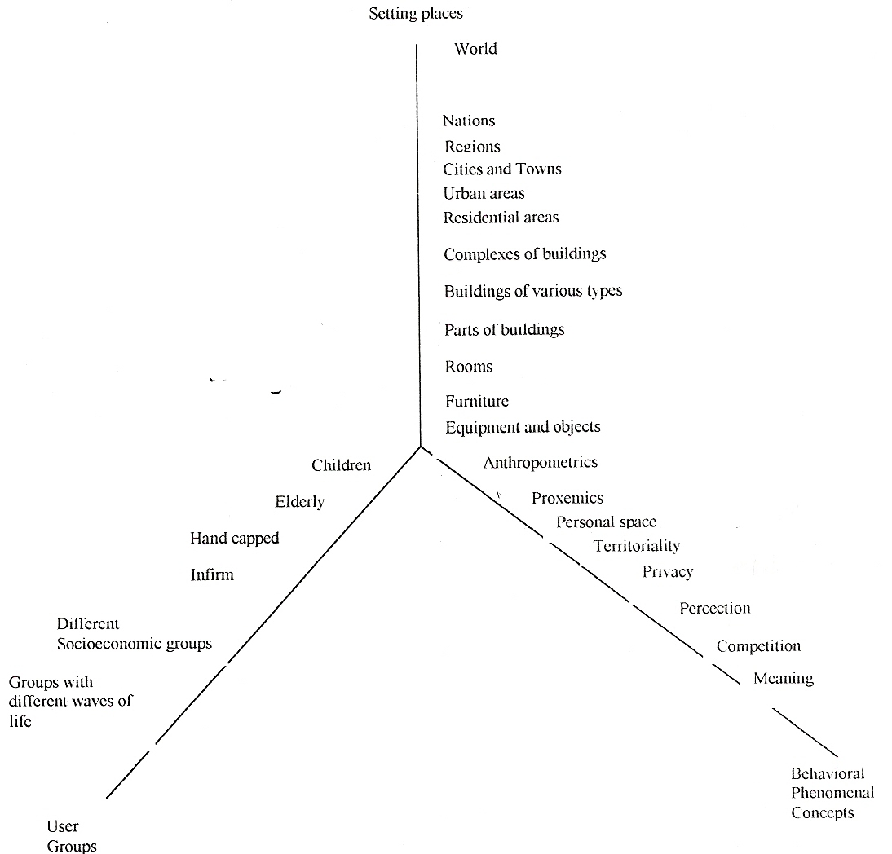

Figure (1): User-setting relationship.
(Source: Moore, 1979)

It may be important to distinguish between attachments to a given place versus attachment to specific locales within that place. People can form attachments to a class of similar settings as well as specific places. (Williams, Patterson & Watson, 1992). Place attachment, for example, may be a fruitful means of segmenting users. (Warzecha & Lime, 2001). Some have suggested that people who are attached to a place may be more willing than others to donate their time and money on its behalf? (Moore & Graefe, 1994); and citizen's groups frequently mobilize to protect what they consider to be special places. (Scenic America, 2001). The question is: What is the best way to add place attachment into the mix of inputs when attempting to make decisions about how to manage an entire system of places and the many sub-features that make it up?
Researchers have sought to understand factors that lead people to develop attachments to places within the natural environment. A few researchers have found that variables related to the activity pursued on-site successfully predict the level of attachment people assign to a given place.
Qualitative and less traditional research methods also seem particularly well suited to understanding the nuances of place meaning. For example, community self-assessment approaches can provide community members and researchers with a more complete understanding of how individuals and groups relate to their surroundings. It is important to know whether or not people are attached to a given area or to certain "special places" within the area. As researchers, the need is urgent to determine the extent to which place attachment may have distinct dimensions and to better understand the dynamics of how attachments form through balancing between potential and effective environment, see figure (2).

Hypotheses, Variables And Methodology:
The hypotheses supposes that an increasing unity of meanings that people gain through their experience with the physical elements surrounding them, can lead to an increasing sense of place attachment.

The research's Variables would be elaborated as:
- Independent Variable: Personalization.
- Dependent Variable: Place attachment.
- Confounding (Sub-variables): Ownership, Identity, Privacy and Security.

Many methods would be used to study personal behavior, such as how habitants mark their territory and how often they engage in defensive personal and territorial behavior. Traditional survey instruments could be used to assess the frequency of specific territorial behaviors, using both self-reports as well as reports from other. Observations and interviews of habitants would provide rich behavioral data.
On the other hand of the methodological spectrum, some research direct questions may be more amenable to experimental designs involving either the observation or manipulation of marking, invasion, and defense of territories; environmental psychology provides strong examples of how experimental methods can profitably be used in the study of personalization.
Some basic descriptive previous studies addressed the range of tactics that habitants use to mark and defend their ownership over space, possessions, ideas, roles, and relationships. Two major factors, concerning the personalization, affecting the sense of attachment to the place. The first includes the physical environment and the provision of personal distinguishing exterior markers, like outer doors, fences, elevations… of each house, and the right to model them to suit ones pleasure and how they adds personality to it. The question could be modified to be: Do people create temporary territories in public settings? This would be examined at the residential campsites of Babylon University near the College of Arts in Hillah. in terms of observed characteristics-including personalization (e.g., flags, banners) and barriers (e.g., fences, gates)…
In addition, it focuses on maintenance of the physical and natural features that are shared by all housing residents and how it affects participation, interaction and intimacy with the place, and therefore affecting people's attachment to it. The physical elements are suggested to be outside and take different meanings for different people of various cultures. Unity of meaning of the physical environment is influenced by the duration of using, ownership, income, benefit, security…
The second factor is place in community, how neighborhoods relationships affect, through mutual interaction, the sense of belonging, and sense of closeness. For, being in community means sharing resources and support. In other way, as a summary of the problem, this would be expressed as follows:
That is the place I call home, people I love, the trees, and everything I need. I feel safe in this place, this place of neighborhood with sight of children playing. I am aware of my belonging to this place.

As a result for these physical and social factors, it would be concluded how people's resistance to changes of physical or social environment would affect place attachment. And to tell that once you have been attached to a place and participate in it, you are gradually shaped by it.
Two kinds of data collection processes were detected. The first is structured interviews. These will include questions on different variables of the physical elements. Interviews are preferred over questionnaire:
- To examine how do respondents will talk about the variables of study, if they are comfortable and proud talking about it or not. This is considered as a very important aspect.
- To listen to some words of mouth of the respondents themselves.
- To explain the questions to the respondents.
Most of these interviews were made accidentally. So that respondents might experience the meaning of the physical elements that would be intended to be asked for them. Other interviews will be made inside the house of the respondents.
The second type of data collection method is an observation to show along with some questions from the interviews. There are many aspects to be observed like:
- Checking whether habitants really take care of the environment they live in, like watching if they maintain their houses appearance clean and beautiful.
- Checking how much time and how many habitants are there in the activity setting near their houses.
- Checking whether habitants do use their setting for socializing at night or do they use their houses to do so, or do they get out to another community.

Results And Discussions
Twenty of the academic staff habitants of Babylon University's residential campus near the College of Arts in 60th St. of the city of Hillah were interviewed while observing thirty housing units there separately. Social aspects in the setting (concerning ownership, privacy, identity and security) would be marked depending on such questions like:
- Are you looking to have this unit for your own or no?
- How long have you been here? And for how long do you plan or intend to stay here?
- How much your income and your average rent?
- To which extent do you think that this campus is suitable for you and your family?
- Do you prefer to change the location of your residence to other unit within the same campus? Why?
- Do you feel secure here?
- What do you think about the outer fence of the campus?
- Do you want to increase the number of artificial obstacles and barriers within the campus?
- Do you prefer to reside the next door of your colleagues in the same department? Or this doesn't matter?
- Do you have any suggestions to develop the campus?

The results indicate that about (90%) of the sampled habitants are working hard to have and build their own independent houses out of the campus because of the temporary occupation nature and high monthly rents, versus a percentage of (7%) hoping to own these units in the future. This bulk percentage do not care about any physical aspects to decorate or personalize their unit houses. Also, they don't prefer to change their location nor having any developing suggestions.
A percentage of (88%) of the habitants feel safe and secure within the campus. (22%) of them declare without any hesitation of having some other alternatives, but they prefer to stay a little more meanwhile versus (61%) of them denied having other choices.
Complaining the lack of privacy and intimacy was the surprising issue. About (10%) of the exemplars need more privacy versus (90%) having adequate amount of it. Identity wasn't mentioned here strongly. About (20%) of the residents feel proud of themselves to gain a house after a long struggling competition among their colleagues and to be remembered, at least, by their institution. They feel that they are from the upper class residing in a significant position distinguishing them from others.
Examined variations in levels of exterior maintenance and adornment among the residents record sort of physical markers to be noticed in the campus. Most of the habitants (about 75%) prefer to keep the same detailing elevations, colors and paintings. (70%) of them claim that this is because of restricted rules and systems. (80%) of the habitants prefer to keep their unit houses as they are for, as they would said, economical reasons! Unfortunately, (65%) of the houses need sort of maintenance and restoration in spite of their short age. (25%) of the residents prefer to put plates of their names on outer doors. No significant lightings were recorded.
Conclusions
Personalization help habitants to control and defend what they own, to feel secure and to define their territories and identities, which are often at risk in times of significant changes. Individuals mark their territories to express these variables through logos and architecture, or through norms.
Groups mark territories in similar ways as individuals, such as claiming group membership through nicknames, passwords, special gatherings, and predetermined membership lists.
The results suggest that exterior personalization in neighborhoods may provide an ecological mechanism indicative of group membership and domain. Identity -oriented marking- or -personalization- increases the degree to which habitants attach to those objects. To the extent they perceive those objects as organizational. Their attachment is also likely to extend beyond the immediate territory to the place as a whole. Therefore, individuals are more likely to identify with their place if they feel they can also express characteristics they value about themselves through personalization.
Also, the results indicate that if the habitants were homeowners, they will exhibit more personalization than renters because ownership leads to a series of personal behaviors, including physical and social marking. Higher sociability scores were significantly associated with long-term residents and security feelings. Privacy and identity would come later in the habitants' priorities surprisingly.
So, using the stringent demarcation and defense criterion would explore that people do create temporary territories in public spaces. Furthermore, the results suggest a close covariation between territorial cognitions and behavior, and the importance of desirability of locale for both of these.
References
Brown, B.B. 1987. Territoriality. In D. Stokols & Altman (Eds.), Handbook of environmental psychology, vol. 2: 505-531. New York: Wiley.
Brown, G., Brown, B.B., & Perkins, D.D. 2004. New housing as neighborhood revitalization: Place attachment and confidence among residents. Environment and Behavior, 36:749-775.
Donald, I. 1994. Management and change in office environments. Journal of Environmental Psychology, 14: 21-30.
Duncan, N.G. 1981. home ownership and social theory. In J.S. Duncan (Ed.), Housing and identity: Cross-cultural perspectives: 98-134. London Croom Helm.
Lewis, C.A. 1979. Comments: Healing in the urban environment. Journal of the Institute of American Planners, 45: 330-338.
Moore, G.T. 1979. Advances in Environmental Behavior and Design: Environment Cognition and Action. Oxford University Press, UK. P:50.
Moore, R.L., & Graefe, A.R. 1994. Attachment to recreation settings: The case of rail-trail users. Lesis. Sci. 16: 17-31.
Pierce, J.L., Kostova, T., & Dirks, K.T. 2001. Toward a theory of psychological ownership in organizations. Academy of Management Review, 261: 298-310.
Pierce, J.L., Kostova, T., & Dirks, K.T. 2003. The state of psychological ownership: integrating and extending a century of research. Review of General Psychology, 7: 84-107.
Richards, J.M., & Gross, J.J. 1999. Composure at any cost? The cognitive consequences of emotion suppression. Personality and Social Psychology Bulletin, 25: 1033-1044.
Scenic America. 2001. Last chance landscapes: Places of beauty or distinctive character with both a pending threat and a potential solution. http:// scenic.org/lcl_nomination.html.
Sundstrom, E.,& Sundstrom, M. G.1986. Work places: The psychology of the physical environment in offices and factories. New York: Cambridge University Press.
Warzecha, C.A., & Lime, D.W. 2001. Place attachment in Canyonalands National Park: Visitors' assessments of setting attributes on the Colorado and Green Rivers. J. Park Rec. Admin. 19: 59-78.
Well, M.M. 2000. Office clutter or meaningful personal displays: The role of office personalization in employee and organizational well-being. Journal of Environment and Psychology, 20: 239-255.
Williams, D.R., Patterson, Roggenbuck, J.W., & Watson, A.E. 1992. Beyond the commodity metaphor: Examining emotional and symbolic attachment to place. Leis. Sci. 14: 29-46.
Wollman, N., Kelly, B.M., & Bordens, K. S. 1994. Environmental and interpersonal predictors of reactions to potential territorial intrusions in the workplace. Environment and Behavior, 26: 179-194.

