Effect of Temperature on the Electronic Structure of Cubic - Silicon Carbide

Hamad Rahman Jappor
Babylon University, College of Education, Department of Physics
Mohammad Ghanam
Babylon University, College of Science, Department of Physics

Abstract
A large unit cell (LUC) formalism of eight atoms within intermediate neglect of differential overlap (INDO) is used to study some properties of cubic-silicon carbide, and to study the effect of temperature on these properties. Cohesive energy, direct and indirect band gap, valence bandwidth, conduction bandwidth and hybridized orbitals of crystal are obtained from the band structure calculations. All the aforementioned properties are obtained by selecting empirical parameter sets for LUC-INDO model. It is found that the result are in good agreement with experimental results, direct and indirect band gap, and valence bandwidth decrease with increasing temperature, while the conduction bandwidth and cohesive energy increase.
الخلاصة
خلية وحدة كبيرة ( (LUC مكونه من ثمان ذرات ضمن الإهمال المتوسط للتداخل التفاضلي (INDO) استعملت لدراسة بعض خصائص كاربيد السليكون ذو الشبيكة المكعبة ولدراسة تأثير الحرارة على هذه الخصائص. طاقة الترابط ، فجوة الطاقة المباشرة، فجوة الطاقة غير المباشرة، عرض حزمة التكافؤ، عرض حزمة التوصيل وتهجين المدارات قد تم الحصول عليها من حسابات التركيب ألحزمي. إن جميع الخواص المذكورة قد تم الحصول عليها باختيار مجموعة مُعلمات تجريبية لأنموذج وحدة الخلية الكبيرة للإهمال المتوسط للتداخل التفاضلي. من خلال الحسابات نجد أن النتائج التي تم الحصول عليها في بحثنا هذا في تطابق جيد مع النتائج العملية، إن النتائج تبين أن فجوة الطاقة المباشرة وغير المباشرة وعرض حزمة التكافؤ تتناقص مع زيادة درجة الحرارة بينما يتزايد عرض حزمة التوصيل و طاقة الترابط.
1. Introduction
Silicon carbide (SiC) is a wide-gap semiconductor with an indirect band gap of intriguing properties. It possesses a number of unique properties, hardness, chemical inertness, low diffusion rates of dopants and host atoms, electrical and thermal properties which make it a potential candidate for semiconducting device application [Choyke et al., 2004]. For example, blue light emitting diodes, high-power, high frequency devices and sensors working in harsh environments are only the first steps in the application of SiC as an advanced material. Consequently, SiC is now in the focus of detailed experimental and theoretical investigations [Pollmann and Krüger, 2004]. In the last few years, the electronic properties of some SiC polytypes have been calculated [Backes et al.,1994], further studies went deep into the optical, the thermomechemical properties [Tang and Yip, 1995], and the high pressure behaviour [Cheong et al., 1991].
Under normal conditions SiC has differing structures depending on how they are ordered, SiC may adopt a large variety of semiconducting polytypic forms that are all very close in energy [Käckell et al., 1994]. They consist of different stacking of hexagonal Si-C, the most common of which are 3C (zinc-blende structure, the stable form), 6H, 4H, and 2H, (wurtzite structure) [Mujica et al., 2003]. Experimental progress in the study of SiC has been obstructed for many years by the difficulty of growing homogeneous single crystal, partly because of large number of SiC polytypes. Recent developments on the bulk crystal growth and control of polytypism [Powell et al., 1993], in epitaxially grown layers, have yielded high quality single crystals, making possible the systematic experimental study of this material.
In this paper, we present detailed information on the band structure, bulk modulus, cohesive energy, hybridization of state, and valence charge density of cubic zinc-blende silicon carbide (3C-SiC) under temperature, calculated using the self-consistent large unit cell within intermediate neglect of differential overlap method (LUC-INDO) in the linear combination of atomic orbital (LCAO) approximation [Radi et al., 2007]. This method, has gained wide acceptance in calculations of the electronic structure of crystals. This model has previously been the successful for reproducing many of elemental semiconductor properties; particularly for diamond [Radi et al., 2007]. Our, study is also extended to SiC in order to check the validity of the approach used.
- Method of Calculation
We use large unit cell in the intermediate neglect of differential overlap (LUC-INDO) to obtain a self-consistent solution for the valence electrons in bulk phases of SiC, at various lattice constants. In a first step, we calculate the lattice constant. The iteration process was repeated until the calculated total energy of crystal converged to less than 1 meV. A total of seven iteration was necessary to achieve self-consistency.
In this work, we choose the large unit cell of eight atoms with zinc- blende structure. The calculations are carried by forming a cube of a side 3a where a is the lattice constant of the Bravais lattice. The number of Bravais lattices in this cube is 27 lattices. The interaction of the atoms in the central Bravais with the surrounding atoms up to the fourth neighbors is included. These calculations require the determination of wave functions and positions of 864 electrons and 216 nuclei. We choose ZB phase since it has fewer atoms per unit cell, and is therefore computationally easier to treat. In the calculations, the Si atom has been chosen to be at the origin and the C atom at the position (1/4, 1/4, 1/4) in units of the lattice constant.
The Fock matrix elements (F_{pp}) in their final forms in the LUC-INDO formalism are used in this work [Radi et al., 2007]:

$\begin{aligned}F_{\text{pp}\left(0\right)}=U_{\text{op},\text{op}}−\sum_{A≠B}{\sum_{v}{Z_{B}}}γ_{\text{AB}}^{\text{ov}}+\sum_{v}{β_{A}^{0}}(S_{\text{op},\text{vp}}−δ_{\text{ov}})+\sum_{r}{\sum_{v}{P_{\text{rr}}}}(0)γ_{\text{AB}}^{\text{ov}}− \\ \frac{1}{2}\sum_{v≠0}{P_{\text{pp}}(0)f(x)γ_{\text{AA}}^{\text{ov}}}−\frac{1}{2}\sum_{r}{P_{\text{rr}}(0)(φ_{p}^{r}φ_{r}^{o}|φ_{p}^{o}φ_{r}^{o})}\end{aligned}$ (1)
$F_{\text{pq}\left(0\right)}=\sum_{v}{β_{\text{AB}}^{0}S_{\text{op},\text{vp}}}−\frac{1}{2}\sum_{v}{P_{\text{pq}}\left(0\right)f\left(x\right)γ_{\text{AB}}^{\text{ov}}}$ (2)
For p and q on different atomic centers, and
$F_{\text{pq}\left(0\right)}=\sum_{v}{β_{A}^{0}S_{\text{op},\text{vp}}}−\frac{1}{2}\sum_{v≠0}{P_{\text{pq}}(0)f(x)γ_{\text{AA}}^{\text{ov}}}+\frac{1}{2}P_{\text{pq}}(0)[(φ_{p}^{o}φ_{q}^{o}|φ_{r}^{o}φ_{s}^{o})−(φ_{p}^{o}φ_{r}^{o}|φ_{s}^{o}φ_{q}^{o})]$ (3)

For p and q on the same atomic center.

Where β_{AB} is the bonding parameter, P is the density matrix, Z is the nuclear charge, S_{pq} is the overlap integral for atomic function $φ_{q}$and   $φ_{p}$, $γ_{\text{AB}}^{\text{ov}}$ is the average electrostatic repulsion between any electron on atom A and any electron on atom B, $δ_{\text{ov}}$is the Kronecker delta and U_{pp} is the local core matrix element and can be written as [Pople and Beveridge, 1970]:

$U_{\text{pp}}=−\frac{1}{2}(I_{p}+A_{p})+(Z_{A}−\frac{1}{2})γ_{\text{AA}}$ (4)

where I_{p} and A_{P} are the ionization potential and electron affinity, respectively, f(x) is the modulating function and is given by [Szymanski, 1984]
$f(x)=(\frac{\text{sin}x}{x})^{2}$ (5)
For the 8 atom LUC x is given by
$x=\frac{{\text{π R}}_{\text{AB}}}{a}$ (6)

R_{AB} is the distance between the atom A at the central lattice o and the atom B at the v lattice.
The equations (1), (2), and (3) are programmed to calculate the effect of temperature on the electronic structure of silicon-carbide crystal.
3. Results and discussion
  - Choice of parameters
The number of parameters in the LUC–INDO method is four. These are the orbital exponent ζ, the bonding parameter β, the electronegativity of s-orbital (E_{s}), and the electronegativity of p-orbital (E_{p}). The value of the orbital exponent determines the change distribution of electrons around the nucleus or in the solid. These parameters are varied firstly to give nearly the exact value of the equilibrium lattice constant, cohesive energy, indirect band gap and valence bandwidths. The remaining of the output data of the programs is a result of the theory that is used in the present work. We found that the investigated properties were sensitive to the aforementioned parameters. The optimum values of these parameters used for SiC in the present work are listed in table (1).

Table (1). Parameter sets of 3C-SiC used in this work.
Parameter | Si | C
ζ (a.u)⁻¹ | 1.657 | 1.872
β (eV) | -5.52 | -9.83
E_{s} (eV) | 7.58 | 5.69
E_{p} (eV) | 4.72 | 4.24

3.2. The electronic and structural properties
Figure (1) displays the total energy versus lattice parameter of SiC, obtained using the same set of parameters. The curve is fitted to the Murnaghan's equation of state [Ziambaras and Schröder, 2003] from which we obtain the equilibrium lattice parameter a₀, the bulk modulus B, and its derivative$B_{0}^{'}$. The results of structural and electronic properties of 3C-SiC are given in table (2), along with the experimental measurements and other results. We notice that the lattice parameter and the cohesive energy for 3C-SiC is in a good agreement with experimental results. For example, the calculated lattice constant and the cohesive energy are 4.3592 Å and - 6.3398 eV/atom, respectively, in good agreement with the corresponding experimental values of 4.3596 Å and -6.34 eV/atom , respectively ( see Table 2).

Figure (1). Total energy as a function of lattice constant for 3C-SiC.

Based on the total energy results, we obtained the cohesive energy (E_{coh}) as follows:
-E_{coh} =E_{tot}/8 – E_{free} - E₀ (7)
Where E_{tot} is the total energy, E_{free} is the free atom sp shell energy, and E₀ is the zero – point vibration energy. In this work E_{free} =125.582 eV, and this value is taken from ionization potential of SiC, so E₀= 0.233 eV, is calculated by the formula E₀= (9/8) k_{В}Ө_{D} (per atom), where k_{B} is Boltzmann constant, with Ө_{D} being the Debye temperature which is equal to 1200 K [Pässler, 1999].
The minimum gap is indirect for SiC with conduction-band minimum (CBM) occurring at X point. The indirect bandgap, valence and conduction bandwidth are listed in table (2) and the differences between LUC-INDO and experimental result of indirect bandgap, and valence bandwidth are relatively small, where the bandgap values is higher than experimental values this is, mainly, a consequence of two approximations made in this calculation. First, the core structure was ignored, through some compensation results from using semiempirical parameters. Second, using minimal basis set atomic orbitals (without considering any excited levels). However, the INDO method predicts a one - electron eigenvalues band gap that is too large and conduction bands that is much narrower than the band model values.

Table (2). Structural and electronic properties of 3C-SiC at zero Kelvin determined by LUC-INDO compared to other theoretical calculations and experiments.

Property | Present work | Other results | Experimental
Lattice constant (Å) | 4.3592 | 4.376 [Ziambaras and Schröder, 2003] | 4.3596 [Madelung, 1982, V. 17c]
Cohesive energy (eV/atom) | - 6.3398 | - 6.18 [Tang and Yip, 1995] | -6.34 [Verna and Krishna , 1966]
Conduction bandwidth (eV) | 13.4785 | ---- | ----
Valence bandwidth  (eV) | 17.664 | ---- | 15.44, 16.85 [Furthmüller et at., 2002]
Indirect bandgap  (eV) | 2.8315 | 2.59 [Theodorou et al., 1999] | 2.39 [ Madelung et al.,1982 V.17a]
Hybridization state Si  C | s^{0.9776} p^{3.588}  s^{0.759} p^{2.6758} | ----  ---- | ----  ----
Bulk modulus (GPa)  B | 216 | 213 [Ziambaras and Schröder, 2003] | 224 [Batsanov , 1994]
 | 4.14 | 3.93 [Ziambaras and Schröder, 2003] | 4.0 [Strössner et al., 1987]

The valence and conduction states X₁ of the zinc blende lattice that have degeneracy two split into the nondegenerate state X₁ and X₃ when the antisymmetric potential is introduce. This splitting produces a gap in the valence band of the ZB type compounds. The splitting X₁- X₃ seems to decrease with increasing atomic number of elements of the compound.
Hybridization state show an increasing s-state occupation and p-state occupation with the increasing atomic number of the compound where the occupation of s and p orbital of silicon is larger than of that for carbon. This reflects the weaking of the directional character of these bonds represented by the sp³ hybridized orbitals with increasing the atomic number.
3.3 The band structure and energy eigenvalues
The energy eigenvalues for 3C-SiC crystal are calculated at various high symmetry points of the Brillouin zone and the results are listed in table (3). For folding reasons, the electronic structure is only studied at Г and Χ points of the fcc Brillouin zone (BZ). The most important band states are considered. They are the valence bands Г_{1v}, Г_{15v}, X_{1v}, and X_{5v}. In the case of the conduction bands we consider the states X_{1c}, X_{5c}, Г_{15c} , and Г_{1c}. Selected energy eigenvalues at various high symmetry points of the BZ are listed in table (3), along with the results of the GW method [Rohlfing et al., 1993], and the DFT-LDA method [Theodorou et al., 1999]. We also include experimental data in table (3), for comparison to theoretical results. The agreement between the present calculations, LUC-INDO results, and the experimental data is a good agreement. For a more detailed comparison, we presented in table (4) the calculated values of direct gaps in 3C-SiC and the experimental results, which are in good agreement.

Table (3). Eigenvalues (in electron volts) at Γ and Χ high-symmetry points of Brillouin zone from the present (LUC-INDO) method, compared with other result.
Experimental | [Rohlfing et al., 1993] | [Theodorou et al., 1999] | LUC–INDO | Symmetry point
---- | -16.54 | -15.51 | -17.664 | Г_{1v}
0.0 | 0.0 | 0.0 | 0.0 | Г_{15v}
7.4 [Lambrecht et al., 1994]. | 7.24 | 6.77 | 6.546 | Г_{1c}
9±0.2 [Lambrecht et al., 1997] | 8.35 | 8.77 | 9.904 | Γ_{15c}
---- | -11.46 | -10.50 | -10.209 | X_{1v}
-3.4 [ Lambrecht et al. , 1994] | -3.65 | -3.24 | -4.4344 | X_{5v}
2.39 [ Madelung et al.,1982 V.17a] | 2.18 | 2.59 | 2.8315 | X_{1c}
---- | 15.91 | 14.17 | 16.31 | X_{4c}

Table (4). Direct gaps in (electron volts) for 3C –SiC, calculated within the LUC-INDO method, compared with other results.
Experimental | [Lambrecht et al., 1994] | [Gavrilenko,1995] | This work | Symmetry point
7.4 [ Lambrecht et al., 1997] | 7.40 | 7.58 | 6.546 | Γ_{1c} - Γ _{15v}
9.0 [ Lambrecht et al., 1997] | 8.27 | 8.81 | 9.904 | Γ_{15c} - Γ _{15v}
6.0 [ Madelung, 1982, V.22] | 5.8 | 6.07 | 7.2659 | Χ_{1c} - Χ_{5v}

The electronic charge density for each direction in the crystal can be calculated in this work from the density matrix. Figure (2) show the charge density along the line joining two IV-IV elements in (100), (110), (200), and (400) directions.
In the zinc-blende structure, the lack of inversion symmetry may cause splitting of this spin degeneracy; only along (100) directions all states remain degenerate, while along the (110) directions the spin degeneracy is removed [Cardona et al., 1988].

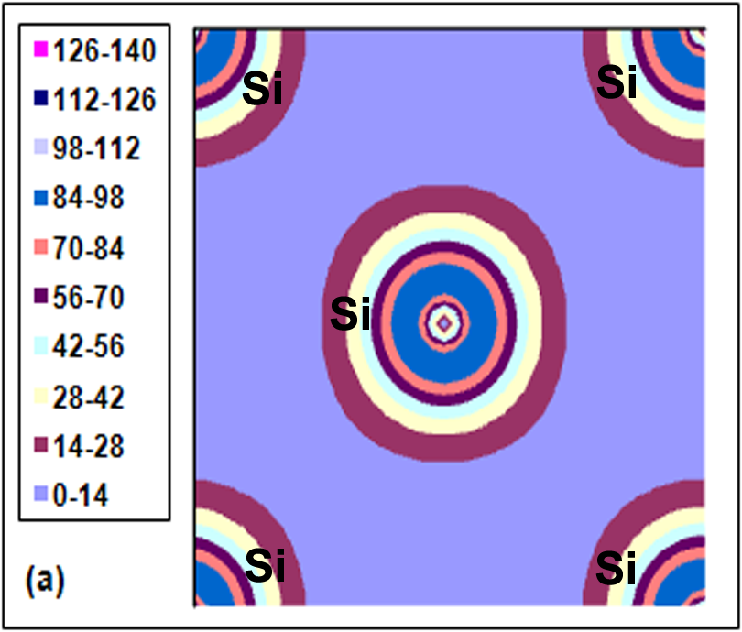
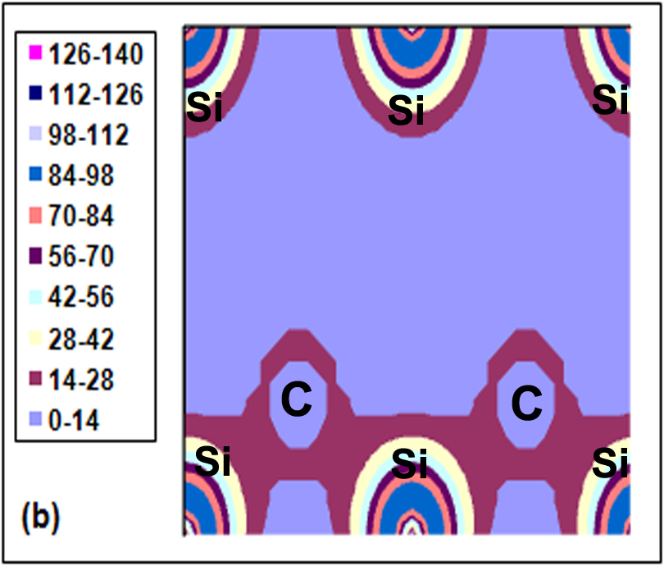

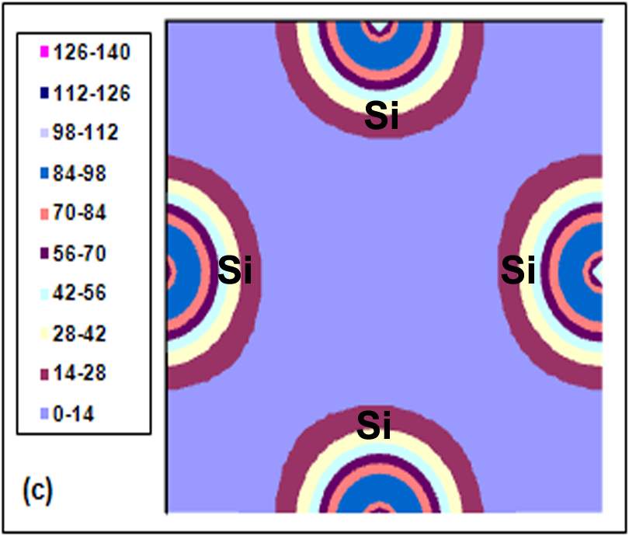
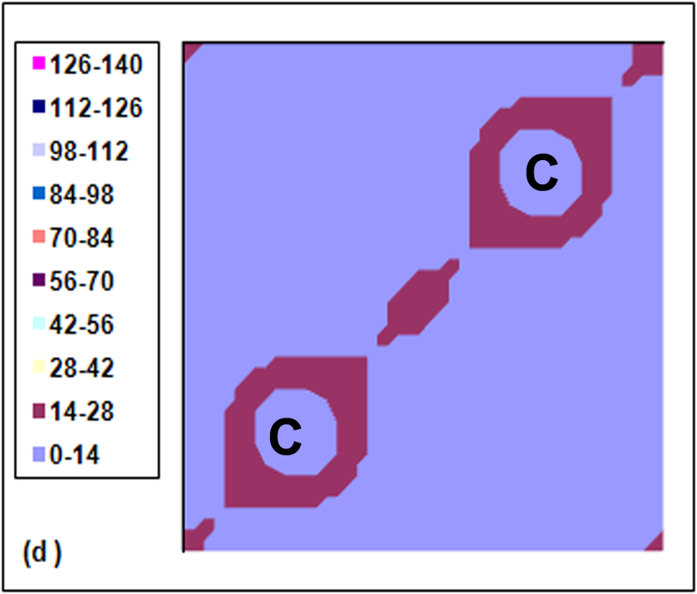

Figure (2). The valence charge density for SiC at zero Kelvin in the planes (a) (100), (b) (110), (c) (200), and (d) (400).
We notice that the silicon ions are larger than the carbon ions and the charge accumulated along the distance between the atoms.

- Effect of temperature on the properties
The effect of temperature on the electronic structure and other properties can be calculated from the present theory and computational procedure. It should be mentioned that the study of the effect of temperature is taken in approximated style because we calculate the effect of temperature only on the internal energy of the crystal. These calculations do not include the vibrational contribution to the free energy. So, the variation of other properties is calculated with the change of internal energy of the crystal.
There are no measurements or calculations of linear thermal expansion in the literature. Therefore, using the empirical equation taken from [Sekkal and Zaoui, 2002] which relates the lattice constant a to the temperature T:
a = a₀ + 3×10⁻⁵×T (8)

where a₀ is the equilibrium lattice constant at temperature (T₀):
The calculated lattice constant as a function of temperature is shown in figure (3)

Figure (3). The effect of temperature on the lattice constant of 3C-SiC.

The relation between the cohesive energy and temperature is shown in figure (4). It is shown from figure (4) that the increase of temperature causes a decrease of the absolute value of the cohesive energy. The linear thermal expansion coefficient can be computed directly from the slope of equation 2 , which is reasonable 6.9 ×10⁻⁵ K⁻¹ at T = 1200 K , this value is in reasonable agreement with experimental results [ Taylor and Jones, 1960]and results obtained by Karch et al from first principle calculation [Karch et al, 1995]

Figure (4). Cohesive energy of 3C-SiC as a function of temperature.

Figure (5). The effect of temperature on the high symmetry points in (a) conduction band (X_{5c}, Г_{15c,} Г_{1c}, X_{1c}), and (b) valence band (X_{5v}, X_{1v}, Г_{1v}).

From figure (5) we predict eigenvalues at conduction band (X_{5c} , Г_{15c} , Г_{1c} , X_{1c}) are decrease with temperature, whereas eigenvalues at valence band (X_{5v}, X_{1v}, Г_{1v}) are increase, so, the increase of X_{5v} , X_{1v} with temperature are small.
It has been noted that the direct gaps of 3C-SiC varies with the increase of temperature. This decrease is shown in figure (6).

Figure (6). The effect of temperature on direct gaps for 3C –SiC, calculated within the LUC-INDO method

The predicted effect of temperature on the indirect bandgap, valence bandwidth, and conduction bandwidth is illustrated in figure (7), the indirect bandgap and the valence bandwidth decrease with the increase of temperature, while the conduction bandwidth increase with the increase of temperature. In the present work, the temperature derivative of the indirect bandgap is computed to be - 31.2 meV/K, for the valence bandwidth and conduction bandwidth our calculation give temperature derivative - 29 meV/K for the valence bandwidth, and 30.7 meV/K conduction bandwidth.

Figure (7). Effect of temperature on (a) indirect band gap, (b) the valence bandwidth, and (c) conduction bandwidth.

We found that the s and p states occupation for Si increase with the increase of temperature, whereas the s and p states occupation for C decrease in this case. The s and p states occupation for Si and C with temperature are shown in figure 8, the increase of temperature causes an increase of the probability of electron transition from s-orbital and p-orbital of c to s-orbital and p-orbital of Si, this phenomenon is known and leads to phase transition due to the change of electronic distribution such as s-d transition in alkali metals [Takemura and Syassen, 1983].

Figure (8). The effect of temperature on the hybridization of (a) s- state and (b) p- state.

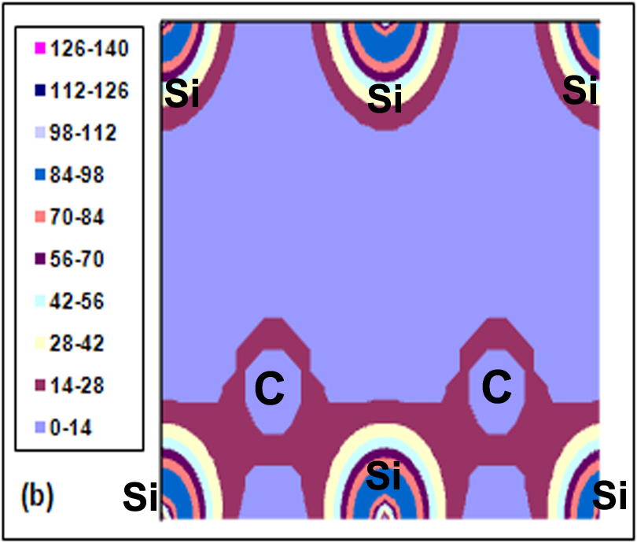
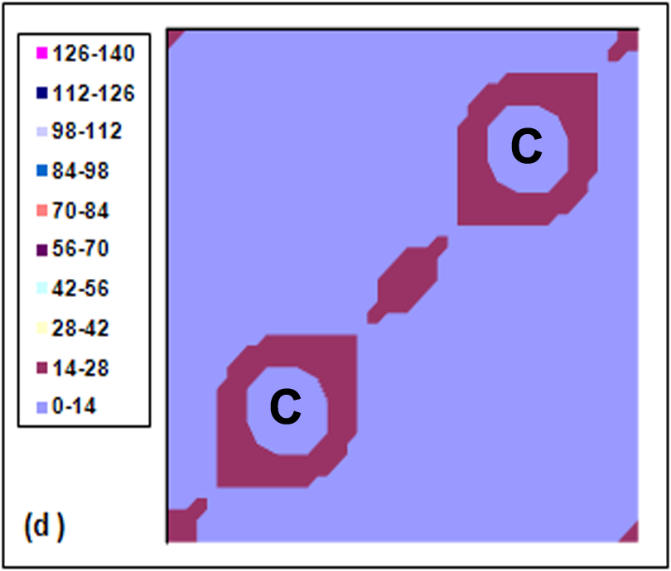

Figure 9. Valance charge density of 3C-SiC at temperature 1600 K in the planes (a) (100), (b) (110), (c) (200), and (d) (400)
The valence charge densities in the planes (100), (110), (200), and (400) at (1600K) are shown in figure (9). It be noted that the increase of temperature causes, in general, a slight decrease of valence charge density around the nuclei and an increase of this density at the intermediate distance between the nuclei.

5. Conclusions
In summary, we have performed calculation for the electronic, structural properties, and the effect of temperature on these properties. For the evaluation of the electronic properties, the LUC-INDO method was used. It is found that the equilibrium lattice constant and cohesive energy is in excellent agreement .The indirect band gap and valence bandwidths are greater than the experimental results. The results on high symmetry point are in reasonable agreement with experimental results. It is found that the direct and indirect band gap, valence bandwidth , and the s and p states occupation for C decrease with increasing temperature, whereas lattice constant, the conduction bandwidth, the s and p states occupation for Si increase. It be noted that the increase of temperature causes, in general, a slight decrease of valence charge density around the nuclei and an increase of this density at the intermediate distance between the nuclei.
It is concluded that the (LUC-INDO) method gives good results when choosing optimum empirical parameter sets and it has a reliable prediction for the effect of temperature.
References
Backes, W. H., Bobbert, P. A., and van Haeringen, W., 1994," Energy-band structure of SiC polytypes by interface matching of electronic wave functions",Phys. Rev. B Vol. 49 pp 7564-7568.
Batsanov, S. S., 1994,"Effects of Explosions on Materials: Modification and Synthesis under High Pressure Shock Compression", (New York: Springer).
Cardona, M., Christensen, N. E., and Fasol, G., 1988," Relativistic band structure and spin-orbit splitting of zinc-blende-type semiconductors", Phys. Rev. B Vol. 38, pp 1806-1827.
Cheong, B. H., Chang, K., and Cohen, M, 1991,"Pressure dependences of band gaps and optical-phonon frequency in cubic SiC", Phys. Rev. B Vol. 44, pp 1053- 1056.
Choyke,W. J., Matsunami, H., and Pensl, G.,2004," Silicon Carbide, Fundamental Questions and Applications to Current Device Technology" (Berlin: Springer).
Furthmüller, J., Gappellini, G., Weissker, H., and Bechstedt, F., 2002," GW self-energy calculations for systems with huge supercells", Phys. Rev. B Vol.66, pp 045110-045117.
Gavrilenko, V. I., 1995,"Calculated differential reflectance of the (110) surface of cubic silicon carbide", Appl. Phys. Lett. Vol. 67, pp16-18.
Käckell, P., Wenzein, B., and Bechstedt, F., 1994," Influence of atomic relaxations on the structural properties of SiC polytypes from ab initio calculations", Phys. Rev. B Vol.50, pp17037-17046.
Karch, K., Pavone, p., Windl, W., Strauch, D., and Bechstedt, F., 1995, Int. J. Quantum Chem., Vol.56, pp 801.
Lambrecht, W. R. L., Limpijumnong, S., Rashkeev, S. N., and Segall, B., 1997," Electronic Band Structure of SiC Polytypes: A Discussion of Theory and Experiment" Phys. Status Solidi b Vol. 202, pp5-33.
Lambrecht, W. R. L., Segall, B., Yoganathan, M., Suttrop, W., Devaty, R. P., Choyke, W. J., Edmond, J. A., Powell, J. A., and Alouani, N.,1994, Phys. Rev. B Vol.50, pp10722.
Madelung, O., (ed.), Landolt-Börnstein, 1982, New Series, Group III, Vol.17c, (Springer, Berlin).
Madelung, O., (ed.), Landolt-Börnstein, 1982, New Series, Group III, Vol.22, (Berlin: Springer).
Madelung, O., (ed.), Schultz, M., and Weiss, H., Landolt-Börnstein, 1982, New Series, Group III, Vol.17a, (Springer, Berlin).
Mujica, A., Rubio, A., Muñoz, A., and Needs, R. J., 2003, "High-pressure phases of group-IV, III–V, and II–VI compounds", Rev. Mod. Phys. Vol. 75, pp 863-912.
Pässler, R., 1999," Parameter Sets Due to Fittings of the Temperature Dependencies of Fundamental Bandgaps in Semiconductors", phys.stat.sol. (b) Vol. 216, pp 975-1007.
Pollmann, J., and Krüger, P., 2004, J. Phys.: Condens. Matter Vol.16, pp S1659.
Pople, J., and Beveridge, D., 1970, "Approximate Molecular Orbital Theory", McGraw – Hill.
Powell, J. A., Pirouz, P., and Choyke, W. J., 1993,"Semiconductor Interfaces Microstructures and Devices", (Bristol, Institute of Physics) p 257.
Radi, I. O., Abdulsattar, M. A., and Abdul-Lettif, A. M., 2007,"Semiempirical LUC-INDO calculations on the effect of pressure on the electronic structure of diamond", phys. stat. sol. (b) Vol. 244, pp 1304 -1317.
Rohlfing, M., Krüger, P., and Pollmann, J., 1993,"Quasiparticle band-structure calculations for C, Si, Ge, GaAs, and SiC using Gaussian-orbital basis sets", Phys. Rev. B Vol.48, pp17791-17805.
Sekkal, W., and Zaoui, A., 2002, "Predictive study of thermodynamic properties of GeC", New Journal of Physics, Vol. 4, pp 9.1- 9.9.
Strössner, K., Cardona, M., and Choyke, W. J., 1987, Solid State Commun. Vol.63, pp 113.
Szymanski, J. E., 1984,"Semiempirical Methods of Total Energy Calculations", Ph. D., University of York.
Takemura, K., and Syassen, K., 1983,"High-pressure phase transitions in potassium and phase relations among heavy alkali metals", Phys. Rev. B Vol.28, pp1193-1196.
Tang, M., and Yip, S., 1995," Atomistic simulation of thermomechanical properties of β-SiC", Phys. Rev. B Vol. 52, pp 15150-15159.
Taylor, A., and Jones, R. M., 1960," Silicon carbide –A high temperature semiconductor ed. J R O Connor and J Smiltens (Oxford: Pergamon)
Theodorou, G., Tsegas, G., and Kaxiras, E., 1999,"Theory of electronic and optical properties of 3C-SiC ", J. Appl. Phys. Vol. 85, pp 2179 -2184.
Verna, A. R., and Krishna, R., 1966,"Polymorphism and Polytypism in Crystals", (New York: Wiley) p 103.
Wang, S. Q, Ye, H. Q., 2005," Ab initio investigation of the pressure dependences of phonon and dielectric properties for III–V semiconductors", J. Phys.: Condens. Matter, Vol. 17, pp 4475- 4488.
Ziambaras, E., Schröder, E., 2003,"Theory for structure and bulk modulus determination", Phys. Rev. B Vol. 68, pp 064112-1 - 064112-7.

