Algorithms and Flowcharts

1- Algorithms
Algorithms : The term algorithm originally referred to any computation performed via a set of rules applied to numbers written in decimal form. The word is derived from the phonetic pronunciation of the last name of Abu Ja'far Mohammed ibn Musa al-Khowarizmi, who was an Arabic mathematician who invented a set of rules for performing the four basic arithmetic operations (addition, subtraction, multiplication and division) on decimal numbers. Thus An algorithm is a representation of a solution to a problem.
Definition:
An algorithm is procedure consisting of a finite set of simple rules which specify a finite sequence of operations that provides the solution to a problem, or to a specific class of problems for any allowable set of input quantities. In other word, an algorithm is a step-by-step procedure to solve a given problem.

Example 1: write the algorithm to find the results of this equation :
S = A+B+C+D
Solution :
- Start
- Read A,B,C,D
- Calculate S =A+B+C+D
- Print the value of S
- End.

Example 2: Write an algorithm to determine a student’s final grade and indicate whether it is passing or failing. The final grade is calculated as the average of four marks.
Solution :
- Start
- I= I+1
- Input M

- S=S+M
- If I< 4 go to the step 2
- Av = S / 4
- If Av below 50 print “pass” , else , print “fail”.
- End.

Example 3: Write an algorithm to determine the result of the flowing sequent :
S = 1+2+3+4+5+6+……………+ n
Solution :
- Start
- Read n
- Let S = 0
- Let I = 1
- Let S = S + I
- Let I = I + 1
- If I ≤ n go to the step 5
- Print the value of S
- End .
Example 4: Write an algorithm to convert the length in foot to centimeter.
Solution :
- Start
- Input the length L in FT.
- Calculate the length in CM by multiply 30.45
- Print the length in CM.
- End.
Example 5: Write an algorithm that reads two values, determines the largest value and prints the largest value with an identifying message.
Solution :
- Start
- Read v1, v2
- If v1> v2 then MAX = v1 else MAX= v2
- Print “the largest value is “;MAX
- End.
Example 6:Write an algorithm to compute the sum and count of odd and even numbers from 1 to 20.

Solution:
- Start
- I=0
- Let I=I+1
- A= I / 2
- IF A = INT(I / 2) THEN 6 ELSE 9
- S= S+ I S=110,K=10
- K= K+1
- GOTO 11
- M= M+1 M=100,F=10
- F= F+1
- IF I <= 20 THEN 3
- PRINT S,K,M,F
- END

Example 7:Write an algorithm to compute the max number for ten numbers.
Solution:
1- Start
2- I=0
3- MAX=A
4- Let I=I+1
5- INPUT A
6- IF A > MAX THEN MAX =A
7- IF I <= 10 THEN 4
8- PRINT MAX
9- END

2- Flowcharts
Flowchart is a graphical representations of algorithms. flowchart is a diagram made up of boxes, diamonds and other shapes, connected by arrows - each shape represents a step in the process, and the arrows show the order in which they occur. Flowcharting combines symbols and flow lines, to show figuratively the operation of an algorithm.
Few basic symbols
– Terminal
– Processes
– Decisions
Flowcharting Symbols
There are 6 basic symbols commonly used in flowcharting of assembly language
Programs as below :

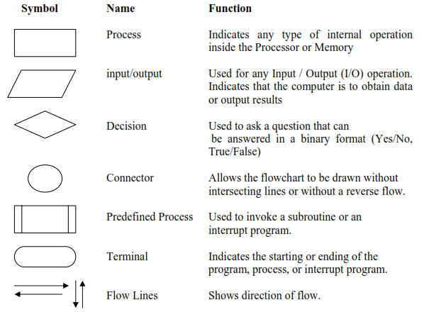

General Rules for flowcharting

1. All boxes of the flowchart are connected with Arrows. (Not lines)
2. Flowchart symbols have an entry point on the top of the symbol with no other entry points. The exit point for all flowchart symbols is on the bottom except for the Decision symbol.
3. The Decision symbol has two exit points; these can be on the sides or the bottom and one side.
4. Generally a flowchart will flow from top to bottom. However, an upward flow can be shown as long as it does not exceed 3 symbols.
5. Connectors are used to connect breaks in the flowchart. Examples are:
• From one page to another page.
• From the bottom of the page to the top of the same page.

Example 1: Draw the flowchart to find the result of the equation
Y=A²+B²+C²

START
READ A,B,C
Y = A² + B² + C²

PRINT Y
END

Example 2 : Draw the flowchart to find the result of the sequent
START
INPUT N
S = 0 , I = 1

PRINT S
END
S = S + I

IF I>N
I = I+1
S = 1+2+3+4+5……+n

No
Yes

START
INPUT X
Y=X

PRINT X,Y
END
IF X>1
Y=-X

YES
NO
Example 3 : Draw the flowchart to find the value of Y :
Y = X IF X > 1
Y = -X IF X ≤ 1

Example 4 : Draw the flowchart to find the value of Y :
X= (A+B)/2
Y=X²+X-3 IF A=1 or B=3
Y=X²+3X+5 IF A>2 and B>4
Y=X³+2X²+X otherwise
PRINT A,B,X,Y
END
I=I+1

IF I<N
1
2
NO
IF A=1
or B=3
YES
START
INPUT N
I = 0

INPUT A,B
X=(A+B)/2

Y=X²+X-3

IF A>2
& B>4
Y=X²+3X+5

Y=X³+2X²+X

NO
YES
1
2

YES

No

Example 5 : Write an algorithm and draw the flowchart to reads two values, determines the largest value and prints the largest value with an identifying message.

The algorithm :  - Start  - Read value1 and value2  - If value1> value2 then MAX = value1 else MAX= value2  - Print “the largest value is “;MAX  - End. | The flowchart :  MAX=V2  MAX=V1  IF V1>V2  Read V1,V2  NO  YES  END  PRINT MAX  START

Example 6 : Write an algorithm and draw the flowchart to reads three values, determines the largest value and prints the largest value with an identifying message.

The algorithm : | The flowchart :

