Bacterial Cell

The cell is the structural and functional unit of life. All living organisms on earth are made up of single or many cells.
Bacteria are single cellular microscopic organisms. The study of bacteria is known as bacteriology and it is a branch of microbiology. The singular world of bacteria is bacterium. Bacteria have been grouped into prokaryotic, which means absence of nucleus.

Structure of Bacteria
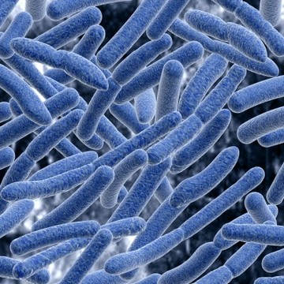

Characteristics of Bacteria

→ There are 3 types of bacteria based on their shapes such as: Bacteria grow in number not in size, but they make copies of themselves by dividing into half. There are three basic shapes of bacteria:
• Rod shaped bacteria called as bacilli.
• Spherical shaped bacteria called as cocci.
• Curved shaped bacteria called as spirilla.

Some of the bacteria exist as single cells, others exist as cluster together.

Respiration in bacteria:

Anaerobic bacteria: does not require oxygen for respiration.
Aerobic bacteria: require oxygen for respiration.

Gram staining bacteria are a method of differentiating bacterial species into two large groups, which are based on their chemical and physical properties of their cell wall.
Gram positive bacteria: Those bacteria when they are stained in gram stain results in purple colour.
Gram negative bacteria: Those bacteria when they are stained in gram stain results in pink colour.
Locomotion of bacteria:
They move around by using their locomotion organs such as cilia and flagella.

Nutrition of bacteria:
They exhibits different modes of nutrition level such as-

• Autotrophic bacteria: These bacteria are able to synthesize their own food. For e.g.: Phototropic bacteria and chemosynthetic bacteria
• Heterotrophic bacteria: These bacteria are unable to synthesize their own food, hence they depends on other organic materials. For e.g.: saprophytic bacteria-these bacteria feeds on dead and decaying matter.
• Symbiotic bacteria: These bacteria have a mutual benefit from other organisms. For e.g.: nitrogen fixing bacteria (or) rhizobium.
• Parasitic bacteria: These bacteria are present in plants, animals and human beings. These bacteria feeds on host cells and causes harm to the host.

Reproduction in Bacteria:
The reproduction in bacteria is mainly by cell division and binary fission. In some cases few bacteria also reproduce by budding.
Bacterial Cell Structures
Back to Top

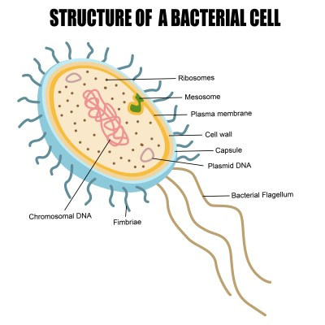
Cell Wall:
• Cell walls of bacteria are made up of glycoprotein murein.
• The main function of cell wall is it helps in providing support, mechanical strength and rigidity to cell.
• It protects cell from bursting in a hypotonic medium.
Plasma Membrane:
•
• It is also known as cytoplasmic membrane (or) cell membrane.
• It is composed of phospholipids, proteins and carbohydrates, forming a fluid-mosaic.
• It helps in transportation of substances including removal of wastes from the body.
• It helps in providing a mechanical barrier to the cell.
• Plasma membrane acts as a semi permeable membrane, which allows only selected material to move inside and outside of the cell.
Cytoplasm:
• Helps in cellular growth, metabolism and replication.
• Cytoplasm is the store houses of all the chemicals and components that are used to sustain the life of a bacterium.
Ribosome:
• A tiny granule made up of RNA and proteins.
• They are the site of protein synthesis.
• They are freely floating structures that helps in transferring the genetic code.
•
Plasmid:
• Plasmids are small circle of DNA.
• Bacterial cells have many plasmids.
• Plasmids are used to exchange DNA between the bacterial cells.
Flagella:
• This is a rigid rotating tail.
• It helps the cell to move in clockwise and anticlockwise, forward and also helps the cell to spin.
• The rotation is powered by H+ gradient across the cell membrane.
Pilli:
• Short protein appendages.
• Smaller than flagella.
• Fixes bacteria to surfaces.
• It also helps in reproduction during conjugation.
Capsule:
• Capsule is a kind of slime layer, which covers the outside of the cell wall.
• They are composed of a thick polysaccharide.
• It is used to stick cells together and works as a food reserve.
• It protects the cell from dryness and from chemicals.

- DONATE
- HELP
- JOIN
- SIGN IN

- DASHBOARD
- GROUPS
- LIBRARY
- BROWSE

Bacteria Characteristics

Introduces bacterial cell shapes and structures.
0%
PROGRESS
Practice Bacteria Characteristics
Practice
- All (6)
- Read (1)
- Assessments (2)
- Web Links (1)
- Real World (2)
- Add to Library
- Share to Groups
- Add to FlexBook® Textbook
- Customize
- Details
- Resources
- Download
Bacteria Characteristics
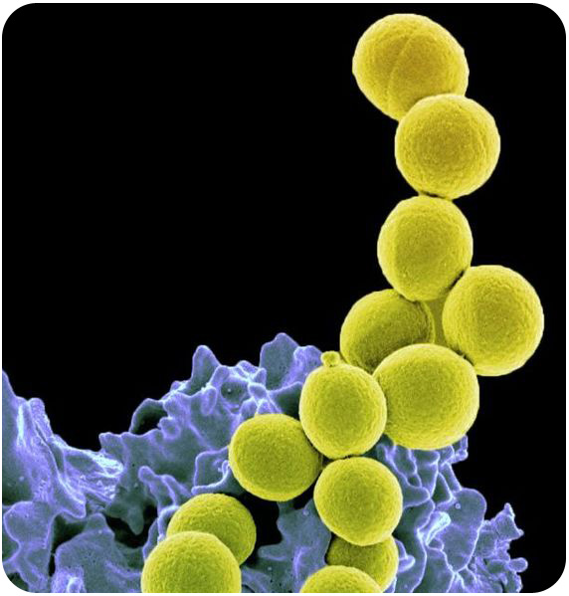
Are bacteria living things?
Bacteria are individual living cells. Bacteria cells are similar to your cells in many ways; yet, they also have distinct differences. Bacteria have many unique adaptations allowing them to live in many different environments.

Characteristics of Bacteria
Bacteria are the most successful organisms on the planet. They lived on this planet for two billion years before the first eukaryotes and, during that time, evolved into millions of different species.

Size and Shape
Bacteria are so small that they can only be seen with a microscope. When viewed under the microscope, they have three distinct shapes (Figure below). Bacteria can be identified and classified by their shape:
- Bacilli are rod-shaped.
- Cocci are sphere-shaped.
- Spirilli are spiral-shaped.
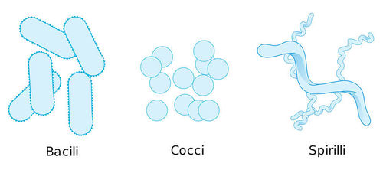

Similarities to Eukaryotes
Like eukaryotic cells, bacterial cells have:
- Cytoplasm, the fluid inside the cell.
- A plasma or cell membrane, which acts as a barrier around the cell.
- Ribosomes, in which proteins are put together.
- DNA. By contrast though, bacterial DNA is contained in a large, circular strand. This single chromosome is located in a region of the cell called the nucleoid. The nucleoid is not an organelle, but a region within the cytoplasm. Many bacteria also have additional small rings of DNA known as plasmids.

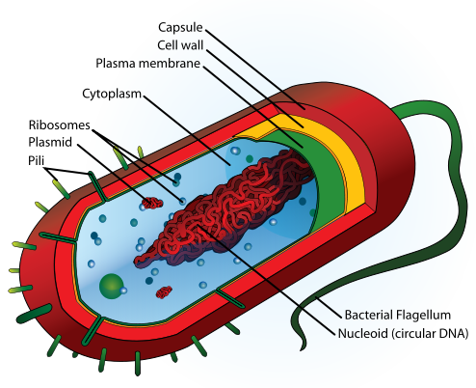

Unique Features
Bacteria lack many of the structures that eukaryotic cells contain. For example, they don't have a nucleus. They also lack membrane-bound organelles, such as mitochondria or chloroplasts. TheDNA of a bacterial cell is also different from a eukaryotic cell. Bacterial DNA is contained in one circular chromosome, located in the cytoplasm. Eukaryotes have several linear chromosomes. Bacteria also have two additional unique features: a cell wall and flagella. Some bacteria also have a capsule outside the cell wall.

The Cell Wall
Bacteria are surrounded by a cell wall consisting of peptidoglycan. This complex molecule consists of sugars and amino acids. The cell wall is important for protecting bacteria. The cell wall is so important that some antibiotics, such as penicillin, kill bacteria by preventing the cell wall from forming.
Some bacteria depend on a host organism for energy and nutrients. These bacteria are known as parasites. If the host starts attacking the parasitic bacteria, the bacteria release a layer of slime that surrounds the cell wall. This slime offers an extra layer of protection.

Flagella
Some bacteria also have tail-like structures called flagella (Figure below). Flagella help bacteria move. As the flagella rotate, they spin the bacteria and propel them forward. It is often said the flagella looks like a tiny whip, propelling the bacteria forward. Though some eukaryotic cells do have a flagella, a flagella in eukaryotes is rare.

