**INTRODUCTION**

**MICROBIOLOGY** is a specialized area of **biology**  that concerns with the study of microbes ordinarily too small to be seen without magnification. Microorganisms are **microscopic** and independently living cells that, like humans, live in communities. Microorganisms include a large and diverse group of microscopic organisms that exist as single cell or cell clusters (e.g., **bacteria, archaea, fungi, algae, protozoa and helminths**) and the

**viruses,** which are microscopic but not cellular. While bacteria and archaea are classed as **prokaryotes** the fungi, algae, protozoa and helminths are **eukaryotes**.

Microorganisms are present everywhere on earth, which includes humans,

animals, plants and other living creatures, soil,water and atmosphere.

Microorganisms are relevant to all of our lives in a multitude of ways. Sometimes, the influence of microorganisms on human life is beneficial, whereas at other times, it is detrimental. For example, microorganisms are required for the production of **bread, cheese, yogurt, alcohol, wine,beer, antibiotics** (e.g., penicillin, streptomycin, chloramphenicol), **vaccines, vitamins, enzymes** .

**HISTORICAL DEVELOPMENTS IN MICROBIOLOGY**

**The beginnings**

The study of microorganisms, or microbiology began when the first microscopes were developed in 1665 by the English scientist, **Robert Hooke** who viewed many small objects and structures using a simple lens that magnified approximately 30 times. **Robert Hooke was the first person to describe microorganisms**.

Unicellular life was first described just a few years after Hooke recorded his observations of the microscopic world. **Antony van Leeuwenhoek** was a Dutch merchant who polished grains of sand into lenses which were able to magnify 300 times and added a simple focus mechanism. With his microscope, van Leeuwenhoek viewed rain and pond water, infusions made

from peppercorns, and scrapings from his teeth in the year 1674 and termed the tiny microorganisms as **‘animalcules’**. In 1676, van Leeuwenhoek sent his drawings to the Royal Society of London. This has special significance to microbiology because it contained his first detailed description of the

microorganism.

**Antony van Leeuwenhoek**  was born in Holland . In **1674**, he made first

observation of microoraganisms and was the **first person to observe and**

**accurately describe and measure bacteria and protozoa**, termed by him, as

**“animalcules”** which he thought were tiny animals. In **1677**, he became the

**first person to describe spermatozoa and was one of the earliest to describe red blood corpuscles**. In 1680, he was elected a fellow of the Royal Societyof London, and with Isaac Newton and Robert Boyle, he became one of thefirst famous men of his time. He died on August 30, 1723 at the age of 90.Because of his extraordinary contribution to microbiology, he is consideredas the **father of bacteriology and protozoology**

**The transition period**

Biology of the 1700s was a body of knowledge without a focus. It consisted of observations of plant and animal life and the attempts by scientists to place the organisms in logical order. The dominant figure of the era was **Carolus Linnaeus (1707–1778),** a Swedish botanist who brought all the plant

and animal forms together under one **Binomial nomenclature (naming of an organism by two names—the genus and species) system of classification scheme**. His book, ***Systemanaturae,*** was first published in 1735.

Discovery of the microscopic world raised some interesting queries and eventually ledscientists to question some of the long-held beliefs. At that time in history, the scientific communityused a theory known as **‘spontaneous generation’** to explain the apparently magical origins of life. The theory proposed that simple life forms arose spontaneously from non-living materials and had its basis in the findings of **Aristotle** in the fourth century **BC**.

Although most people accepted spontaneous generation, the theory did have some strong opponents. Among the first to dispute the theory of spontaneous generation was the Italian scientist, **Francesco Redi (1626–1697).** He reasoned that flies had reproductive organs while observing van Leeuwenhoek’s drawings. He suggested that flies land on pieces of exposed meat and lay their eggs, which then hatch to maggots. This would explain the ‘spontaneous’ appearance of maggots. In the 1670s, Redi performed a series of tests in which he covered jars of meat with fine lace, thereby preventing the entry of flies. The meat would not produce maggots as it was protected and Redi temporarily put to rest the notion of spontaneous generation.

In 1748, British clergyman**, John Needham** (1713–81) put forth the notion that in flasks of mutton gravy, microorganisms arise by spontaneous generation. He even boiled several flasks of gravy and sealed the flasks with corks as Redi had sealed his jars. Still,the microorganisms appearedItalian scientist **Abbe LazzaroSpallanzani**(1729–99) criticized Needham’s work. In 1767,Spallanzani boiled meat and vegetable broths for long period of time and then sealed the necksby melting the glass. As control experiments, he left some flasks open to the air, stoppered someloosely with corks, and boiled some briefly, as Needham had done. After two days, he found thecontrol flasks swarming with organisms, but the sealed flasks had no organisms. **Needhamcountered that Spallanzani**had destroyed the ”vital force” of life with excessive amounts of heat.

**Edward Jenner** was accorded honours in 1798 when he discovered immunization for smallpox, despite the fact that he could not explain the causeof the disease.

**John Snow**, a British physician, traced the source of cholera to the municipal water supply of London during an 1854 outbreak. He reasoned that by avoiding the contaminated water source,people could avoid the disease.

**The classical golden age of microbiology (1854–1914)**

The science of microbiology blossomed during a period of about 60 years referred to as the **Golden Era of Microbiology.** The period began in 1857 with the work of **Louis Pasteur** and continued into thetwentieth century until the advent of World War I. During this period, numerous branches of

microbiology were laid for the maturing process that has led to modern microbiology.

**Louis Pasteur** was the first to report the role of microorganisms in fermentation in 1848, he achieved distinction in organic chemistry for his discovery that tartaric acid, a fourcarbonorganic compound, forms two different types of crystals. Pasteur successfully separated the crystals while looking through the microscope. In 1854, at the age of 32, he was appointed Professor of Chemistry at the University of Lille in northern France.

Pasteur in 1857 unravelled the mystery of sour wines. In a classic series of experiments, Pasteur clarified the role of yeasts in fermentation of fruits and grains resulting in the production of alcohol.

He also found that bacteria were responsible for spoilage of wine. He firmly disproved the spontaneous generation doctrine by his **Swan-Neck Flask experiment** (Fig. 1.1). He proposed **germtheory of disease** and discovered the existence of life in the absence of free oxygen (anaerobic growth). He showed that mild heating could be used to kill microorganisms in broth **(pasteurization)**.



**Fig. 1.1:** Pasteur’s experiment with the swan-necked flasks to disprove spontaneous generation. (a) Life appeared in broth in flasks exposed to air. (b) No life appeared in sealed flasks. (c) No life appeared in flasks where the neck was continuously heated. (d) No life appeared in flasks when the microorganisms were trapped in the bend of the side arm.

**Louis Pasteur- Notable Contributions**

1857 – Lactic acid fermentation is due to a microorganism

1860 – Yeasts are involved in alcoholic fermentation

1861 – Disproved the theory of spontaneous generation

1861 – Introduction of the terms aerobic and anaerobic for yeasts.

Production of more alcohol in the absence of oxygen during

sugar fermentation- **The Pasteur Effect**

1862 – Proposed germ theory of disease

1867 – Pasteur devised the process of destroying bacteria known

as **pasteurization.**

1881 – Development of anthrax vaccine. Resolved Pebrine

problem of silkworms.

1885 – Development of a special vaccine for rabies (the **Pasteur**

**treatment**)

The definite proof of the germ theory of disease was offered by **Robert Koch**

from East Russia, now part of Germany. Koch’s primary interest was **anthrax,** a deadly blood disease in cattle and sheep. In 1875, he injected mice with the blood of diseased sheep and cattle.

He then performed meticulous autopsies and noted that the same symptoms appeared regularly.

He isolated a few rod shaped bacilli from a mouse’s blood by placing the bacilli in the sterile aqueous humor from an ox’s eye. The symptoms of anthrax appeared within hours. Koch autopsied the animals and found their blood swarming with bacilli. He reisolated the bacilli in sterile aqueous

humor. Koch’s procedures came to be known as **Koch’s postulates** (Fig. 1.2)**.** The four postulates are:

• The suspected microorganism must always be found in diseased but never in healthy individuals.

• The microorganism must be isolated in pure culture (one free of all other types of microbes) on a nutrient medium.

• The same disease must result when the isolated microorganism is inoculated into a healthy host.

• The same organism must be reisolated from the experimentally infected host.

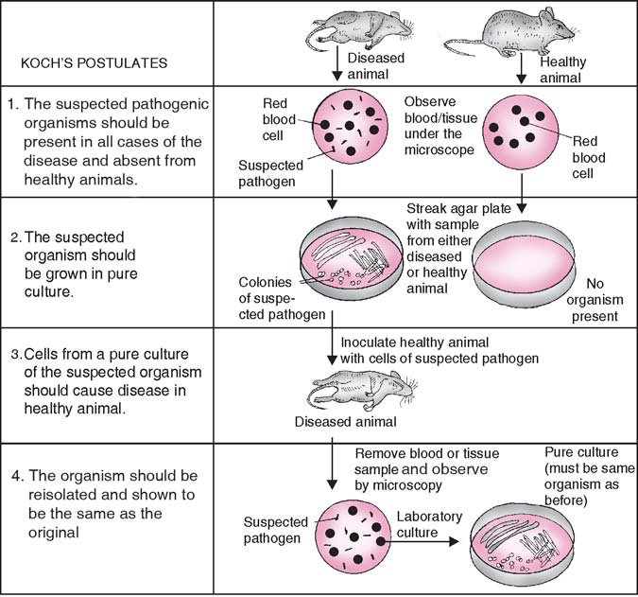

**Notable contributions of Robert Koch**

1876 – Koch demonstrated that anthrax is caused by *Bacillus anthracis.*

1877 – Methods for staining bacteria, photographing and preparing

permanent visual records on slides.

1881 – Koch developed solid culture media and the methods for studying

bacteria in pure cultures.

1882 – Isolated the bacterium—*Mycobacterium tuberculosis*—that causes

tuberculosis.

1882 – Use of agar as a support medium for solid culture in Koch’s lab by

Hesse.

1883 – Isolation of *Vibrio cholerae*, the cause of cholera.

1883 – Verification of the germ theory of disease by relating a specific

organism to the specific disease.

1884 – Koch put forth his postulates—known as Koch’s postulates.

A Pasteur Institute scientist, **Charles Nicolle**, proved that **typhus fever** was transmitted by lice.

**Albert Calmette**, also of the Institute, developed a harmless strain of the *Tubercle bacillus* used for immunization. **Jules Bordet**, a Belgian bacteriologist isolated the bacillus of **pertussis (**whooping cough**)** and developed the complement fixation test, a procedure once widely used in the diagnosis of disease.

**The era of chemotherapy**

The credit for the discovery of the first”wonder drug”, **penicillin** goes to a Scottish physician and bacteriologist, **Sir Alexander Fleming** in 1929 from the mold *Penicilliumnotatum*. Fleming discovered the first antibiotic which is a microbial product that can kill susceptible microorganisms and inhibit their growth. **Sir Howard. W. Florey** and **Ernst B.Chain** at Oxford University in 1941 developed methods for industrial production of penicillin in England. Fleming, Florey and Chain shared the Nobel Prize in 1945 for the discovery and ssproduction of penicillin.

**Microbial Ecology** : Study of interrelationships between microbes and environment.