Lecture 12:
Dr.Amjed H.Abbas
Project: Physics of eyes and vision
Objectives:
1. To get information about physical laws and their applications in medical physics.
2. Ability to identify relevant principles and laws when dealing with certain
investigational tools in both and disease state.

The sense of vision consists of three major components
- the eye that focus image from outside world on the retina
- the system of millions of nerves that carries information deep into the brain
- the visual cortex part of brain
blindness results if anyone of parts does not function
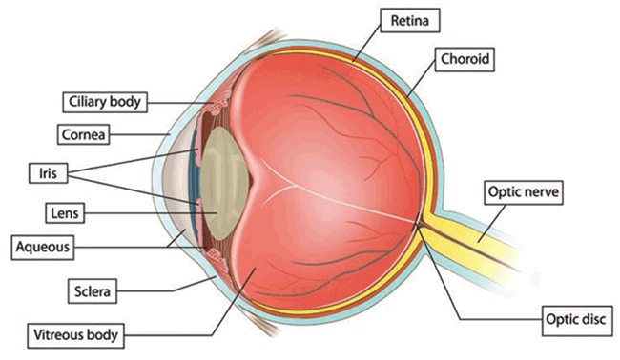
Figure 12-1: Cross section of the eye.

Retina the light detector of eye:
Retina is the light sensitive part of eyes, converts the light images into electrical nerve impulses that are sent to the brain. The photon must be above minimum energy to cause the reaction.
Infrared photons have insufficient energy and are not seen.
Ultraviolet photons have sufficient energy but they are absorbed before they reach the retina and also are not seen. There are 2 types of photo receptors in the retina:
the cones 6.5 million in each eye used for day light, the rods used for night vision, it is about 120 million in each eye
Diffraction effects on the eye:
All light waves undergo diffraction when it passes through small openings thus the iris produces diffraction pattern on the retina.
All lenses have defects aberration.
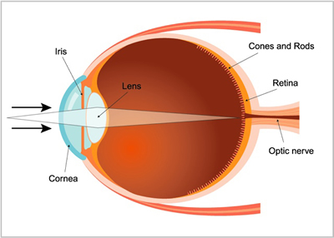
Figure 12-2: Diffraction of light in the eye.
The effect of such aberration is reduced if the lenses opening are made smaller. A point source of light will not be focused on single cone because of diffraction effects.
figure above. The angular spread (2ɵ) of the central bright spot at retina for λ = 555 m and pupil 3 mm diameter (a ) is given by:
2ɵ = 2(1.22) λ /a
= 2(1.22) (555 x 10 ⁻⁹ / 3 x 10 ⁻³) = 4.5 x 10 ⁻⁴ radians
The diameter of center bright spot at retina = the effective aperture to retina distance 17 mm x 2 ɵ = 17 x 4.5 x 10 ⁻⁴ = 8 μm. This spot will include many cons (diameter ~ 1.1 μm)
Focusing elements of the eye:
The eye has two major focusing components:
- The cornea which is clear transparent bump on the front of the eye. the cornea is fixed focus element.
- The lens is variable in shape and has ability to focus at various distances.
- The cornea focus by bending (refraction) the light rays, the amount of bending depends on the curvature and speed of the light in lens.
- When cornea under ware it losses most of its focusing power because the index of refraction of water (1.33) close to that of cornea (1.37).
Fish have similar problem out of water.
- Divers keep air round cornea by wearing face mask.
Some other elements of the eye:
The pupil is the opening in the center of the iris where light enters the lens it appears black because essentially all of light that enters is absorbed inside the eye. Under average light condition the opening is about 4 mm in diameter. It can change from about 3 mm in diameter in bright light to about 8 mm in diameter in dim light about 300 sec are needed for it to fully open and about 5 sec required for it to close as much as possible.
It is believed that the iris aids the eye by increasing or decreasing incident light on the retina until the retina has adapted to the new lighting conditions.
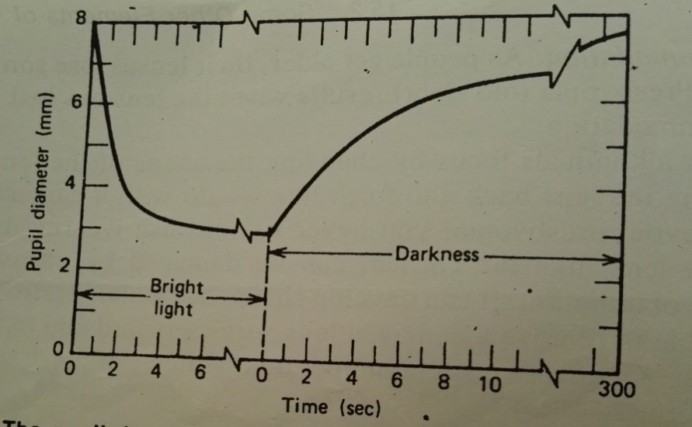
Figure 12-3: The pupil does not open and close rapidly

The aqueous humor fills the space between lens and cornea, this fluid mostly water is continuously being produced and the surplus escapes through a drain tube when you rub your eyes you greatly increase the internal pressure.
The vitreous humor is a clear jelly like substance that fills the large space between lens and retina, it helps the shape of the eye fixed and it is essentially permanent it is sometimes called vitreous body.

Table ( ): some diseases of refractive errors of vision
Focusing problem | Common name | Usual cause | Correction
Myopia | near sighted vision | long eye ball or cornea too curved | negative lens or cornea too  curved
Hyperopic | far sighted vision | short eye ball or cornea not curved Enough | positive lens
Astigmatism |  | unequal curvature of cornea | cylindrical lens
Presbyopia | old age vision | lack of accommodation | bifocals

Defective vision and its correction:
1/F = 1/P + 1/Q basic equation of simple lenses
F = focal length P = object distance Q = image distance (F) & is measured in meter 1/F is the lens strength in diopter D
The focal length of combination of two lenses :
$$1/F = 1/F1 + 1/F2 for 3 1/F = 1/F1 + 1/F2 + 1/F3$$
The combination in diopter = Σ of diopter of various lenses
Example: if FA = 0.33 m combined with FB = 0.25 m what is the focal length of combination and diopteric strength ?
$1/F = 1/FA + 1/FB = 1/0.33 + 1/0.25 = 1/0.143$
$$Or F = 0.143 m$$
$D for A = 3D D for B = 4D$The combination = 7D
Consider the image distance Q of cornea and lens of the eye to be 2 cm or 0.02 m when normal eye focused at distance ( infinity).
1/F = 1/Q = 1/0.02 m then eye has strength of 50 D

If eye focus an object at P = 0.25 then
$$1/F = 1/P + 1/Q = 1/0.25 + 1/0.02 = 4 + 50 = 54 D$$

Small group discussion:
Q1/ Describe and explain the adjustment that takes place within the eye when it changes from viewing a nearby object to a distant object.
Q2/ Man has near point at 50 cm, what is the kind of lens used to correct this case.
Q3/ Patient has far point 200 m, what is the type of this refractive error and how we can correct this defect.
Q4/ What is the optimum size of the pupil in an emmetropic eye?
Q5/ What is presbyopia?

