Session 2
Lecture 4: Energy, work, and power of human body
Lecture Objectives:
- Knowledge of the principles of energy, work and power when dealing with certain investigational tools in disease state.
- Definition of BMR and physical factors affecting it.
- Methods of heat losing.
- Thermography applications.

      - Energy change in the body, the process of catabolism is based on transformation of organic substances in the food by oxidization into CO₂, H₂O, and energy. For basal conditions there are about:
- 25% of the body's energy used by the skeletal muscle and heart.
- 19% used by the brain.
- 10% used by kidneys.
- 27% used by the liver, spleen.
The body use food energy to operate its various organs, maintain constant body temperature, and do external work, small percentage (5%) of the body energy excreted in the feces and urine, any energy left over is stored as a body fat.
Conservation of Energy in the body:
$$∆U = ∆Q- ∆W$$
∆U= change in stored energy, ∆ Q= heat lost or gain, ∆W= work done

      - BMR (basal metabolic rate): Is the amount of energy needed to perform minimal body function (such as breathing, and pumping blood through arteries under resting condition). BMR depends primarily upon thyroid function.
A person of an over active thyroid has a higher BMR than a person with normal thyroid function. Since the energy used for basal metabolism becomes heat and dissipated from the skin, so BMR is related to the surface area, or the mass of the body.
The metabolic rate depends on temperature of the body, if temperature changes by 1Cº there is a change about 10 % in the metabolic rate.

For example:,
if a patient has temperature of 40 Cº or 3 above normal, the BMR is about 30% greater than normal, you can see why patients temperature sometimes lowered during heart surgery.
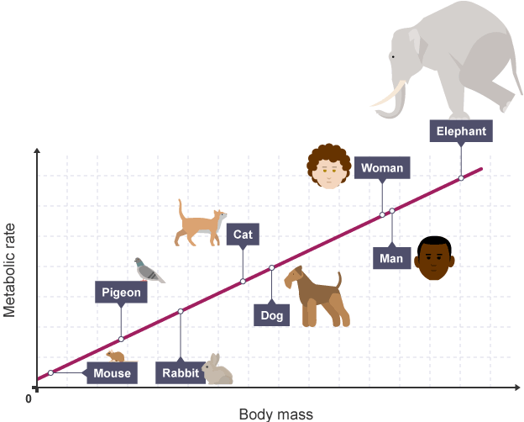
Figure 1: Relationship between BMR and body mass for different animals.

Work and power:
$∆W = F∆X$F= force ∆X= distance
$P=∆W/∆t=F∆X/∆t=Fv$ P= power
ϵ = work done / energy consumed, ϵ= efficiency
The convenient unite for expressing the rate of energy consumption of the body is the met; the met is defined as 50 Kcal/m² of body surface area per hour.
In oxidation by consumption heat is released within the body heat is released as energy of metabolism. The rate of oxidation is called metabolic rate.
The oxidation of glucose a common form of sugar used for intravenous feeding. The oxidation equation for one mole of glucose C₆ H₁₂ O₆ is:
C₆ H₁₂O₆ + 6 O₂ → 6 H₂ O + 6 CO₂ + 686 Kcal
That is 1 mole of glucose (180) gm combines with 6 moles of O₂ (129) gm to produce 6 moles each of H₂O (108) gm and CO2 (264) gm releasing 686 Kcal of heat energy in the reaction.

      - Heat losses from the body:
The main heat loss mechanisms are
- Radiation
- Convection
- Evaporation (perspiration)
- Some cooling of the body in lungs.
The hypothalamus of brain contains body thermostat to keep temperature close to normal value. If the core temperature rises, the hypothalamus initiate sweating and vasodilatation which increases blood flow to the skin and increase skin temperature which help to get rid of extra heat. If the skin temperature drops, the thermo receptors on the skin inform hypothalamus and it initiate shivering, which causes increase in the core temperature.
- The difference between energy radiated by the body and the energy absorbed from surrounding can be calculated by:
$$Hr = Kr Ar e (Ts-Tw)$$
Hr = energy loss or gain
Ar = surface area emitting radiation E = emissivity of body
Ts = skin temperature T_{w} =surrounding temperature.
Kr = constant= 5 Kcal/m²hr Cº
- The heat loss due to convection Hc is given by: $Hc =Kc Ac (Ts–Ta)$
Kc = constant depends upon the movement of air, Ac = surface area
Ta = air temperature. When the wind constant Kc = 2.3 Kcal / m³hr Cº
When Ta = 25 Cº Ts = 34 Cº Ac = 1.2 m²
The nude body losses about 25 Kcal /hr by convection or about 25% of body
heat loss.
When the air is moving, the constant Kc increases according to the equation: $Kc = 10.45 – v + 10 √ v$ Where v is the wind speed.

      - Thermography applications:
It is a tool useful to obtain a surface temperature map (Thermogram), which is used to accurately measure the surface temperature of the body and rotate it to pathologic conditions.
- The principle of this technique is to measure the radiation emitted from the body.
- Thermography has been most commonly used as an aid in detecting breast cancer.
Thermography has been used to detect other types of cancers and is also used to study circulation of blood in the head, differences in temperature between left and right sides can indicate circulatory problem. Thermography has increases in reducing leg amputations in diabetics.

