Session 3
Lecture 6: Cardiovascular instrumentation
Lecture Objectives:
- Physical principles of different parts of ECG machine.
- Physics of defibrillator and pacemakers.

People have been dying of heart diseases for years. If you have heart attack in 1960, you put to bed and your physician hoped for the best, now patient are monitored with ECG which is continuously displayed on oscilloscope.
Electrodes:
A major problem of ECG is the metal electrode; assume the body as a bag of salt water & current flows by moving ions. In wire and metals from which the electrode is made, its current flows by moving electrons. So at the interface between the body and a metal electrode, the ion flow must be converted to electron flow through a chemical reaction.
If ordinary metal are used for electrodes, polarization results from chemical reaction. At electrode, gas bubbles form due to electrolysis and this become unstable, this instability produces electrical noise, and these problems may be avoided by using silver–silver chloride electrode.
Amplifier:
The amplitude of ECG signal is about 1 mv. The amplifier used to record ECG must be able to eliminate interference from voltages induced in the body from such external sources. If there is problem in amplifier, oscilloscope is used to observe ECG, since oscilloscope requires power about 1 μA current flow to ground through B.
$$V = I x R = (10-6 A) (10-4 Ω) = 0.01 V= 10 mv$$
Voltage is 10 times ˃ ECG
To avoid this interference voltage we may use differential amplifier on some oscilloscopes.
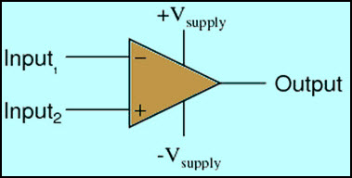
Figure 1: Differential amplifier
Another cause of interference in ECG is illustrated in Figure 2 changing magnetic field produced by alternating current flow through wires and strong near motors and transformers since the induced voltage is proportional to the loop, this interference minimized by keeping the area of the loop small.
The wires can be either twisted or run parallel and close together in a bundle.
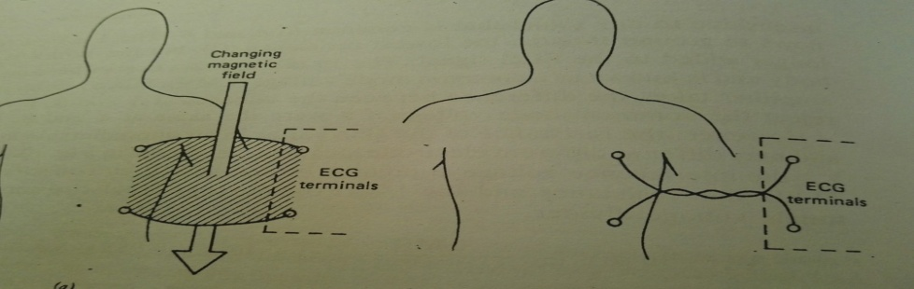
Figure 2: The effect of wire twisting on the formation
of interference in the ECG recording
Patient monitoring:
ECG recording using pen recorder is a permanent record and it’s impractical for continuous monitoring of heart attack.
A more convenient approach is enough for doctors or nurses to assess the patient condition using modern monitors which use microcomputers to store ECG information.
It is very difficult to maintain vigilance while watching ECG tracing on scope, so automatic alarm devices have been used to measure the time between successive R waves.
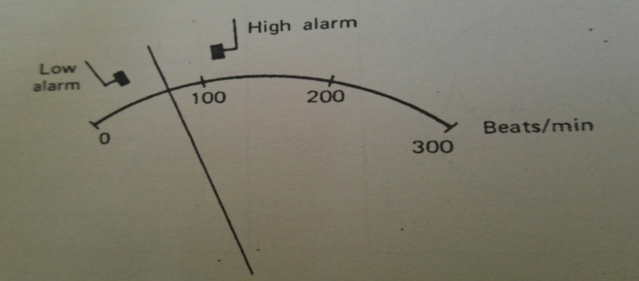
Figure 3: The use automatic detection of heart rate
Defibrillator:
Many heart attack patients undergo sudden change in rhythm. Death flow within minutes unless the can be defibrillated, defibrillator shown in the fig. (3).
The paddles are metal electrodes 7.5cm in diameter coated with conductive paste placed above and below the heart. When switch thrown a current, about 20 flows through heart for about 5 msec.
This current contracts every muscle fiber in the heart at the same time; the heart can initiate normal rhythm.

Pacemaker:
The atria of heart are separated from ventricles by fatty layer that doesn’t conduct electricity, at single location the atrioventricular node impulses are conducted from atria to the ventricles. If this node is damaged, the ventricles receives no signal from the atria however the ventricles does not stop pumping. There are natural pacing centers in the ventricles that provide pulse if none has been received from atria for 2 sec. The resulting heart rate 30 beats /min. will sustain life but the patient may have to live semi-invalidism, artificial pacemakers have been developed about 72 pulse/ min.

