Decoder
In both the multiplexer and the demultiplexer, part of the circuits decode the address inputs, i.e. it translates a binary number of n digits to 2n outputs, one of which (the one that corresponds to the value of the binary number) is 1 and the others of which are 0. It is sometimes advantageous to separate this function from the rest of the circuit, since it is useful in many other applications. Thus, we obtain a new combinatorial circuit that we call the decoder. It has the following truth table (for n = 3):
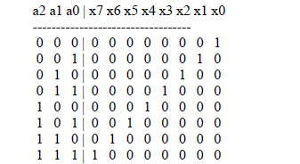
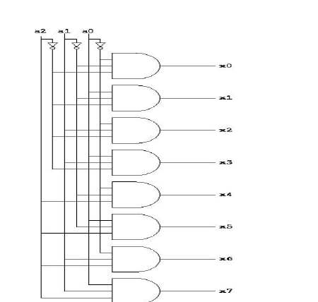
Encoder An encoder has 2n input lines and n output lines. The output lines generate a binary code corresponding to the input value. For example a single bit 4 to 2 encoder takes in 4 bits and outputs 2 bits. It is assumed that there are only 4 types of input signals these are : 0001, 0010, 0100, 1000.
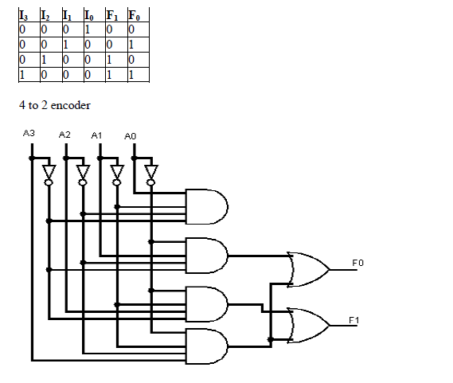
Sequential circuit
Introduction
In the previous session, we said that the output of a combinational circuit depends solely upon the input. The implication is that combinational circuits have no memory. In order to build sophisticated digital logic circuits, including computers, we need more a powerful model. We need circuits whose output depends upon both the input of the circuit and its previous state. In other words, we need circuits that have memory. For a device to serve as a memory, it must have three characteristics:
• the device must have two stable states
• there must be a way to read the state of the device
• there must be a way to set the state at least once.

It is possible to produce circuits with memory using the digital logic gates we've already seen. To do that, we need to introduce the concept of feedback. So far, the logical flow in the circuits we've studied has been from input to output. Such a circuit is called acyclic. Now we will introduce a circuit in which the output is fed back to the input, giving the circuit memory. (There are other memory technologies that store electric charges or magnetic fields; these do not depend on feedback.)
Latches and flip-flops
In the same way that gates are the building blocks of combinatorial circuits, latches and flip-flops are the building blocks of sequential circuits. While gates had to be built directly from transistors, latches can be built from gates, and flip-flops can be built from latches. This fact will make it somewhat easier to understand latches and flip-flops. Both latches and flip-flops are circuit elements whose output depends not only on the current inputs, but also on previous inputs and outputs. The difference between a latch and a flip-flop is that a latch does not have a clock signal, whereas a flip-flop always does.
Latches
How can we make a circuit out of gates that is not combinatorial? The answer is feed-back, which means that we create loops in the circuit diagrams so that output values depend, indirectly, on themselves. If such feed-back is positive then the circuit tends to have stable states, and if it is negative the circuit will tend to oscillate. In order for a logical circuit to "remember" and retain its logical state even after the controlling input signal(s) have been removed, it is necessary for the circuit to include some form of feedback. We might start with a pair of inverters, each having its input connected to the other's output. The two outputs will always have opposite logic levels
The problem with this is that we don't have any additional inputs that we can use to change the logic states if we want. We can solve this problem by replacing the inverters with NAND or NOR gates, and using the extra input lines to control the circuit. The circuit shown below is a basic NAND latch. The inputs are generally designated "S" and "R" for "Set" and "Reset" respectively. Because the NAND inputs must normally be logic 1 to avoid affecting the latching action, the inputs are considered to be inverted in this circuit. The outputs of any single-bit latch or memory are traditionally designated Q and Q'. In a commercial latch circuit, either or both of these may be available for use by other circuits. In any case, the circuit itself is:
For the NAND latch circuit, both inputs should normally be at a logic 1 level. Changing an input to a logic 0 level will force that output to a logic 1. The same logic 1 will also be applied to the second input of the other NAND gate, allowing that output to fall to a logic 0 level. This in turn feeds back to the second input of the original gate, forcing its output to remain at logic 1. Applying another logic 0 input to the same gate will have no further effect on this circuit. However, applying a logic 0 to the other gate will cause the same reaction in the other direction, thus changing the state of the latch circuit the other way. Note that it is forbidden to have both inputs at a logic 0 level at the same time. That state will force both outputs to a logic 1, overriding the feedback latching action. In this condition, whichever input goes to logic 1 first will lose control, while the other input (still at logic 0) controls the resulting state of the latch. If both inputs go to logic 1 simultaneously, the result is a "race" condition, and the final state of the latch cannot be determined ahead of time. The same functions can also be performed using NOR gates. A few adjustments must be made to allow for the difference in the logic function, but the logic involved is quite similar. The circuit shown below is a basic NOR latch. The inputs are generally designated "S" and "R" for "Set" and "Reset" respectively. Because the NOR inputs must normally be logic 0 to avoid overriding the latching action, the inputs are not inverted in this circuit. The NOR-based latch circuit is: For the NOR latch circuit, both inputs should normally be at a logic 0 level. Changing an input to a logic 1 level will force that output to a logic 0. The same logic 0 will also be applied to the second input of the other NOR gate, allowing that output to rise to a logic 1 level. This in turn feeds back to the second input of the original gate, forcing its output to remain at logic 0 even after the external input is removed.
Applying another logic 1 input to the same gate will have no further effect on this circuit. However, applying a logic 1 to the other gate will cause the same reaction in the other direction, thus changing the state of the latch circuit the other way.
Note that it is forbidden to have both inputs at a logic 1 level at the same time. That state will force both outputs to a logic 0, overriding the feedback latching action. In this condition, whichever input goes to logic 0 first will lose control, while the other input (still at logic 1) controls the resulting state of the latch. If both inputs go to logic 0 simultaneously, the result is a "race" condition, and the final state of the latch cannot be determined ahead of time.
One problem with the basic RS NOR latch is that the input signals actively drive their respective outputs to a logic 0, rather than to a logic 1. Thus, the S input signal is applied to the gate that produces the Q' output, while the R input signal is applied to the gate that produces the Q output. The circuit works fine, but this reversal of inputs can be confusing when you first try to deal with NOR-based circuits.

