T Flip-Flop
The T flip-flop is a single input version of the JK flip-flop. As shown in Figure 7, the T flip-flop is obtained from the JK type if both inputs are tied together. The output of the T flip-flop "toggles" with each clock pulse.
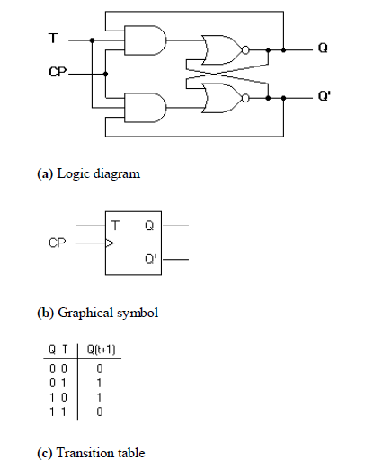
Triggering of Flip-flops
The state of a flip-flop is changed by a momentary change in the input signal. This change is called a trigger and the transition it causes is said to trigger the flip-flop. The basic circuits of Figure 2 and Figure 3 require an input trigger defined by a change in signal level. This level must be returned to its initial level before a second trigger is applied. Clocked flip-flops are triggered by pulses.
The feedback path between the combinational circuit and memory elements in Figure 1 can produce instability if the outputs of the memory elements (flip-flops) are changing while the outputs of the combinational circuit that go to the flip-flop inputs are being sampled by the clock pulse. A way to solve the feedback timing problem is to make the flip-flop sensitive to the pulse transition rather than the pulse duration. The clock pulse goes through two signal transitions: from 0 to 1 and the return from 1 to 0. As shown in Figure 8 the positive transition is defined as the positive edge and the negative transition as the negative edge.
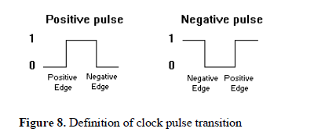
The clocked flip-flops already introduced are triggered during the positive edge of the pulse, and the state transition starts as soon as the pulse reaches the logic-1 level. If the other inputs change while the clock is still 1, a new output state may occur. If the flip-flop is made to respond to the positive (or negative) edge transition only, instead of the entire pulse duration, then the multiple-transition problem can be eliminated.
Summary
Since memory elements in sequential circuits are usually flip-flops, it is worth summarising the behaviour of various flip-flop types before proceeding further. All flip-flops can be divided into four basic types: SR, JK, D and T. They differ in the number of inputs and in the response invoked by different value of input signals. The four types of flip-flops are defined in Table 1.
Table 1. Flip-flop Types
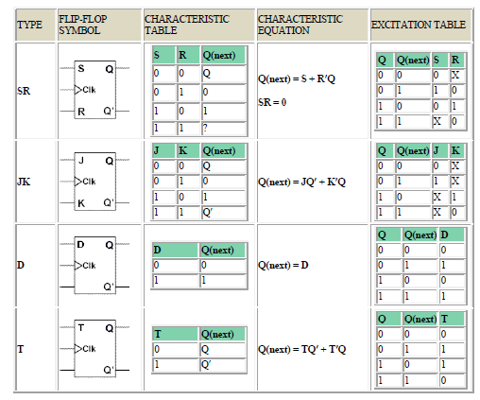
Synchronous and asynchronous sequential circuit
asynchronous system is a system whose outputs depend upon the order in which its input variables change and can be affected at any instant of time. Gate-type asynchronous systems are basically combinational circuits with feedback paths. Because of the feedback among logic gates, the system may, at times, become unstable. Consequently they are not often used. Synchronous type of system uses storage elements called flip-flops that are employed to change their binary value only at discrete instants of time. Synchronous sequential circuits use logic gates and flip-flop storage devices. Sequential circuits have a clock signal as one of their inputs. All state transitions in such circuits occur only when the clock value is either 0 or 1 or happen at the rising or falling edges of the clock depending on the type of memory elements used in the circuit. Synchronization is achieved by a timing device called a clock pulse generator. Clock pulses are distributed throughout the system in such a way that the flip-flops are affected only with the arrival of the synchronization pulse. Synchronous sequential circuits that use clock pulses in the inputs are called clocked-sequential circuits. They are stable and their timing can easily be broken down into independent discrete steps, each of which is considered separately. A clock signal is a periodic square wave that indefinitely switches from 0 to 1 and from 1 to 0 at fixed intervals. Clock cycle time or clock period: the time interval between two consecutive rising or falling edges of the clock.
Design of Sequential Circuits
The design of a synchronous sequential circuit starts from a set of specifications and culminates in a logic diagram or a list of Boolean functions from which a logic diagram can be obtained. In contrast to a combinational logic, which is fully specified by a truth table, a sequential circuit requires a state table for its specification. The first step in the design of sequential circuits is to obtain a state table or an equivalence representation, such as a state diagram. A synchronous sequential circuit is made up of flip-flops and combinational gates. The design of the circuit consists of choosing the flip-flops and then finding the combinational structure which, together with the flip-flops, produces a circuit that fulfils the required specifications. The number of flip-flops is determined from the number of states needed in the circuit. The recommended steps for the design of sequential circuits are set out below:

