Binary subtraction using adders
Our binary adder can already handle negative numbers as indicated in the section on binary arithmetic But we have not discussed how we can get it to handle subtraction. To see how this can be done, notice that in order to compute the expression x - y, we can compute the expression x + -y instead. We know from the section on binary arithmetic how to negate a number by inverting all the bits and adding 1. Thus, we can compute the expression as x + inv(y) + 1. It suffices to invert all the inputs of the second operand before they reach the adder, but how do we add the 1. That seems to require another adder just for that. Luckily, we have an unused carry-in signal to position 0 that we can use. Giving a 1 on this input in effect adds one to the result. The complete circuit with addition and subtraction looks like this:
Medium Scale integration component
The purpose of circuit minimization is to obtain an algebraic expression that, when implemented results in a low cost circuit. Digital circuit are constructed with integrated circuit(IC). An IC is a small silicon semiconductor crystal called chip containing the electronic component for digital gates. The various gates are interconnected inside the chip to form the required circuit. Digital IC are categorized according to their circuit complexity as measured by the number of logic gates in a single packages.
- Small scale integration (SSI). SSi devices contain fewer than 10 gates. The input and output of the gates are connected directly to the pins in the package.
- Medium Scale Integration. MSI devices have the complexity of approximately 10 to 100 gates in a single package
- Large Scale Integration (LSI). LSI devices contain between 100 and a few thousand gates in a single package
- Very Large Scale Integration(VLSI). VLSI devices contain thousand of gates within a single package. VLSI devices have revolutionized the computer system design technology giving the designer the capabilities to create structures that previously were uneconomical.

Multiplexer
A multiplexer is a combinatorial circuit that is given a certain number (usually a power of two) data inputs, let us say 2n, and n address inputs used as a binary number to select one of the data inputs. The multiplexer has a single output, which has the same value as the selected data input. In other words, the multiplexer works like the input selector of a home music system. Only one input is selected at a time, and the selected input is transmitted to the single output. While on the music system, the selection of the input is made manually, the multiplexer chooses its input based on a binary number, the address input. The truth table for a multiplexer is huge for all but the smallest values of n. We therefore use an abbreviated version of the truth table in which some inputs are replaced by `-' to indicate that the input value does not matter. Here is such an abbreviated truth table for n = 3. The full truth table would have 2(3 + 23) = 2048 rows.
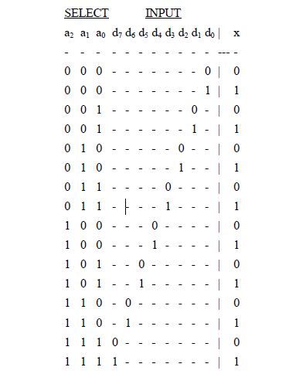
We can abbreviate this table even more by using a letter to indicate the value of the selected input, like this:
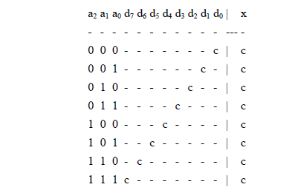
The same way we can simplify the truth table for the multiplexer, we can also simplify the corresponding circuit. Indeed, our simple design method would yield a very large circuit. The simplified circuit looks like this:
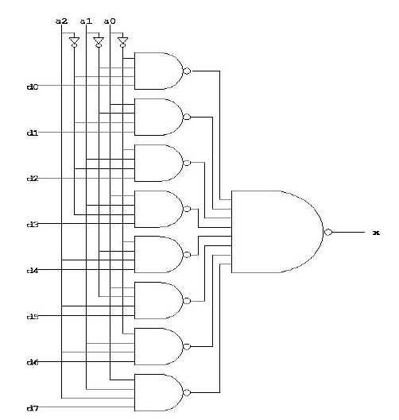
Demultiplexer
The demultiplexer is the inverse of the multiplexer, in that it takes a single data input and n address inputs. It has 2n outputs. The address input determine which data output is going to have the same value as the data input. The other data outputs will have the value 0. Here is an abbreviated truth table for the demultiplexer. We could have given the full table since it has only 16 rows, but we will use the same convention as for the multiplexer where we abbreviated the values of the data inputs.
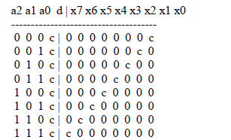
Here is one possible circuit diagram for the demultiplexer:
