Counters
A sequential circuit that goes through a prescribed sequence of states upon the application of input pulses is called a counter. The input pulses, called count pulses, may be clock pulses. In a counter, the sequence of states may follow a binary count or any other sequence of states. Counters are found in almost all equipment containing digital logic. They are used for counting the number of occurrences of an even and are useful for generating timing sequences to control operations in a digital system. A counter is a sequential circuit with 0 inputs and n outputs. Thus, the value after the clock transition depends only on old values of the outputs. For a counter, the values of the outputs are interpreted as a sequence of binary digits (see the section on binary arithmetic). We shall call the outputs o0, o1, ..., on-1. The value of the outputs for the counter after a clock transition is a binary number which is one plus the binary number of the outputs before the clock transition. We can explain this behavior more formally with a state table. As an example, let us take a counter with n = 4. The left side of the state table contains 4 columns, labeled o0, o1, o2, and o3. This means that the state table has 16 rows. Here it is in full:
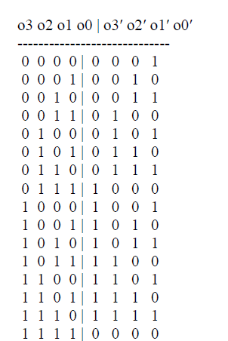
As you can see, the right hand side of the table is always one plus the value of the left hand side of the table, except for the last line, where the value is 0 for all the outputs. We say that the counter wraps around.
Counters (with some variations) play an important role in computers. Some of them are visible to the programmer, such as the program counter (PC). Some of them are hidden to the programmer, and are used to hold values that are internal to the central processing unit, but nevertheless important. Important variations include:
• The ability to count up or down according to the value of an additional input
• The ability to count or not according the the value of an additional input
• The ability to clear the contents of the counter if some additional input is 1
• The ability to act as a register as well, so that a predetermined value is loaded when some additional input is 1
• The ability to count using a different representation of numbers from the normal (such as Gray-codes, 7-segment codes, etc)
• The ability to count with different increments that 1
Design of Counters Example 1.5 A counter is first described by a state diagram, which is shows the sequence of states through which the counter advances when it is clocked. Figure 18 shows a state diagram of a 3-bit binary counter.
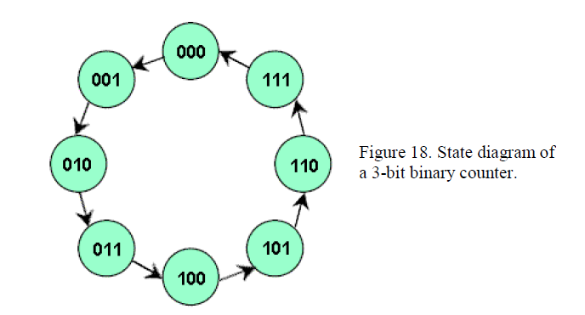
flip-flop in the counter). The next state of the counter depends entirely on its present state, and the state transition occurs every time the clock pulse occurs. Figure 19 shows the sequences of count after each clock pulse.
Once the sequential circuit is defined by the state diagram, the next step is to obtain the next-state table, which is derived from the state diagram in Figure 18 and is shown in Table 15. 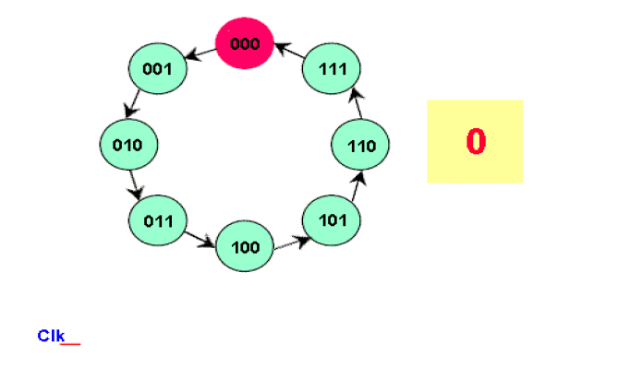
Once the sequential circuit is defined by the state diagram, the next step is to obtain the next-state table, which is derived from the state diagram in Figure 18 and is shown in Table 15.
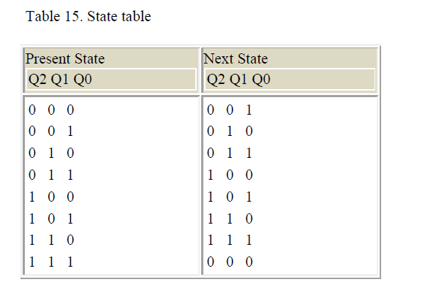
Since there are eight states, the number of flip-flops required would be three. Now we want to implement the counter design using JK flip-flops. Next step is to develop an excitation table from the state table, which is shown in Table 16.
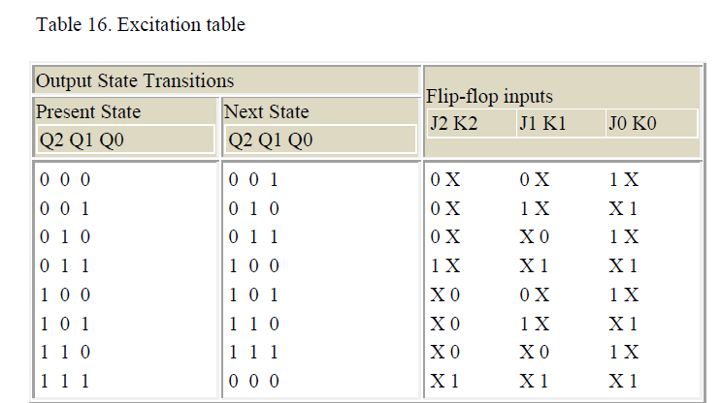
Now transfer the JK states of the flip-flop inputs from the excitation table to Karnaugh maps to derive a simplified Boolean expression for each flip-flop input. This is shown in Figure 20.

