- Convert From Any Base to Decimal
Let's think more carefully what a decimal number means. For example, 1234 means that there are four boxes (digits); and there are 4 one's in the right-most box (least significant digit), 3 ten's in the next box, 2 hundred's in the next box, and finally 1 thousand's in the left-most box (most significant digit). The total is 1234:
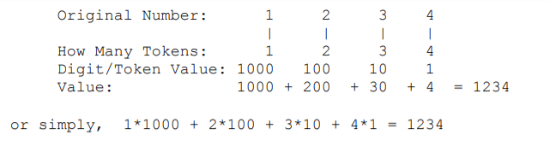
Thus, each digit has a value: 10^0 =1 for the least significant digit, increasing to 10^1 =10, 10^2 =100, 10^3 =1000, and so forth. Likewise, the least significant digit in a hexadecimal number has a value of 16^0 =1 for the least significant digit, increasing to 16^1 =16 for the next digit, 16^2 =256 for the next, 16^3 =4096 for the next, and so forth. Thus, 1234 means that there are four boxes (digits); and there are 4 one's in the right-most box (least significant digit), 3 sixteen's in the next box, 2 256's in the next, and 1 4096's in the left-most box (most significant digit). The total is:
1*4096 + 2*256 + 3*16 + 4*1 = 4660
In summary, the conversion from any base to base 10 can be obtained from the formulae
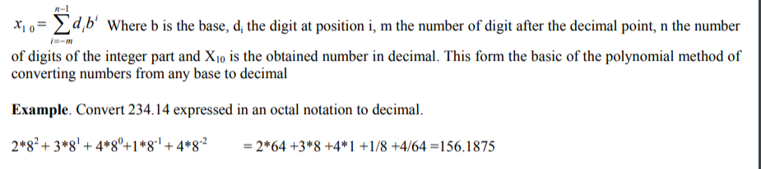
Example. Convert the hexadecimal number 4B3 to decimal notation. What about the decimal equivalent of the hexadecimal number 4B3.3?
Solution:

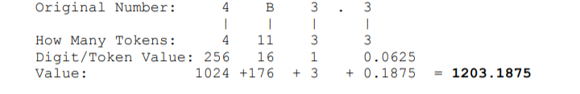
Example. Convert 234.14 expressed in an octal notation to decimal.
Solution:
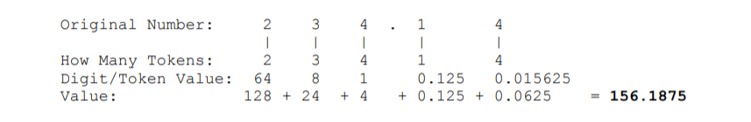
- Relationship between Binary - Octal and Binary-hexadecimal
As demonstrated by the table bellow, there is a direct correspondence between the binary system and the octal system, with three binary digits corresponding to one octal digit. Likewise, four binary digits translate directly into one hexadecimal digit.
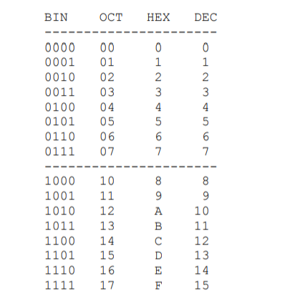
With such relationship, In order to convert a binary number to octal, we partition the base 2 number into groups of three starting from the radix point, and pad the outermost groups with 0’s as needed to form triples. Then, we convert each triple to the octal equivalent.
For conversion from base 2 to base 16, we use groups of four.
Consider converting 10110₂ to base 8:
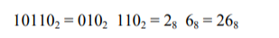
Notice that the leftmost two bits are padded with a 0 on the left in order to create a full triplet.
Now consider converting 10110110₂ to base 16:
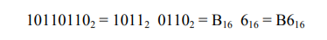
The conversion methods can be used to convert a number from any base to any other base, but it may not be very intuitive to convert something like 513.03 to base 7. As an aid in performing an unnatural conversion, we can convert to the more familiar base 10 form as an intermediate step, and then continue the conversion from base 10 to the target base. As a general rule, we use the polynomial method when converting into base 10, and we use the remainder and multiplication methods when converting out of base 10.
- Binary example
The method of complements is especially useful in binary (radix 2) since the ones' complement is very easily obtained by inverting each bit (changing '0' to '1' and vice versa). And adding 1 to get the two's complement can be done by simulating a carry into the least significant bit. For example:
becomes the sum:
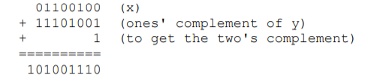
Dropping the initial "1" gives the answer: 01001110 (equals decimal 78)

Signed fixed point numbers
Up to this point we have considered only the representation of unsigned fixed point numbers. The situation is quite different in representing signed fixed point numbers. There are four different ways of representing signed numbers that are commonly used: sign-magnitude, one’s complement, two’s complement, and excess notation. We will cover each in turn, using integers for our examples. The Table below shows for a 3-bit number how the various representations appear.

