EPISTAXIS

Epistaxis is defined as bleeding from the nose.
Vascular anatomy:
The internal and external carotid arteries supply the nose via branches which anastomose extensively within the lateral wall, septum and across the midline. In 1879, James Little identified an arterial plexus on the anterior septum as a frequent site of bleeding and the same plexus was described one year later by Kiesselbach? As a result of these descriptions, the area most frequently implicated in epistaxis is known as Little's area or Kiesselbach plexus.

The external carotid artery supplies the nasal cavity via facial and maxillary branches. The facial artery supplies the most anterior part of the septum (via superior labial artery). The maxillary artery supply is via the sphenopalatine and greater palatine branches. The sphenopalatine artery is the most important supply to the nasal cavity.
It enters through the sphenopalatine foramen and immediately divides into posterior septal and posterior lateral rami. The posterior lateral division gives the inferior and middle turbinate arteries.

The internal carotid contributes the anterior and posterior ethmoidal branches of the ophthalmic artery.
The posterior ethmoidal artery is smaller than the anterior ethmoidal artery and is present in only 80 percent of individuals.

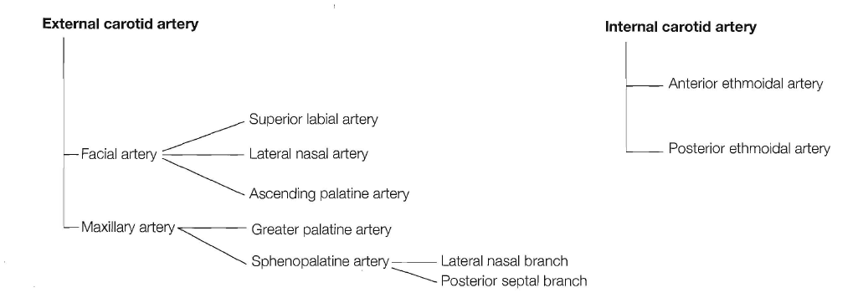

LATERAL WALL OR SEPTAL BLEEDING?
70 percent bled from the septum and 24 percent from the lateral wall. There was no side predilection .

Adult or children
The condition is common in childhood, becomes less common in early adult life and then peaks in the sixth decade.

Primary or secondary
Between 70 and 80 percent of all cases of epistaxis are idiopathic, spontaneous bleeds without any proven precipitant or causal factor.This type of bleeding can be classified as primary epistaxis. As our understanding of the aetiology advances, the number of cases of true primary epistaxis will decrease but, at present, this definition encompasses most cases. A small proportion are due to a clear and definite cause such as trauma, surgery or anticoagulant overdose and can be classified as secondary epistaxis.

Management

The theoretical ideal requires identification of the bleeding point and direct control of the bleeding. First, the patient must be resuscitated, bleeding slowed, the nasal cavity examined and a treatment plan established.

RESUSClTATION
Prompt and effective resuscitation is required. First aid by pinching the ala nasi for 5-10 minutes is supported by the frequency with which the anterior part of 'the septum is the source of bleeding. History and examination will help in assessing the amount of blood lost. In all but the most minor of bleeds, intravenous access is established and baseline blood estimations are taken.

ASSESSMENT
The patient should be assessed in a semi-recumbent position and nursing assistance is mandatory. Everyone involved should wear protective visors and clothing as blood aerosol contamination is common, especially when inserting nasal packing. Basic equipment includes a headlight, suction, vasoconstrictor solutions (lignocaine and pseudoephedrine solution has now widely superseded cocaine solutions) and a selection of packs, and cautery apparatus.

Treatment may be divided into direct (bleeding point specific therapies) or indirect treatments which do not require identification of the bleeding point.
Direct therapy:
Systematic examination with a headlight will identify most bleeding points. Once identified, bleeding points can be directly controlled with bipolar diathermy, chemical cautery (silver nitrate 75% or trichloracetic acid) (difficult in posterior bleeds), or electrocautery. Failure to locate the bleeding point on initial examination is an indication for examination with a rod lens endoscope . Monopolar diathermy should not be used in the nasal cavity as there have been reports of blindness due to current propagation.

Indirect therapies
Failure to find (often the result of failure to look for) the bleeding point is an indication for use of one of numerous traditionally favored indirect strategies.

- Nasal packing
Packing can be anteriorly or posteriorly placed. Ribbon gauze impregnated with petroleum jelly or bismuth iodoform paraffin paste (BIPP) is inserted the entire length of the nasal cavity in an attempt to tamponade the bleeding. Once inserted, the packs are left in situ for between 24 and 72 hours. Complications of packing include sinusitis, septal perforation, alar necrosis, hypoxia and myocardial infarction. Packing is usually considered an indication for antibiotic cover.

- Hot water irrigation :
Irrigation of the nasal cavity with water at 50°C has been proposed as an alternative to packing. Up to a third of patients find the technique difficult to tolerate and so use of specialized irrigation catheters is recommended.

- Systemic medical therapy
Tranexamic acid and epsilon aminocaproic acid are systemic Inhibitors of fibrinolysis. Tranexamic acid has been shown to reduce the severity and risk of rebleeding in epistaxis at a dose of 1.5 g three times a day. These drugs do not increase fibrin deposition and so do not increase the risk of thrombosis. Preexisting thromboembolic disease is a contraindication.

SURGICAL MANAGEMENT

If the techniques described above fail, surgical intervention is required.
Surgical management for continued epistaxis consists of:
• Posterior packing;
• Ligation techniques;
• Septal surgery techniques
•Embolization techniques.

Posterior nasal packs
Posterior packing can be carried out under local anaesthesia but general anaesthesia is preferrable. Nasopharyngeal tamponade is achieved using special gauze packs inserted transorally and positioned by means of tapes passed from the posterior choana to the anterior nares bilaterally. An easier and perhaps kinder alternative is to insert a Foley urethral catheter (size 12 or 14) along the floor of the nasal cavity until the nasopharynx is reached. The Foley catheter is inflated with up to 15 mL of water, pulled forward to engage in the posterior choana and anterior packing is then inserted. ThePosterior packs should be left in position for a minimum of 48 hours.
Ligation techniques:
Ligation is reserved for intractable bleeding where the source cannot be located or controlled by the techniques described above.we can ligate the following vessels :
- sphenopalatine artery;
- internal maxillary artery;
- external carotid artery;
- anterior/posterior ethmoidal artery.

Endonasal sphenopalatine artery ligation

Under general or local anaesthesia. an incision is made approximately 1cm inferior to the posterior end of the middle turbinate. The incision is carried down to the bone and a mucosal flap is elevated posteriorly until the fibroneurovascular sleeve arising from the sphenopalatine foramen is identified. Once the main vessel is identified. it can be ligated using haemostatic clips and divided or coagulated using bipolar diathermy.

Anterior/posterior ethmoidal artery ligation
The arteries are approached by a medial canthal incision which is carried down to the bone of the anterior lacrimal crest. Periosteal elevators are then used to elevate and laterally retract the bulbar fascia. The anterior ethmoidal artery is seen as a fibroneurovascular mesentry running from the bulbar fascia into the anterior ethmoidal foramen. The vessel is clipped and divided and dissection is continued to identify the posterior artery which is located approximately 12 mm behind.

Hereditary haemorrhagic telangiectasia
Hereditary haemorrhagic telangiectasia (HHT), or Rendu-Osler-Weber disease, is an autosomal dominant condition affecting blood vessels in the skin, mucous membranes and viscera. The classical features are telangiectasia, arteriovenous (AV) malformations and aneurysms. Recurrent epistaxis occurs in 93 percent of cases. Management involves packing, cautery, systemic or topical oestrogens, coagulative lasers, septal dermoplasty, and, as a last resort, permanent surgical closure of the nostrils (Young's operation) .

