**Cardiopulmonary resuscitation**

Cardiac arrest is the most time-critical medical emergency an anaesthetist may face. Effective basic

and advanced life support measures must be applied as early as possible to maximise the chance of

survival and minimise hypoxic neurological damage. It is a series of well-defined steps &protocols to revive a

collapsed patient ,to deliver oxygen to the heart &brain &to restore native circulation &ventilation

On normal inspiration, a person breathes in approximately 21% oxygen. The body uses between 4-5% of this amount for its normal functions. Therefore, on expiration a person breathes out approximately 16% oxygen.

Cardiopulmonary resuscitation (CPR) is Expired Air Resuscitation (EAR) used in conjunction with External Cardiac Compressions (ECC). CPR is the most effective form of active resuscitation available today, and is used universally by first aider’s and medical personnel alike. The technique is used to ‘buy time’ in resuscitation of casualties in cardiac arrest.

EAR provides oxygen to the casualty’s lungs and blood whilst external cardiac compressions, when applied correctly pumps the oxygenated blood around the body. Effective CPR can sustain a casualty until more expert medical treatment is available.

You might not think of yourself as having lots of muscles, but there's one super-powerful muscle in your body you absolutely depend on: the tireless blood [pump](http://www.explainthatstuff.com/pumpcompressor.html) in your heart. If your heart stops beating properly and blood stops flowing, your brain starts to lose its oxygen supply and you can die within five minutes. That's why people who suffer **cardiac arrest**(when their heart stops or  goes into a dangerously abnormal rhythm) need emergency medical treatment. CPR (cardiopulmonary resuscitation) can help maintain the flow of oxygen to the brain, but getting the heart restarted and working normally often requires defibrillation with an electric shock.

**Indications for CPR**

* **unconsciousness**
* **no normal breaths, although there may be brief irregular, ‘gasping’ breaths**
* **no signs of circulation**

**A particularly important aspect of CPR is that the rescuer’s hands are positioned correctly. The most common way to locate the correct position to compress is the Xiphoid Location method.**

Using your middle and index fingers, find the lower rib edge nearest to you. Keep your fingers together and slide them Using your middle and index fingers, find the lower rib edge nearest to you. Keep your fingers together and slide them upwards to the point where the ribs join the breastbone (sternum). This point is need to compress the chest the appropriate depth depending on age ofelf. Once **eStages**

1**.basic cardiac life support:resuscitation without the aid of equipment**

**2.advanced cardiac life support:resuscitation with the help of advanced techniques&equipment**.

**BCLS** should started immediately &continued till the ACLS support arrives

It should provide:

1.adequate patent airway.

2.artificial breathing by expired air respiration.

3.artificial circulation by external chest compression.

**Airway**

Tongue may fall to the back of the pharynx:tilt the head back &lift the chin forward:clear the mouth &airway tube may be used.

**Breathing**

If no effective breathing,artificial ventilation should be started by expired air respiration,mouth to mouth breathing ,respiration should be given at 12-15 breaths per minute

**Circulation**

If there is no heart beat,no pulse in big arteries like carotid,femoral,closed chest cardiac massage should be started

Basic life support is commenced when a patient is found to be unresponsive with absent or abnormal

breathing (such as agonal gasps). The absence of a palpable pulse is now regarded as an unreliable sign

and should not be the only sign used to establish cardiac arrest. If trained to do so, rescuers may

attempt to palpate a pulse for up to 10 seconds.

Current guidelines emphasise the quality of chest compressions. The chest should be compressed at

least 5 cm and at a rate of approximately more than100/min up to 120. The chest should be allowed to fully recoil between

compressions. Interruptions to chest compressions should be minimised.

Rescuer fatigue is associated with worsening rate and depth of chest compression even before the

rescuer is aware of fatigue. Where feasible, to avoid fatigue, rescuers should rotate chest compression

duties. Rotation at 2 minute intervals, regardless of whether the rescuer feels tired, is optimal and can

be integrated with the intervals for rhythm analysis during advanced life support.

Chest compressions and ventilations are delivered at a ratio of 30 chest compressions : 2 ventilations

before the airway is secured, regardless of the number of rescuers (previous guidelines recommended a

ratio of 15:2 when a second rescuer was available). This maximises the number of compressions given

and minimises interruptions, which in turn maximised perfusion

**EARLY DIAGNOSIS OF CARDIAC ARREST IS ESSENTIAL:**

1.no pulse in big vessels. 2.no respiration \gasping. 3.unconscious 4.widly dilated pupils,unresponsive to light

6.sudden cessation of bleeding on operation site 7.ECG findings[asystole,VF,ECGdissociation].

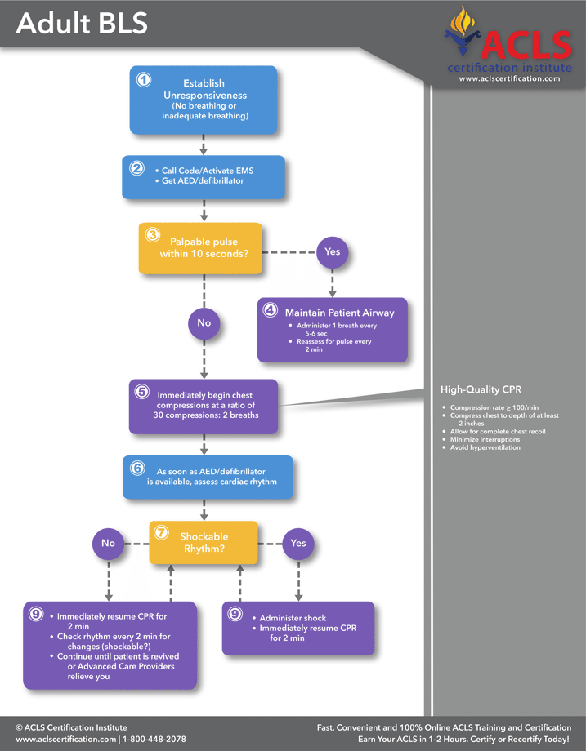

**Mechanism for blood flow during closed chest cardiac compression:**

1.compression of cardiac ventricules

2.increased intrathoracic pressure produces antegrade blood flow[thoracic pump mechanism]

3.patient related factors:

*heart size *anteroposterior chest distance *thoracic compliance *compression depth &duration *manual\mechanical compression.

**NOTE:**

**Resuscitation of children:** depression of sternum by using 3 fingers

Sternal compression:2.5 to4 cm depth , rate:80 to 100\min. sternal compression:ventilation rate=5:1

**Resuscitation in infants:** chest encircled with both hands &depression of mid sternum with thumbs

Sternal compression :1.25 to 2.5 cm depth , rate at least 100\min.

Sternal compression:ventilation ratio=5:1



**Advanced Life Support**

Once effective cardiopulmonary resuscitation (CPR) is established (30 chest compressions : 2 breaths),

a defibrillator is attached and the cardiac rhythm is analysed. Subsequent treatment is determined by

whether there is a “shockable” rhythm i.e. VF or VT or a “non-shockable” rhythm i.e. pulseless

***Shockable rhythm (VF or VT)***

A single DC shock is delivered and CPR is immediately recommenced, without a pause to reassess the

rhythm. CPR is continued, interrupted only every 2 minutes for a rhythm check. A further single DC

shock is delivered if the rhythm remains VF or VT at each rhythm check. Adrenaline 1 mg IV is

administered after the second shock and then every second loop of the ALS algorithm i.e. every second

rhythm check or approximately every 3-5 minutes. Amiodarone 300 mg IV is administered after the

third DC shock if VF/VT persists.

***Non-Shockable rhythm (PEA or asystole)***

Adrenaline 1 mg IV is given immediately. Effective CPR is continued, with a pause to reassess the

rhythm every 2 minutes. Adrenaline 1 mg IV is given every second loop of the algorithm i.e. every 3-5

minutes.

**What is a defibrillator?**

As the name suggests, defibrillation stops **fibrillation**, the useless trembling that a person's heart muscles can adopt during a cardiac arrest. Simply speaking, a defibrillator works by using a high-voltage (something like 200–1000 volts) to pass an [electric current](http://www.explainthatstuff.com/electricity.html) through the heart so it's shocked into working normally again.

**During CPR**

An advanced airway (endotracheal tube or laryngeal mask airway) is placed. Once placed, ventilations

are delivered at a rate of 6-10 per minute, with no interruptions to CPR for delivery of breaths. The

volume delivered should be sufficient for visible chest rise.

100% oxygen is delivered.

Intravenous access is established for the delivery of medications. If this is impossible, intraosseous

access is established.

If available, waveform capnography is used to confirm correct advanced airway placement, guide

effectiveness of CPR and detect return of spontaneous circulation (ROSC).

Reversible causes of the cardiac arrest are sought and treated. The mnemonic “Hs and Ts” is helpful

**Post-Resuscitation Care**

Once ROSC is achieved, the phase of post-resuscitation care is commenced. The patient is reevaluated.

Adequate oxygenation and ventilation must be confirmed. Urgent 12-lead ECG and chest Xray

should be considered. The need for coronary reperfusion should be assessed. Reversible causes ofthe cardiac arrest should be sought and treated.

For patients who remain comatose after ROSC, therapeutic hypothermia should be considered

**Advanced airway**

*Reduced emphasis on endotracheal intubation*

Endotracheal intubation remains the gold standard for establishment of a secure airway. One advantage

of endotracheal intubation is that once achieved, it is possible to continue chest compressions without

interruptions for ventilation. A significant disadvantage however, is that endotracheal intubation .

usually associated with an undesirable, prolonged pause in chest compressions. Rescuers must weigh

the benefits of intubation against the need to provide effective chest compressions.

It is recommended that attempts at intubation not interrupt chest compressions for more than 20

seconds.

Other supraglottic airway devices such as the laryngeal mask airway (LMA) may also be used if

rescuers are adequately trained and skilled to do so.

*Confirmation of endotracheal tube placement*

The performance of clinical assessment in confirming correct tube placement (auscultation of the chest

and epigastrium, condensation in the tube and chest rise) is variable

Secondary confirmation via qualitative end-tidal CO2 or oesophageal detection devices also perform

variably and no better than clinical assessment.

.

Waveform capnometry (ETCO2) has the best sensitivity and specificity and is recommended in

addition to clinical assessment to confirm and continuously monitor correct tube placement.

**Ventilation**

*Avoid hyperventilation*

Hyperventilation is associated with increased intrathoracic pressure, decreased cerebral and coronary

perfusion (hypocapnia causes cerebral and coronary vasoconstriction) and may impair ROSC. In order

to achieve adequate oxygenation and optimise haemodynamics, once an advanced airway is

established, the rate of manual ventilation should be 6-10 breaths per minute, and should not exceed 12

breaths per minute. As a guide, one ventilation can be given after every 15 chest compressions,

delivering the ventilation during the relaxation phase of chest compression, without a pause

(simultaneous ventilation and compression may impair coronary perfusion and adversely affect

survival).

Specific guidelines are not given for optimal tidal volume. Ventilations should be adequate to produce

visible chest rise. PaCO2 (but not ETCO2) via arterial blood gas analysis may allow individual titration

of ventilation.

*Mechanical ventilation*

There is insufficient evidence to support or refute the use of automatic ventilators over manual bag valve

ventilation. A mechanical ventilator may enable rescuers to perform more tasks and removes the

risk of inadvertent hyperventilation. There is however a risk of hypoventilation due to non-delivery of

mechanical breaths.

**Monitoring during resuscitation - ETCO2**

Continuous waveform end-tidal CO2 (ETCO2) monitoring is a useful adjunct to monitor the

effectiveness of chest compressions. Falling ETCO2 may indicate rescuer fatigue or inadequate depth

or rate of compressions thus providing real-time feedback to the resuscitation team.

A sudden rise in ETCO2 may also be used for early detection of ROSC, during chest compressions,

prior to the next pause for rhythm analysis.

**Defibrillation - perform with minimal interruptions to chest compressions**

Biphasic (rather than monophasic) defibrillators are currently recommended. The use of adhesive pads

is preferred over paddles. The default energy setting should be 200J for all shocks in adults (360J if

monophasic).

A single shock strategy is recommended over previously suggested stacked shocks. Single shocks are

associated with shorter interruptions to chest compressions.

Immediately after defibrillation, there should not be a pause for rhythm analysis. Chest compressions

should immediately be recommenced after shock delivery and continue for two minutes prior to rhythm

analysis. So defibrillate first, then perform compressions, then check the rhythm.

The defibrillator should be charged during chest compressions, allowing immediate defibrillation,

without pause for charging, once VT or VF is detected at rhythm analysis.

Chest compressions during defibrillation are not currently recommended due to safety concerns,

although this technique may be feasible5.

**Medications in Cardiac Arrest**

*Intraosseous administration*

In previous guidelines, endotracheal administration of drugs was recommended where intravenous

access was unavailable. Currently, the intraosseous route is preferred as it is safe and effective.

Administration of drugs via this method should achieve adequate serum concentrations, whereas

absorption via the endotracheal route is variable and serum concentrations are generally lower.

*Medication and long term outcome*

Despite widespread use, there is no evidence that any medication improves the rate of neurologically

intact survival from cardiac arrest.

***Adrenaline***

Adrenaline remains the vasopressor of choice - it may improve likelihood of ROSC and short-term

survival. There is no evidence to define the optimal dose or timing of adrenaline, and the role of

adrenaline in resuscitation protocols is based on consensus opinion.

***Amiodarone***

No studies have shown a long-term survival benefit from amiodarone. However amiodarone may

improve rates of survival to hospital admission in out-of-hospital cardiac arrest and may improve the

response to defibrillation in shock-refractory VT or VF.

***Atropine***

Atropine is no longer recommended for use in PEA or asystolic cardiac arrest.

**Ultrasound during cardiac arrest**

If a trained operator and equipment is available, bedside ultrasound may be a useful tool to help

diagnose reversible cardiac and non-cardiac causes of cardiac arrest eg. pericardial effusion and

tamponade, right ventricular dysfunction due to massive pulmonary embolism, absence of lung artifact

in tension pneumothorax.

Ultrasound may also be used to detect cardiac standstill, the presence of which is highly predictive of

death and indicates that further resuscitative efforts are futile

Aggressive therapeutic efforts should not cease after ROSC and are likely to significantly influence the

patient’s long term outcome. Reversible causes of the arrest must again be evaluated and

treated.

Adequate oxygenation should be maintained in the post-resuscitation phase, preventing hypoxaemia.

However, new evidence suggests that exposure to excessive oxygen (hyperoxaemia) may also be

detrimental. Oxygenation may be monitored either by pulse oximetry or by arterial blood gas and

inspired oxygen should be titrated to SaO2 94% - 98%. No PaO2 target is recommended in the

guidelines.

***Temperature control***

Therapeutic hypothermia, in randomised trials has shown a benefit in terms of intact long-term

neurological survival in comatose victims of out-of-hospital VF or VT cardiac arrest. Current

guidelines recommend cooling to 32 - 34 degrees C for 12 - 24 hours. Therapeutic hypothermia may

also be of benefit after non-shockable rhythms and in-hospital arrests but level I evidence is lacking.

Hypothermia can be induced by rapid infusion of 30mL/kg of cold (4 degrees C) fluid (either 0.9%

saline or Hartmann’s solution). Alternatively, ice packs placed against the patient’s neck, axillae and

groin are effective. Maintenance of hypothermia can be safely achieved with continued use of ice

packs. Shivering, which counteracts lowering of temperature should be suppressed by neuromuscular

blocking drugs.

**Put in mind that early chest compression immediately circulate oxygen that still in blood stream by changing sequence,**

**Chest compression are intiated sooner&delay in ventilation should be minimal**

**SUMMARY**

**• The cornerstone of resuscitation is effective chest compressions with minimal**

**interruptions**

• compress more than100 per minute up to 120

• compress to at least 5 cm depth

• 30 compressions : 2 ventilations

• rotate rescuers to avoid fatigue

• Consider alternatives to endotracheal intubation in order to minimise interruption to

chest compression

• Avoid hyperventilation

• Consider End-Tidal CO2 monitoring during resuscitation

• Defibrillation

• single-shock strategy

• charge the defibrillator during chest compressions

• minimise interruptions to chest compressions

• Obtain intraosseous access where intravenous access is impossible

• Adrenaline and amiodarone remain the only routine medications. Atropine is no

longer recommended

• Consider bedside ultrasound to assess for reversible causes and to detect cardiac

standstill

• Post-resuscitation care

• avoid hypoxaemia and hyperoxaemia institute therapeutic hypothermia where

indicated

Only stop CPR if:

* the scene becomes unsafe
* another trained first aider arrives and takes over
* qualified help arrives and takes over
* the casualty shows signs of recovery
* you become physically unable to continue

**CRITERIA FOR NOT STARTING CPR**

-rigor mortis.

-tissue decomposition

-obviously fatal truma

-unwitnessed death in presence of serious chronic debilitating disease in the terminal stage of fatal illness

-valid DNAR orders[i.e.do not attempt resuscitation]

eason EAR **Any resuscitation is better than no resuscitation at all!**