Vibrio Cholerae Ass.Prof. Dr. Lamees A. Razzaq
Structure, Classification, and Antigenic Types
The cholera vibrios are Gram-negative, comma-shaped or slightly curved rods whose highly motile, motility depends on a single polar flagellum. Their nutritional requirements are simple. Fresh isolates are prototrophic (i.e., they grow in media containing an inorganic nitrogen source, a utilizable carbohydrate, and appropriate minerals). In adequate media, they grow rapidly with a generation time of less than 30 minutes. Although they reach higher population densities when grown with vigorous aeration, they can also grow anaerobically. Vibrios are sensitive to low pH and die rapidly in solutions below pH 6; however, they are quite tolerant of alkaline conditions.
The vibrios that caused epidemic cholera were subdivided into two biotypes: classical and El Tor.
Characteristics: Classical Eltor
1. Hemolysis – +
2. Resistant to polymyxin B – +
3. VP – +
Strains of the El Tor biotype, however, produce less cholera enterotoxin, but appear to colonize intestinal epithelium better than vibrios of the classical variety. Also, they seem some what more resistant to environmental factors. Thus, El Tor strains have a higher tendency to become endemic and exhibit a higher infection-to-case ratio than the classical biotype.
The operational serology of the cholera vibrios which belong in O antigen group 1 is relatively simple. Both biotypes (El Tor and classical) contain two major serotypes, Inaba and Ogawa . These serotypes are differentiated in agglutination and vibriocidal antibody tests on the basis of their dominant heat-stable lipopolysaccharide somatic antigens. The cholera group has a common antigen, A, and the serotypes are differentiated by the type-specific antigens, B (Ogawa) and C (Inaba). An additional serotype, Hikojima, which has both specific antigens, is rare. V cholerae O139 appears to have been derived from the pandemic El Tor biotype but has lost the characteristic O1 somatic antigen; it has gained the ability to produce a polysaccharide capsule; it produces the same cholera enterotoxin; and it seems to have retained the epidemic potential of O1 strains.
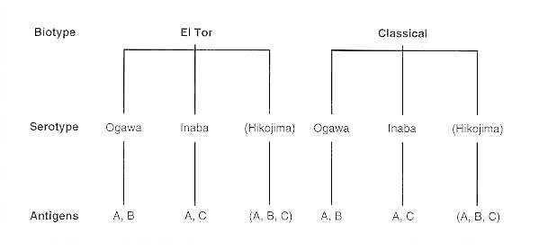
Figure 1:Vibrio cholerae (O group 1 antigen).
Pathogenesis
Cholera is exclusively a disease of the small bowel. To establish residence and multiply in the human small bowel (normally relatively free of bacteria because of the effective clearance mechanisms of peristalsis and mucus secretion), the cholera vibrios have one or more adherence factors that enable them to adhere to the microvilli. Several hemagglutinins and the toxin-coregulated pili have been suggested to be involved in adherence but the actual mechanism has not been defined. In fact, there may be multiple mechanisms. The motility of the vibrios may affect virulence by enabling them to penetrate the mucus layer. They also produce mucinolytic enzymes, neuraminidase, and proteases. The growing cholera vibrios elaborate the cholera enterotoxin (CT or choleragen), a polymeric protein consisting of two major domains or regions. The A region, responsible for biologic activity of the enterotoxin, is linked by noncovalent interactions with the B region, which is composed of five identical noncovalently associated peptide chains of M_{r} 11,500. The B region, also known as choleragenoid, binds the toxin to its receptors on host cell membranes.
The molecular events in these diarrheal diseases involve an interaction between the enterotoxins and intestinal epithelial cell membranes. The toxins bind through region B to a glycolipid, the G_{M1} ganglioside, which is practically ubiquitous in eukaryotic cell membranes. Following this binding, the A region, or a major portion of it known as the A₁ peptide, penetrates the host cell and enzymatically transfers ADP-ribose from nicotinamide adenine dinucleotide (NAD) to a target protein, the guanosine 5′-triphosphate (GTP)-binding regulatory protein associated with membrane-bound adenylate cyclase. Thus, CT (and LT) resembles diphtheria toxin in causing transfer of ADP-ribose to a substrate. With diphtheria toxin, however, the substrate is elongation factor 2 and the result is cessation of host cell protein synthesis. With CT, the ADP-ribosylation reaction essentially locks adenylate cyclase in its “on mode” and leads to excessive production of cyclic adenosine 5¹-monophosphate (cAMP). Pertussis toxin, another ADP-ribosyl transferase, also increases cAMP levels, but by its effect on another G-protein, G_{i}. The subsequent cAMP-mediated cascade of events has not yet been delineated, but the final effect is hypersecretion of chloride and bicarbonate followed by water, resulting in the characteristic isotonic voluminous cholera stool. In hospitalized patients, this can result in losses of 20 L or more of fluid per day. The stool of an actively purging, severely ill cholera patient can resemble rice water—the supernatant of boiled rice.
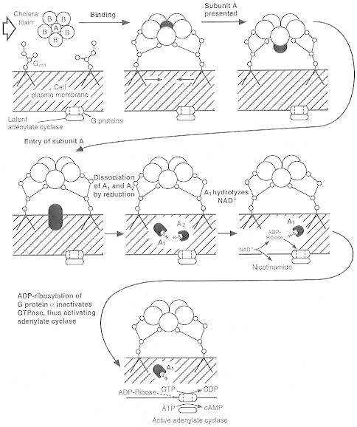
Figure 2:Mechanism of action of cholera enterotoxin.

Clinical Manifestations
Following an incubation period of 6 to 48 hours, cholera begins with the abrupt onset of watery diarrhea. The initial stool may exceed 1 L, and several liters of fluid may be secreted within hours, leading to hypovolemic shock. Vomiting usually accompanies the diarrheal episodes. Muscle cramps may occur as water and electrolytes are lost from body tissues. Loss of skin turgor, scaphoid abdomen, and weak pulse are characteristic of cholera. Various degrees of fluid and electrolyte loss are observed, including mild and subclinical cases. The disease runs its course in 2 to 7 days; the outcome depends upon the extent of water and electrolyte loss and the adequacy of water and electrolyte repletion therapy. Death can occur from hypovolemic shock, metabolic acidosis, and uremia resulting from acute tubular necrosis.
Epidemiology
Humans apparently are the only natural host for the cholera vibrios. Cholera is acquired by the ingestion of water or food contaminated with the feces of an infected individual. Cholera appears to exhibit three major epidemiologic patterns: heavily endemic, neoepidemic (newly invaded, cholera-receptive areas), and, in developed countries with good sanitation, occasional limited outbreaks. These patterns probably depend largely on environmental factors (including sanitary and cultural aspects), the prior immune status or antigenic experience of the population at risk, and the inherent properties of the vibrios themselves, such as their resistance to gastric acidity, ability to colonize, and toxigenicity.
Diagnosis
Rapid bacteriologic diagnosis offers relatively little clinical advantage to the patient with secretory diarrhea, because essentially the same treatment (fluid and electrolyte replacement) is employed regardless of etiology. Because of their rapid growth and characteristic colonial morphology, V cholerae can be easily isolated and identified in the bacteriology laboratory, provided, first, that the presence of cholera is suspected and, second, that suitable specific diagnostic antisera are available. The vibrios are completely inhibited or grow somewhat poorly on usual enteric diagnostic media (MacConkey agar or eosin-methylene blue agar). An effective selective medium is thiosulfate-citrate-bile salts-sucrose (TCBS) agar, on which the sucrose-fermenting cholera vibrios produce a distinctive yellow colony. They can also be isolated from stool samples or rectal swabs from cholera cases on simple meat extract (nutrient) agar or bile salts agar at slightly alkaline pH values. Following observation of characteristic colonial morphology with a stereoscopic microscope using transmitted oblique illumination, microorganisms can be confirmed as cholera vibrios by a rapid slide agglutination test with specific antiserum.
The string test demonstrates the property, shared by most vibrios and relatively few other genera, of forming a mucus-like string when colony material is emulsified in 0.5 percent aqueous sodium deoxycholate solution.
Control
Treatment of cholera consists essentially of replacing fluid and electrolytes. Formerly, this was accomplished intravenously, using costly sterile pyrogen-free intravenous solutions. The patient's fluid losses were conveniently measured by the use of buckets, graduated in half-liter volumes, kept underneath an appropriate hole in an army-type cot on which the patient was resting. Antibiotics such as tetracycline, to which the vibrios are generally sensitive, are useful adjuncts in treatment. They shorten the period of infection with the cholera vibrios, thus reducing the continuous source of cholera enterotoxin; this results in a substantial saving of replacement fluids and a markedly briefer hospitalization. Note, however, that fluid and electrolyte replacement is all-important; patients who are adequately rehydrated and maintained will virtually always survive, and antibiotic treatment alone is not sufficient.
Recently it has been recognized that almost all cholera patients and others with similar severe secretory diarrheal disease can be maintained by fluids given orally if the solutions contain a usable energy source such as glucose. Because of this discovery, packets containing appropriate salts are distributed by such organizations as WHO and UNICEF to cholera-afflicted areas, where they are dissolved in water as needed. One such formulation, called ORS for oral rehydration salts, contains NaCl, 3.5 g; KCl,1.5 g; NaHCO₃, 2.5 g (or trisodium citrate, 2.9 g); and glucose, 20.0 g. This mixture is dissolved in 1 L of water and taken orally in increments.

Campylobacter jejuni
Structure
Campylobacter jejuni, like all Campylobacter species, is a microaerophilic, non-fermentative Gram-negative organism. The name Campylobacter, meaning “;curved rod,”. In young cultures, organisms are comma shaped, spiral, S shaped, or gull-winged shaped; as cultures age or are subjected to atmospheric or temperature stresses, round or coccoid forms appear. Is motile, with a single flagellum at one or both poles of the cell
Pathogenesis
As with other enteric pathogens, the attack rate of C jejuni varies with the ingested dose. In outbreaks of Campylobacter enteritis, the incubation period has ranged from 1–7 days, with most illness developing 2–4 days after infection. Infection leads to multiplication of organisms in the intestines. Patients shed 10⁶ to 10⁹ Campylobacter per gram of feces, concentrations similar to those shed in Salmonella and Shigella enteric infections. The sites of tissue injury include the small and large intestines, and the lesions show an acute exudative and hemorrhagic inflammation. Patients frequently have colonic involvement consisting of inflammation of the lamina propria with neutrophils, eosinophils, and mononuclear cells. Destruction of epithelial glands with crypt abscess formation occurs in severe cases . The pathologic lesions seen in Campylobacter colitis are difficult to distinguish from those in ulcerative colitis. Therefore, before ulcerative colitis can be diagnosed, infection by Campylobacter and related organisms should be ruled out.
The mechanisms by which C jejuni causes illness are uncertain. Cellular infiltration in colonic biopsy specimens of patients with Campylobacter infections and the occasional presence of bacteremia suggest that these organisms may be invasive. That most Campylobacter enteritis in developed countries is associated with fever and the presence of fecal leukocytes and blood in the stool also is consistent with the invasive characteristics of the organisms. Some C jejuni isolates elaborate very low levels of cytotoxins similar to Shiga toxin. Some isolates have been reported to elaborate an enterotoxin similar to cholera toxin. Enterotoxin production has been more frequently observed in isolates from developing countries, where infection by C jejuni has been associated with watery diarrhea. Campylobacter jejuni may adhere in vitro in several tissue culture lines. This may be important in intestinal colonization or may enhance tissue invasion. A superficial antigen (PEB1) that appears to be the major adhesin is conserved among C jejuni strains. However, the actual in vivo significance of adherence remains undefined.
Clinical Manifestations
The symptoms and signs of Campylobacter enteritis are not distinctive enough to differentiate it from illness caused by many other enteric pathogens. Symptoms range from mild gastrointestinal distress lasting 24 hours to a fulminating or relapsing colitis that mimics ulcerative colitis or Crohn's disease. The predominant symptoms experienced by individuals in developed countries are diarrhea, abdominal pain, fever, nausea, and vomiting. A history of grossly bloody stools is common, and many patients have at least one day with eight or more bowel movements; fecal leukocytes are usually present. A cholera-like illness with massive watery diarrhea may also occur. Campylobacter enteritis usually is self-limiting with gradual improvement in symptoms over several days. Most patients recover within a week, but 10%–20% experience relapse or a prolonged severe illness. Toxic megacolon, pseudomembranous colitis, and massive lower gastrointestinal hemorrhage also have been described. Mesenteric adenitis and appendicitis have been reported in children and young adults. Campylobacter infections have been identified as the most common antecedent to an acute neurological disease, the Guillain-Barré syndrome
Host Defenses
Nonspecific defenses such as gastric acidity and intestinal transit time are important. Specific immunity, involving intestinal immunoglobulin (IgA) and systemic antibodies, develops. Persons deficient in humoral immunity develop severe and prolonged illnesses.
Diagnosis
The presence of neutrophils or blood in the feces of patients with acute diarrheal illnesses is an important clue to Campylobacter infection. Darting motility in a fresh fecal specimen observed by dark-field or phase-contrast microscopy or characteristic vibrio forms visible after Gram staining permit a presumptive diagnosis. The diagnosis is confirmed by isolating the organism from a fecal culture or, rarely, from a blood culture. strains. The optimal temperature for growth is 42°C for C jejuni, and 37°C for many of the other enteric Campylobacters
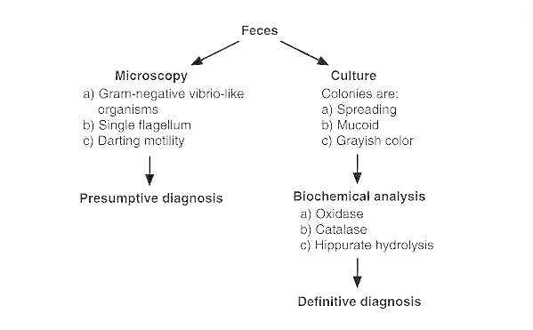
Detection of C jejuni and related enteric bacteria.
Treatment
Fluid and electrolyte replacement are the cornerstones for treatment. Specific treatment with antimicrobial agents indicated for persons with severe or prolonged symptoms. However, for mild infections, the efficacy of treatment with antimicrobial agents has not yet been demonstrated. When treatment is required, erythromycin or ciprofloxacin appear to be the agents of choice.

References:-
1-Todar's Online Textbook of Bacteriology
2- Medical Microbiology. 5th edition. by Sherris

