Obstetrics
Lec. 3 د. بان عامر موسى
Antenatal Care
Definition:- Antenatal care is the care that pregnant lady receive it from healthcare professionals during her pregnancy to maintain the physical, mental and social health of mother and baby by providing education on nutrition, personal hygiene and birthing process then detect and manage complications during pregnancy, whether medical, surgical or obstetrical.
Objectives of ANC
Promoting health and preventing disease
Preparation for birth and potential complications
Tetanus toxoid, nutritional supplementation, etc
Detection of existing diseases and treatment, HIV, syphilis, tuberculosis, other co-existing medical diseases ((e.g., hypertension, diabetes)).
Early detection and management of complications, Help prepare mother to breastfeed successfully, experience normal puerperium, and take good care of the child physically, psychologically and socially. Diagnose Pregnancy through an understanding of the symptoms and positive signs of pregnancy Given the date of the last menstrual period: calculate the EDD and the gestational age at any time Describe the interventions appropriate to the expected physiologic and psychological changes of pregnancy
Describe the care of the pregnant patient at the initial prenatal visit and follow up visits. Taken the patient’s OB/GYN history, determine the gravidity and parity.
Teach patients how to manage common pregnancy discomforts.
Analyze risk factors of the pregnant patient Consider developmental level and cultural background when planning pregnancy care and delivery.
The Initial “Booking” Antenatal Visit
A booking visit :: - is a risk assessment which will outline factors such as mother health, diet, any illnesses and several other factors surrounding her lifestyle.
Medical history; Menstrual history; Physical exam ; Investigations; Diagnostic tests; Screening Tests Assess risk factors and building up a strategy for the antenatal care
Health Education with exhaustive efforts and advices.
Age
Occupation
Education
Residence
Ethnicity
Race
Religion

Important Demographic Data
Medical and Family History
Prior or current health issues
Medications and allergies
Possible inherited diseases in the families
Significant health issues in family members
Use of tobacco, alcohol, street drugs
Menstrual History
Expected Date of Delivery
Duration of pregnancy
280 days or 40 weeks or 10 lunar months Naegele's rule::-Add seven days to and subtract three months [or add 9 months] The concept of reliable dates
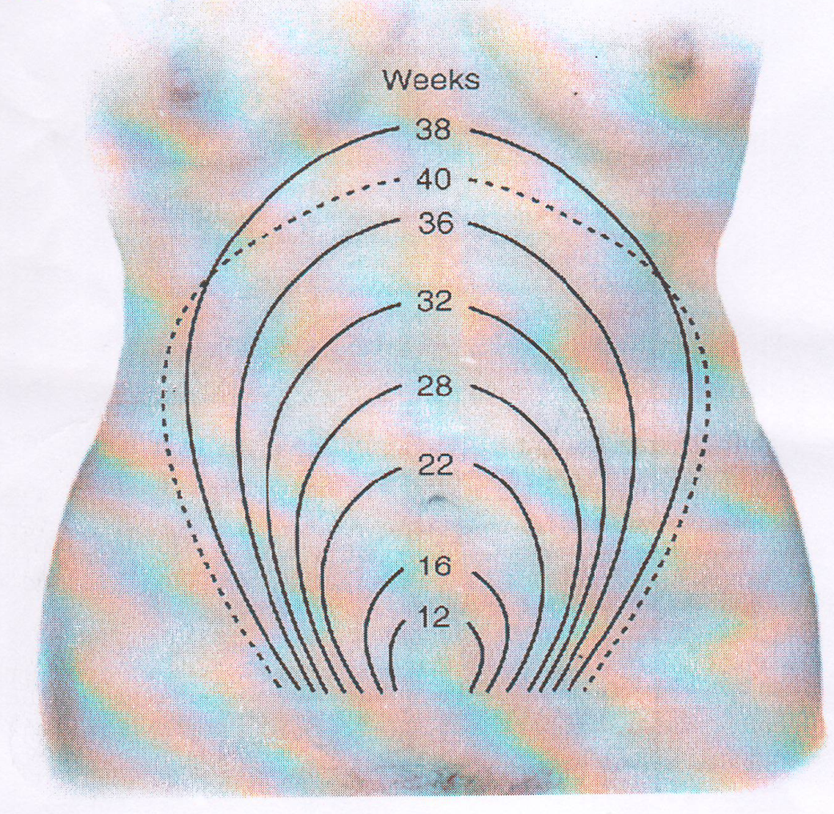
Measurement Symphyseal Fundal height
Evidence supports either palpation or S- F measurement at every AN visit to monitor fetal growth
measurement should start at the variable point (F) and continue to the fixed point (S)
SF measurement should be recorded in a consistent manner ((therefore in cms ))
Causes of oversized uterus (larger than period of amenorrhea)
.Wrong dates
.Polyhydramnios
.Hydatidiform mole
.Macrocosmic fetus
.Concealed accidental hemorrhage
.Twins
.Tumors as fibroids and ovarian cysts Fetal malformations as .hydrocephalus

Causes of undersized uterus (smaller than period of amenorrhea)
.Wrong dates
.Oligohydramnios
.Fetal death
.IUGR or Small fetus
.Pregnancy during period of amenorrhea as lactation or injectable contraception
Malpresentations as transverse lie

Gravidity and Parity G P A
Gravida G-number of pregnancies Para P-number of births after 24 weeks A-abortions and miscarriages (before 24weeks)
Laboratory Analysis and Testing
Blood tests
Blood type and Rh status
Antibody screen (Coombs’ test)
CBC
Rubella titer
HIV Hepatitis B
Syphilis
Sickle cell
Glucose screen
Triple screen
Cystic fibrosis
Varicella
Other Testing
Ultrasound( dating U/S)
Urinalysis Pap smear
GC culture Chlamydia culture Group B streptococci

Body Mass Index (BMI)
A commonly used measure to differentiate underweight, normal .weight, overweight and obesity
Obtained by dividing the weight of the subject (in kilos) by the .square of her height in meters
Pre-pregnant weight status | Recommended range of weight gain
A. Twin Pregnancy | 15- 20 Kg.
B. Underweight (BMI<18.5) | 12-17 kg.
C. Normal Weight (BMI 18.5 to 24.9) | 11-15 Kg.
D. Overweight (BMI 25.0 to 29.9) | 6-11 Kg.
E. Obese (BMI > 30.0) | 6 Kg.
Immunization
--Live attenuated virus vaccines as measles, rubella, mumps, poliomyelitis are contraindicated
--Inactivated virus vaccines as influenza, and rabies are safe to be given
--Inactivated bacterial vaccines as cholera, meningococcus, and typhoid are safe to be given
--Toxoids as tetanus and diphtheria toxoid are safe to be given
--Immune globulins as for hepatitis, tetanus and rabies can be given
Warning signs:
The pregnant woman must immediately report if any one of the following signals occur:
.Vaginal bleeding
.Swelling of the face, fingers and limbs
.Swollen tender calf muscles
.Severe headache
.Blurring of vision
.Abdominal pain
.Persistent vomiting
.Chills and fever
Escape of fluid from the vagina
Visit Schedule
The return visits are
Every 4 weeks until 28 weeks then
Every 2 weeks until 36 weeks then
Weekly thereafter. A more flexible schedule is at times better Perinatal outcome benefits were more pronounced with antenatal care after 30 weeks
The mother is advised to call or come when she feels undue worry. In each visit the well-being of mother and fetus are assessed

First appointment
The first appointment needs to be earlier in pregnancy (prior to 12 weeks) than may have traditionally occurred and, because ‘of the large volume of information needs in early pregnancy .two appointments may be required :At the first (and second) antenatal appointment give information, with an opportunity to discuss issues and ask questions; offer verbal information supported by written information (on topics such as diet and lifestyle considerations, pregnancy care services available, maternity benefits and sufficient information to enable informed decision making about screening tests identify women who may need additional care and plan pattern of care for. the pregnancy
check blood group and RhD status offer screening for anaemia, red-cell alloantibodies, Hepatitis B virus, HIV, rubella susceptibility and syphilis offer screening for asymptomatic bacteriuria (ASB) offering screening for Down’s syndrome offer early ultrasound scan for gestational age assessment (offer ultrasound screening for structural anomalies (20 weeks) measure BMI, blood pressure (BP) and test urine for proteinuria Pre- and Periconceptional Folic acid supplementation to prevent recurrent neural tube defects Iodine supplementation in populations with a high incidence of endemic cretinism.

