Laser principles-lecture -1-
The first stage
Mohammed Hamza
PROPERTIES OF LIGHT

PROPERTIES OF WAVES:
A wave is a disturbance that transmits energy from one point to another. Any periodic disturbance can be represented by waves; for example, musical sounds, human speech, the swine of a pendulum, a cork bobbing up-and-down in the water, and the violent shock from an earthquake. Light, as it travels through space, also can be described as a wave phenomenon
Figure 1 illustrates a wave traveling to the right at one instant of time. The displacement is the vertical distance from the equilibrium position at any point along the wave. The amplitude is the maximum displacement of the wave. Wavelength is defined as "the distance over which the wave repeats itself" and is represented by the Greek letter lambda (λ).
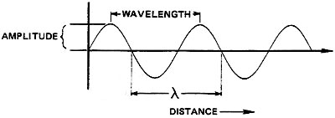
Fig. 1 Displacement-versus-distance along a
Figure 2 illustrates the same wave as a function of time at a single point. The period is the time over which the wave repeats itself. The time required for one complete cycle of the wave. The frequency of the wave is the number of cycles of the wave in one second and is represented by the Greek letter nu (ν).
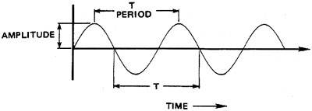
Fig. 2 Displacement-versus-time at one point on the wave

Frequency and period are related by Equations 1:
Equation 1
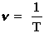
where: | T = Period in seconds (sec).  ν = Frequency in hertz (Hz).
The unit of frequency is cycles/second, or hertz, and may be expressed symbolically as Hz, sec⁻¹, or /sec. Period is measured in seconds and wavelength in meters. Table 1 lists prefixes used with these base units and the common units formed. The unit micrometer (10⁻⁶ m) is a widely-used unit of length and also is called a "micron." The micron is represented by either μm or μ, with μm preferred. A common wavelength unit not included in this table is the angstrom (1 Angstrom = 10⁻¹⁰ m)
Prefix | Symbol | Value | Common Use
Prefix | Symbol | Value | Wavelength (m) | Time (sec) | Frequency (Hz)
Tera  Giga  Mega  kilo  milli  micro  nano  pico | T  G  M  k  m  μ  n  p | 10¹²  10⁹  10⁶  10³  10⁻³  10⁻⁶  10⁻⁹  10⁻¹² | mm  μm or μ  nm | ms  μs  ns  ps | THz  GHz  MHz  kHz
Since speed is defined as distance traveled divided by elapsed time, the speed of a wave is the distance traveled in one cycle, or the wavelength divided by the time required for one cycle (the period). Equations 2 and 3 are expressions of wave speed.

Equation2
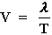
where: | T = Period of the wave  λ = wavelength  ν = Frequency of the wave  V = Speed of the wave
The speed of light waves through a vacuum is 3 x 10⁸ m/sec and is expressed by the symbol c , which can be substituted for V in Equation 2 to give Equations 3.
Equation 3
c = λν (في الفراغ )

Given: | A radio wave has a wavelength of 30 m.
Find: |  | The frequency and period of the wave.
Solution: |  | 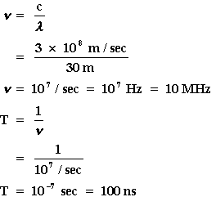

Given: |  | Ordinary ac current has a frequency of 60 Hz.
 | Find: | The wavelength and period of the wave.
 | Solution: | 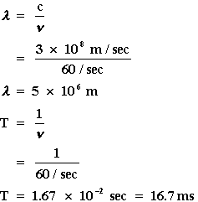

Given: | The light produced by a He-Ne laser has a period of 2.11 x 10⁻¹⁵ sec.
Find: | The frequency and wavelength of the wave.
Solution: | 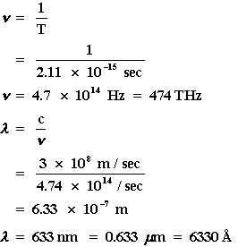

THE ELECTROMAGNETIC SPECTRUM:
The span of frequencies and wavelengths covered by electromagnetic radiation is indicated by portion A of Figure 3.
Fig. 3 The electromagnetic spectrum
This wave consists of variations in two types of fields in space. In this case, the electric field (E) always oscillates vertically to form an electric wave; the magnetic field (B) always oscillates horizontally to form a magnetic wave. The two fields are perpendicular to each other, and both are perpendicular to the direction of propagation of the wave. All electromagnetic waves have this same basic composition. They differ only in frequency and wavelength
Radio Waves: Radio waves have the longest wavelengths of all the electromagnetic waves. They range from around a foot long to several miles long. Radio waves are often used to transmit data and have been used for all sorts of applications including radio, satellites, radar, and computer networks.
Microwaves :are shorter than radio waves with wavelengths measured in centimeters. We use microwaves to cook food, transmit information, and in radar that helps to predict the weather. Microwaves are useful in communication because they can penetrate clouds, smoke, and rain.
Infrared :Between microwaves and visible light are infrared waves. Infrared waves are sometimes classified as "near" infrared and "far" infrared. Near infrared waves are the waves that are closer to visible light in wavelength. These are the infrared waves that are used in your TV remote to change channels. Far infrared waves are further away from visible light in wavelength. Far infrared waves are thermal and give off heat. Anything that gives off heat radiates infrared waves. This includes the human body!
Visible light :The visible light spectrum covers the wavelengths that can be seen by the human eye. This is the range of wavelengths from 390 to 700 nm which corresponds to the frequencies 430-790 THz.
Ultraviolet waves: have the next shortest wavelength after visible light. It is ultraviolet rays from the Sun that cause sunburns. We are protected from the Sun's ultraviolet rays by the ozone layer. Some insects, such as bumblebees, can see ultraviolet light.
X-rays: have even shorter wavelengths than ultraviolet rays. At this point in the electromagnetic spectrum, scientists begin to think of these rays more as particles than waves. X-rays were discovered by German scientist Wilhelm Roentgen. They can penetrate soft tissue like skin and muscle and are used to take X-ray pictures of bones in medicine.
Gamma rays :As the wavelengths of electromagnetic waves get shorter, their energy increases. Gamma rays are the shortest waves in the spectrum and, as a result, have the most energy. Gamma rays are sometimes used in treating cancer and in taking detailed images for diagnostic medicine. Gamma rays are produced in high energy nuclear explosions. .
H.W :What’s the wavelengths in nanometer of all colors in the visible regions(400nm to 700 nm)?

INDEX OF REFRACTION:
All electromagnetic waves travel through a vacuum at the constant speed of c = 3 * 10⁸ m/sec. When these waves travel through a transmitting material, however, their speed is reduced. The index of refraction of a material is the ratio of the speed of light in a vacuum to its speed in that material and is given by Equation 4
Equation 4
$$n=\frac{c}{V}$$
where: | n = Index of refraction.  V = Speed of light inside material.
The frequency of a light wave does not change when it enters a material, but its wavelength is reduced (Figure 4). The index of refraction is also the ratio of wavelength in vacuum to the wavelength in the material (Equation 9).
Equation 5
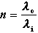
where: | λ₀ = Wavelength in vacuum.  λ_{i} = Wavelength in material.
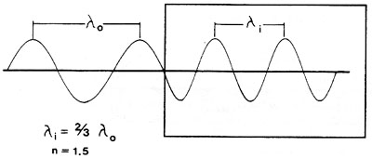
Fig. 4 Wavelength reduction in material

When light leaves a material and enters a vacuum, it returns to speed c and to wavelength λ₀? The index of refraction of air is about 1.0003, but is assumed to be 1 in most applications.
Given: | Light travels through a ruby laser rod at a speed of 1.74 * 10⁸ m/sec.
Find: | Index of refraction of ruby.
Solution: | 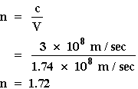

Given: |  | A He-Ne laser beam (λ = 633 nm) travels through a glass window with an index of refraction of 1.65.
 | Find: | Speed and wavelength inside the glass.
 | Solution: | 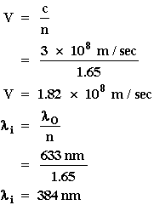

PROPERTIES OF LIGHT:

POLARIZATION:
All light consists of wave variations in electric and magnetic fields. Many applications require that the electric and magnetic fields have a particular direction. If the direction of one of these fields is known, the direction of the other must be specified since the two are always perpendicular. The polarization of light describes the orientation of the electric field in space. Unpolarized light has no specific orientation of electric field. The types of polarization is given by :
- 1- Plane-polarized light is light in which the electric field oscillates in one plane only.
- A- In vertically-polarized light (Figure 5a), the plane of the electric field is vertical — up and down in the plane of the paper and shown as vertical arrows.
- B- In horizontally-polarized light (Figure 5b), the plane that contains the electric field is horizontal — perpendicular to the plane of the paper.
- 2- In circularly-polarized light, The direction of the electric field of circularly-polarized light sweeps out a circle during each period of the wave.
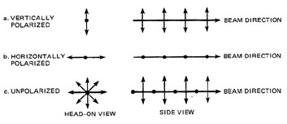
Fig. 5 Representations of polarized light
Brewster's Angle:
Brewster's angle is related to the index of refraction by Equation :
n = tan B | Equation 6
This equation states that Brewster's angle for a material in air is the angle whose tangent is equal to the index of refraction of the material.
Given: | The index of refraction of the fused quartz window of a He-Ne laser tube is 1.45. The fused quartz window is adjacent to air.
Find: | Brewster's angle.
Solution: | n = tan B  B = arc tan N  = arc tan (1.45)  B = 55.4
Figure 6 is concerned with the operation of Brewster windows in a gas laser to produce a polarized laser beam. Figure 6a shows the overall cavity geometry, including the two cavity mirrors, the two Brewster windows and the gas laser tube. Figure 6b shows the initial action of a Brewster window on an Unpolarized laser beam incident on the window at Brewster's angle (56 for an air-to-glass interface). .
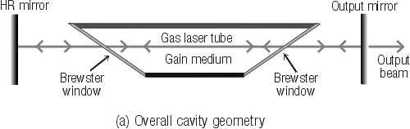
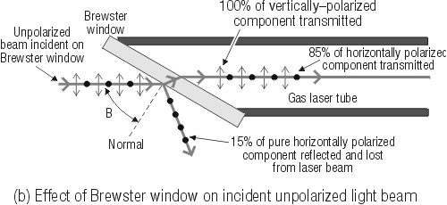

Fig. 10 Action of Brewster windows on an initially Unpolarized beam reflecting back and forth in the cavity laser cavity.

