Laser principels:lecture-4-
The first stage:
Mohammed Hamza
LASING ACTION
When light travels through a material, part of the light energy is absorbed by the atoms in the material. The amount of light absorbed is dependent upon the characteristics of the material and its thickness. Optical components, such as lenses and windows, are made of materials that absorb very little of the light energy in the wavelength region within which they are designed to function. Optical filters are designed to transmit only a particular portion of the light that strikes them. They may attenuate some wavelengths or eliminate some selected wavelengths, and transmit the remaining ones with no change. The absorption of light is a critical process in the optical pumping of solid and liquid lasers.
When a laser beam passes through the active medium of a laser, energy is added to the laser beam through a process called "optical gain."
This module discusses the absorption of light by materials and the gain of a laser medium. The similarities of these two processes are examined, and both are measured experimentally in the laboratory.

ATTENUATION OF LIGHT:
Figure 1 depicts a beam of light traveling through a piece of optical material. Some of the light energy is absorbed by the material, and some is transmitted.
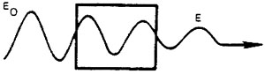
Fig. 1 Attenuation of a light beam
The transmission of the optical material is given by Equation 1.
Equation 1
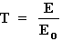
where: | T = Transmission.  E₀ = Irradiance of light incident upon the material.  E = Irradiance of light transmitted through the material.

EXAMPLE A: CALCULATION OF THE TRANSMISSION
Given: | The light incident upon the material in Figure 1 has an irradiance of 2.5 mW/cm². The irradiance of the transmitted light is 0.50 mW/cm².
Find: | The transmission.
Solution: | 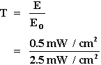  T = 0.20  20% of the light is transmitted.
In some cases, almost no light is absorbed, and the transmission is almost 1.0. In others, there is no transmission at all (T = 0). Reflection and scattering of light together with absorption account for losses in all optical systems, but reflection and scattering are not considered in this module.

THE EXPONENTIAL LAW OF ABSORPTION:
Obviously, any increase in the thickness of the absorbing material will decrease the irradiance of the transmitted light. Figure 2 depicts light traveling through four identical pieces of filter material, each 1 mm thick and each filter absorbing one-half the light incident upon it. Figure 3 is a plot of the transmission of this filter material as a function of total filter thickness. Transmission in this case is based upon incident and transmitted power, rather than upon irradiance. The curve in Figure 3 is called an "exponential curve." It begins at an initial value of 1.0 and approaches zero asymptotically as thickness increases. The degree of transmission for any thickness of a material is given by the exponential law of absorption, as stated in Equation 2.
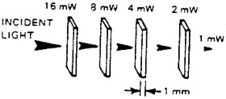
Fig. 2 Transmission of light through a series of filters
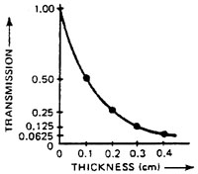
Fig. 3 Transmission as a function of thickness
Equation 2
T = e^{–kx}
where: | T = Transmission.  e = The natural logarithm base = 2.718.  k = The absorption coefficient of the material in cm^{–1}.  x = The thickness of the material in cm.
The unit cm^{–1} in this equation should not be confused with the reciprocal centimeter used to indicate wave number in the previous module. In this case, the absorption coefficient is measured in terms of absorption per centimeter. The absorption coefficient is numerically equal to the reciprocal of the thickness of a specific material that results in a transmission of 1/e (0.368) of the incident light. The units of thickness and absorption coefficient must be reciprocals of one another in order that their product, the exponent of e, will remain a dimensionless quantity.
EXAMPLE B: THE EXPONENTIAL LAW OF ABSORPTION
Given: | The absorption coefficient of a material is 5.0 cm⁻¹.
Find: | The transmission of pieces of this material having the following thicknesses:  (a) 0.01 cm  (b) 0.10 cm  (c) 1.0 cm
Solution: | (a) T = e^{–kx}  (a) T = e^{–(5.0 cm–1)(0.01 cm)}  (a) T = e^{–0.05}  (a) T = 0.951  (b) T = e^{–(5.0 cm–1)(0.1 cm)}  (b) T = e^{–0.5} (evaluate using e^{x} key on calculator)  (b) T = 0.606  (c) T = e^{–(5.0 cm–1)(1.0 cm)}  (c) T = e^{–5}  (c) T = 0.0067
Equation 2 may be solved for the absorption coefficient through the following steps:
Equation 2
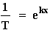 |  | (by taking the reciprocal of both sides of the equation)
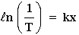 |  | (by taking the natural logarithm of both sides of the equation)
Rearrangement of terms yields Equation 3 for the absorption coefficient.

Equation 3
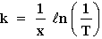
This equation is utilized to solve a problem in Example C.
EXAMPLE C: CALCULATION OF ABSORPTION COEFFICIENT
Given: | A 10-mW laser beam strikes a piece of filter material 1.2 cm thick. A beam of 0.42 mW is transmitted.
Find: | Absorption coefficient of the material.
Solution: | 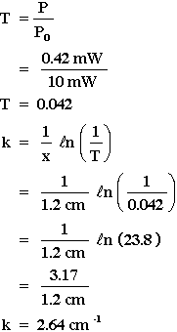 | 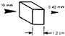

ABSORPTION AS A FUNCTION OF WAVELENGTH:
Optical filters come in many varieties. Generally, they are used to (1) select one wavelength region over another, (2) select a very narrow wavelength region and exclude all other wavelengths above and below this region, (3) select a broad range of wavelenths which, as a group, are all transmitted with the same intensity.
Optical filters are generally made of colored glass, metals, and thin dielectric films, often arranged in complicated "sandwich" geometries to achieve a special type and degree of filtering of the light incident on them. You will find such names as colored glass filters, thin metallic film filters, hot and cold mirrors, neutral density filters, bandpass filters, narrow band interference filters, and broadband interference filters, if you peruse the section on "Filters," covered, for example, in catalogs of optical fabrication companies such as Melles Griot. You should "walk through" such a section to develop an appreciation for the many types of filters available. Here we shall concentrate on the important types–cutoff filters, narrow bandpass filters, and neutral density filters.
The absorption coefficient (and thus the transmission) of any material is a function of the wavelength of the light striking that material. Until now, discussion in this module has dealt with thickness variations of absorbing materials at a single wavelength. This section assumes a fixed absorber thickness and presents transmission variations as a function of wavelength changes. Three types of optical filters are used as examples.
Figure 4 gives the transmission of two optical filters as a function of wavelength. The blue filter in Figure 4a allows most of the blue light to pass, but absorbs other colors of the visible spectrum, while the red filter (Figure 4b) allows only red light to pass through. This type of filter has a sharp division between high- and low-transmission regions and thus is called a "cutoff filter." Optical components of this type are used to eliminate unwanted wavelengths in many optical systems. Laser safety goggles are an important example of cutoff filters.
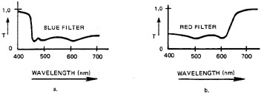
Fig. 4 Transmission-versus-wavelength for cutoff filters
Figure 5 depicts the transmission curve of a band pass filter. This type of filter passes a narrow band of wavelengths but blocks all light outside this band. Darkroom safelights contain band pass filters that pass only those light wavelengths to which the film is not sensitive.
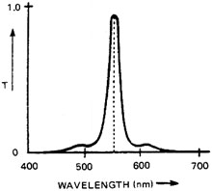
Fig. 5 Transmission-versus-wavelength for a "spike" or band-pass filter
Transmission of a neutral density filter is illustrated in Figure 6. This filter is designed to have the same transmission for all wavelengths over a broad range of the spectrum. The gray lenses of most sunglasses are neutral density filters for visible light.
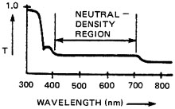
Fig. 6 Transmission-versus-wavelength for a neutral density filter
A term often used to describe the transmission of neutral density filters, laser safety goggles, and other low-transmission filters is optical density. If the optical density of a filter is known, its transmission can be calculated from Equation 4.
Equation 4
T = 10^{–OD}
where: | T = Transmission.  OD = Optical density.
Thus, a filter with an optical density of 2.0 has a transmission of 10^{–2}, or one percent. (Table 1 lists some OD values.) Example D illustrates the use of this equation in solving another problem.
TABLE 1. Optical Density Values.
OD | Transmission |  | % Transmission
0 | 1 | 1.0 | 100%
1 | 10^{–1} | 0.1 | 10%
2 | 10^{–2} | 0.01 | 1%
3 | 10^{–3} | 0.001 | 0.1%
4 | 10^{–4} | 0.0001 | 0.01%
5 | 10^{–5} | 0.00001 | 0.001%

EXAMPLE D: CALCULATION OF TRANSMISSION FROM OPTICAL DENSITY
Given: | A neutral density filter has an optical density of 0.6.
Find: | Transmission of filter.
Solution: | T = 10^{–OD}  T = 10^{–(0.6)}  T = 0.25

GAIN IN A LASER:
POPULATION INVERSION:
Figure 7 illustrates the normal population distribution of atoms in their various energy levels in a given material at some given temperature. 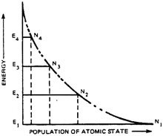

Fig. 7 Normal population distribution
The lengths of the horizontal lines in this figure represent the number of atoms in each energy state. The majority of the atoms are always in the ground state, and the population of each successively-higher energy state is less than that of any other lower energy state.
The absorption coefficient of this material at a wavelength of light corresponding to the transition from E₃ to E₂ is proportional to the quantity N₂ – N₃. A greater difference in population of the two energy states results in a Greater absorption coefficient. If atoms were to be removed from E₂ and added to E₃ to reduce the population difference, the absorption coefficient would be reduced.
If the populations of the two states are the same, the absorption coefficient is, in effect, zero. Although absorption still occurs, stimulated emission occurs at a similar rate, replacing photons as they are removed by absorption. The two processes balance each other, and the net difference is zero, hence an effective zero absorption coefficient.
In Figure 8, the populations of energy states E₂ and E₃ have been altered until the quantity N₂ – N₃ is negative.
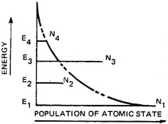
Fig. 8 Population inversion between states E₂ and E₃
The population inversion between E₂ and E₃ now requires that the value of the absorption coefficient also must become negative. This condition is called a "population inversion" because the populations of the two atomic states have been inverted with respect to each other. When a population inversion exists, the absorption coefficient in the equation T = e^{–kx} is negative; and the transmission is then necessarily greater than one. Under these conditions, stimulated emission occurs at a rate greater than the rate of absorption, and the light passing through the material is amplified.
The gain of such an optical amplifier is dependent upon the quantity N₃ – N₂; therefore, greater population inversion produces greater gain. To increase the gain of a laser, some method must be utilized to increase of the upper energy state of the lasing transition. Since the lasing process itself will transfer atoms to the terminal state of the losing transition, some process must be available to reduce the population of this lower energy state. If atoms are allowed to remain in this terminal state, the population of the state will increase to the point at which a population inversion no longer exists, and the losing activity of the medium will cease.

AMPLIFIER GAIN OF A LASER:
The amplifier gain of a laser medium is given by Equation 5.
Equation 5
G_{a} = e ^{αx}
where: | G_{a} = Amplifier gain.  α = Gain coefficient.  x = Length of active medium.
The gain coefficient usually is expressed in cm^{-l}, with the active medium length in cm; but sometimes the gain is in m⁻¹, and the active medium length is in m. In solving problems, one must ensure that the unit of gain coefficient is the reciprocal of the unit of length.

EXAMPLE E: AMPLIFIER GAIN OF A LASER
Given: | A ruby rod is 10 cm in length and has a gain coefficient of 0.23 cm⁻¹.
Find: | The gain of the amplifier.
Solution: | G_{a} = e^{αx}  G_{a} = e^{(0.23 cm-1)(10 cm)}  G_{a} = e^{2.3}  G_{a} = 10
Equation 5 is of the same form as Equation 2 (the exponential law of absorption) with a replacing –k and G_{a} replacing T. If these quantities are substituted into Equation 3 for the absorption coefficient, the result is Equation 6 for the gain coefficient.
Equation 6
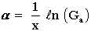
EXAMPLE F: CALCULATING GAIN COEFFICIENT
Given: | A He-Ne laser tube 50 cm long has a gain of 1.08.
Find: | The gain coefficient.
Solution: | 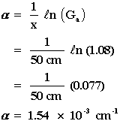

LASER GAIN AS A FUNCTION OF WAVELENGTH:
"Absorption and Emission of Light," discussed briefly the width of spectral lines and the factors leading to broadening of a line. The same factors apply to the wavelength range over which the active medium provides gain in a laser. Figure 9 exhibits the general shape of the gain versus wavelength curve for most lasers. In all cases, the active medium provides gain, not at a single wavelength, but over a narrow range of wavelengths. The effect of the gain profile upon laser output will be discussed further in Module 1-7, "Optical Cavities and Modes of Oscillation."
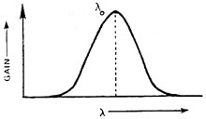
Fig. 9 Gain as a function of wavelength

ENERGY TRANSFER IN LASERS

ENERGY TRANSFER IN GAS LASERS:
The excitation mechanism in most gas lasers is a direct-current discharge through the gas (the active medium). Gas atoms gain energy through collisions with energetic free electrons produced in the gas ionization process. In ion lasers, the atoms are pumped upward in energy through several intermediate energy states by multiple collisions. In lasers, such as the He-Ne and CO₂ types, that contain gas mixtures, the electron collisions excite one type of atom or molecule to an upper energy state. This excited atom or molecule then collides with an atom or molecule of the losing gas, and energy is transferred through this collision.
The depopulation of the lower losing level E₂ in gas lasers may occur through spontaneous emission of photons or through additional collisions, either with atoms or with the walls of the container.

ENERGY TRANSFER IN SOLID LASERS:
Most solid lasers (and liquid lasers) employ optical pumping. Light from a flash lamp is absorbed by atoms in the active medium, raising them to "level" E₄ (Figure 10). In solid and liquid lasers the level E₄ is not a single level; rather it consists of a series of energy levels, or pumping bands as depicted in Figure 10. The fast decay transitions from E₄ to E₃ often are radiationless transitions that contribute to heating the laser active medium.
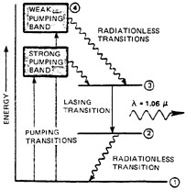
Fig. 10 Energy-level diagram for Nd:YAG
In order for the optical energy from the flash lamp to be absorbed efficiently, its wavelength must correspond to a transition from the ground state to an available pumping band of the active medium. For Nd:YAG crystal, the strong pumping band has a wavelength range of 790-820 nm, and the weak pumping band has a range of 730-760 nm. The lamps used with these lasers, therefore, must produce their maximum output at these wavelengths for efficient laser operation. This matching process is called "spectral matching" of the pump source and active medium.
The transition from E₂ to E₁ usually is a radiationless transition. Both the population of energy level E₂ and the rate of decay from that level depend upon the temperature of the active medium. Water cooling normally is employed in solid lasers to remove waste heat and to depopulate the lower lasing level by reduction of the ambient heat level.

THE THREE LEVEL LASER:
In a three level laser (Figure 11), the lower losing level is the ground state. This type of laser can have a population inversion only if more than half the atoms in the ground state are pumped to higher energy states. In the four level laser, such intense pumping is unnecessary because a high ground state population does not affect the population inversion between the upper and lower laser levels. The ruby laser is the only important three-level laser.
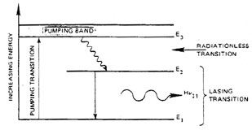
Fig. 11 Three-level laser

THE FOUR LEVEL LASER:
Figure 12 is the energy level diagram of a four level laser model. The lasing transition occurs between E₃ and E₂. Energy level E₃ is called the upper lasing level and is a metastable state, with a lifetime of 10^{–6} seconds or longer.
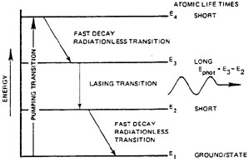
Fig. 12 Four-level laser
Atoms remain in this metastable state for a relatively long time, increasing both the population inversion and the probability of stimulated emission. Level E₂ has a short atomic lifetime, which means that atoms leave this energy state quickly and return to the ground state.
An upward transition to the metastable state is just as unlikely as a downward transition from it; therefore, the pumping of atoms directly from the ground state to the upper lasing level would be impractical. An alternative energy level, E₄, is a short-lived atomic state above E₃, to which atoms may be pumped more easily. Since short energy transitions are more likely to occur than long energy transitions, most of the atoms pumped to atomic state E₄ can be counted on to decay rapidly to atomic state E₃, the metastable state.

