4th Stage Obstetric د. بان عامر موسى

Induction of labour
Definition-: Induction of labour is defined as the artificial initiation of labour, performed when it is considered that there are benefits to the baby and or mother if the baby is delivered, compared with the alternative of the baby remaining in utero .
Current rate of induction of labour are 20 - 22 % .
Indications
- Abruptio placentae.
- Chorioamnionitis.
- fetal demise.
- Gestational hypertension.
- Pre-eclampsia and eclampsia .
- Pre-labour rupture of membranes .
- post term.
- Maternal medical conditions .
- fetal comprise.
Contraindications ::-- Absolute
- Contraindication to vaginal delivery such as complete placenta praevia , vasa praevia, transverse lie .
- Conditions need immediate delivery such as cord prolapse
- Previous classical C/S and previous myomectomy entering the endometrial cavity.
Relative
Previous C/S (at increased risk of uterine rupture ).
Success of induction of labor::- IOL is most successful when the cervix is ripe at the time of induction .
Ripening: is the process by which the cervix changes in consistency prior to the onset of labour, collagen content decline and water content increases . The most commonly used assessment of cervical ripening is the Bishop score . this score comprises five components of the cervix, all assessed on vaginal examination . IOL with unripe cervix will require more uterine activity to effect cervical dilatation , potentially causing, a longer labour, more pain and stress for both mother and baby, higher risk of uterine rupture and increase incidence of instrumental delivery and C/S .

BISHOP SCORE

to assess cervical favorability
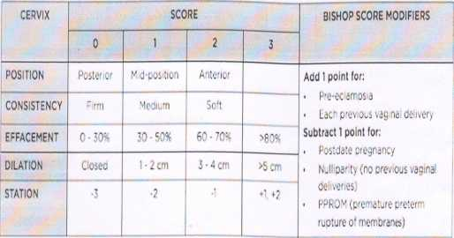
Bishop score of 8 and above mean high success rate of induction while low score mean unfavorable cervix and high failure rate of induction.
Pharmacological method
1 -intravaginal prostaglandin (PG E2, dinoprostone)
2- intravaginal prostaglandin (PG El, misoprostol)
Mechanical method (increase maternal infection)
- intrauterine administration of Foley catheter followed by extra amniotic saline.
- laminaria.
- Membrane sweeping.
Once the cervix is ripe , continuation of labor induction may involve fore water amniotomy (artificial rupture of membrane) with or without augmentation of labor with Syntocinon .
Augmentation of labor is the process of speeding up the first stage of labor . Amniotomy with or without oxytocin has been the standard intervention.
Complications
- Failure of procedure , 15% in primigravida with unfavorable cervix but less commonly with multigravida and primi. with favorable cervix and high Bishop score at the start of induction
- Caesarean section and operative delivery .
- Hyperstimulation :- uterine hyperstimulation is defined as a contraction frequency of more than five in 10 min. or contraction exceeding 2 min. duration .
- Tachysystol : occur when uterine hyperstimulation is accompanied by abnormal FHR patter n, which manage by Putting the patient in left lateral position, 02 mask, rehydration , and if FHR not improve finally we can give the patient tocolytic agent such as Teributalin .
Monitoring
Monitoring of maternal and fetal wellbeing during induction of labor is sparse . cardiotocograph should be performed to confirm that the FHR is normal prior to PG insertion .The CTG should repeated when contraction begin, normally 2-6 hr after PG administration .

