Laser principles:
The first stage:
Mohammed Hamza:
TEMPORAL CHARACTERISTICS
OF LASERS
One of the more important characteristics of any laser is the temporal distribution of its output. Continuous wave lasers produce a steady beam at an essentially constant power output. Pulsed lasers emit their energy in short bursts. Typical laser pulses may last several milliseconds or may be as short as a few femtoseconds, depending upon the methods used to shape the pulse and control its duration.
The coherence of a laser beam is related to its temporal characteristics. For example, the longitudinal coherence length is determined by the range of frequencies present in the beam.
This module discusses the temporal characteristics of lasers. In the laboratory, the student will measure the duration and power of laser pulses.

PULSED LASERS:
Lasers may be divided into two broad groups (1) continuous wave (CW) and (2) pulsed. A CW laser is one whose power output undergoes little or no fluctuation with time. It exhibits a steady flow of coherent energy. Helium neon and argon gas lasers are typical examples. They are said to operate in the "CW mode." A larger group of lasers has output beams that Undergo marked fluctuations; that is, the beams' power changes with time in a very noticeable fashion. They are said to operate in the "pulsed mode." Nd:YAG solid crystal lasers and CO₂ gas lasers often, but not always, are operated in the pulsed mode.
Pulsed laser operation may be further subdivided according to pulse length and methods for producing such pulses. The following are the four basic operating modes for pulsed lasers:
- Normal pulsed mode.
- Q-switched mode.
- Mode locked.
- Cavity-jumped mode

NORMAL PULSED LASERS:
Figure 1 shows graphically the output pulse of a solid state laser operating in the normal pulsed mode. Such a pulse has a nominal duration of from a tenth of a millisecond to several milliseconds. The pulse is composed of many small pulses, each lasting about 50 ns. Module 1-6, "Lasing Action," discusses the variations in amplifier gain that lead to this spiking in the laser output. But there is another factor that must be considered to account for the large number of spikes present and their overlapping. Solid state lasers typically have a laser line width of 30 GHz or greater and therefore, operate on a hundred or more longitudinal modes. [Recall Examples E and H in Module 1-7. There it was shown that a typical Md:YAG laser has a mode spacing of of 258 MHz (Example E) and, if the fluorescent linewidth of the Nd:YAG laser is 30GHz, then the number of longitudinal modes is calculated to (Example H).]Each of these longitudinal modes exhibits a spiking behavior independent of the behavior of the other modes. The total output pulse is composed of thousands of these short pulses.
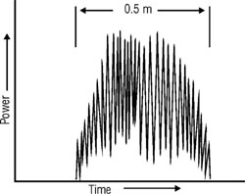
Fig. 1 Normal pulsed showing longitudinal modes
giving rise to many spikes within the pulse width
the pulse with of 0.5 ms.
The total energy of the pulse and the total pulse duration remain essentially the same from shot to shot for such a laser. But the maximum output power reached during one pulse may be very different from that of the next. For this reason, such lasers often are classified according to energy per pulse and pulse duration. A rough approximation of maximum pulse power may be calculated from these values.

Q-SWITCHED LASERS:
Figure 2 shows a schematic diagram for a Q-switched laser. Several types of Q-switches are in common use, each type being suited to a particular type of laser and pulse domain. The Q-switch acts as a shutter within the laser cavity. When this shutter is closed, light passing through the active medium is blocked from reaching the HR mirror, or is reflected out of the cavity. Consequently, the high reflectivity (HR) mirror provides no feedback. The Q-switch introduces sufficient loss in the laser cavity to prevent lasing, which, in turn, allows the amplifier gain of the laser to increase far above the normal lasing threshold. When the Q-switch is opened that is, when feedback between the mirrors is restored lasing is initiated, and the energy stored in the active medium is subsequently released in one intense pulse.
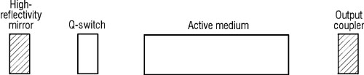
Fig. 2 Q-switched laser schematic.
There are generally four types of Q-switches in use:
mechanical, acousto-optic, electro-optic, and dye.
Figure 3 compares the operation of a pulsed laser in the Q-switch mode to the operation of the same laser in the normal pulsed mode. Without the Q-switch, the amplifier gain reaches the lasing threshold at t₁, and lasing begins. The lasing process removes energy from the active medium in the form of the spiked output of a normal pulse. The amplifier gain and output power of the normal pulsed mode laser are indicated by dotted lines.
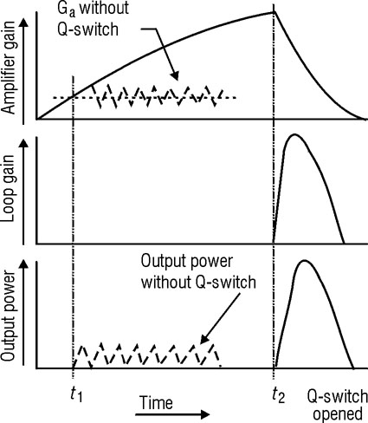
Fig. 3 Operation of a Q-switch
The values for the Q-switched mode are indicated by solid lines. The Q-switch prevents internal feedback of the beam and maintains a loop gain value of zero until the energy stored in the active medium has reached a maximum value. At time t₂ in Figure 3, the amplifier gain is many times the maximum gain value in a normal pulsed laser, due of course, to the large population inversion created. When the Q-switch is opened, loop gain rises rapidly to a large value – in some cases, the value may be several hundred. This large increase in loop gain can produce intense standing waves in many cavity modes, and all the stored energy is released in the resulting pulse. Q-switched pulses range in duration from a few seconds to several hundred nanoseconds. And the peak power of a Q-switched pulse may be several thousand times greater than that of the same laser without a Q-switch. While Q-switching reduces the total energy of the pulse, the pulse width is shortened even more.
The "Q" in Q-switching stands for "quality factor" and is a carryover from electronics. The quality of a cavity is defined as the ratio of the amount of energy stored in that cavity in the form of a standing wave to the amount of energy lost for all reasons during a round trip of the cavity. When the Q-switch of a laser is closed, there is no feedback and thus no standing wave. The loss is very high and thus the quality factor is zero. When the Q-switch is opened, a strong standing wave is formed, causing the loss to be reduced. The Q-switch receives its name from the fact that it allows the "Q" of the cavity to be "switched" from (feedback blocked) a low value to a high value. (feedback restored) However, actual calculations of the quality factor are seldom made for laser cavities.
No mechanical shutter can open fast enough for effective Q-switching. The simplest mechanical method of achieving Q-switching at the necessary rate is the rotation of the HR mirror. The HR mirror is mounted on the shaft of a motor that has a rotational rate of 30,000 rpm or greater. Once during each revolution, the mirror is aligned for nanoseconds and the laser pulse is produced. As indicated in the caption of Figure 2, one can use acousto-optic, electro-optic and dye switches, in addition to mechanical switches, to effectively Q-switch the cavity.

MODELOCKED LASERS:

Figure 4 illustrates the output of a modelocked laser. This output consists of a train of laser pulses, each pulse having a duration of from picoseconds to a fraction of a nanosecond, depending upon the laser. The separation of the pulses is equal to the time required for light to make one round trip around the laser cavity, from mirror to mirror and back again. If the distance between mirrors is l, then the roundtrip time is 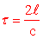where c is the speed of light in the cavity.
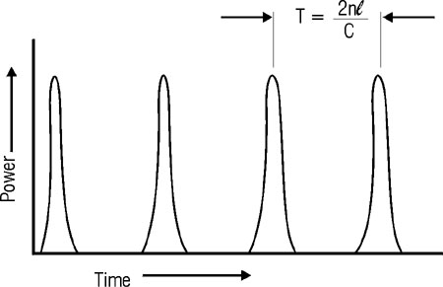
Fig. 4 Train of pulse output of a modelocked laser
How is modelocking achieved? To understand the process, recall the work in Module 1-7, Optical Cavaities and Modes of Scillation, where we showed that many longitudinal modes (standing waves) exist in a cavity at the same time. In Figure 11 of Module 1-7 we showed how the number of modes found in the spectral distribution of the laser output depended on the width of the laser transition line, the cavity round trip gain, and the frequency spacing equation between the longitudinal modes.
In the drawing below, Figure 5, we show at a certain instant of time only three of the many modes that are oscillating. There are of course, the waves that bounce continually back and forth between the mirrors, forming standing waves with modes at the mirrors, and each mode with a whole number of half-wavelengths filtering exactly between the mirrors as we showed in Figures 6 and 7 of Module 1-7. (They are separated vertically in the drawing below only for clarity.)
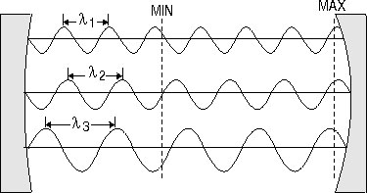
Fig. 5 Three longitudinal modes
–vertically separated only for clarity–
overlap and interfere constructively in the cavities
at the axial position labeled MAX and
destructively at the axial position labeled MIN.
(14b) If all the longitudinal modes were shown, the resultant would be an intensity profile of nearly zero amplitude at most locations with one or more positions where the resultant amplitude would be a maximum, as sketched in Figure 6.

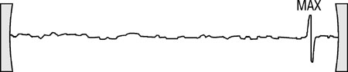

Fig. 6 Longitudinal modes interfere to
produce a maximum amplitude at a certain position, with nearly zero intensity everywhere else. A modulelocker insures that the modes in the cavity (such as the three shown in Figure 5) remain locked in phase so as to alwys produce the same maximum pulse. This pulse travels back and forth between the mirrors with the speed c.
Now with an appropriate modelocker–acousto-optic, electro-optic or dye device–appropriately positioned in the cavity, the intensity profile shown in Figure 6 can be "locked in postion," maintaining the identical profile relative to the individual longitudinal modes from which it came. Just as the individual modes bounce back and forth between the two mirrors so does the resultant maximum pulse. But this first situtation happens only with a modelocker in place. Why? Because in a cavity without the modelocker–a so-called free running laser–the phases of the separate longitudinal modes (such as shown in Figure 5) would change relative to one another and the position of the maximum pulse would be constantly shifting, i.e., it would be "unlocked". If the modelocker is a dye switch for example, it would open (pause light) only when the high intensity of the pulse caused the dye to bleach and transmit the laser energy. Otherwise it would remain closed. In this way the modes remain locked in relative phase with one another, and the maximum pulse makes a cavity roundtrip in time equation, so that modelocked pulses appear in the ouput of the laser separately in time by an interval equation.

CAVITY-DUMPED MODE:
A cavity-dumped laser is just a different type of Q-switch laser. In the normal Q-switched laser, as we have already discussed, the population inversion is built to very high lead, then released all at once, giving rise to a large pulse of energy. This is achieved

CHARACTERIZATION OF PULSED LASER OUTPUTS:
Pulsed lasers may be divided into two further subclasses—(1) single-pulsed lasers and (2) repetitively-pulsed lasers. Single-pulsed lasers produce one pulse of light per laser operation. Repetitively pulsed lasers produce a train of pulses at equal spacing whenever the laser is in operation.

SINGLE PULSED LASERS:
Figure 7 gives the power of a single laser pulse as a function of time. The maximum power of the pulse is P_{max}. The total duration of the pulse at the base line is difficult to determine because the pulse dies out slowly toward zero power. The most convenient method of measuring the temporal length of the pulse is at the ha1f power point (1/2 P_{max}). "Pulse duration," or "pulse width," is the duration of the pulse at one-half the maximum power. This relationship sometimes is referred to as the full width at half maximum (FWHM), and is represented by Δt_{1/2}. (while we will use Δt_{1/2} here for clarity, others often use simply t, or T, for the pulse width)
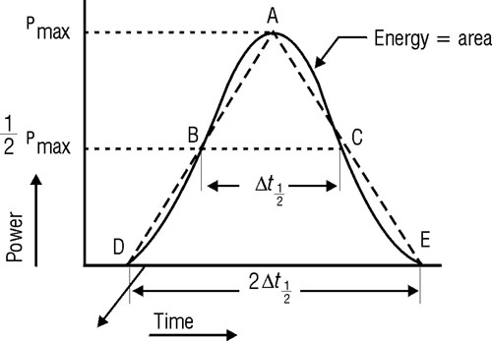
Fig. 7 Energy of a laser pulse
Since "power" is defined as "energy divided by time," energy is the product of power and time. In Figure 7, the total energy of the pulse is represented by the area under the power curve. The actual area can be determined through the use of calculus; but in most cases, an approximation is used. A triangle is drawn—its sides starting at the maximum power point (A) and extending through the edges of the pulse at the ha1f power points (B and C) to the base line (D and E). The area of this triangle is not exactly the same as that of the actual pulse, although it is a close approximation.
The area of triangle ADE in Figure 7 can be determined from Equation 1.
Equation 1
A = 1/2 bh
where: | b = Length of triangle base.  h = Height of triangle.
The base of the triangle in Figure 7 is 2Δt_{1/2}; therefore one half the base is the pulse duration, Δt_{1/2}. The height of the triangle is the maximum power of the pulse P_{max}. Substitution of these quantities into Equation 1 yields Equation 2.
Equation 2
E = (Δt_{1/2})(P_{max})
The energy content of a laser pulse is the product of the maximum power and the pulse duration.
In most practical situations, measurements of pulse duration and energy can be made. Measurements of pulse power cannot be made; therefore, the most useful form of Equation 2 is that for maximum power given in Equation 3.
Equation 3
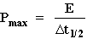
Example A demonstrates the use of Equation 3 in the solution of a problem.
EXAMPLE A: MAXIMUM POWER OF A LASER PULSE
Given: | The output pulse from a Q-switched ruby laser has a duration of 5 ns and an energy of 1 J.
Find: | Maximum power.
Solution: | 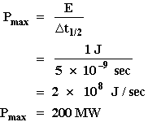
In practice, the measurement of single laser pulses is accomplished with two measuring systems. A calorimeter is used to determine the energy of the pulse. This instrument consists of a sensor, which absorbs the energy of the pulse, and a display mechanism, which indicates how much energy has been absorbed. Pulse duration is determined when a small portion of the laser pulse is directed onto a fast photodiode. The photodiode converts part of the laser power to an electrical signal, which is displayed on an oscilloscope. This display is photographed, and the pulse duration is measured. Maximum power then is calculated from Equation 3.

REPETITIVELY PULSED LASERS:
Figure 8 illustrates the output power of a repetitively pulsed laser as a function of time. The quantities P_{max}, Δt_{1/2}, and E are as defined previously. P_{avg} is the average power of the laser. The pulse repetition time (PRT) is the time interval between similar points on two consecutive laser pulses.
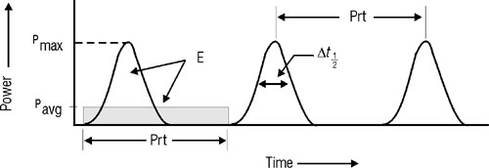
Fig. 8 Repetitively-pulsed laser output
The pulse repetition rate is the number of pulses per second and is related to pulse repetition time by Equation 4.
Equation 4
PRR = 1/PRT
where: PRR = Pulse repetition rate.
The shaded area in Figure 8 represents the product of the average power and the pulse repetition time. This area is the same as that of one of the laser pulses; therefore, Equation 5 can be used to determine the energy of a single pulse in a repetitively pulsed laser.
Equation 5
E = (P_{avg})(PRT)
The use of this equation is illustrated in Example B.
EXAMPLE B: ENERGY PER PULSE
Given: | A Q-switched Nd:YAG laser produces 5000 pulses per second at an average power of 20 W.
Find: | Energy of a single pulse.
Solution: | 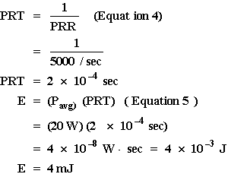
The "duty cycle" of a repetitively pulsed laser is defined as the ratio of the time the laser is ON to the time the laser is OFF. The ratio is usually expressed as a percentage. Thus, a 10% duty cycle means that the laser is on for 10% of that period, while a 90% duty cycle means the laser is on for 90% of that period. Quantitatively, the duty cycle is equal to the ratio of pulse duration (Δt_{1/2}) to pulse repetition time (PRT), thus is given by Equation 6.
Equation 6
DC = Δt_{1/2}/PRT
where DC = Duty cycle.
From Equation 5—
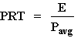
From Equation 2—
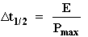
Substitution of these values into Equation 6 yields Equation 7.
Equation 7
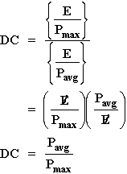

EXAMPLE C: DUTY CYCLE AND MAXIMUM POWER OF A REPETITIVELY PULSED LASER
Given: | A repetitively pulsed CO₂ laser has an average power of 100 W, a pulse duration of 0.5 ms, and a pulse repetition of 500/sec.
Find: | Duty cycle and maximum power.
Solution: | 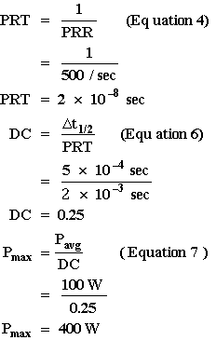
In most cases, repetitively pulsed lasers are characterized by measurement of the average power of the laser with a power meter and determination of pulse duration and pulse repetition time with a photodiode and oscilloscope. All other quantities then can be calculated as in Example D.
EXAMPLE D: CHARACTERIZING A REPETITIVELY PULSED LASER
Given: | A GaAs semiconductor laser produces an average power of 25 mW. The pulse duration is 2.5 μs, and the pulse repetition time is 1 ms.
Find: | Duty cycle, maximum power, and energy per pulse.
Solution: | Duty cycle:  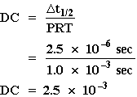  Maximum power:  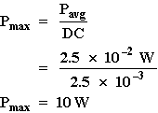  Energy per pulse:  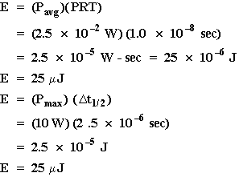

LONGITUDINAL COHERENCE LENGTH:
The longitudinal coherence length is a measure of the temporal coherence of a laser beam and is the distance along the beam over which the laser light has sufficient coherence to produce visible interference fringes. Longitudinal coherence length is important whenever a laser beam is split and recombined to form an interference pattern. This principle is illustrated by the Michelson interferomoter of Figure 9. Light entering from the left strikes a beam splitter at point A and is split into two beams. The beam reflected from the splitter travels to the mirror at B and is reflected back to the beam at D. The beam transmitted through the splitter travels to the mirror at C and is reflected back to D. At point D, the two beams recombine. Part of the return beam from B is transmitted through the splitter to the screen, and part of the return beam from C is reflected from the splitter to the screen.
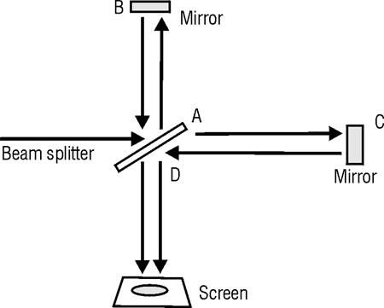
Fig. 9 Michelson interferometer
This optical system contains two optical paths (1) A to B to D and (2) A to C to D. The optical path difference is the difference in length between these two paths. If the optical path difference is less than the longitudinal coherence length of the light, interference fringes are formed on the screen. If the optical path difference is greater than the longitudinal coherence length of the light, no interference fringes are formed. In most applications that involve interferometry, the longitudinal coherence length of the laser light must be known; and in many cases steps must be taken to extend the coherence length.
The longitudinal coherence length of light is given by Equation 8.
Equation 8
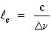
where: | c = Longitudinal coherence length.  c = Speed of light.  Δν = Total bandwidth of light.

EXAMPLE E: COHERENCE LENGTH OF A He-Ne LASER
Given: | The total bandwidth of a multimode He-Ne laser is 1.5 GHz.
Find: | Coherence length.
Solution: | 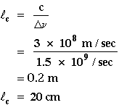
The coherence length of a typical He-Ne laser is about 20 cm, which means that such a laser can be used with an interferometer to produce interference fringes if the optical path difference is less than 20 cm. For optical path differences of greater than 20 cm, no interference patterns can be formed.
The longitudinal coherence length of laser light is inversely proportional to the bandwidth of the output laser light; therefore, the coherence length can be extended by reduction of the bandwidth. In some lasers, this reduction is accomplished by allowing only one longitudinal mode to oscillate within the laser cavity. This process reduces the bandwidth of the output beam from the multimode bandwidth (which is essentially equal to the full line width of the laser fluorescent transition) to the single-mode bandwidth of a cavity mode. The effect on the coherence length is illustrated in Example F.

EXAMPLE F: COHERENCE LENGTHS OF ARGON LASERS
Given: | An argon ion laser has a laser fluorescent line width of 10 GHz. The bandwidth of a single cavity mode is 7.5 MHz.
Find: | Coherence length with all possible cavity modes oscillating and coherence length if only one mode oscillates.
Solution: | If all modes oscillate, the bandwidth of the output is equal to the total laser fluorescent line width:  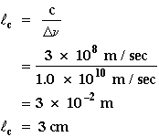  If only one mode oscillates, the bandwidth of the output is the bandwidth of that mode:  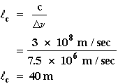
Single-mode operation can be achieved in many lasers by installation of an optical element called an "etalon" inside the optical cavity. The etalon acts as a secondary optical cavity within the primary cavity of the laser. Standing waves can be formed only at light frequencies that form standing waves in both optical cavities. The proper selection and installation of an etalon can achieve single mode operation in any CW laser and in many pulsed lasers, as well.

