Laser principles:
First stage:
Mohammed Hamza
SPATIAL CHARACTERISTICS
OF LASERS
The spatial distribution of the irradiance of a laser beam is of prime importance in many applications. For example, laser drilling requires beams of a particular diameter so that holes of the proper size can be drilled. Laser ranging requires well collimated beams that diverge slowly as they travel away from the laser. Almost all applications require the uniform spatial distribution of irradiance produced by the Gaussian, or TEM₀₀ mode.

TRANSVERSE ELECTROMAGNETIC MODES:
Optical Cavities and Modes of Oscillation, "describe the variations in the electromagnetic field along the optical axis of the laser cavity. A complete description of the E-M field requires that variations in directions perpendicular to the optical axis also be considered. Electromagnetic field variations perpendicular to the direction of travel of the wave are called "transverse electromagnetic modes," or "TEM modes" as shown in Figure 1.
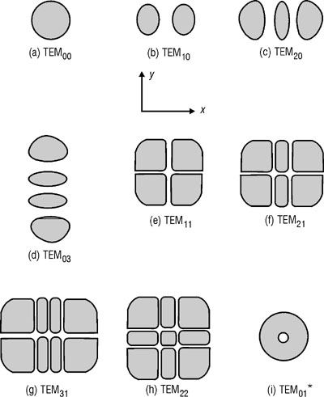
Fig. 1 Transverse electromagnetic modes
Figure 1 illustrates the irradiance patterns produced by lasers operating in various transverse modes. The general mode is specified as TEM_{mn}, where m is the number of dark bands (white areas in Figure 1) crossing the horizontal axis and n is the number of dark bands (white areas) crossing the vertical axis. Thus, TEM₂₁ (Figure 1f) has two vertical bands (shown as white) crossing the x-axis and one horizontal band (shown as white) crossing the y-axis.
The centers of the dark bands (white bands) in the intensity patterns of the TEM modes actually are nodes in the electric field within the laser cavity. The electric fields of two modes within the cavity of a vertically polarized laser are depicted in Figure 2. Figure 2a shows the electric field of the TEM₀₀ mode in a plane perpendicular to the optical axis of the cavity that contains an antinode of the longitudinal mode at one instant of time. The electric field is upward at all points within this plane. The curve drawn on the plane represents the magnitude of the electric field along the x-axis of the plane. The field is maximum at the center of the cavity and decreases uniformly toward the edges of the cavity aperture.
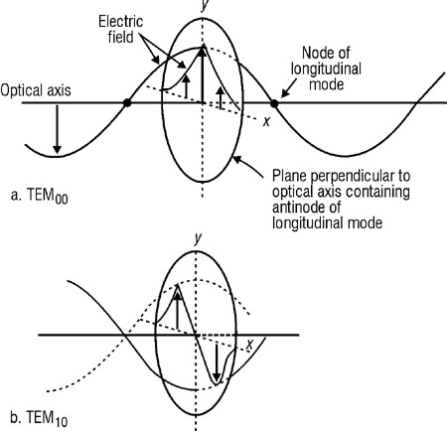
Fig. 2 Electric fields of transverse
modes in a laser cavity
(6) The same curve is the solid line in Figure 3a. After a time equal to one-half the period of the wave, the direction of the electric field in this plane will be pointed downward, as indicated by the dotted line in Figure 3a. The boundaries of the cavity aperture are nodes of this transverse standing wave.
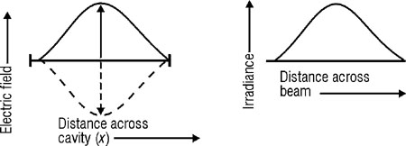
Fig. 3a

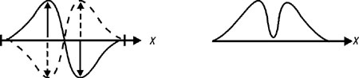
Fig. 3b

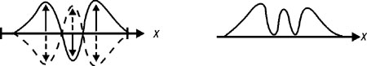
Fig. 3c
Fig. 3 Electric field and irradiance of transverse modes
Figure( 2b) displays the electric field distribution of the TEM₁₀ mode. In this case, the field is upward on one side of the cavity and downward on the other. The field is also represented by the solid line in Figure 3b. One half cycle later, the direction of the field will reverse, as indicated by the dotted line. This mode has a node in a vertical plane through the optical axis.
Figure 3c gives the electric field pattern of TEM₂₀ as a function of distance across the cavity at two instants of time and the irradiance patterns caused by the three modes.
The mode in Figure 1i is called the "TEM₀₁ quadrature" mode or, more commonly, the "doughnut" mode. This pattern results when TEM₀₁ or TEM₁₀ oscillates in a cavity at the same time with a phase difference of 90, as often occurs.
A laser will produce an output for all TEM modes for which gain exceeds loss within the laser cavity. Some lasers will laser on several transverse modes at the same time, as indicated by Figure 4. Such simultaneous lasing produces a beam that has dark spots and "hot" spots, i.e., regions of low and high irradiance.
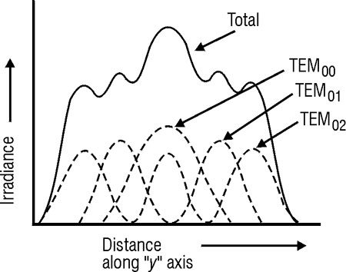
Fig. 4 Multimode output irradiance distribution
If sufficient losses are introduced within the cavity for a particular mode, that mode will cease to oscillate; for example, a vertical scratch through the center of one mirror will cause losses for all modes that do not have a vertical node through their center. In this case, modes TEM₁₀, TEM₃₀, etc., would suffer no loss since such modes have a node or zero electric field at the center of the TEM pattern.
Notice that in Figure 4, TEM₀₀ has a smaller diameter than any other mode. All modes except TEM₀₀ can be eliminated by a cavity aperture diameter that produces little or no loss for the TEM₀₀ mode, but that introduces greater loss for all higher order modes. Optical cavities that exhibit high diffraction losses tend to oscillate in the TEM₀₀ mode only. Thus, any cavity can be restricted to TEM₀₀ by installation of a suitable aperture. For most gas lasers, the diameter of the laser tube is chosen only for the purpose of limiting oscillation to TEM₀₀.
A further examination of Figure 2b reveals that the two bright spots of the TEM₁₀ mode are 180 out of phase with one another. In any transverse mode, each bright spot is 180 out of phase with all adjacent bright spots, as illustrated for TEM₂₂ in Figure 5.
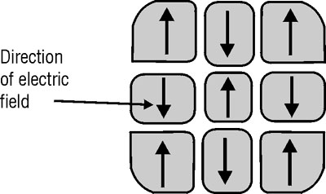
Fig. 5 Phase differences in TEM₂₂
TEM₀₀ is termed the "uniphase or pure Gaussian mode" because it is the only transverse mode in which all the light is in one phase at any given time. This uniphase mode is the only mode in which all laser light is spatially coherent, resulting in the following three important characteristics of this mode:
1-It has a lower beam divergence than other modes. Lower divergence is important in the transmission of beams over large distances, as, for example, in laser ranging.
2-It can be focused to a spot smaller than other existing modes. This is important in an application such as drilling.
3-Its spatial coherence is ideal for applications that depend upon the interference of light. Other modes cannot be used because they lack adequate spatial coherence.
Most lasers are designed to operate in TEM₀₀ only. The remainder of this module discusses characteristics that apply to such lasers operating in this mode.

BEAM DIAMETER AND SPOT SIZE:
Figure 6 indicates the profile of a TEM₀₀ laser beam. Since the irradiance of the beam decreases gradually at the edges, specification of beam diameter out to the points of zero irradiance is impractical. The "beam diameter" is defined as "the distance across the center of the beam for which the irradiance (E) equals 1/e² of the maximum irradiance (1/e² = 0.135)." The "spot size" (ω) of the beam is "the radial distance (radius) from the center point of maximum irradiance to the 1/e² point." These definitions provide standard measures of laser beam size.

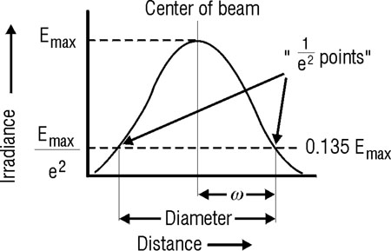
Fig. 6 Definitions of beam diameter and spot size (ω)

TRANSMISSION OF A BEAM THROUGH AN APERTURE:
If a laser beam is centered upon a circular aperture, the edges of the beam may be truncated as illustrated in Figure 7.
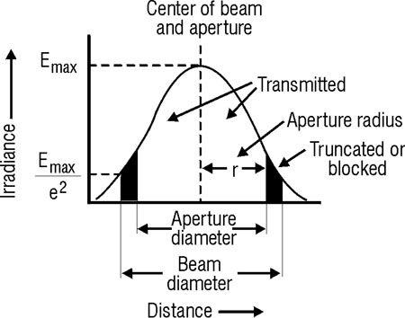
Fig. 7 Transmission through a circular aperture
The fraction of beam power transmitted through the aperture is given by Equation 1.
Equation 1
where: | T = Fractional transmission.  r = Radius of aperture.  ω = Spot size (radius of beam to 1/e² points).
In some situations, it is useful to be able to calculate the ratio of the aperture radius all of those are lower case R to the beam spot size (w) from a knowledge of the beam power transmitted through a given aperture. In that event, one can rearrange Equation 1A as follows:
Equation 1B
 | ; Equation 1A
 | ; (rearrange terms)o
 | ; take l n of each side and recognize that 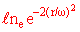is by definition
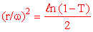 | ; solve for
Equation 1B
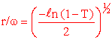 | ; solve for desired ration r/w by taking square root of each side.
where r = Radius of aperture
w = Spot size of laser beam passing through aperture
T = Fractional transmission (T passing/T incident)

EXAMPLE A: TRANSMISSION THROUGH AN APERTURE
Given: | A laser beam is centered upon an aperture of a diameter equal to the beam diameter.
Find: | Transmission of the aperture.
Solution: | 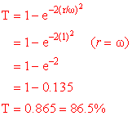

EXAMPLE B: RATIO OF APERTURE DIAMETER TO BEAM DIAMETER FOR A GIVEN FRACTIONAL TRANSMISSION.
Given: | The power of 4mw He-Ne laser is cut in half after passing through an aperture of radius 2.50 mwn.
Find: | Spot size (w) of laser beam
Solution: | Use Eq. 1B to solve for the ratio r/w for T-0.50, then solve for w.  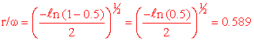  (Note that the value of r/w agrees with data given in Figure 8 for T=50%).  Now solve for spot size w:  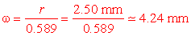  Spot size of laser beam is a little over 4 mm.
Figure 8 is a transmission curve based upon Equation 1A. The horizontal scale gives the ratio of aperture diameter (2r) to beam diameter (2w). The vertical scale is calibrated in percent of transmission. The transmission curve can be used with a calibrated aperture to determine the diameter of a laser beam, as illustrated in Example C.

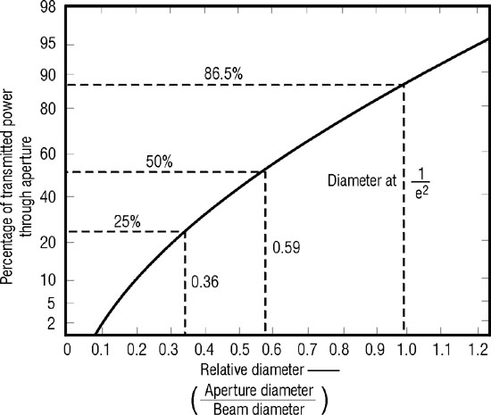
Fig. 8 Percentage of transmitted power through an aperture

EXAMPLE C: DIAMETER OF A LASER BEAM
Given: | A 2-mW He-Ne laser beam is centered on an aperture having a diameter of 3 mm. The transmitted power is 1 mW.
Find: | Beam diameter.
Solution: | Diameter of aperture: d_{a} = 3 mm  Transmission = T = 50%  Diameter of beam: d_{b}  From Figure 8,  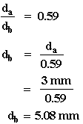
The method illustrated in Example C is used for the determination of beam diameter in the laboratory exercise of this module.

BEAM DIVERGENCE:
The light emitted by a laser is confined to a rather narrow cone; but, as the beam propagates outward, it slowly diverges or fans out. Figure 9, greatly exaggerated, illustrates the way in which a beam of circular cross-section diverges. At the output aperture of the laser, the beam diameter is d. Its beam divergence angle is , usually expressed in milliradians. In traversing a distance . the beam diverges to a circle of diameter . Simple geometrical considerations indicate that for a small divergence angle, the diameter of the beam at a distance from the output aperture is approximated by Equation 2.
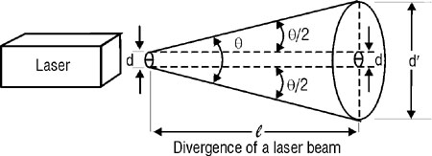
Fig. 9 Divergence of a laser beam
Equation 2
where: | l = Distance from laser output aperture to measurement position.  Τ = Full-angle beam divergence in radians.  d = Initial beam diameter.  = Beam diameter at measurement position.

EXAMPLE D: BEAM DIAMETER AT A DISTANCE
Given: | A He-Ne laser has an output beam diameter 1.5 mm and a full-angle divergence of 1 mrad.
Find: | Beam diameter at 100 m.
Solution: | 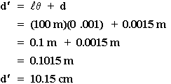
In the past, some manufacturers have specified the "half angle beam divergence" given as in Figure 9. The most common practice in recent years has been to specify the "full angle beam divergence." Specifications must be checked with care in order that these different terms will not be confused.

MEASURING BEAM DIVERGENCE:
The divergence of a CW laser beam can be determined by measurement of the beam diameter at two points (Figure 10). The full angle beam divergence is given by Equation 3.
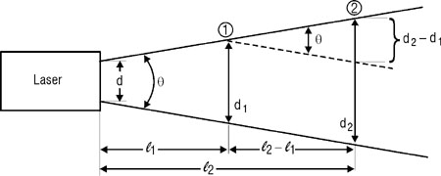
Fig. 10 Measurement of beam divergence
Equation 3
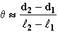
where: | d₁ = Beam diameter at point 1.  d₂ = Beam diameter at point 2.  ₁ = Diameter from laser to point 1.  ₂ = Diameter from laser to point 2.
Equation 3 is valid for small , typical of most lasers.
EXAMPLE E: CALCULATION OF BEAM DIAMETER
Given: | A He-Ne laser beam has a diameter of 3.5 mm at a distance of 2 m from the laser. At 4 m, the beam has expanded to a diameter of 5.9 mm.
Find: | Beam divergence.
Solution: | 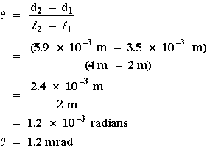

REDUCTION OF THE BEAM DIVERGENCE OF GAS LASERS:
Figure 11 illustrates the optical cavity and beam profile of a typical gas laser. The laser beam diverges in the cavity as it strikes the output coupler, and would diverge even more outside the cavity if the second surface of the output coupler were flat. To prevent greater divergence, the second surface is curved slightly more than the first surface to form a positive lens that collimates the beam. The output coupler actually is a positive lens that has a focal length equal to the radius of curvature of its reflective surface.
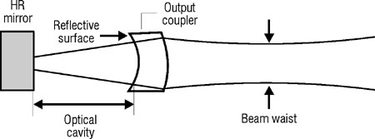
Fig. 11 Collimation of a laser beam by the output coupler
In most cases, this results in a slight convergence of the beam just past the output aperture. The beam passes through a minimum diameter, or "waist," and then diverges. This external beam waist serves as a "controlling aperture" which determines the beam divergence as the beam continues on past the beam waist.

THE NEAR AND FAR FIELDS:
The discussion of beam divergence accompanying Figure 11 approximates the behavior of the beam near the laser only. The use of Equation 2 and 3 are valid only in the "for fills," at a certain distances from the laser. This range of distances is specified by Equation 4.
Equation 4
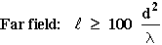
where: | = Distance from laser to observation position.  d = Diameter of output aperture.  λ = Wavelength of laser light.
The region closer to the laser is the "near field" and is defined by the condition given by Equation 5:
Equation 5
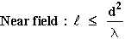
The beam divergence in the near field may differ considerably from that in the far field, as illustrated in Figure 11. Why the difference in divergence occurs is beyond the scope of this module. In the "gray area" between the ner field, defined by Equation 5, and the far field, defined by Equation 6, one may use Equation 2 and 3 to obtain reasonable approximations of the laser beam divergence. They involve simple calculations and good "ballpark" results.
Example E is a calculation of near field and far field distances for a typical He-Ne laser. The "gray area" would be that region between 1.6 meters and 160 meters.

EXAMPLE F: NEAR- AND FAR-FIELD DISTANCES
Given: | The effective output aperture diameter (see Figure 11) of a Ne-He laser (λ = 632.8 nm) is 1.0 mm.
Find: | Near- and far-field distances.
Solution: | 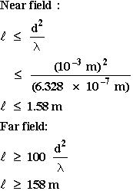
The far-field beam divergence (full angle) of a laser is given by Equation 6.
This equation is the "diffraction limited beam divergence" (see discussion after Example G) because it is the minimum divergence possible when light of wavelength λ is diffracted as it passes through an effective aperture* of diameter d. Example G illustrates the use of this equation.
Equation 6 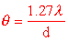
EXAMPLE F: CALCULATION OF BEAM DIVERGENCE
Given: | A He -Ne laser has an effective output aperture diameter of 1.2 mm. (λ = 632.8 nm)
Find: | Beam divergence.
Solution: | 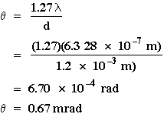
*It is well to point out here that the effective aperture "d" in Equation 6 is in truth equal to the diameter of the beam waist located somewhere in the cavity of the laser. That is always the case of the output coupler does not further reshape the output laser beam as it exits the laser. If the output coupler does as shown in Figure 11, then the effective aperture "d" is the diamter of that beam waist formed by the output coupler located external to the laser beam, as shown in Figure 11. It is also well to point out that, for an ordinary light beam passing through a circular hole of diameter "d" (a light beam described as plane waves with a uniform intensity) the correct far-field beam divergence is given by = 2.44 λ/d. But, for a TEM₀₀ Gaussian laser beam, the correct far-field beam divergence from a cavity is precisely as given in Equation 6. Do not confuse the two situations. They are distinctly different.

A NOTE ON DIFFRACTION—LIMITED OPTICS:
Determining Laser Spot Size when focused by a lens
When light passes through circular openings such as pin holes or apertures, light spread out and diverges. When light is focused by a lens, the light does not focus to a geometrical point; instead it focuses to a tiny spot of some diameter, surrounded by alternate bright and dark rings, the entire image referred to as an AIRY diffraction pattern. The wave theory of light explains the behavior of the spreading of light passing through aperturer as well as the focusing of light as AIRY patterns rather than geometrical points. This is generally handled under the concepts of diffraction of lightwaves.
As such, diffraction theory set a lower limit on the amount of beam divergence that occurs when a laser beam passes through an effective aperture. Thus, any real optical system, containing imperfections in optical lenses, variation in the index of refraction along the atmosphere path of propagation and so on, the divergence is greater than that predicted by Equation 6, . In the same way, the spot size of a focused laser beam, as discussed in the next section, is predicted by diffraction theory to be of a value given by Equation 7, =f. However, for real optical systems and real lenses, the focused spot is in fact, larger than that predicted by Equation 7.
So diffraction-limited optics sets the ideal limit for such results as expected beam divergence of expected focal spot size. When you use relationships such as Equation 6 and 7, to calculate beam divergence or focused spot size , be aware that you are obtaining the "best" values possible in view of light diffraction. In fact, for your "real" optical systems, the beam divergence and spot sized will both be larger than the equations predict. Real optical systems are therefore poorer in performance than those limited only by diffraction. We often refer to such real systems as many-times diffraction limited. For example, if Equation 6 predicts a beam divergence of = 1 milliradian for your systems, but you actually measure =5 milliradians, you can conclude that your system is 5-time diffraction limited.

THE FOCUSING OF LASER BEAMS:
Figure 12 illustrates a laser beam focused by a positive lens. The beam is focused to a radius called the "diffraction limited spot size." The diameter of this spot is given approximately by Equation 7.
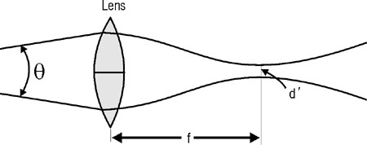
Fig. 12 Focusing of a laser beam
Equation 7
d' = f
where: | d' = Diameter of focused spot.  f = Focal length of lens.  = Full-angle beam divergence.

EXAMPLE H: DIAMETER OF FOCUSED LASER BEAM
Given: | An Nd:YAG laser has a beam divergence of 2.0 mrad. The beam is focused by a lens of focal length 2.5 cm.
Find: | Diameter of focused spot.
Solution: | d' = f  d' = (2.5 * 10^{–2} m)(2.0 * 10^{–3} rad)  d' = 5.0 * 10^{–5} m  d' = 50 μm
Example I is a more complicated problem that involves the use of several equations presented in this module.
EXAMPLE I: BEAM DIVERGENCE AND FOCUSING IN AN OPTICAL SYSTEM
Given: | The beam of a 25-mW He-Ne laser with an effective output aperture diameter of 1.5 mm travels 10 m to a positive lens having a focal length of 3 cm.
Find: | a. Beam divergence.  b. Beam diameter at lens.  c. Beam diameter of focused spot.  d. Irradiance of the focused spot.
Solution: | A:  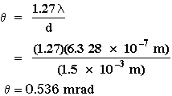  B:  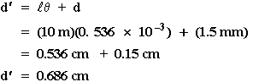  C:  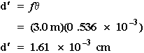  D:  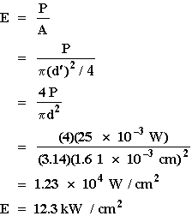mmmmmmm

References

