Obstetrics
Lec. 1 د. بان عامر موسى
المرحلة الرابعة

Female Reproductive system Anatomy
The female reproductive organs can be subdivided into the internal and external genitalia. The internal genitalia are those organs that are within the true pelvis. These include the vagina, uterus, cervix, uterine tubes (oviducts or fallopian tubes), and ovaries . The external genitalia lie outside the true pelvis. These include the perineum, mons pubis, clitoris, urethral (urinary) meatus, labia majora and minora, vestibule, greater vestibular (Bartholin) glands, Skene glands, and periurethral area.

Functions:-
Female reproductive system is designed to carry out several functions.
The Reproductive Cycle
The female reproductive cycle is the process of producing an ovum and readying the uterus to receive a fertilized ovum to begin pregnancy. If an ovum is produced but not fertilized and implanted in the uterine wall, the reproductive cyele resets itself through menstruation. The entire reproductive cycle takes about 28 days on average, but may be as short as 24 days or as long as 36 days for some women.
It produces the female egg cells necessary for reproduction, called the ova or oocytes. The system is designed to transport the ova to the site of fertilization. Conception, the fertilization of an egg by a sperm, normally occurs in the fallopian tubes. The next step for the fertilized egg is to implant into the walls of the uterus, beginning the initial stages of pregnancy. If fertilization and/or implantation does not take place, the system is designed to menstruate (the monthly shedding of the uterine lining). In addition, the female reproductive system produces female sex hormones that maintain the reproductive cycle.
Oogenesis and Ovulation
Under the influence of follicle stimulating hormone (FSH), and luteinizing hormone (LH), the ovaries produce a mature ovum in a process known as ovulation. By about 14 days into the reproductive cycle, an oocyte reaches maturity and is released as an ovum. Although the ovaries begin to mature many oocytes each month, usually only one ovum per cycle is released.

How Many Eggs Does a Woman Have?
The vast majority of the eggs within the ovaries steadily die, until they are depleted at menopause. At birth, there are approximately 1 million to 2 million eggs; by the time of puberty, only about 300,000 remain. Of these, only about 500 will be ovulated during a woman's reproductive lifetime. Any < .remaining eggs gradually die out at menopause.

Fertilization
The sperm cell is released into the female organ. The cells make their way through to the top of the vagina, through the cervix and into the uterus. But they do not stay there — they continue their journey into the fallopian tube and travel upward.
If there is any ovum (egg cell) released, the egg cell and the sperm cells meet, the fimbriae catch the egg and direct it down the fallopian tube to the uterus. It takes about a week for the .ovum to travel to the uterus
When they meet, there are millions of sperm cells, and they will all meet the only egg. When the sperm cells meets the egg, only the sperm cell that is able to break through the egg membrane win . When the male and female gametes fused in the ampulla of the tube, the spermatozoa fertilize the oocyte after undergoing the capacitation and acrosomal reaction in the sperm head under influence of substance from corona radiata cells of the oocytes then multiple fusion point between plasma membrane of the oocytes and the outer membrane of the acrosomes permit the release of acrosomal contents needed to penetrate the corona radiata and zona pellucida. After a two- week period of rapid cell division known as the germinal period of development, the zygote forms an embryo. The embryo will then implant itself into the uterine wall and develop there during pregnancy.

Fertilization
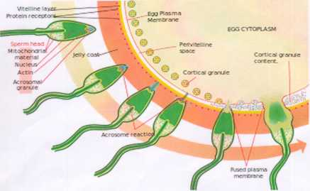

In the diagram, notice how millions of sperm cells all trying to break through the membrane of the egg cell.
Once a sperm fertilizes an egg cell, it becomes a zygote. The zygote (fertilized egg) at this stage possesses half the DNA (characteristics) of each of its two parents. The zygote then divides itself to form a very tiny ball called an embryo.
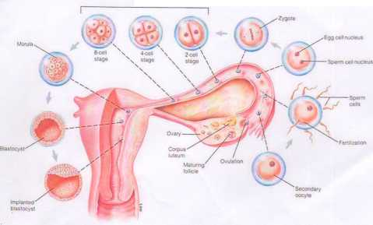
Zygote-by mitotic division - blastomere stage - Morela (12- lb) cell stage - the inner the cell mass give the embryo and the outer cell mass give the trophoblast (the future placenta ) the morela inter the uterine cavity 4 days after fertilization .
Implantation
The zygote stays in the fallopian tube for about 3-4 days but within 24 hours of being fertilized it starts dividing very fast into many cells it keeps dividing as it moves slowly through the fallopian tube to the uterus . In human, implantation of a fertilized ovum (blastocyst stage) is most likely to occur about 9 days after ovulation,ranging between 6-12 .
The trophoblast over the embryo give protiolytic enzymes to penetrate deep between the cells of endometrium at 6th day after fertilization at time of implantation (the secretory endometrium , the glands become coiled and highly edematous )
The blastocyst embedded itself in the stratum compactum of the decidua most frequently in the upper and posterior part of the uterine cavity producing slight projection into the uterine lumen.
The decidua:
Transformation of secretory endometrium to decidua by hormones, according to its relation to the embryo , it is divided into 3 parts
- Decidua basalis site of placental attachment.
- Decidua capsularis
- Decidua parietalis

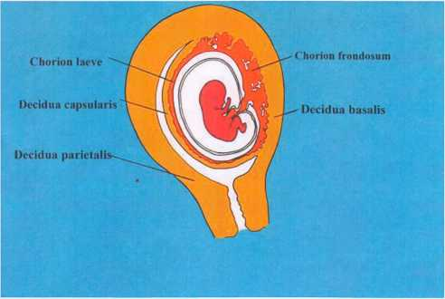

Embryology
The development stages of pregnancy are called trimesters ,or 3 month periods , because of the distinct changes that occur in each stages .
First trimester :
Soon after fertilization the zygote pass through the fallopian tube to the uterus . During this journey , the zygote divides , within 72 hours , it will have gone from one cell to eight cells then it becomes known as a blastocyst. the inner group of cells will form the embryo , the outer group of cells will form the placenta which will provide the nourishment. By the fifth week of pregnancy , the brain , spinal cord , heart and other organ begun to form . the embryo is now made up of three layers . the ectoderm, mesoderm , and endoderm . The ectoderm will form the nervous system and backbone . The mesoderm will form the heart and circulatory system and the endoderm will form the lung ,GIT ,thyroid , liver and pancreas .
In the last few weeks of the first trimester , the embryo really starts to take shape . the facial structures begin to form and become recognizable . The neural tube ,which will form the brain and spinal cord, develops .Little buds emerge and grow into arms and legs . Pregnancy has three trimesters, each of which is marked by specific fetal developments. A pregnancy is considered full-term at 40 weeks; infants delivered before the end of week 37 are considered premature. Premature infants may have problems with their growth and development, as well .as difficulties in breathing and digesting.
First Trimester: (0 to 13 Weeks)
The first trimester is the most crucial to baby's development. During this period, baby's body structure and organ systems develop. Most miscarriages and birth defects occur during this period.
Maternal body also undergoes major changes during the first trimester. These changes often cause a variety of symptoms, including nausea, fatigue, breast tenderness and frequent urination.
Second Trimester (14 to 26 Weeks)
The second trimester of pregnancy is often called the "golden period" because many of the unpleasant effects of early pregnancy disappear. During the second trimester, the mothers are likely to experience decreased nausea, better sleep patterns and an increased energy level. However, they may experience a whole new set of symptoms, such as back pain, abdominal pain, leg cramps, constipation and heartburn.
Somewhere between 16 weeks and 20 weeks, they may feel baby's first fluttering movements

Third Trimester (27 to 40 Weeks)
Some of the physical symptoms, may experience during this period include shortness of breath, hemorrhoids, urinary incontinence, varicose veins and sleeping problems. Many of these symptoms arise from the increase in the size of the uterus .

