physiology GIT)) كلية الطب

المحاضرة الثانية المرحلة الثانية

**Ingestion of food**

The amount of food that a person ingests is determined by intrinsic desire for food called hunger .The type of food that a person preferentially seeks is determined by appetite.

Chewing and swallowing are the first steps in processing of ingested food.

**1- Chewing (Mastication):**

Chewing has three functions:

**A**- It mixes food with saliva, lubricating it to facilitate swallowing

**B** - it reduce the size of food which facilitates swallowing.

**C**- It mixes carbohydrates with salivary amylase to begin carbohydrate digestion.

It include as both voluntary and involuntary components, involuntary component involves reflexes initiated by the presence of a bolus food in the mouth. Sensory information is relayed from mechanoreceptors in the mouth to the brain stem. While voluntary chewing occur at any time. The teeth is designed for chewing. The incisor providing a strong cutting action, and the molars for grinding action.

Most of the muscles of chewing are innervated by motor branch of the 5Th cranial nerve, and the chewing process is controlled by nuclei in the brain stem. Stimulation of specific reticular areas in the brain stem taste centers will cause rhythmical chewing movements

.Also, stimulation of areas in the hypothalamus, amygdala, and even the cerebral cortex near the sensory areas for taste and smell can often cause chewing.

Chewing process is caused by chewing reflex. The presence of a bolus of food in the mouth causes reflex inhibition of muscles or mastication which allows the lower jaw to drop. The drop in turn initiates a stretch reflex of the jaw muscles ( the masseter, medial pterygoid, and temporalis muscles) that lead to *rebound contraction,*

This automatically raises the jaw to cause closure of the Teeth but it also compresses the bolus against the lining of the mouth and push the food to come in contact with buccal receptors, which inhibit the jaw muscles again allowing the jaw to drop and rebond another time; this is repeated again and again.

**2- Swallowing: (deglutition ):**

Swallowing is initiated voluntarily In the mouth but thereafter it is under involuntary

or reflex control. Swallowing center is located in the medulla. Sensory information ( food in the mouth detected by somatosensory receptors located near pharynx), this afferent information is carried to medullary swallowing center via vagus and gloss pharyngeal nerves. The information is coordinated in medulla, motor (efferent) to striated muscle of the pharynx and upper esophagus.

There are 3 phases involved in the swallowing:

**A- Oral phase:** it is initiated when the tongue forces a bolus of food back toward the pharynx, which contains high density of receptors, which initiate the involuntary swallowing reflex in medulla

**B- Pharyngeal phase**: The purpose of this phase to propel the food bolus from the mouth through the pharynx to esophagus in the following step:

**1-** The soft palate is pulled upward, creating a narrow passage for food to move into the pharynx, so food cannot reflux into nasopharynx.

**2-** Epiglottis move to cover opening of larynx to prevent food from entering the trachea.

**3-** Upper esophageal sphincter relaxes allowing food to pass from pharynx to esophagus.

**4**-Aperistaltic wave of contraction is initiated in pharynx and propel food through the open sphincter. The breathing is inhibited during the pharyngeal phase of swallowing:

**C- Esophageal phase:** it is controlled by swallowing reflex. in this phase, food propelled through the esophagus to the stomach the esophageal secretions are entirely mucous provide lubrication for swallowing. Once the bolus has passed through the upper esophagus sphincter in pharyngeal phase. The reflex closes the sphincter. so food cannot reflux into pharynx. Primary peristaltic wave coordinated by swallowing reflex, travels down the esophagus propelling the food along the secondary wave which is mediated by the enteric nervous system, begins at site of distension and travels down ward.

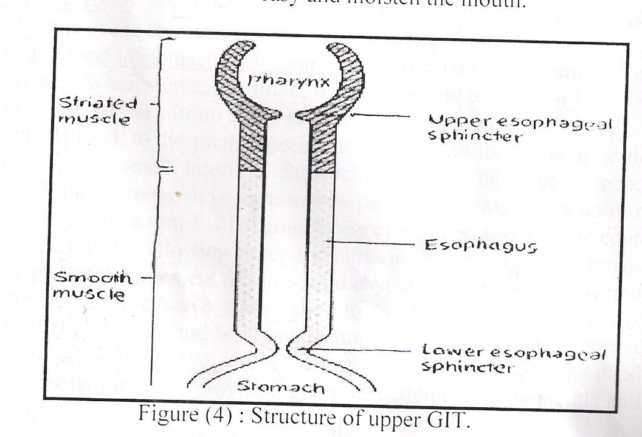

Upper esophageal sphincter

lower esophageal sphincter

esophagus

pharynx

Striated muscle

Smooth muscle

Upper esophageal sphincter

lower esophageal sphincter

esophagus

pharynx

Striated muscle

Smooth muscle

stomach

structure of structure of upper GIT

**Disorders of Swallowing**

Damage to the 5th, 9th, or 10th cerebral nerve , swallowing center and brain stem can cause paralysis swallowing mechanism .

As well as deep anesthesia ,cause blocked the reflex mechanism of swallowing, in this case large quantities of vomiting materials come from the stomach into the pharynx; then, instead of swallowing the materials again, they suck them into the trachea. As a result, such patients choke to death on their own vomitus.

**Disorders of esophagus**

Achalasia or Megaesophagus is a condition in which the lower esophageal sphincter fails to relax during swallowing. As a result of damaging in the neural network of the myenteric plexus,lead to lost its ability to transmit a signal to cause “receptive relaxation” of the gastroe sophageal sphincter the food fails to pass from the esophagus into the stomach Antispasmotic drugs (drugs that relax smooth muscle) can be helpful.

**Secretion of saliva:**

The gland of salivation are the parotid, submandibular, and sublingual gland in addition there are many tiny buccal gland. Secretory cells are found in acinus. Each acinus is connected to the ductal system,acinus consists of a single layer of cuboidal epithelial cells surrounding a lumen, a central opening where the saliva is deposited after being produced by the secretory cells.

The three forms of produced: [serous](http://en.wikipedia.org/wiki/Serous), [mucoserous](http://en.wikipedia.org/wiki/Mucoserous" \o "Mucoserous) and [mucous](http://en.wikipedia.org/wiki/Mucus).

[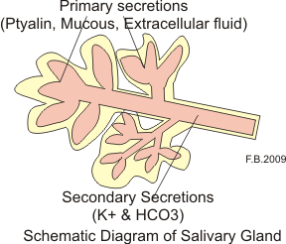](http://commons.wikimedia.org/wiki/File:Salivary1.png)

The daily normal secretion of saliva is between 500-1500 ml, it is hypotonic and contains high concentration of K+ ions and bicarbonate ions and lower concentration of Na +and CL- ions. Saliva has PH 6.0-7.4 6.0-7.0 this range is important for digestive action of ptyalin

Saliva consists of two types of protein secretion:-

**1- Serous secretion**: (watery saliva) containing ptyalin (α-amylase) which is an enzyme for digesting starches. Very small amount of lingual lipase which begins the process of fat digestion.

**2- Mucous secretion:** containing mucin (glycoprotein) for lubricating purposes. The parotid glands secrete serous type, submandibular and sublingual glands secrete both. The buccal glands secrete only mucous.

Salivary glands are controlled by parasympathetic nervous signals from the salivary nuclei which are located at junction of medulla and Pons.

The *appetite area* of the brain too, regulates these effects, is located in anterior hypothalamus, and it functions to a great extent in response to signals from the taste and smell areas of the cerebral cortex or amygdala.

**Factors that induce salivation**

**A**- Taste and tactile stimuli from the tongue and other area of mouth and pharynx. Sour and smooth objects increase salivation more time.

.

**B-** impulse arriving in the salivary nuclei from higher centers of CNS. When a person smell or eats favorite foods, salivation is greater than when disliked food is smelled or eaten.

**C-** response to reflex originating in the stomach and upper intestine when very irritating foods are swallowed or when a person is nauseated.

The swallowed saliva may help to remove the irritating factor in the GIT by diluting or neutralizing the irritant substances.

Parasympathetic nerve stimulation causes the salivary cells to secrete a large volume of watery fluid that is high in electrolytes but low in proteins.

While Sympathetic nerve stimulation causes the salivary gland to secrete a small volume of fluid containing a high concentration of mucous.(in excitation)

Under basal conditions, saliva is secreted all time except during sleep when the secretion become very little.

**Important role of saliva in protection of the mouth:**

**1**-cooling hot food to maintain healthy oral tissues.

**2**-The saliva oral hygiene, it helps to prevent the harmful effect of bacteria by continuous washing away the pathogenic bacteria.

**3-** Saliva contains many factors that can kill bacteria by ions, proteolytic enzymes and antibodies.

**4-**Saliva digests starch by α-amylase and fat by lingual lipase.

**5**- Saliva Lubricates the food to make swallow easy and moisten the mouth

**6**-Saliva content also fluoride which is important for preventing dental caries.

**7**-Na+ and CL- which is present in concentration less than that of plasma (hypotonic)this is important for taste sensation if it was isotonic taste buds will not be stimulated by salt this decrease in concentration occur because of the active reabsorption of Na+ which is followed by CL- reabsorption .

**The stomach**

**Structure of the** **stomach:**

The stomach can be divided into: Fundus, body, antrum and pylorus regions lesser curvature and greater curvature. The stomach has three layers of muscle: an Outer longitudinal layer, a middle circular layer and *an* inner oblique layer. The stomach has very rich blood and lymphatic supply.

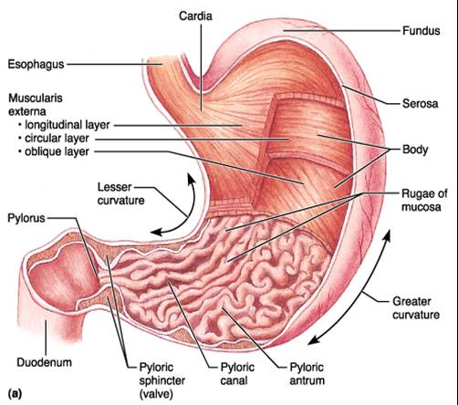

**Motor Functions of stomach:**

**1- Storage of the food**:

Until the food can be processed in the stomach, duodenum, and lower intestinal tract when the food enter the stomach there is receptors decrease the muscle tone of the stomach wall due to a vagovagal reflex.

**2- mixing of the food in stomach with gastric secretion**:

To form a semi fluid mixture called *chyme*. When stomach is filled, weak peristaltic constrictor waves. mixing wave, move toward the antrum along stomach wall once every 20 seconds.

**3**-**slow empty of food**:

From stomach into the to the small intestine at rate suitable for proper digestion and absorption by the small intestine. Stomach emptying the food is opposed to resistance of the pylorus, it is promoted by peristaltic waves in the antrum of the stomach. The pylorus remains not completely closed because of tonic contraction of the pyloric muscle, allowing water and other fluid to empty from stomach ,while prevents movement of semi-solid chyme into duodenum except when a strong antral peristaltic wave forces the chyme through.

This is controlled by signals from the stomach and from duodenum, When pyloric tone is normal. each strong antral peristaltic wave forces several ml of chyme into the duodenum, Thus, the peristaltic wave provide a pumping action that is frequently called the pyloric pump

**Regulation of gastric emptying (pyloric pump):**

**A- The stomach excitatory signals:**

**1-** **Excitatory nervous reflexes caused by**

distension of the antrum by food. This distension cause a stretch of the antral wall

which increases vagovagal and local enteric nervous system reflexes to increase

activity of the pyloric pump and inhibit the pylorus.

**2-** **The hormone gastrin**

released into the circulation from the antral mucosa in response to stretch the antral wall mediated by vagus nerve and enteric nervous system increase pyloric pumping force and inhibit the pylorus. The gastrin also has effect on gastroesophegal sphincter at lower of esophagus to prevent reflux of gastric contents into the esophagus during gastric activity.

**B-The duodenal inhibitory signal**:

Depress the pyloric pump and increase pyloric tone preventing the flow of chyme due to inhibitory nervous reflexes which are stimulated by high fat and H +ions in the duodenum. The hormones cholecystokinin (CCK) is released from duodenum in response to fat. It acts by blocking the" excitatory effects of gastrin on gastric muscle. Secretin is released from the duodenum in response to the presence of acid and has direct inhibitory effect on smooth muscle. When pH of chyme in duodenum falls below 5.5 – 4 reflex is elicited. Reducing or blocking further release of acidic stomach content into the duodenum until the duodenal chyme can be neutralized by pancreatic HCO3 .

**Gastric motility:**

There are two types of gastric motility:

**A- Peristalsis:** which is initiated near the fundal-body border and producing a

peristaltic wave that propels the food towards the pylorus. Peristaltic contraction occur every 20 seconds. These wave responsible for the rhythm and force of gastric contraction.

**B- Retropulsion**: It is the back and forth movement of the chyme caused by the

forceful propulsion or food against the closed pyloric sphincter.

**Hunger Contractions**.

Another type of intense contractions, called hunger contractions, often occurs when the stomach has been empty for several hours or more. The successive contractions become extremely strong, they often fuse to cause a continuing titanic contraction that sometimes lasts for 2 to 3 minutes,greatly increased by the person’s having lower than normal levels of blood sugar . Hunger contractions cause mild pain in the pit of the stomach, called hunger pangs.

**Castric secretion:**

About 2 L / day of gastric secretions are produced. The cells of the gastric mucous Secrete a fluid called gastric juice. The four major components of gastric juice are:

**1**- Hydrochloric acid (HCL).

**2**- Pepsinogen.

**3**- intrinsic factor.

**4**-mucous.

The function of HCI is to convert pepsinogen which is inactive to active form pepsin at low pH. Pepsin is the protease that initiates protein digestion. Intrinsic factor is necessary for the absorption of vitamin Bl2 in the ileum. Mucous protect the gastric mucous from the action of HCI, also lubricates the gastric contents.

**The structure and cell types of gastric mucous**:

The lumen of stomach is lined by epithelial cells, deeper are:

**A-oxyntic gland** consist of:-

**1- Mucous cells** :-Mucous secretion rich in alkaline bicarbonate protects the stomach from the Hydrochloric acid of the gastric juice.

[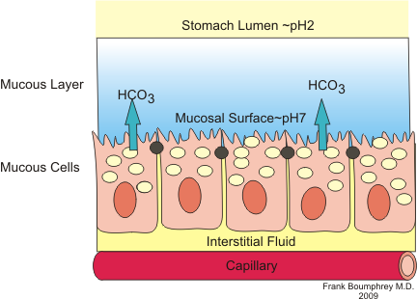](http://commons.wikimedia.org/wiki/File:Stomach_mucous.png)

**2- Parietal oxyntic cells**  which have two secretary products (HCL and intrinsic factor) HCl acidifies the gastric contents to pH l-2.

**3- Chief(peptic cells)** which have one secretary product pepsinogen, which converted by HCL to pepsin

**B- pyloric glands** contain two cell types, the **G** cells and **mucous** cells. The G cells secrete gastrin into circulation.

Other cells Enterochromaffin-like cells or (ECL) cells which secret histamine **,** Delta cells (or D cells) are [somatostatin](http://en.wikipedia.org/wiki/Somatostatin" \o "Somatostatin)-producing [cells](http://en.wikipedia.org/wiki/Cell_(biology)" \o "Cell (biology)).D cellscan be found in the [stomach](http://en.wikipedia.org/wiki/Stomach), [intestine](http://en.wikipedia.org/wiki/Intestine) and the [Islets of Langerhans](http://en.wikipedia.org/wiki/Islets_of_Langerhans) in the [pancreas](http://en.wikipedia.org/wiki/Pancreas).

