Minor (also known as “trace”)minerals
(micro minerals)
1-IRON

Total body content of iron is 3 to 5 gm out of which 75 % is recorded in blood and rest of them are recorded from liver, spleen, bone marrow and muscle. The normal limit for iron consumption is 20 mg/day for adults, 20-30 mg/day for children and 40 mg/day for pregnant women.

The source
The sources of iron are includes leafy vegetables and red meat .While milk is considered as a poor source of iron.

Factors influencing absorption of iron
Iron is absorbed by upper part of duodenum and is affected by various factors;
(1) Only reduced form of iron (ferrous) is absorbed and ferric form are not Absorbed.
(2) Ascorbic acid (Vitamin C) increases the absorption of iron
(3) The Solubility lead to the interfering substances such as phytic acid and oxalic acid decreases absorption of iron.
(4) Increase amount of Fe in diet lead to increase iron absorption
(5) Increase concentration of Cu in diet lead to increase iron absorption
(6) Body need ((Apoferritin & Ferritin))

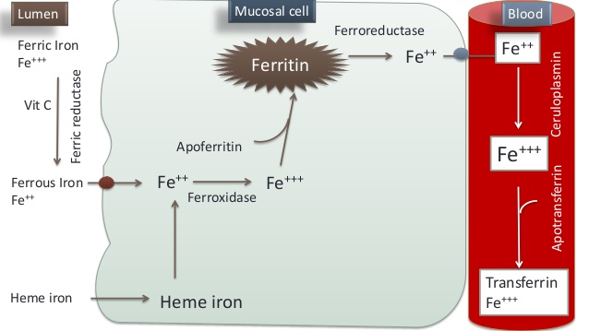

Iron transport in blood
The transport form of iron in blood is transferin. Transferin are glycoprotein secreted by liver. In blood, the ceruloplasmin is the ferroxidase which oxidizes ferrous to ferric state.

Apo-Transferin + 2Fe²⁺ → Transferin combined with 2Fe³⁺

Storage form of iron is ferritin. Almost no iron is excreted through urine. Feces contains iron as well as iron trapped in the intestine cells.
- Anemia is the most common nutritional deficiency disease. The microscopic appearance of anemia is characterized by microcytic hypochromic anemia.
- Iron toxicity or excess of iron is called as hemosiderosis. Iron toxicity occurs due to repeated blood transfusion.

Function
Function of Iron

Heam Containing Compounds | Non- Heam Containing Compounds
-Hemoglobin | -Transferrin
-Myoglobin | -ferritin
-Cytochromes | -Hemosidrin (Toxic protein)
-Catalase | -Flavo-protein
-Tryptophan pyrrolase

2-COPPER

Total human body contains about 100 mg of copper and are encountered in muscle, liver, bone marrow, brain, kidney, heart and in hairs. Enzymes such as cytochrome oxidase, tyrosinase, lysyl oxidase, allanine synthase, monoamine oxidase, superoxide dismutase and phenol oxidase contains copper. The normal copper limit for human are 1.5 to 3 mg/day.

The source
The main sources of copper are cereals, meat, liver, nuts and green leafy vegetables. From the total dietary copper only 10% are absorbed. Copper are mainly excreted through bile. The normal serum level of copper is 25 to 50 mg/dl.

Absorption
Copper is absorption from the stomach and the small intestine. And the absorbed copper is transported to liver in portal blood bound to albumin and is exported to peripheral tissue mainly bound to ceruloplasmin and ,to lesser extent, albumin.

Functions of copper
(a) Copper is necessary for iron absorption and incorporation of iron into
hemoglobin.
(b) It is very essential for tyrosinase activity
(c) It is the co-factor for vitamin C requiring hydroxylation
(d) Copper increases the level of high density lipoprotein and protects the
heart
(e) It is very essential for catalase & SOD enzymes

Abnormal metabolism of copper
The abnormal metabolism of copper leads to Wilson’s disease and Menke’s kidney hair syndrome.

(a) Wilson’s disease
In case of Wilson’s disease ceruloplasmin level in blood is drastically reduced. The incidence of Wilson’s disease is noticed for 1 in 50,000 populations. The defect in a gene encoding copper binding ATPase of liver cells leads to Wilson’s disease. Wilson’s disease leads to
(1) Accumulation of copper in liver leads to hepatocellular degeneration and cirrhosis
(2) Deposition of copper in brain basal ganglia leads to leticular degeneration
(3) Copper deposits as green pigmented ring around cornea and the condition is called as Kayser-Kleischer ring
Over accumulation of copper can be treated by consumption of diet containg low copper and injection of D-penicillamine, which excretes copper through urine.

3-ZINC
The daily requirement of Zinc for human consumption ranges 10mg /day. The major sources of Zinc includes grains, beans, nuts cheese, meat and shellfish. The normal serum level of Zinc in human is 100mg/day. In the human total body the content of Zinc is 2gm, out of which 60 % is encountered in skeletal muscle and 30% in bones highest concentration is seen in hippocampus area of brain and prostatic secretion.

Function
-Zinc important for hormone like insulin and also important for vitamin like vitamin D.

-More than 300 enzymes in human body are zinc-dependent; some of them are carboxypeptidase, carbonic anhydrase, alkaline phosphatase, lactate dehydrogenase, alcohol dehydragenase. The enzyme RNA polymerase, which is required for transcription, contains zinc and it is essential for protein bio synthesis.

-Deficiency in Zinc leads to poor wound healing, lesions of skin impaired spermatogenesis, hyperkeratosis, dermatitis and alopecia. Consumption of more than 1000 mg /day leads to zinc toxicity.
Zinc toxicity leads to gastric ulcer, pancreatitis, anemia, nausea and vomiting.

4-SELENIUM

The normal limit of Selenium for human consumption is 50-100 mg/day and the normal serum level is 50-100 mg/day. Selenium dependent enzymes include glutathione Peroxidase and 5-de-iodinase. Selenium concentration in testis is the highest in adult. It is very necessary for normal development and maturation of sperm. And it's very important as antioxidant.
Selenium toxicity could be termed as selenosis. The toxicity symptoms include hair loss, falling of nails, diarrhea, weight loss and garlicky odor in breath.

5-MANGANESE
The normal limit of Manganese for human is 5mg/day. The major source of Manganese are nuts. In metabolism, its absorption is inhibited by iron. In blood, it binds with transmanganin and excreted through bile.

