6-Membered Heterocyclic Compounds
- With heterocycles containing five C atoms, the unsaturated compounds are frequently more stable because of aromaticity.
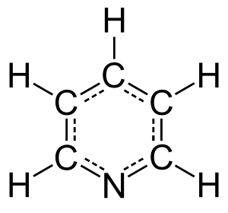
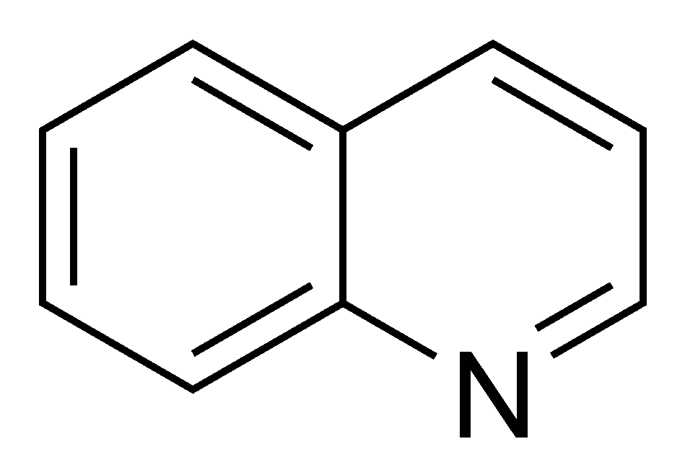
- For examples: Pyridine , Quinoline ,etc…..

- Structure and Properties
- Pyridine replaces the CH of benzene by a N atom (and a pair of electrons)
- Hybridization = sp² with similar resonance stabilization energy
- Lone pair of electrons not involved in aromaticity
- Pyridine is a weak base
- Pyridine is π -electron deficient
- Electrophilic aromatic substitution is difficult
- Nucleophilic aromatic substitution is easy
- Pyridine is a basic heterocyclic organic compound with the chemical formula C5H5N
- The pyridine ring occurs in many important compounds, including azines and the vitamins niacin ,sulfadiazine and pyridoxal.
- Pyridine occurs in coal tar (0.1%) and in the distillate from bones (bone oil) and has been produced industrially from these sources.
- According to the resonance theory, pyridine is considered to be hybrid of the following structures:
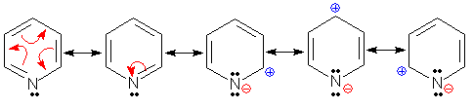

- Pyridine is colourless liquid.use as solvent and base in organic synthesis .
- It’s boiling point 115.5°C and melting point −41.6 °C.
- It have characteristic unpleasant odor.
- It is soluble in water and most organic solvent .
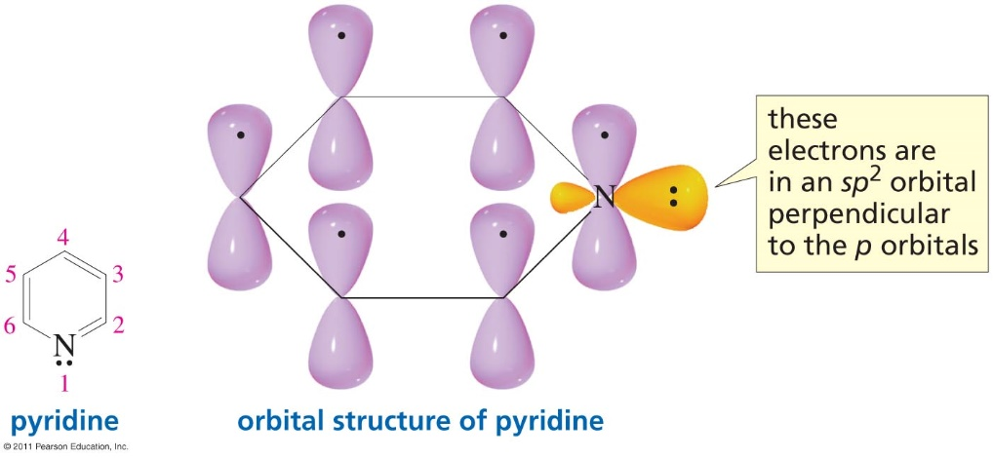
- Pyridine is conventionally detect ed by the gas chromatography and mass spectrometry methods.

- The pyridinium ion is a stronger acid than a typical ammonium ion.
- Pyridine reacts like a tertiary amine .
- The nitrogen lone pair is not released into the aromatic system because it is perpendicular to the π system.
- The nitrogen withdraws electrons by resonance, resulting in an electron-deficient ring system
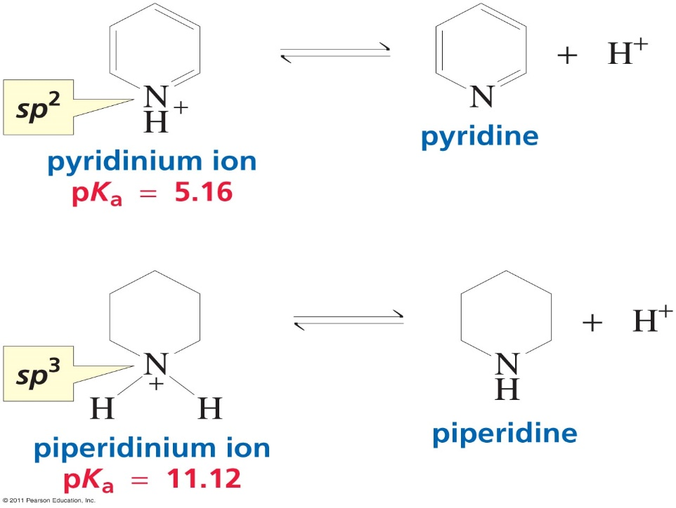
- Pyridine as a nucleophile

- Use Pyridine as a solvent to make esters
Acyl pyridinium ion
Reactive intermediate

- The difference between benzene and pyridine

- Benzene symmetrical non-polar but pyridine polar

It resist electrophilic substitution only in N-atom or at meta-position.

It is highly susceptible to neucleophilic substitution
The difference between benzene and pyridine:
It is basic compound [its basicity less than aliphatic amine

Sources of Pyridine:
- Found in coal tar ,
- Oxidation of picolines yields the pyridine carboxylic acids.

The 4- isomer has been used in the
form of its hydrazide in treatment of T.B
The 3- isomer is Vitamin
- Preparation of Pyridine:
From acrolein by the following steps:
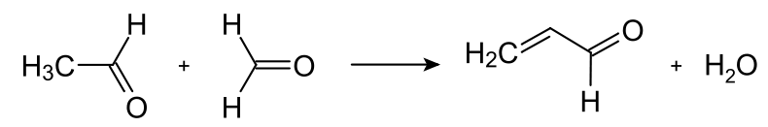

Formation of acrolein from acetaldehyde and formaldehyde .

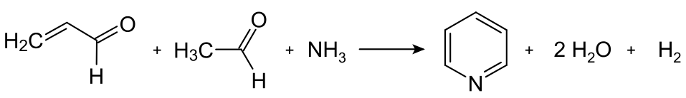

Condensation of pyridine from acrolein and acetaldehyde

Pyridine undergoes electrophilic aromatic substitution at C-3:

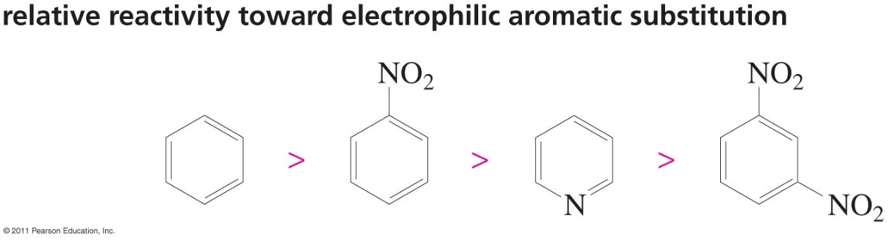
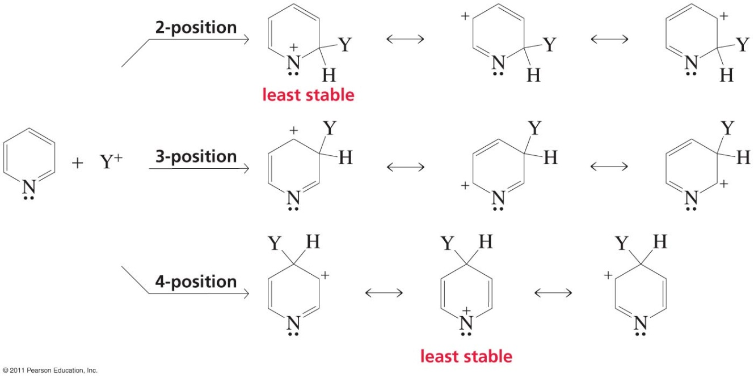

SO the pyridine nitrogen is a meta director P.3

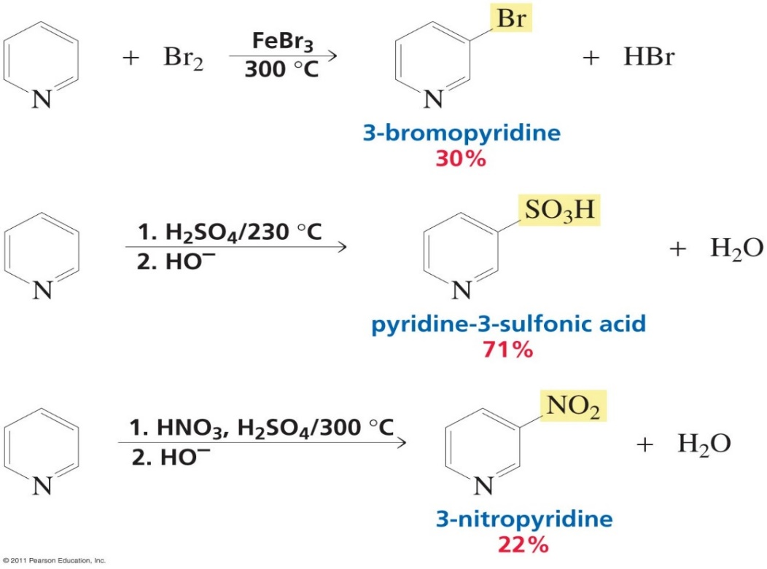
- Pyridine is reactive toward nucleophilic aromatic substitution because of the presence of the electronegative nitrogen:

