LECTURE 1
The Cell
The Cell Definition: The cell (from Latin cella, meaning "small room") is the basic structural, functional, and biological unit of all known living organisms. A cell is the smallest unit of life that can replicate independently, and cells are often called the "building blocks of life". The study of cells is called cell biology.
Cells consist of cytoplasm enclosed within a membrane, which contains many biomolecules such as proteins and nucleic acids. Organisms can be classified as unicellular (consisting of a single cell; including bacteria) or multicellular (including plants and animals). While the number of cells in plants and animals varies from species to species, humans contain more than 10 trillion cells. Most plant and animal cells are visible only under a microscope, with dimensions between 1 and 100 micrometres.
The cell theory, first developed in 1839 by Matthias Jakob Schleiden and Theodor Schwann, states that (1) all organisms are composed of one or more cells, (2) that cells are the fundamental unit of structure and function in all living organisms, (3) that all cells come from preexisting cells, and (4) that all cells contain the hereditary information necessary for regulating cell functions and for transmitting information to the next generation of cells. Cells emerged on Earth at least 3.5 billion years go.

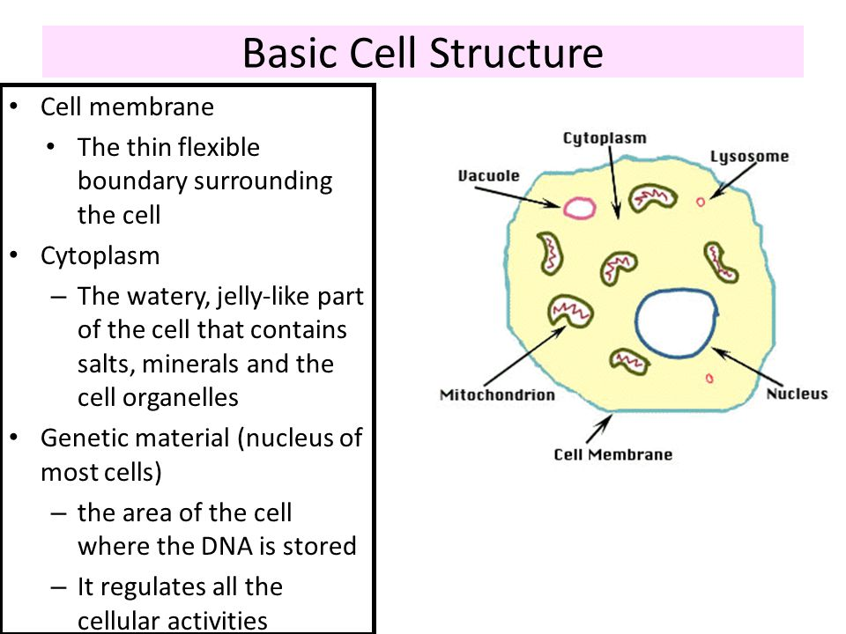

The compartion between eukaryotic and prokarytic cells
A prokaryote is a unicellular organism that lacks a membrane-bound nucleus (karyon), mitochondria, or any other membrane-bound organelle. The word prokaryote comes from the Greek πρό (pro) "before" and καρυόν (karyon) "nut or kernel".Prokaryotes can be divided into two domains. In contrast, species with nuclei and organelles are placed in the domain Eukaryota.
In the prokaryotes, all the intracellular water-soluble components (proteins, DNA and metabolites) are located together in the cytoplasm enclosed by the cell membrane, rather than in separate cellular compartments.
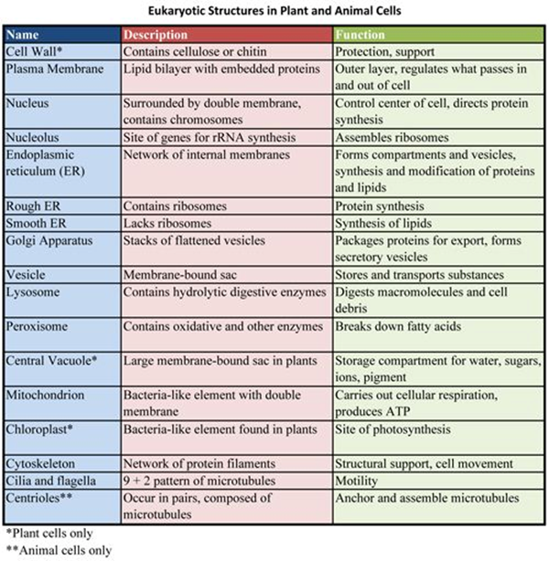

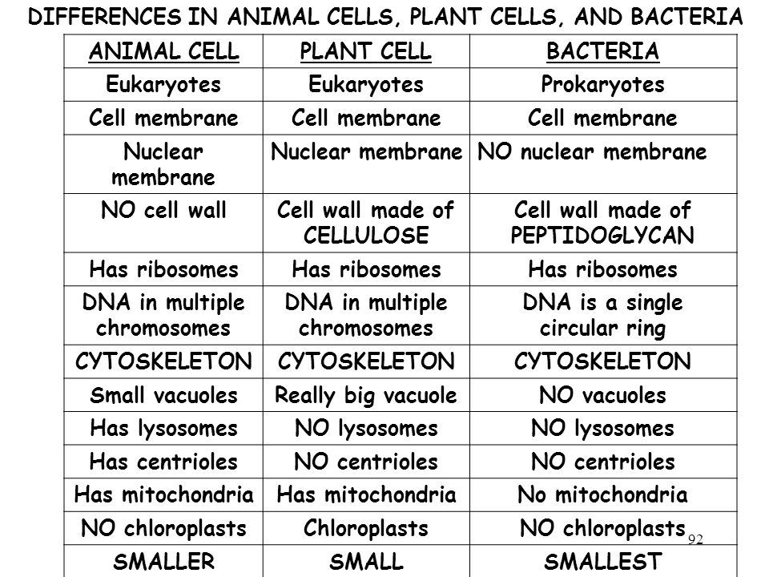

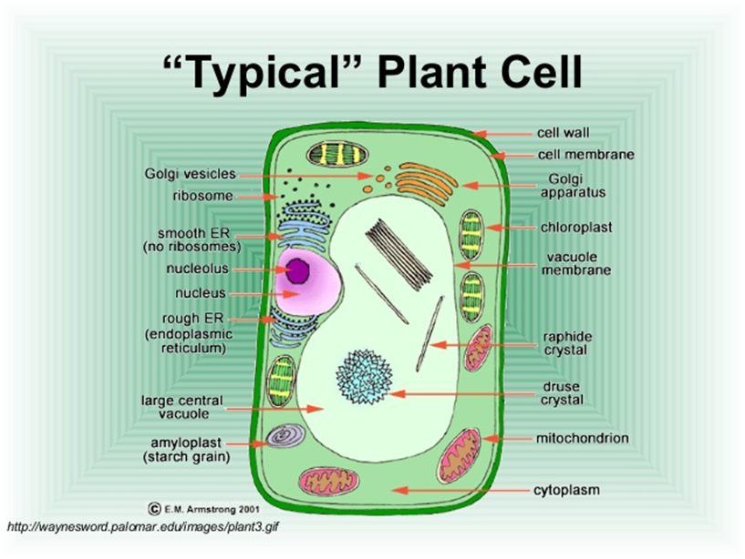
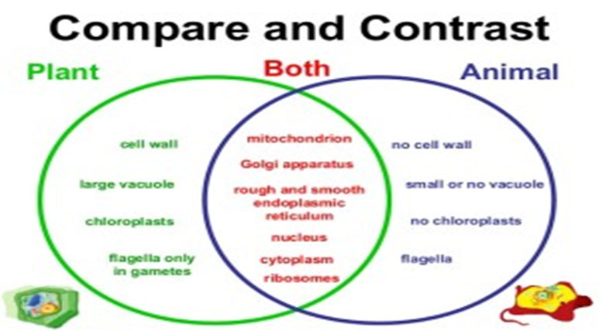

The cell wall
A cell wall is a layer of non-living polysaccharides structure surrounding some types of cells, situated outside the cell membrane. It can be tough, flexible, and sometimes rigid. It provides the cell with both structural support and protection, and also acts as a filtering mechanism. Cell walls are present in most prokaryotes except mycoplasma bacteria, in algae, plants and fungi but rarely in other eukaryotes including animals. A major function is to act as pressure vessels, preventing over-expansion of the cell when water enters.
The composition of cell walls varies between species and may depend on cell type and developmental stage. The primary cell wall of land plants is composed of the polysaccharides cellulose, hemicellulose and pectin. Often, other polymers such as lignin, suberin or cutin are anchored to or embedded in plant cell walls. Algae possess walls made of glycoproteins and polysaccharides such as carrageenan and agar that are absent from land plants. In bacteria, the cell wall is composed of peptidoglycan. Fungi possess cell walls made of the glucosamine polymer chitin. Unusually, diatoms have a cell wall composed of biogenic silica.

