Mineral Metabolism
1-SODIUM

Sodium is the most abundant cation in the ECF, representing 90% of all extracellular cations, and largely determines the osmolality of the plasma. Na⁺ concentration in the ECF is much larger than inside the cells.

functions of Sodium

- It is usually associated with chloride and bicarbonate in regulation of acid base equilibrium .
- the preservation of normal irritability of muscles
- permeability of cells and in the maintenance of osmotic pressure of body fluid , thus protecting the body against excessive fluid loss .
- Transmission and conduction of nerve impulses
- Responsible for osmolarity of vascular fluids
- Sodium shifts into cells and potassium shifts out of the cells (sodium pump)
- Sodium ions are essential for muscles contraction

Daily requirement is 1-3.5 gm . About 95 % of the sodium which leaves the body is excreted in the urine as sodium chloride .
. Sodium is readily absorbed so that faces contains very little except in diarrhea . Sodium is present in the blood mainly in the serum . Normal serum sodium level is 133-146m Eq / L.

Hyponatremia
Low levels of sodium in serum is called hyponatremia . It occurs in the following condition :
1. Excessive vomiting and diarrhea resulting in excessive loss of fluid from gastrointestinal tract .
2. Severe burns
3. Acute Addison's disease
4. Chronic renal disease with acidosis
5. In active sweating and when take plain water .
6. Diabetes mellitus
7. Diuretics

Hypernatremia
It is the increased level of serum sodium . This is not very common but may occur due to :
1. Hyperactivity of adrenal cortex as in Cushing's disease
2. Prolonged administration of cortisone , ACTH and sex hormones .
3. increased salts intake

2-POTASSIUM

Potassium (K⁺) is the major intracellular cation. Like Na⁺, K⁺ would eventually diffuse across the cell membrane until equilibrium is reached. The Na⁺, K⁺ -ATPase ion pump moves three Na⁺ ions out of the cell in exchange for two K⁺ ions moving into the cell as ATP is converted to ADP.

Function of Potassium
1-Potassium is the principal cation of the intracellular fluid . It is also a very important constituent of the extracellular fluid .
2- influences muscles activity .
3-Potassium ions are essential for contraction of cardiac and skeletal muscles .
4-During muscular contraction , potassium from the muscle cells are lost into the ECF and after muscle contraction they are returned to the muscle cells .
5-Potassium is essential for the activity of nerve cells and is present in the nerve fibers and maintains the proper transmission of nerve impulses . It maintains the electric potential of the cells as also their size .
6- It influences the acid base balance and is also related to carbohydrate metabolism .
The normal concentration of potassium in the serum is 3.5 – 5.5 m Eq /L
or 14-24 mg/dL

The source :
Vegetables are rich sources of potassium . The recommended amount of potassium for adults 4 gm / day

Hyperkalaemia
This is due to increased serum potassium and occurs in the following conditions :
1. Renal failure
2. Advanced dehydration
3. Addison's disease
4. Shock
5. Intravenous administration of excess amount of potassium.
6. Acidosis

Hypokalaemia
This is due to low levels of serum potassium and occurs in cases of :
1. Diarrhea and vomiting
2. Metabolic alkalosis
3. Over activity of adrenal cortex ( Cushing's syndrome )
4. Prolonged administration of diuretics because of excretion of potassium in the urine
5. During heart failure .
6.Alkalosis .An alkalosis may cause a shift of potassium from the ECF to the ICF.

Hormone controlling plasma Na⁺
Aldosterone is a type of steroid hormone that acts primarily in renal collecting ducts to stimulate reabsorption of Na⁺ as well as secretion of K⁺ and H⁺.
- It produced by adrenal cortex
- It acts on renal distal convoluted tubule
- It regulates water reabsorption by increasing sodium uptake from the tubular fluid into the blood but potassium is excreted
- It responsible for reabsorption of sodium & water into the vascular compartment
-Aldosterone is a function of the inverse of the sodium intake as sensed via osmotic pressure.
Aldosterone increases the excretion of potassium and the reabsorption of sodium in the distal tubule. Aldosterone is released if blood levels of potassium increase, if blood levels of sodium severely decrease, or if blood pressure decreases. Its net effect is to conserve and increase water levels in the plasma by reducing the excretion of sodium, and thus water, from the kidneys. In a negative feedback loop, increased osmolality of the ECF (which follows aldosterone-stimulated sodium absorption) inhibits the release of the hormone.
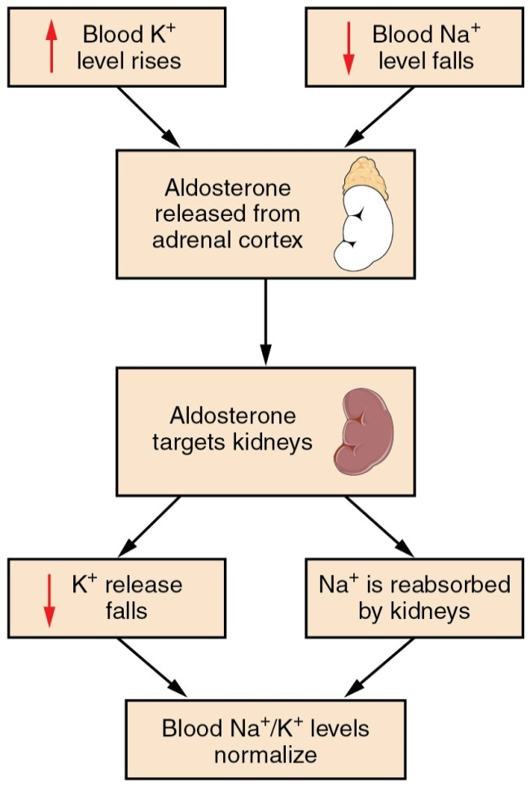
3-Chloride
Chloride is the predominant extracellular anion.
1-Chloride is a major contributor to the osmotic pressure gradient between the ICF and ECF, and plays an important role in acid-base balance .
2-Chloride functions to balance cations in the ECF, maintaining the electrical neutrality of this fluid.
Hypochloremia: or lower-than-normal blood chloride levels, can occur because of defective renal tubular absorption. Vomiting, diarrhea. While The most important is produce HCL
Hyperchloremia: or higher-than-normal blood chloride levels, can occur due to dehydration, excessive intake of dietary salt (NaCl) or swallowing of sea water, aspirin intoxication, congestive heart failure, and the hereditary, chronic lung disease, cystic fibrosis. In people who have cystic fibrosis, chloride levels in sweat are two to five times those of normal levels, and analysis of sweat is often used in the diagnosis of the disease.

