Theories of Development

Learning Objectives:
Mastery of content in this chapter will
enable the student to:
■ Identify the major concepts of selected theories of
development.
■ Compare the major points of view related to the
formulation of selected developmental theories.
■ Assess the relevance of selected theories of
development to nursing care of children, adults,
and old age.

1

Psychosocial theories

Erikson's Concept of Development

Erik Erikson's stages’ theory of
psychosocial development contributed
to our understanding of personality
development throughout the lifespan.

2

Erik Erikson was born June 15, 1902.

Died May 12, 1994.

3
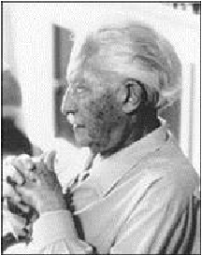

Erickson

describes eight developmental

phases.
Five of these phases attribute to childhood
and three attribute to adulthood.
Erickson uses the word sense to describe
the affective states being dealt with in the
progression (sequences) of development in
each phase.

4

Development for Erickson is Tridimensional:

1.

2.

There is the progression from one phase to
another.

Development involves a set of mutual (shared)
feelings:

A.

B.

C.

D.

E.

F.
Between infant and one-child-caring person
(mother).
Between child and child caring persons later.
Between child and peers.
Then between adolescent and his peers.
In early adulthood, mutuality is between intimate
friends and parents.
Later between generations.

3.

Development is relative.

5

Developmental phases of Erickson:

6
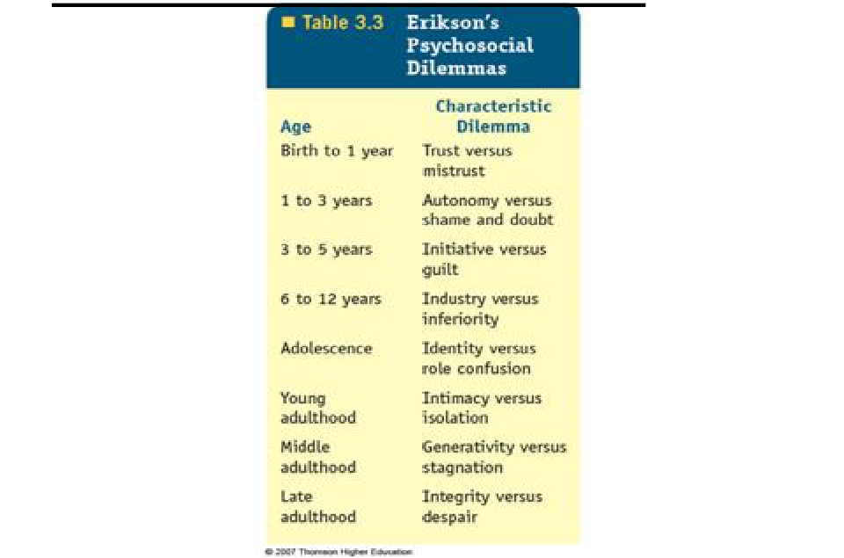

Phase I: (birth – 1 year), a sense of basic
trust V/S basic mistrust.

*Phase I, starts from birth till the end of the first
year of life.

*The infant acquires a sense of basic trust
while overcoming a sense of basic mistrust.

7

■

■

■

Affective development, that is, emotional
development, is started in the very early
experience of this phase.

Infants are born with their basic abilities
needed for extra-uterine survival, such as
respiration, thermoregulation and
digestion.

They cannot survive without the care given to
provide for those essential needs such as
food, warmth and, security.

8

■

■

■

■

For the newborn, a sense of trust requires a
feeling of physical comfort and a minimum
amount of uncertainty (insecurity) and discomfort.

In contrast, a sense of mistrust arises with
unsatisfactory physical experiences and the
association of frustration with them.
Frustration طابحلإا. leads to feeling of fear and
lack of hope for finding the desired change.

Trust helps the infant to feel confident in
himself as well as in others.

9

*During the first 3 to 4 months, much of the infant's routine
centers around the intake of food, light, sound and around
general bodily tactile stimulations. Oral contact and
sucking alleviate (relieve) discomfort while providing them
with a source of satisfaction.

*Love and pleasure of dependency, which is important in
this phase, are given or provided to the child through his
mother or the care giver by her comforting warmth, smile,
and way of talking, as well as through the quality of care.

·

The infant develops a sense of trust when he learns

that his outside world is a giving one and when his
needs are satisfied properly.
*A sense of mistrust develops when there is too much or
too little frustration resulting from too late gratification
(satisfaction) of needs.

10

Phase II: (1- 3 yrs.), a sense of autonomy V/S a
sense of doubt and shame.

*When the infant gains trust in his outside world and
way of life, he is ready to acquire a sense of
autonomy and he realizes his will.

*He starts to practice being independent; however,
his continued dependencies create a sense of
doubt in his abilities and capacities, and also
create a sense of shame for continuing to be
dependent on his mother.

11

Specific developmental tasks a toddler
will deal with:

1. Differentiation of himself from others,
particularly his mother.

2. Toleration of separation from mother,
parents, and family.

3. Ability to interact with others in less
egocentric (selfish), autistic manner.

12

Characteristics of typical autonomy:

1. Negativism: the toddler starts to use the word "No"
2. Ritualism: doing certain actions or behaving in a
ritual manner i.e. repeat certain behavior several
times.
3. Emotions becomes very strongly expressed, e.g.
one minute the child can be involved in an activity and
the next minute he might be violently angry because
he was unable to manipulate a toy or to open a box or
a door.
Temperament )عبط ,جازم((is the manner of thinking,
behaving or reacting characteristic of an individual and
refers to the way in which a person deals with life)
may appear if he is scolded for doing something
wrong.

13

Phase III: (3/4 – 5 yrs), a sense of initiative
and V/S a sense of guilt.

*The child in this phase starts to be more active
and positive in performing certain tasks.

*Erickson refers to these developmental
years as the "Play age".

*The use of the language in this phase is
improved.

14

*Psychological development in this phase
centers in to major tasks:

1. The child begins his relationship with others
such as parents, peers, and other adult in
the life.

2.
The child begins to notice sex differences –
the children are now experiencing being a
boy or girl.

15

Phase IV: (6 – 11 years), A sense of
industry V/S inferiority

*The divergenceنيابت of this phase is a sense of
industry versus a sense of inferiority.

*The child's energy is directed toward
inventions and production.

*Beginning to create, develop, and manipulate.

*Developing sense of competence and
perseverance.

16

Phase V: (12-20 years), Identity V/S Identity
diffusion
*A sense of identity means a sense of being
at one with oneself as one grows and
develops.
*Identity development is closely linked with the
mastery of skills.
*Achieving a sense of identity as well as
overcoming a sense of identity diffusion
*Children physically mature into adulthood;
they experience rapid body growth, important
physiological and anatomical changes.
Previous trust in their body and their mastery
of its functions is suddenly shaken.

17

■

■

■

■

Young adolescents experience a close attachment to
their parents while they reach for new and more
satisfactory contacts in association outside the family.

They learn to interact with more and more people at a
given times and they learn in which way they should
relate to them. In this process they become individuals in
and members of their community.

Adolescents develop their relationship with significant
adult in his/her life.

Identity development moves from the reality of being to
the reality of becoming

18

Phase VI: (20-40 years), a sense of intimacy and
solidarity V/S Isolation.

*This period is a time to enjoy life with adult liberty and
responsibility.

*The major developmental theme now involves
psychological readiness and a commitment to
mutual intimacy in the partnership of marriage.

*In this phase a foundation is prepared for the couple's
own life and the lives of others. Graduation from
adolescence requires a sense of shared identity.

*Intimacy involves a balance between giving to other
and maintaining oneself.

19

Phase VII: (40 - 60 years): a sense of Generativity
V/S self absorption.

*The second of developmental phase of adulthood
deals with assuring care for the new generation.

*Generativity refers to the care they provide as a unit
in society at large to the next generation.

*It is the period in life when individuals are productive
in work to satisfy themselves and people beyond
their own family borders.

20

Phase VIII:

(60 years & above): a sense of Integrity

V/S Despair.
*Integrity refers to the acceptance of the individual life
cycles of human beings as something that has to be. If in
old age one prefers not to be what one was not meant to
be, one has found a sense of integrity.
*It includes overcoming a sense of despair, a sense of
disgust at certain life styles, and a fear of death at the
end.
*In this phase, one often finds wisdom and a philosophy of
life which extends beyond one's own life cycle to future
developmental cycle.
*With a faith and trust in generations, Erickson says"
healthy children will not fear life, if their parents have
integrity enough not to fear death".

21
Erikson's Psychosocial Stages Summary

Stage

Infancy (birth to
18 months)
Basic
Conflict

Trust vs.
Mistrust
Important
Events

Feeding
Outcome

Children develop a sense of trust when caregivers provide
reliability, care, and affection. A lack of this will lead to

mistrust.

Early
Childhood
(2 to 3 years)

Autonomy
vs.
Shame and

Toilet
Training

Children need to develop a sense of personal control over physical
skills and a sense of independence. Success leads to feelings
of autonomy, failure results in feelings of shame and doubt.

Doubt

Preschool
(3 to 5 years)

Initiative vs.
Guilt

Exploration

Children need to begin asserting control and power over the
environment. Success in this stage leads to a sense of

purpose. Children who try to exert too much power experience
disapproval, resulting in a sense of guilt.

School Age
(6 to 11 years)

Industry vs.
Inferiority

School

Children need to cope with new social and academic demands.
Success leads to a sense of competence, while failure results

in feelings of inferiority.

Adolescence
(12 to 18 years)

Young
Adulthood
(19 to 40 years)

Middle
Adulthood
(40 to 65 years)

Identity vs.
Role
confusion

Intimacy vs.
Isolation

Generativity
vs.
Stagnation

Social
Relationships

Relationships

Work and
Parent Hood

Teens needs to develop a sense of self and personal identity.
Success leads to an ability to stay true to yourself, while failure
leads to role confusion and a weak sense of self.

Young adults need to form intimate, loving relationships with other
people. Success leads to strong relationships, while failure
results in loneliness and isolation.

Adults need to create or nurture things that will outlast them, often
by having children or creating a positive change that benefits
other people. Success leads to feelings of usefulness and

accomplishment, while failure results in shallow involvement in
the world.

Maturity
(65 to death)

Ego Integrity
vs. Despair

Reflection on
Life

Older adults need to look back on life and feel a sense of fulfillment.
Success at this stage leads to feelings of wisdom, while failure
results in regret, bitterness, and despair.
22

Have a nice
day

23

