Cardiovascular physiology

Cardiac output

Cardiac output (COP) is the quantity of blood pumped into the aorta each minute by the heart, or it is the output of the heart per unit of time (stroke volume × heart rate), which equals to the quantity of blood that flows through the circulation. Cardiac output is one of the most important factors to consider in relation to the circulation because it is the sum of the blood flows to all the tissues of the body.
As mentioned previously, the amount of blood pumped out of the heart per beat, the stroke volume, is about 70 ml from each ventricle in
a resting man of average size in the supine position; so COP averages about 5 L/min (70 ml × 72 BPM). In women, the value of COP averages about 4.9 L/min.
Venous return is the quantity of blood flowing from the veins into the right atrium each minute. The venous return and COP must equal each other.

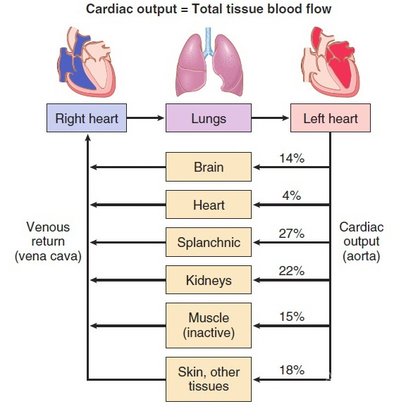

Figure (1) Cardiac output and venous return

When one states that cardiac output is controlled by venous return, this means that it is not the heart itself that is normally the primary controller of cardiac output. Instead, it is the various factors of the peripheral circulation that affect flow of blood into the heart from the veins, called venous return, that are the primary controllers.
Cardiac output varies widely with the level of activity of the body. Factors that have direct effect on cardiac output are (1) the basic level of body metabolism, (2) exercise, (3) age and (4) the size of the body. The effects of various conditions on cardiac output are summarized in table (1).

Table (1) Effect of various conditions on cardiac output
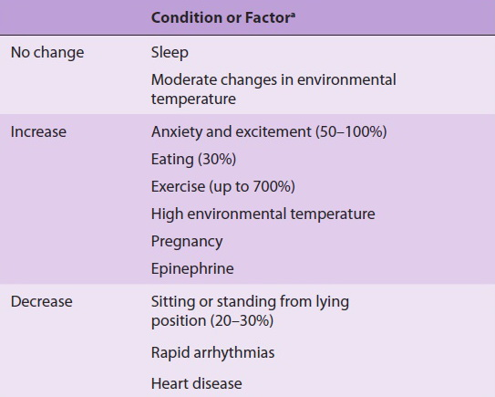

Cardiac index
Experiments have shown that the cardiac output increases approximately in proportion to the surface area of the body. Therefore, cardiac output is frequently stated in terms of the cardiac index, which is the cardiac output per square meter of body surface area. The average human being who weighs 70 kilograms has a body surface area of about 1.7 square meters, which means that the normal average cardiac index for adults is about 3 L/min/m² of body surface area.

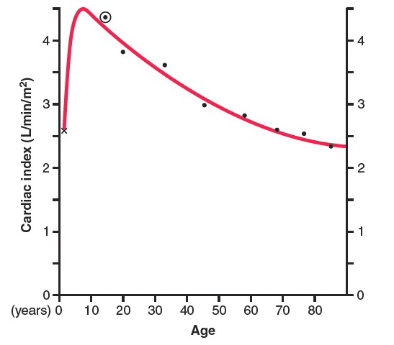

Figure (2) Cardiac index for humans at different ages

Factors controlling COP

Predictably, changes in cardiac output are caused by physiologic conditions affecting heart rate, stroke volume, or both. The heart rate is controlled primarily by the autonomic nerves, with sympathetic stimulation increasing the rate and parasympathetic stimulation decreasing it.
Stroke volume is also determined in part by neural input, with sympathetic stimuli making the myocardial muscle fibers contract with greater strength at any given length and parasympathetic stimuli having the opposite effect. When the strength of contraction (contractility) increases without an increase in fiber length, more of the blood that normally remains in the ventricles is expelled; that is, the ejection fraction increases.
The catecholamines liberated by sympathetic stimulation increase the heart rate, this accelerator action of them is known as chronotropic effect; moreover, they increase the strength of cardiac contraction, an action that is known as inotropic effect.
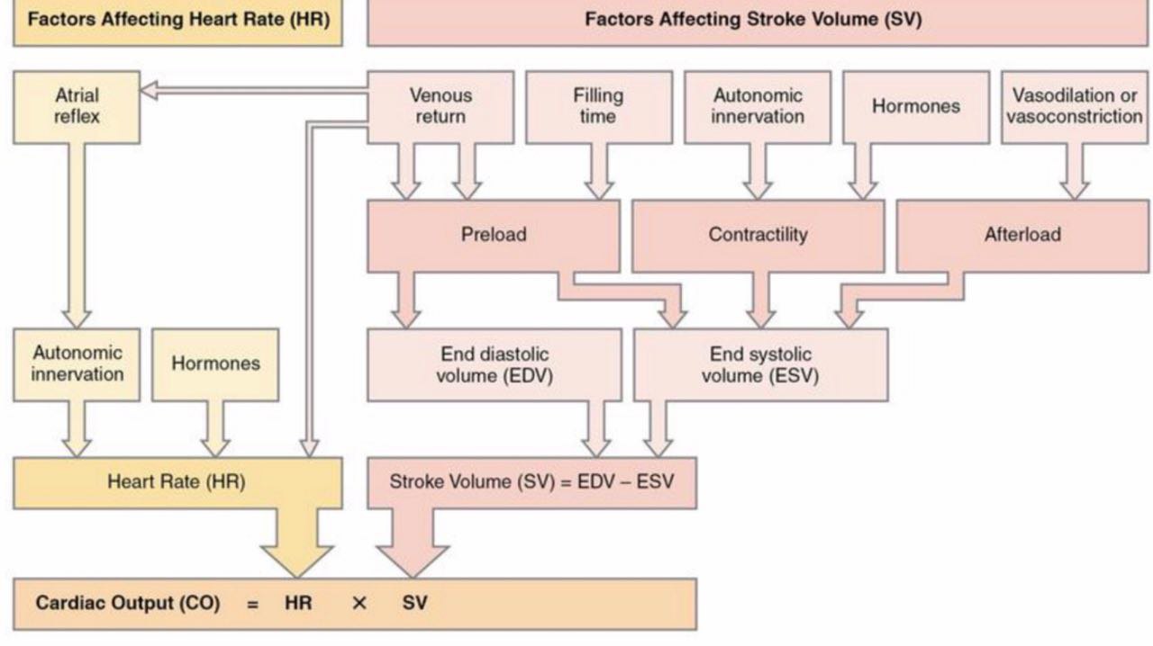
Figure (3) Factors controlling COP

Preload and afterload

In assessing the contractile properties of a muscle, it is important to specify the degree of tension on the muscle when it begins to contract, which is called the preload, and to specify the load against which the muscle exerts its contractile force, which is called the afterload.
For cardiac contraction, the preload is usually considered to be the end-diastolic pressure when the ventricle has become filled. The afterload of the ventricle is the pressure in the aorta leading from the ventricle.

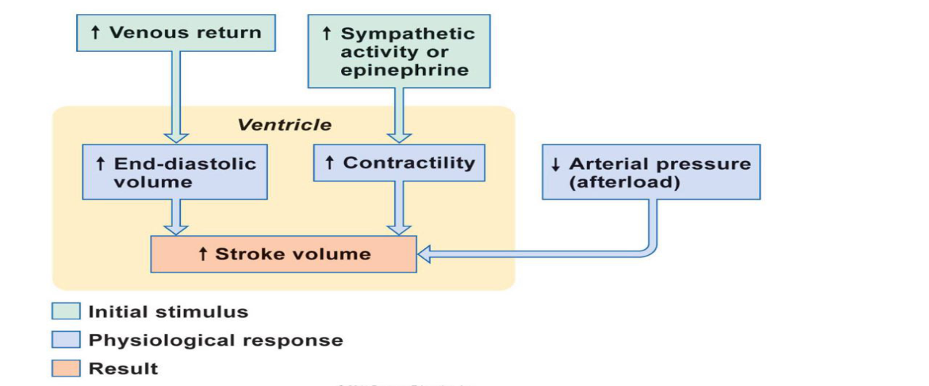

Figure (4) Interactions between the components that regulate cardiac output

