The objectives
1- Be able to identify connective tissue
2. What is the function of the connective tissue.
3. Explain the main component of C.T?
4. Describe the components of the extracellular matrix
5-Numerate the types of cells which are found in C.T.?
6. What are the fibers? Classify it?
7- Be able to recognize between the three types of fibers
Connective Tissue: Introduction
Connective tissue are responsible for providing and maintaining the form of organs throughout the body. Functioning in a mechanical role, they provide a matrix that connects and binds other tissues and cells in organs and gives metabolic support to cells as the medium for diffusion of nutrients and waste products.
Structurally, connective tissue is formed by three classes of components: cells, fibers, and ground substance. Unlike the other tissue types (epithelium, muscle, and nerve), which consist mainly of cells, the major constituent of connective tissue is the extracellular matrix (ECM). Extracellular matrices consist of different combinations of protein fibers (collagen, reticular, and elastic fibers) and ground substance. In addition to its major structural role, molecules of connective tissue serve other important biological functions, such as forming a reservoir of factors controlling cell growth and differentiation. The hydrated nature of much connective tissue provides the medium through which nutrients and metabolic wastes are exchanged between cells and their blood supply.
- Cells of Connective Tissue
A variety of cells with different origins and functions are present in connective tissue. Fibroblasts originate locally from undifferentiated mesenchymal cells and spend all their life in connective tissue; other cells such as mast cells, macrophages, and plasma cells originate from hematopoietic stem cells in bone marrow, circulate in the blood, and then move into connective tissue where they remain and execute their functions. White blood cells (leukocytes) are transient cells of most connective tissues; they also originate in the bone marrow and move to the connective tissue where they reside for a few days, then usually die by apoptosis. Table 1 shows the main types and functions of connective tissue cells
Cell Type | Representative Product or Activity | Representative Function
Fibroblast, chondroblast, osteoblast, odontoblast | Production of fibers and ground substance | Structural
Plasma cell | Production of antibodies | Immunologic (defense)
Lymphocyte (several types) | Production of immune competent cells | Immunologic (defense)
Eosinophilic leukocyte | Participation in allergic and vasoactive reactions, modulation of mast cell activities and the inflammatory process | Immunologic (defense)
Neutrophilic leukocyte | Phagocytosis of foreign substances, bacteria | Defense
Macrophage | Secretion of cytokines and other molecules, phagocytosis of foreign substances and bacteria, antigen processing and presentation to other cells | Defense
Mast cell and basophilic leukocyte | Liberation of pharmacologically active molecules (eg, histamine) | Defense (participate in allergic reactions)
Adipocyte | Storage of neutral fats | Energy reservoir, heat production

- Ground substance is a highly hydrophilic, viscous complex of an ionic macromolecules (glycosaminoglycans and proteoglycans) and multiadhesive glycoproteins (laminin, fibronectin, and others) that stabilizes the ECM by binding to receptor proteins (integrins) on the surface of cells and to the other matrix components. is a colorless, transparent, gel-like material in which the cells and fibers of connective tissue are embedded. Ground substance serves as a lubricant, helps prevent invasion of tissues by foreign agents, and resists forces of compression.
- Fibers: are long, slender protein polymers present in different proportions in different types of connective tissue. The three main types of connective tissue fibers are collagen, reticular, and elastic fibers. Collagen and reticular fibers are both formed by the protein collagen, and elastic fibers are composed mainly of the protein elastin. These fibers are distributed unequally among the types of connective tissue and the predominant fiber type is usually responsible for conferring specific properties on the tissue.
- Collagen fibres
Collagen fibers are the dominant fiber type in most connective tissues. The primary function of collagen fibers is to add strength to the connective tissue. The thickness of the fibers varies from ~ 1 to 10 µm. Longitudinal striations may be visible in thicker fibers. These striations reveal that the fibers are composed of thinner collagen fibrils (0.2 to 0.5 µm in diameter). Each of these fibrils is composed of microfibrils, which are only visible using electron microscopy.
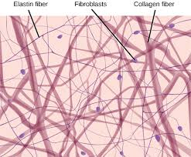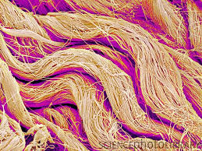
- Reticular fibers: Reticular fibers are very delicate and form fine networks instead of thick bundles. They are usually not visible in histological sections but can be demonstrated by using special stains. For example, in silver stained sections reticular fibers look like fine, black threads - coarse collagen fibers appear reddish brown in the same type of preparation.
Because of their different staining characteristics, reticular fibers were initially thought to be completely different from collagen fibers. We now know that reticular fibers consist of collagen - although the main type of tropocollagen found in reticular fibers, type III, is different from that of the coarse collagen fibers. Reticular fibers give support to individual cells, for example, in muscle and adipose tissue.
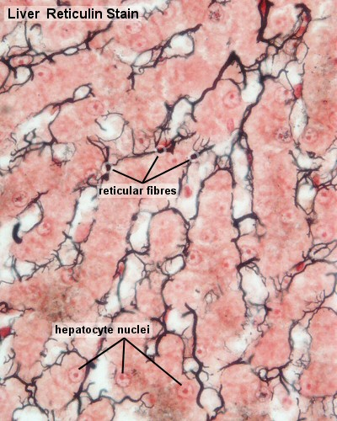

Elastic fibers
Elastic fibers are colored in fresh tissues - they are light yellow - but this coloration is only visible if large amounts of elastic fibers are present in the tissue, for example, in the elastic ligaments of the vertebral column. Special stains are necessary to show elastic fibers in tissue sections.
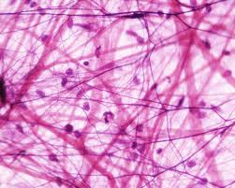
MM
MDICAL APPLICATION
The regenerative capacity of connective tissue is clearly observed in organs damaged by ischemia, inflammation, or traumatic injury. Spaces left after such injuries, especially in tissues whose cells divide poorly or not at all (eg, cardiac muscle), are filled by connective tissue, forming dense irregular
scar tissue. The healing of surgical incisions and other wounds depends on the reparative capacity of connective tissue, particularly on activity and growth of fibroblasts. In some rapidly closing wounds, a cell called the myofibroblast, with features of both fibroblasts and smooth muscle cells, is also observed. These cells have most of the morphologic characteristics of fibroblasts but contain increased amounts of actin microfilaments and myosin and behave much like smooth muscle cells. Their activity is important for the phase of tissue repair called wound contraction. http://staff.uobabylon.edu.iq/lectures.aspx?id=604

