The objectives
1-To understand the different type of muscles in human body
2- Learn the different function, shape and structures
3- Give an example for each type of muscle tissue
3- Muscle Tissue
Muscle tissue, the third basic tissue type with epithelia, connective tissues, and nervous tissue, is composed of cells that optimize the universal cell property of contractility. As in all cells, actinmicrofi-laments and associated proteins generate the forces necessary for the muscle contraction. Essentially all muscle cells are of mesodermal origin and differentiate by a gradual process of cell lengthening with abundant synthesis of the myofibrillar proteins actin and myosin. Three types of muscle tissue can be distinguished on the basis of morphologic and functional characteristics:
■ Skeletal muscle contains bundles of very long, multinucleated cells with cross-striations. Their contraction is quick, forceful, and usually under voluntary control.
■ Cardiac muscle also has cross-striations and is composed of elongated, often branched cells bound to one another at structures called intercalated discs that are unique to cardiac muscle. Contraction is involuntary, vigorous, and rhythmic.
■ Smooth muscle consists of collections of fusiform cells that lack striations and have slow, involuntary contractions.
1- Skeletal Muscle: (or striated) muscle consists of muscle fibers, which are long, cylindrical multinucleated cells with diameters of 10 to 100 μm. Elongated nuclei are found peripherally just under the sarcolemma, a characteristic nuclear location unique to skeletal muscle fibers/cells. Longitudinally sectioned skeletal muscle fibers show cross striations of alternating light and dark bands. The dark bands are called A bands and the light bands are called I band. In the TEM, each I band is seen to be bisected by a dark transverse line, the Z disc (Ger. zwischen, between). The repetitive functional subunit of the contractile apparatus, the sarcomere, extends from Z disc to Z disc and is about 2.5 μm long in resting muscle.
2- Smooth Muscle: Smooth muscle is specialized for slow, steady contraction and is controlled by a variety of involuntary mechanisms. Fibers of smooth muscle (also called visceral muscle) are elongated, tapering, and nonstriated cells, each of which is enclosed by a thin basal lamina and a fine network of reticular fibers, the endomysium. Smooth muscle cells may range in length from 20 μm in small blood vessels to 500 μm in the pregnant uterus. Each cell has a single long nucleus located in the center of the cell’s central, broadest part.
3- Cardiac Muscle:.
Cardiac muscle cells have central nuclei and myofibrils that are less dense and less well-organized than those of skeletal muscle. Also, the cells are often branched. Mature cardiac muscle cells are approximately 15 μm in diameter and from 85 to 100 μm in length. They exhibit a cross-striated banding pattern comparable to that of skeletal muscle. Unlike multinucleated skeletal muscle, however, each cardiac muscle cell possesses only one (or two) centrally located, pale-staining nuclei. Surrounding the muscle cells is a delicate sheath of endomysium with a rich capillary network. A unique and distinguishing characteristic of cardiac muscle is the presence of dark-staining transverse lines (Intercalated disk) that cross the chains of cardiac cells at irregular intervals where the cells join. These intercalated discs represent the interface between adjacent muscle cells and contain many junctional complexes.
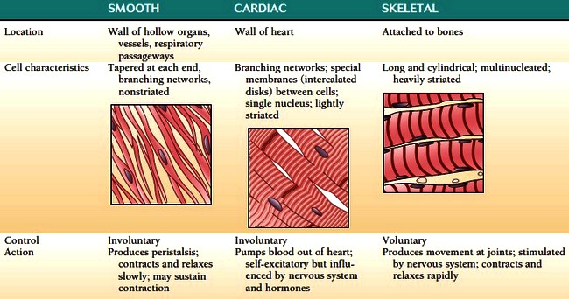

MMMAL APPLICATION
MEDICAL APPLICATION
Myasthenia gravis is an autoimmune disorder that involves circulating antibodies against proteins of acetylcholine receptors. Antibody binding to the antigenic sites interferes with acetylcholine activation of their receptors, leading to intermittent periods of skeletal muscle weakness.
As the body attempts to correct the condition, junctional folds of sarcolemma with affected receptors are internalized, digested by lysosomes, and replaced by newly formed receptors. These receptors, however, are again made unresponsive to acetylcholine by similar antibodies, and the disease follows a progressive course. The extraocular muscles of the eyes are commonly the first affected.

